Parallel system

[alias]

$$Tightly-couple multiprocessor system$$

[intro]

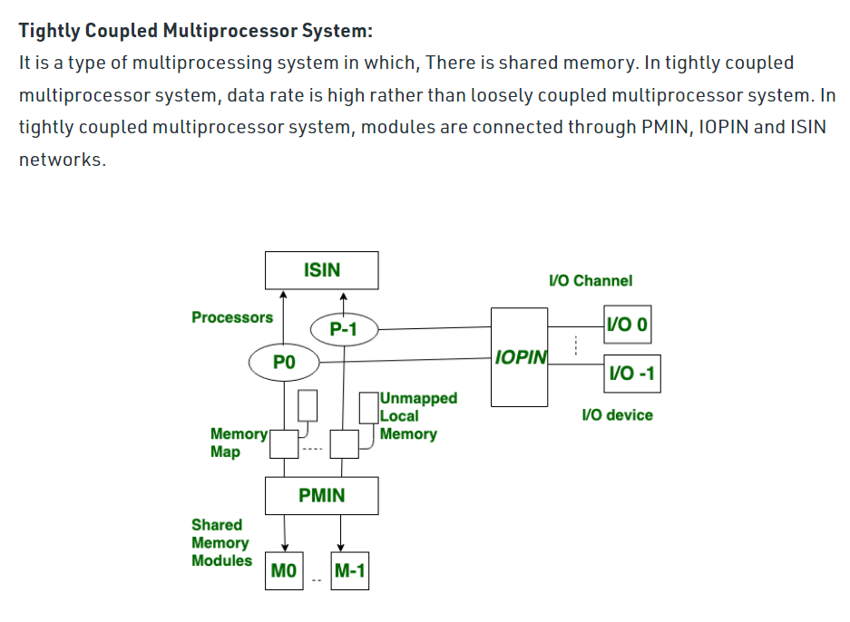

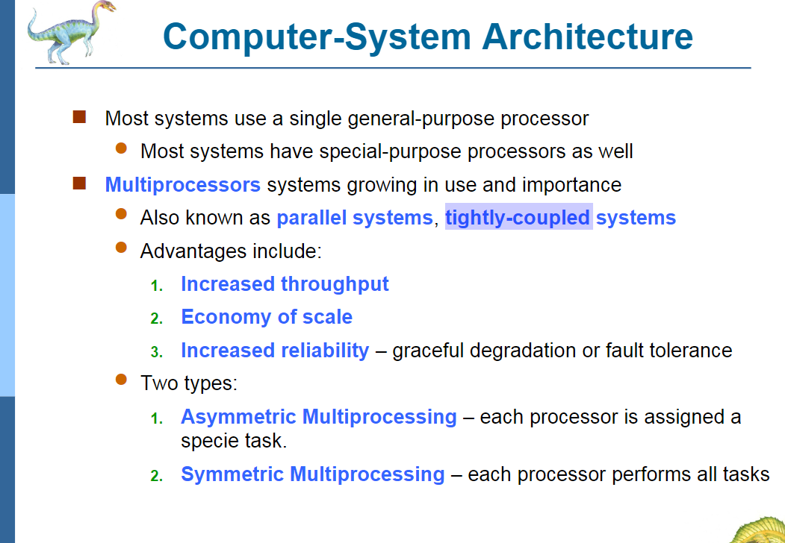

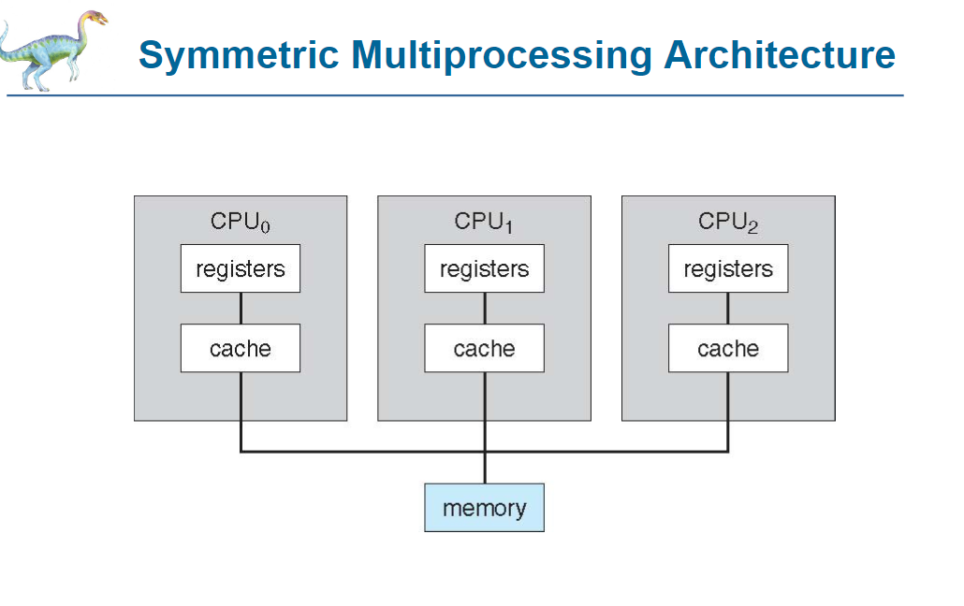

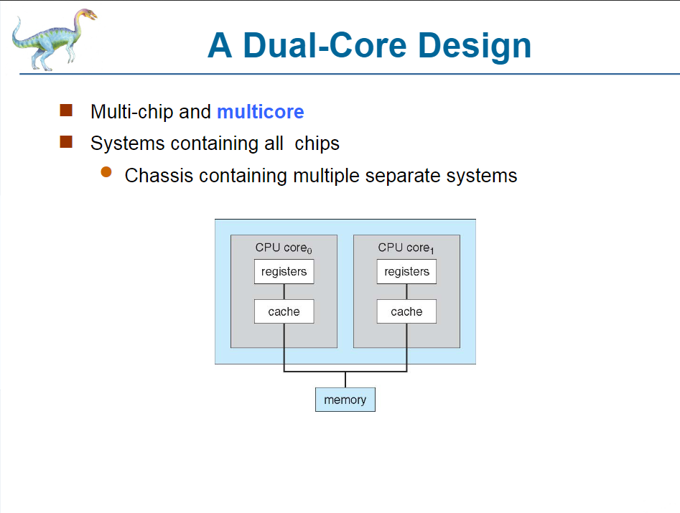

[ref]

[Difference between Loosely Coupled and Tightly Coupled Multiprocessor System - GeeksforGeeks](https://www.geeksforgeeks.org/difference-between-loosely-coupled-and-tightly-coupled-multiprocessor-system/)