RAID

[abbr]

$$Redundant Arrays of Independent Disks$$

[intro]

$$It is commonly used to address the performance$$

$$and reliablity issues.$$

[term]

$$1.\left(MTBF\right) Mean time between failures:$$

$$The average time between two failures occurs of 1 disk.$$

$$MTBF=\frac{number of disks}{total failure}$$

$$2.\left(MTTR\right) mean time to repair:$$

$$When a disk failure occurs,$$

$$the average time to repair the disk failures.$$

$$3.\left(MTTDL\right)mean time to data loss:$$

$$The average time of a data lost.$$

[term]

$$1.redundancy:$$

$$We can store some extra information that$$

$$is NOT normally needed but can be used$$

$$in the event of the disk failure.$$

$$2.mirroring:$$

$$duplicate every drive.$$

$$3.mirrored volume:$$

$$The result of mirroring.$$

[term]

$$1.data stripping:$$

$$Stripped the drives$$

[improvement]

$$1.Improvement of reliability:$$

$$Mirroring$$

$$Once a disk failure occurs, the data will be lost.$$

$$How can we do?$$

$$Use redundancy.$$

$$\left(1\right)mirroring:$$

$$Duplicate every drive.$$

$$It is the simplest but most expensive way.$$

$$2.Improvement of performance:$$

$$Stripping$$

$$We can use parellel access to multiple drives to$$

$$improve performance.$$

$$With mirroring,the rate at which read requests can be handled$$

$$is doubled, since read requests can be sent to either$$

$$drives.$$

$$The transfer rate of each read is same as$$

$$in a singled-drive system,$$

$$but the number of reads per unit time has doubled.$$

$$With multiple drives,we can improve the transfer rate as well$$

$$by stripping data accross the drives.$$

$$The technique is called data stripping.$$

$$\left[type\right]$$

$$(1)bit-level stripping$$

$$Data stripping consists of splitting the bits of each byte$$

$$across multiple drives.$$

$$Such stripping is called bit-level stripping.$$

$$It can be generalized to include a number of drives$$

$$that either is a multiple of 8 or divides 8.$$

$$i.e.With the number of drives n:$$

$$n\left|8 or 8\right|n.$$

$$\left(2\right)Block-level stripping:$$

$$Blocks of a file are stripped across multiple drives,$$

$$such as bytes of a sector or sectors of a block,$$

$$also are possible.$$

$$With the n drives,block i of a file b_{i} goes to the drive d_{i}$$

$$where$$

$$d_{i}=\left(i mod n\right)+1$$

$$Here block-level stripping is the only$$

$$common available stripping.$$

$$Parallelism in a storage system as achieved through stripping$$

$$has two main goal.$$

$$\left(2.1\right)Increase the throughput of multiple small accesses$$

$$\left(page accesses\right) by loading balancing.$$

$$\left(2.2\right)Reduce the response time of large accesses.$$

[conclusion]

|  |  |  |
| --- | --- | --- |
| $$Action$$ | $$Pro$$ | $$Con$$ |
| $$Mirroring$$ | $$Reliability$$ | $$Costly$$ |
| $$Stripping$$ | $$High$$ $$data-transfer$$ $$rate$$ | $$NOT improve$$ $$reliability$$ |

[RAID level]

$$Mirroring and stripping are NOT perfect for us.$$

$$How can we do?$$

$$Some experts proposed RAID level.$$

$$It consists of stripping and mirroring.$$

$$RAID=stripping+mirroring$$

$$or$$

$$RAID=mirroring+stripping$$

$$\left[type\right]$$

$$\left(1\right)RAID level 0:$$

$$It refers to drive arrays with stripping at the level$$

$$of blocks but without any redundancy$$

$$\left(such as mirroring or parity bits.\right).$$

$$Rebuild performance:$$

$$nothing since mirror is NOT used.$$

$$\left(2\right)RAID level 1:$$

$$It refers to drive mirroring.$$

$$Rebuild performance:$$

$$One drive, easiest since we can directly copy it.$$

$$\left(3\right)RAID level 4:$$

$$It is also known as \left(ECC\right)$$

$$memory-style error-correcting-code orginazation.$$

$$The idea of ECC can be used directly in the storage arrays$$

$$via stripping of blocks across drives.$$

$$Rebuild performance:$$

$$One drive.$$

$$\left(4\right)RAID level 5:$$

$$It is also called block-interleaved distributed parity.$$

$$It differs from RAID level 4 in that it spreads data and parity$$

$$among all N+1 drives, rather than storing data$$

$$in N drives and parity in one drive.$$

$$Rebuild performance:$$

$$All drives,bad‼!$$

$$\left(5\right)RAID level 6:$$

$$It is also called as P+Q redundancy scheme$$

$$It is much like RAID level 5 but stores extra redundant$$

$$information to guard against multiple drive failures.$$

$$XOR parity can NOT be used on both parity blocks$$

$$because they would be identical and would NOT provide$$

$$more recovery information.Instead of parity,$$

$$error-correcting codes such as$$

$$Galois field math are used to calculate Q.$$

$$\left(6\right)Multidimensional RAID level 6:$$

$$Some sophosticated storage arrays amplify RAID level 6.$$

$$Consider an array containing hundreds of drives.$$

$$Putting those drives in a RAID level 6 stripe would result in$$

$$many data drivers and only two logical parity drives.$$

$$Multidimensional RAID level 6 logically arranges drives into$$

$$rows and columns.The system can recover from any failure$$

$$or indeed multiple failures by using parity blocks$$

$$in any of these blocks.$$

$$\left(7\right)RAID level 0+1:$$

$$RAID level 0+1=RAID level 0+RAID level 1$$

$$It refers to a combination of RAID level 0 and 1.$$

$$RAID 0 provides performance,$$

$$while RAID 1 provides the reliability.$$

$$Generally, this level provides better performance than$$

$$RAID level 5.$$

$$It is common in environments where performance and$$

$$reliability are important.Unfortunately,like RAID level 1,$$

$$it doubles the number of drives needed for storage,$$

$$so it is relatively expensive.$$

$$In RAID 0+1, a set of drives are stripped, and then$$

$$the stripe is mirrored to another,equivalent stripe.$$

$$\left(8\right)RAID level 1+0:$$

$$Its drives are mirrored in pairs and then$$

$$the resulting mirrored pairs are stripped.$$

$$This schemes has some theoretical advantages over$$

$$RAID level 0+1.$$

$$For example,if a single drive fails in RAID level 0+1,$$

$$an entire stripe is inaccessible,$$

$$leaving only the other stripe.$$

$$If a single drive fails in RAID level 1+0,$$

$$a single drive is unavailable,$$

$$but the drive that mirrors it is still available, as are all the rest$$

$$of the drives.$$

[selection]

$$What kinds of RAID level should we select for use?$$

$$It depends on your consideration.$$

$$In my consideration, the following factors are considered.$$

$$\left(1\right)Rebuild performance:$$

$$Since rebuild a drive may spend at least several hours.$$

$$(2)$$

[illustration]

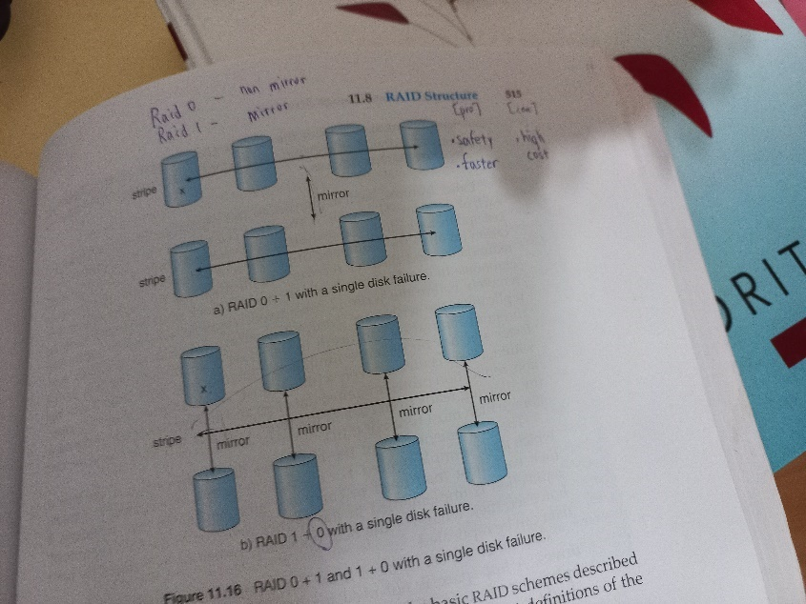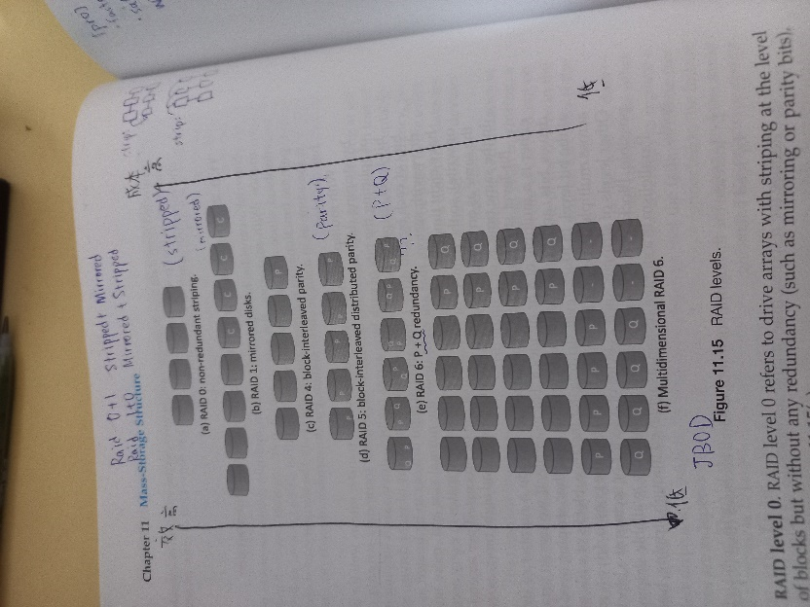

[conclusion]

|  |  |  |  |
| --- | --- | --- | --- |
|  |  |  |  |
|  |  |  |  |
|  |  |  |  |
|  |  |  |  |
|  |  |  |  |
|  |  |  |  |
|  |  |  |  |
|  |  |  |  |
|  |  |  |  |

|  |  |  |
| --- | --- | --- |
|  |  |  |
|  |  |  |
|  |  |  |
|  |  |  |
|  |  |  |
|  |  |  |
|  |  |  |
|  |  |  |

|  |  |
| --- | --- |
|  |  |
|  |  |
|  |  |
|  |  |
|  |  |
|  |  |

[problem]

$$Although using RAID has a better performance or$$

$$reliablity \left(or both\right), it causes some problem or trouble.$$

$$RAID does NOT always assure that data is available for$$

$$the OS and its users.A pointer to a file could be wrong.$$

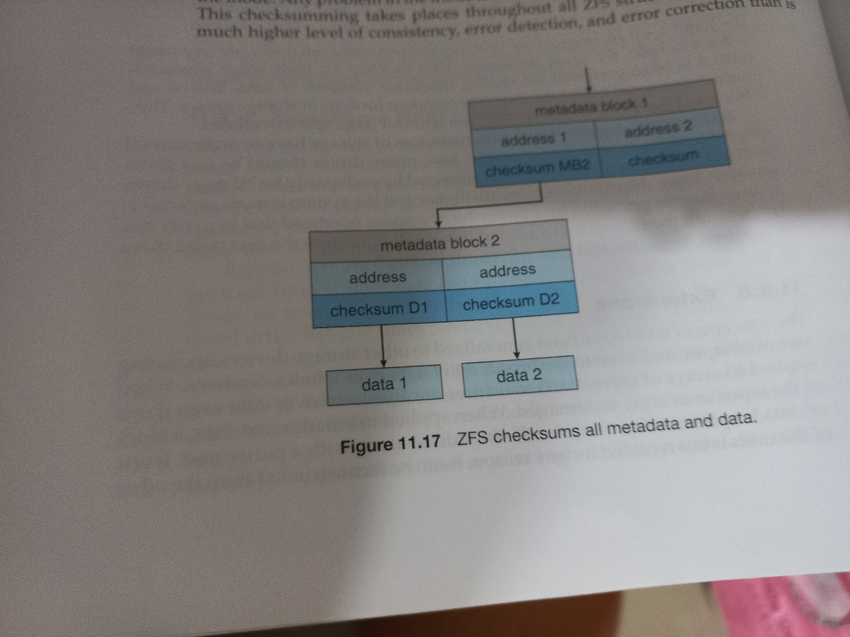

[ref]

See OS textbook CH11