Semaphore

[intro]

$$A semaphore S is an integer variable that$$

$$check the number of concurrent working processes.$$

[implementation]

$$One implementation using an integer variable.$$

void wait(S){

while(S<=0){;}//busy wait

S--;

}

void signal(S){

S++;

}

$$Another implementation using a boolean variable.$$

void wait(S)

{

while(S==T){;}//busy wait

S=T;

}

Void Signal(S){

S=F;

}

[pro]

$$\left(1\right)Convenient mechanism$$

$$\left(2\right)Effective machanism$$

[con]

$$\left(1\right)Timing errors occur when using them incorrectly.$$

[related]

$$(1)monitor$$

[illustration]

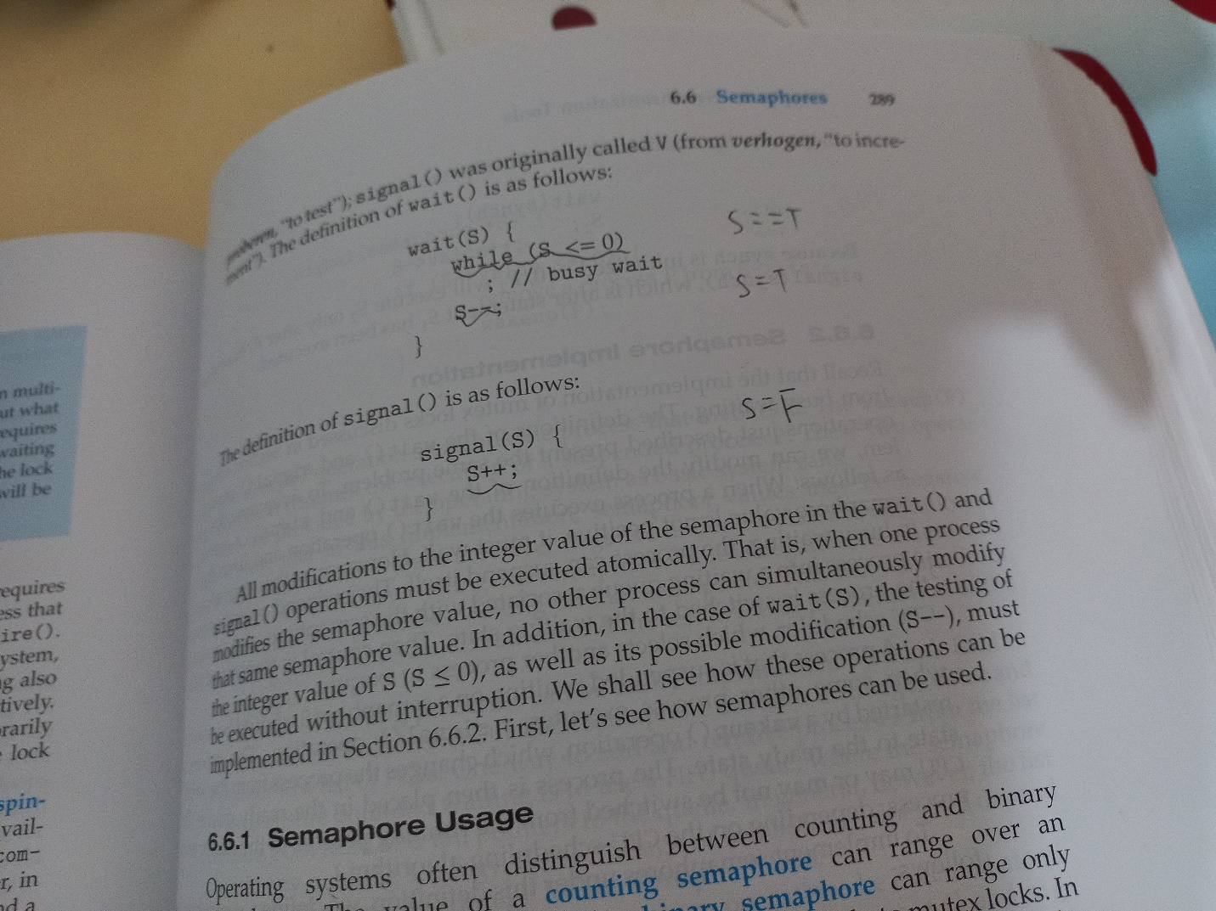

[ref]

[Semaphore (programming) - Wikipedia](https://en.wikipedia.org/wiki/Semaphore_(programming))