Source program

[intro]

$$Q:How must steps be done for$$

$$a source program before execution?$$

$$A:A source program must be compiled by a compiler and$$

$$it generates an object file.$$

$$An object file or many object files must be linked$$

$$by a linker and it generates an executable file.$$

$$Then it must be loaded by a loader before execution.$$

[illustration]

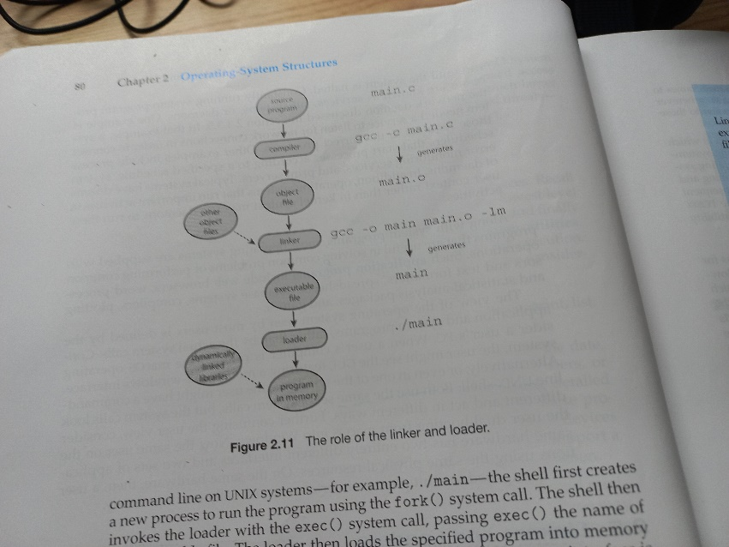

[ref]

OS textbook CH2-5