State space tree

[intro]

$$A state space tree is a tree with nodes considered$$

$$as a current possible state.$$

$$That is, it consists of all possibles states.$$

[E.g.]

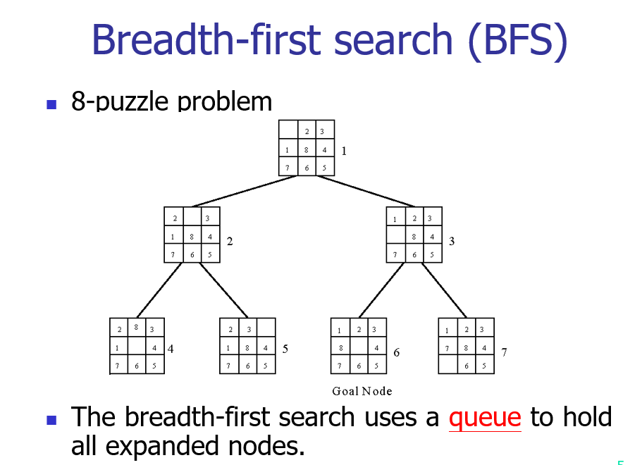s

[ref]

[What is a state space tree? - Quora](https://www.quora.com/What-is-a-state-space-tree)