Synchronization

[Example]

$$\left(1\right)Solaris$$

$$\left(2\right)Windows$$

$$\left(3\right)Linux$$

$$(4)Pthread$$

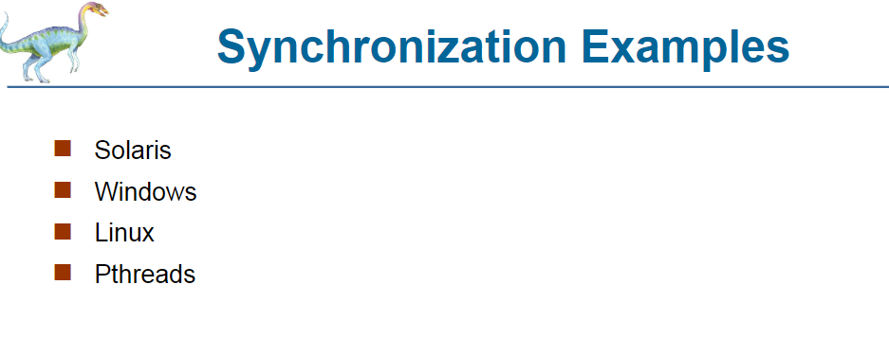

$$\left(1\right)Solaris Synchronization:$$

$$\left(1.1\right)Adaptive mutexes$$

$$\left(1.2\right)Condition variables.$$

$$\left(1.3\right)Reader-writer locks$$

$$(1.4)Turnstile$$

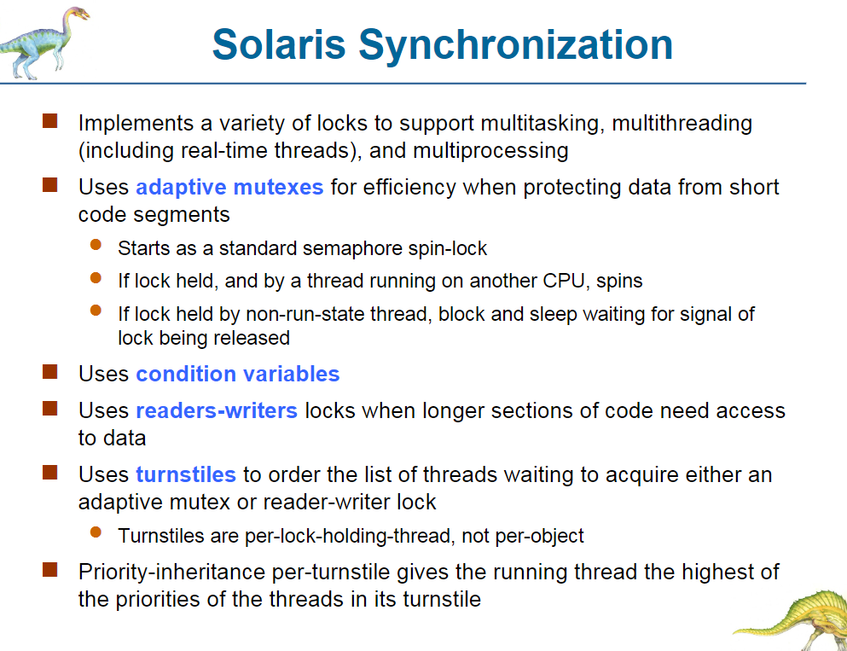

$$\left(2\right)Window synchronization$$

$$\left(2.1\right)Interrupt mask$$

$$\left(2.2\right)Spinlock$$

$$\left(2.3\right)Dispacther objects user-land$$

$$\left(2.3.1\right)Mutex$$

$$\left(2.3.2\right)Semaphore$$

$$\left(2.3.3\right)Event$$

$$(2.3.4)Timers$$

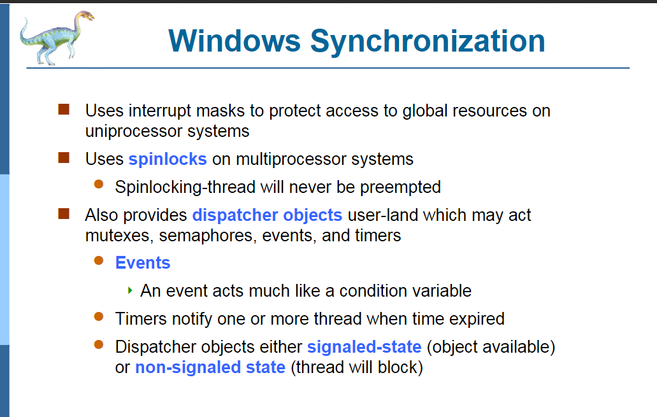

$$\left(3\right)Linux synchronization$$

$$\left(3.1\right)Semaphore$$

$$\left(3.2\right)Atomic integers$$

$$\left(3.3\right)Spinklock$$

$$\left(3.4\right)Reader-writer versions of both$$

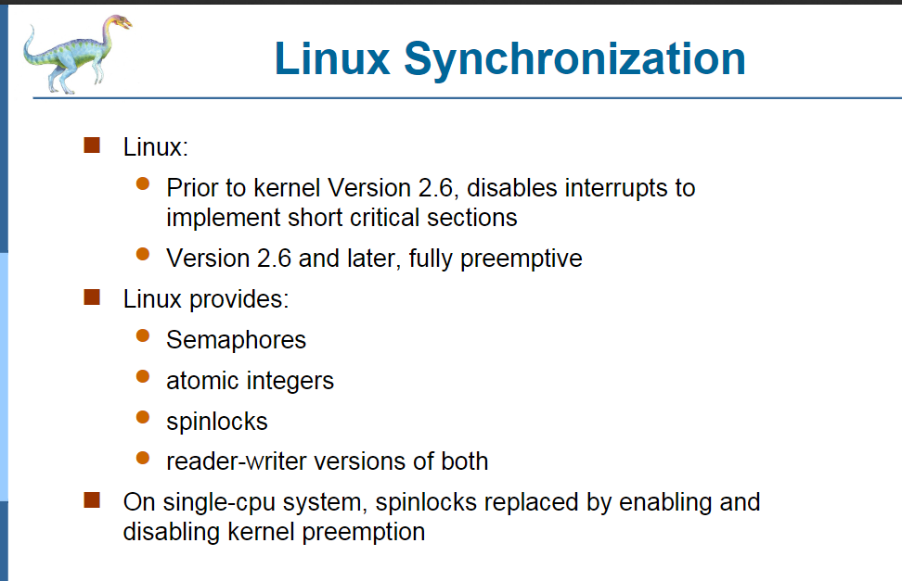

$$\left(5\right)PThread:$$

$$Portable$$

$$\left(5.1\right)Mutex lock$$

$$\left(5.2\right)Condition variable$$

$$Nonportable$$

$$\left(5.3\right)Read-write lock$$

$$(5.4)Spinlock$$

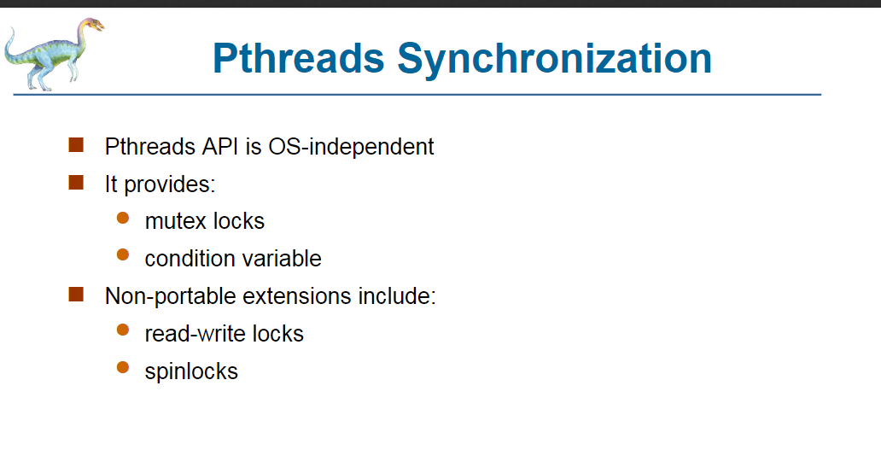

$$\left(1\right)Transactional memory$$

$$\left(2\right)OpenMP$$

$$\left(3\right)Function Programming Language$$

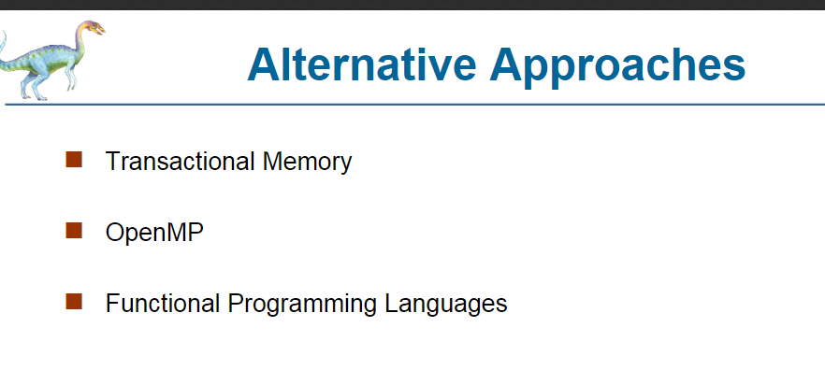

$$\left(1\right)Transactional memory:$$

$$A sequence of read-write operations to memory$$

$$that are performed atomically.$$

$$\left(2\right)OpenMP:It is a open soruce programming language$$

$$that supports parallel execution.$$

$$\left(3\right)Function Programming Language:$$

$$In Function Programming Language,$$

$$functions are treated as first-class citizens,$$

$$meaning that they can be bound to names$$

$$\left(including local identifiers\right),$$

$$passed as arguments, and returned from other functions,$$

$$just as any other data type can.$$

$$I remember a programming language has one feature$$

$$that the variable in function$$

$$is immutable by default.$$

$$That is, if you change the number into$$

$$a variable which is declared in the function section.$$

$$The value of the variable will NOT be changed.$$

$$Take Perl for example.$$

$$Consider the following codes in Perl.$$

#!/usr/bin/perl

# Function Definition using

# 'is copy' trait

sub Func(Int $variable is copy)

{

# Operation to be performed

$variable += 5;

}

# Defining a local variable

my $value = 10;

# Function Call with local variable

print Func($value), "\n";

# Checking if

# $value gets updated or not

print $value;

#!/usr/bin/perl

# Function Definition using

# 'is rw' trait

sub Func(Int $variable is rw)

{

# Operation to be performed

$variable += 5;

}

# Defining a local variable

my $value = 10;

# Function Call with local variable

print Func($value), "\n";

# Checking if

# $value gets updated or not

print $value;

[Functional programming - Wikipedia](https://en.wikipedia.org/wiki/Functional_programming)

[Perl | Mutable and Immutable parameters - GeeksforGeeks](https://www.geeksforgeeks.org/perl-mutable-and-immutable-parameters/)

