Chi-square

Pearson Product Chi-square test

Category:

Chi-square test of homogeneity

Population: they are same.

Reference:

[Goodness of fit - Wikipedia](https://en.wikipedia.org/wiki/Goodness_of_fit)

Chi-square test of independence

Population: they are not same.

Pro:

Easy to learn.

Cons:

Larger error than other type of chi-square.

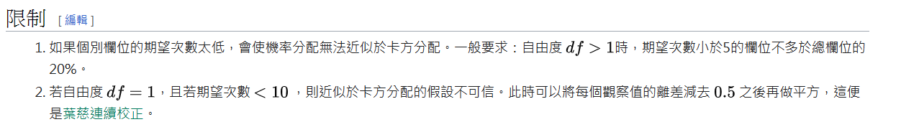

Reference

[皮爾森卡方檢定 - 維基百科，自由的百科全書 (wikipedia.org)](https://zh.wikipedia.org/zh-tw/%E7%9A%AE%E7%88%BE%E6%A3%AE%E5%8D%A1%E6%96%B9%E6%AA%A2%E5%AE%9A)

# Yates's correction for continuity

Figure:

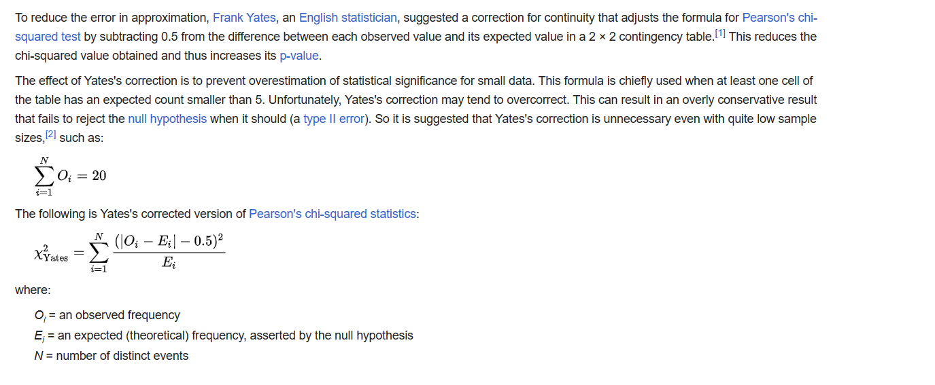

Formula:

When requirements are satisfied,

$$sigma\left(i=1,n,p\left(i\right)\right)==1$$

$$In Yates correction for continuity, X^{2 } is equal to$$

$$X_{Yates}^{2} = sigma{\left(i=1, N , \frac{{\left(\left|O_{i }−E_{i}\right|−0.5\right)}^{2}}{E_{i }}\right)}^{}$$

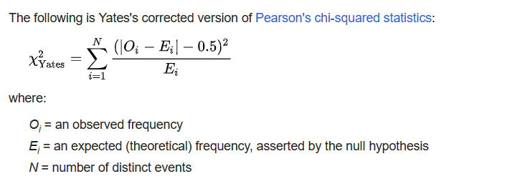

2 * 2 Table

Formula:

$$X_{Yates}^{2} = N ⋅ \frac{{\left(\left|ad−bc\right|−\frac{N}{2}\right)}^{2}}{\left(a+b\right)⋅\left(a+c\right)⋅\left(b+d\right)⋅\left(c+d\right)}$$

We can use other way to represent it:

$$X_{Yates}^{2} = N⋅\frac{\left({\left(\max\left(0,\left|ad−bc\right|−\frac{N}{2}\right)\right)}^{2}\right)}{N_{s}⋅N_{F}⋅N_{A}⋅N_{B}}$$

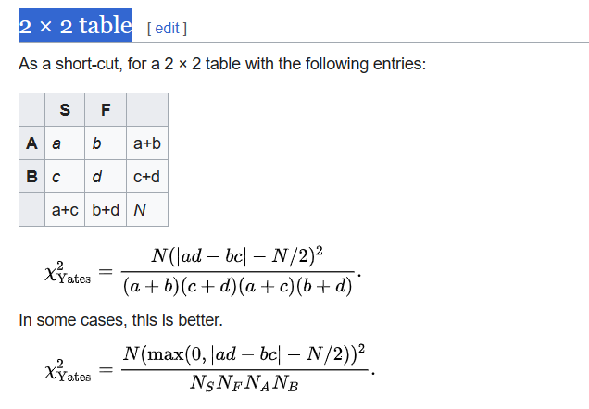

Proof

$$For a, a−E\left(a\right) = a−\frac{\left(a+b\right)}{N}⋅\left(a+c\right)$$

Thus,

$$\left(a−E\left(a\right)\right)⋅\left(b−E\left(b\right)\right)⋅\left(c−E\left(c\right)\right)⋅\left(d−E\left(d\right)\right)$$

$$=\frac{ad−bc}{\left(a+b+c+d\right)}$$

$$E\left(a\right)⋅E\left(b\right)⋅E\left(c\right)⋅E\left(d\right)$$

$$=\frac{\left(a+b\right)}{N}⋅\left(a+c\right)⋅\frac{\left(a+b\right)}{N}⋅\left(b+d\right) ⋅\frac{\left(a+c\right)}{N}⋅\left(c+d\right)⋅\frac{\left(c+d\right)}{N}⋅\left(b+d\right)$$

End of proof

Reference

[Yates's correction for continuity - Wikipedia](https://en.wikipedia.org/wiki/Yates%27s_correction_for_continuity)

See also

For proof of Fisher-Yates algorithm:

[probability - Fisher-Yates algorithm proof - Mathematics Stack Exchange](https://math.stackexchange.com/questions/3920328/fisher-yates-algorithm-proof)

Reference

[卡方檢定 - 維基百科，自由的百科全書 (wikipedia.org)](https://zh.wikipedia.org/zh-tw/%E5%8D%A1%E6%96%B9%E6%A3%80%E9%AA%8C)

Chi – squared Distribution

Category

