Homotopy

Intro

A homotopy is a path in the mapping space $$M\left(X,Y\right)$$ from the first function to second.

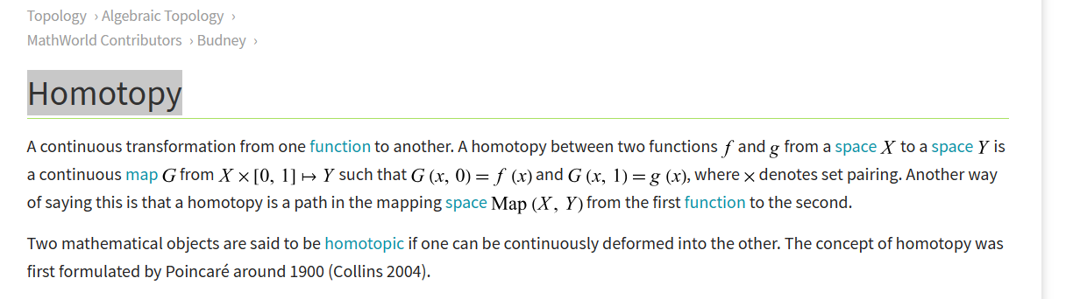

Def

Ref

[Homotopy -- from Wolfram MathWorld](https://mathworld.wolfram.com/Homotopy.html)