Dispersion(statistics)

Category

In statistics, there are many ways to measure dispersion.

1. Variance: $$d$$ = $$Var\left(X\right)$$
2. Variance-to-mean: $$d$$ = $$\frac{Var{\left[X\right]}^{2}}{E\left[X\right]}$$

Variance-to-mean

Alias

Index of dispersion

Dispersion index

Relative variance

Variance-to-mean ratio (VMR)

Intro

VMR is a normalized measure of the disperse of a probability distribution.

Case

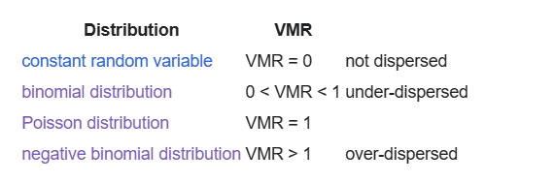

Skewed distributions

CD

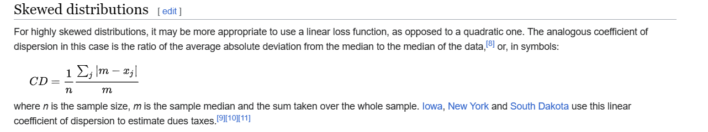

Ref

[Index of dispersion - Wikipedia](https://en.wikipedia.org/wiki/Index_of_dispersion)