Kurtosis

Def

$$Kurtosis\left(X\right)$$

= $$E\left[Z^{4}\right]$$

where

$$Z$$ is standard random variable of $$X$$

$$Z$$ = $$\frac{\left[X−E\left[X\right]\right]}{std\left(X\right)}$$

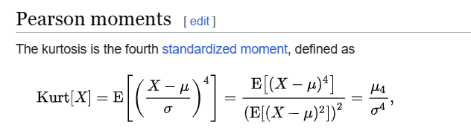

Property

Inequality

$$\frac{u_{4}}{std{\left(X\right)}^{4}}≥{\left(\frac{u_{3}}{std{\left(X\right)}^{3}}\right)}^{2}+1$$

where

$$u_{4}$$ is 4th central moment

$$u_{3}$$ is 3th central moment

Proof:

Sum

$$Kurtosis\left[X+Y\right]$$

= $$\frac{1}{std{\left(X+Y\right)}^{4}}$$ $$⋅A$$

$$A$$ = $$std{\left(X\right)}^{4}⋅Kurtosis\left[X\right]$$

+ $$4⋅std{\left(X\right)}^{3}⋅std\left(Y\right)⋅Cokurtosis\left[X,X,X,Y\right]$$

+ $$6⋅std{\left(X\right)}^{2}⋅std{\left(Y\right)}^{2}⋅Cokurtosis\left[X,X,Y,Y\right]$$

+ $$4⋅std\left(X\right)⋅std{\left(Y\right)}^{3}⋅Cokurtosis\left[X,Y,Y,Y\right]+std{\left(Y\right)}^{4}⋅Kurtosis\left[Y\right]$$

Proof:

$$Kurtosis\left[X+Y\right]$$

= $$E\left[\frac{{\left(\left(X+Y\right)−E\left(X+Y\right)\right)}^{4}}{std{\left(X+Y\right)}^{4}}\right]$$

= $$E\left[\frac{{\left(\left(X+Y\right)−E\left[X\right]−E\left[Y\right]\right)}^{4}}{std{\left(X+Y\right)}^{4}}\right]$$

= $$\frac{1}{std{\left(X+Y\right)}^{4}}⋅E\left[{\left[\left(X−E\left[X\right]\right)+\left(Y−E\left[Y\right]\right)\right]}^{4}\right]$$

Now, let’s evaluate this term first,

$$E\left[{\left[\left(X−E\left[X\right]\right)+\left(Y−E\left[Y\right]\right)\right]}^{4}\right]$$

= $$E\left[{\left(X−E\left[X\right]\right)}^{4}+4{\left(X−E\left[X\right]\right)}^{3}\left(Y−E\left[Y\right]\right)+6{\left(X−E\left[X\right]\right)}^{2}{\left(Y−E\left[Y\right]\right)}^{2}+4\left(X−E\left[X\right]\right)\left(Y−E\left[Y\right]\right)+{\left(Y−E\left[Y\right]\right)}^{4}\right]$$

=

$$E\left[{\left(X−E\left[X\right]\right)}^{4}\right]$$

+ $$4⋅E\left[{\left(X−E\left[X\right]\right)}^{3}\left(Y−E\left[Y\right]\right)\right]$$

+ $$6⋅\left[E{\left(X−E\left[X\right]\right)}^{2}{\left(Y−E\left[Y\right]\right)}^{2}\right]$$

+ $$4⋅\left[E\left(X−E\left[X\right]\right){\left(Y−E\left[Y\right]\right)}^{3}\right]$$

+ $$E\left[{\left(Y−E\left[Y\right]\right)}^{4}\right]$$

With definition of Kurtosis and Cokurtosis, we can imply 1th term to.

$$E\left[{\left(X−E\left[X\right]\right)}^{4}\right]$$

= $$\frac{std{\left(X\right)}^{4}}{std{\left(X\right)}^{4}}⋅E\left[{\left(X−E\left[X\right]\right)}^{4}\right]$$

= $$std{\left(X\right)}^{4}⋅E\left[\frac{{\left(X−E\left[X\right]\right)}^{4}}{std{\left(X\right)}^{4}}\right]$$

= $$std{\left(X\right)}^{4}⋅Kurtosis\left[X\right]$$

To do so for all terms, we have that

$$E\left[{\left(\left(X−E\left[X\right]\right)+\left(Y−E\left[Y\right]\right)\right)}^{4}\right]$$

= $$std{\left(X\right)}^{4}⋅Kurtosis\left[X\right]$$

+ $$4⋅std{\left(X\right)}^{3}⋅std\left(Y\right)⋅Cokurtosis\left[X,X,X,Y\right]$$

+ $$6⋅std{\left(X\right)}^{2}⋅std{\left(Y\right)}^{2}⋅Cokurtosis\left[X,X,Y,Y\right]$$

+ $$4⋅std\left(X\right)⋅std{\left(Y\right)}^{3}⋅Cokurtosis\left[X,Y,Y,Y\right]$$

+ $$std{\left(Y\right)}^{4}⋅Cokurtosis\left[Y,Y,Y,Y\right]$$

Then the expression

$$Kurtosis\left[X+Y\right]$$

will be

$$Kurtosis\left[X+Y\right]$$

= $$\frac{1}{std{\left(X+Y\right)}^{4}}⋅E\left[{\left(\left(X−E\left[X\right]\right)+\left(Y−E\left[Y\right]\right)\right)}^{4}\right]$$

$$\frac{1}{std{\left(X+Y\right)}^{4}}⋅A$$

where

$$A$$ is defined above.

Hence proved.

Fisher’s Kurtosis

If Kurtosis is about Fisher’s, it is decreased by 3.

$$Kurtosis\left[Y\right]$$

= $$Kurtosis\left[X\right]−3$$

Annotation

Complexity

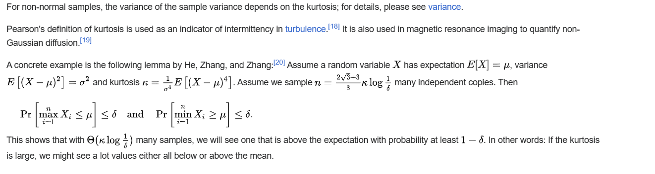

Ref

[Kurtosis - Wikipedia](https://en.wikipedia.org/wiki/Kurtosis#Excess_kurtosis)