Skew

Definition:

Definition 1:

Skew(X)

= $$\frac{E\left[{\left(X−avg\left(X\right)\right)}^{3}\right]}{std{\left(X\right)}^{3}}$$

Ref:

According to statproofbook website.

P.S.

$$Here, std\left(X\right)$$ can be considered as a constant.

Thus, The formulas are equivalent.

Definition 2:

$$r_{1}≔$$

$$slashmu_{3}=$$

$$E\left[\frac{{\left(X−avg\left(X\right)\right)}^{3}}{std{\left(X\right)}^{3}}\right]$$

where

$$r_{1} is defined as skewness of random variable of X$$.

$$slashmu_{3}$$ is 3th standard moment.

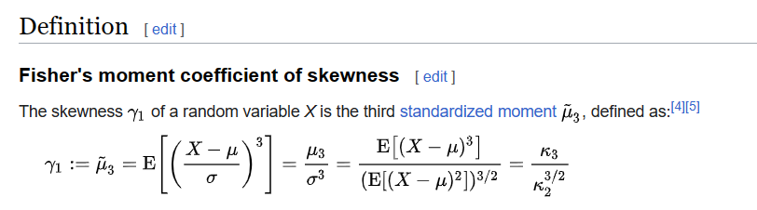

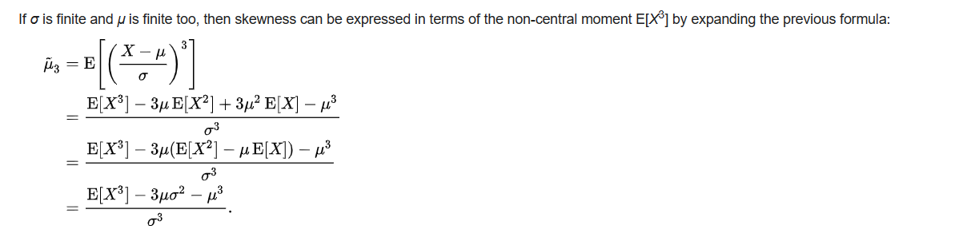

Ref:

According to fisher’s moment discussed in Wiki.

Category:

Mode skewness:

Pearson 1th Skewness coefficient

$$\frac{\left(mean\left(X\right)−mode\left(X\right)\right)}{std\left(X\right)}$$

Median skewness:

Pearson 2th Skewness coefficient

$$\frac{3\left(mean\left(X\right)−mode\left(X\right)\right)}{std\left(X\right)}$$

Groeneveld and Meeden’s skewness:

$$\frac{\left(avg\left(X\right)−median\left(X\right)\right)}{E\left(\left|X−median\left(X\right)\right|\right)}$$

Distance skewness:

$$1−\frac{E\left(norm\left(X−X^{′},Eucidean\right)\right)}{E\left(norm\left(X+X^{′}−2theta,Eucidean\right)\right)}$$

if

$$\operatorname{Pr}\left(X=x\right)!=1$$

Theorem:

Theorem 1:

Partition of skewness into expected values

Claim:

Skew(X) =

$$\frac{\left[E\left(X^{3}\right)−3E\left(X\right){\left[std\left(X\right)\right]}^{2}−E{\left(X\right)}^{3}\right]}{{\left[std\left(X\right)\right]}^{3}}$$

Proof:

Recall about definition of skewness and variance.

Skew(X)

= $$\frac{E\left[{\left(X−avg\left(X\right)\right)}^{3}\right]}{{\left[std\left(X\right)\right]}^{3}}$$

While

$$var\left(X\right)=E\left(X^{2}\right)−{\left[E\left(X\right)\right]}^{2}$$

We can rewrite it as:

Skew(X)

= $$\frac{E\left[{\left(X−avg\left(X\right)\right)}^{3}\right]}{{\left[std\left(X\right)\right]}^{3}}$$

= $$\frac{E\left[X^{3}−3X^{2}avg\left(X\right)+3X^{{\left[avg\left(X\right)\right]}^{2}}−{\left[avg\left(X\right)\right]}^{3}\right]}{{\left[std\left(X\right)\right]}^{3}}$$

= $$\frac{E\left[X^{3}\right]−E\left[3X^{2}avg\left(X\right)\right]+E\left[3X{\left[avg\left(X\right)\right]}^{2}\right]−E{\left[avg\left(X\right)\right]}^{3}}{{\left[std\left(X\right)\right]}^{3}}$$

= $$\frac{E\left[X^{3}\right]−3E\left[X^{2}\right]avg\left(X\right)+3E\left[X\right]{\left[avg\left(X\right)\right]}^{2}−{\left[avg\left(X\right)\right]}^{3}}{{\left[std\left(X\right)\right]}^{3}}$$

= $$\frac{E\left[X^{3}\right]+\left(−3\right)⋅avg\left(X\right)⋅\left[E\left[X^{2}\right]−E\left[X\right]\left[avg\left(X\right)\right]\right]−{\left[avg\left(X\right)\right]}^{3}}{{\left[std\left(X\right)\right]}^{3}}$$

( factoring $$\left(−3\right)⋅avg\left(X\right)$$ out.)

= $$\frac{\left[E\left(X^{3}\right)−3 avg\left(X\right) {\left[std\left(X\right)\right]}^{2}−{\left[avg\left(X\right)\right]}^{3}\right]}{{\left[std\left(X\right)\right]}^{3}}$$

Hence proved.

Ref:

About definition of skewness, see these websites:

[Skewness | The Book of Statistical Proofs (statproofbook.github.io)](https://statproofbook.github.io/D/skew)

For theorem about skewness and its proof, see these websites:

[Partition of skewness into expected values | The Book of Statistical Proofs (statproofbook.github.io)](https://statproofbook.github.io/P/skew-mean)

For category of skewness, see these websites:

[Skewness - Wikipedia](https://en.wikipedia.org/wiki/Skewness)