Torus

Def

A torus can be parameterized as:

$$x=\left(R+r \cos\left(theta_{1}\right) \right)⋅\cos\left(theta_{2}\right)$$

$$y=\left(R+r \cos\left(theta_{1}\right) \right)⋅\sin\left(theta_{2}\right)$$

$$z=r⋅\sin\left(theta_{1}\right)$$

with angular to coordinates $$theta_{1}$$ and $$theta_{2}$$ belongs to $$\left[0,2⋅pi\left(\right)\right)$$ where $$theta_{1}$$

refers the rotation around the the tube while $$theta_{2}$$ refers rotation of axis of revolution.

The major $$R$$ is the distance from the center of the tube to the center of the torus (one can consider $$R$$ as outer one) and the minor radius $$r$$ is the radius of the tube.

The aspect ratio of the torus is $$\frac{R}{r}$$.

Relationship

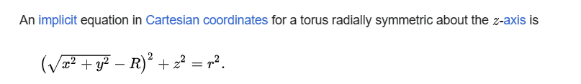

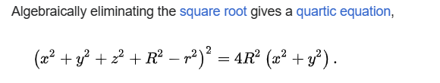

Case

Case 1: $$R>r$$,

$$R>r$$ => familiar ring torus or anchor ring.

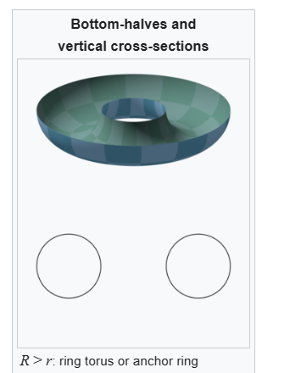

Case 2: $$R==r$$

$$R==r$$ => horn torus

Case 3: $$R<r$$

$$R<r$$ => self-intersecting spindle torus; its inner shell is a [lemon](https://en.wikipedia.org/wiki/Lemon_(geometry)) and its outer shell is an [apple.](https://en.wikipedia.org/wiki/Apple_(geometry))

Case 4:

=> torus degenerates to the sphere

When $$R≥r$$ =>

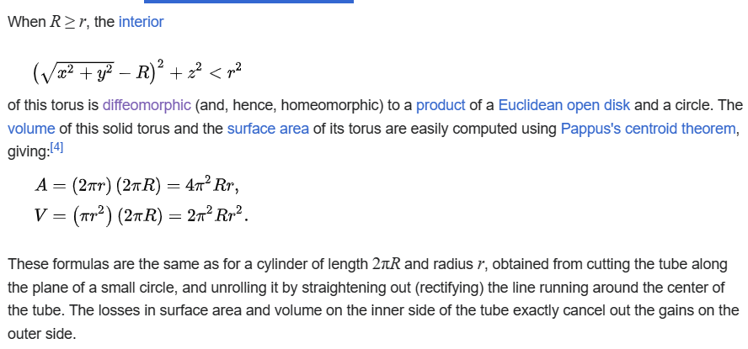

Ref

[Torus - Wikipedia](https://en.wikipedia.org/wiki/Torus)