Idea and techinque of NumberSplitter.Build
In version 2 of Code (../v2/) at GitHub (see Utility/Number/Algorithm/NumberSplitter/v2/README.md at main · 40843245/Utility (github.com)
)

I implement it through dynamical programming and divde-and-conquer techniques.

Given a positive integer n, find max of product of resultTable[j] and resultTable[n-j] with all
j = 1...n . Then find max of the resultant number and n .

Pseudo Code of NumberSplitter.Build
See pseudoCode.txt at GitHub which avails at
Utility/Number/Algorithm/NumberSplitter/v2/pseudoCode.txt at main · 40843245/Utility (github.com)

Why NumberSplitter.Build Works?
Let’s take a glance of the question first. As shown in below figure.
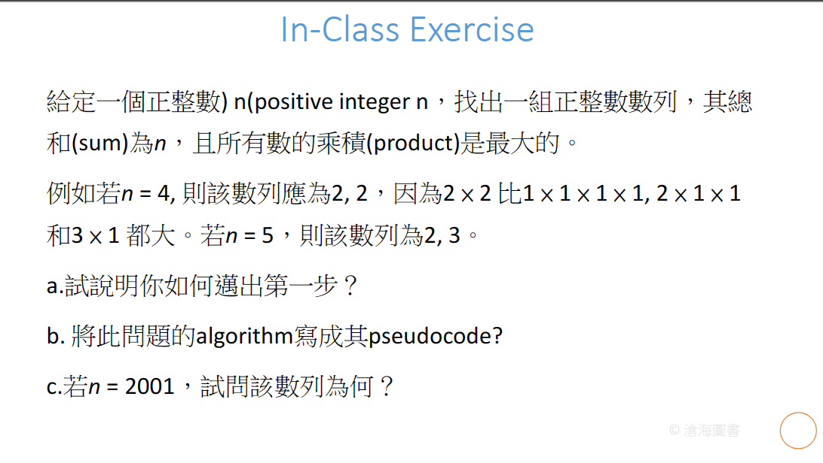
---------------------------------------------------

Let’s quick review the process.

For convience, I defined it as f(x) with given x.
For 1,

Thus , f(1) = 1

For 2,

Thus , f(2) = 1

For 3,

The maximum of them is max{1,2}
Thus , f(3) = 2

For 4,

The maximum of them is max{1,2,3,4}
Thus , f(4) = 4

For 5,

The maximum of them is max{1,2,3,4,6}
Thus , f(5) = 6

---------------------------------------------------

The question asks us

Take for 5 as example.

Due to associativity of addition and multiplication for real numbers, we can get

Thus, I came up with ideas: divide-and-conquer. I divide 5 into:

1 and 4
2 and 3

After that, I product them:
the result of 1 , 4 and
the result of 2 , 3

Finally, I find the max number among these resultant product.

The more detailed procedure shown as follows.

Then finding the max number between above results.
Here, it is

max{
(b[1]*b[1]*b[1]*b[1]*b[1]),
(b[1]*b[1]*b[1]*b[2]),
(b[1]*b[1]*b[3]),
(b[1]*b[4]),
(b[2]*b[3])
}

Additionally, with above procedures. We can easy find that we evaluate some items many time. It is not necessary. To save time, we can use dynamical programming techinque (a technique to store the resultant to the table only after first evaluation. Pick it from the table if necessary, and thus, we can spend less extra space to save time.)

----------------------------------------------

Someone may be curious that why we have to max of the maxProduct and n again. Shown in the following statement of pseudoCode.txt.
r := max(maxProduct,n)

Since they are exception when n is 1 to 3.

In psuedoCode.txt , if we use GetMaxProduct2(1), we will get 1, GetMaxProduct2(2) as 1, and GetMaxProduct2(3) as 2.

If we directly use GetMaxProduct2 or NOT find max of maxProduct and n, we will get unexpected result.

getting
b[3] = 2
But
b[1]*b[2] =
Contradiction occurs.

(I recommend you to evaluate it with hands and pencils )
To handling the exception, I do so.

