logit

Alias

logit

log-odds

Def

logit(p)

= $$\ln\left(\frac{p}{1−p}\right)$$ for all $$0<p<1$$

Property

Other form of definition

logit(p)

= inverse( standardLogistic($$p$$) ) for all $$0<p<1$$

logit(p)

= $$2 ⋅\tanh^{−1}{} \left(2p−1\right)$$

where

$$\tanh^{−1}{} p$$ is prounced as arc hyperbolic tan of p.

Inverse

Inverse of logit are:

inverse(logit(p))

= logistic(p)

inverse(logit(p))

= $$\frac{1}{1+e^{−p}}$$

inverse(logit(p))

= $$\frac{\tanh\left(\frac{p}{2}\right)+1}{2}$$

Odds Ratio

$$\ln\left(R\right)$$

= logit($$p_{1}$$) - logit($$p_{2}$$)

where

$$R$$ refers the odds ratio.

Application

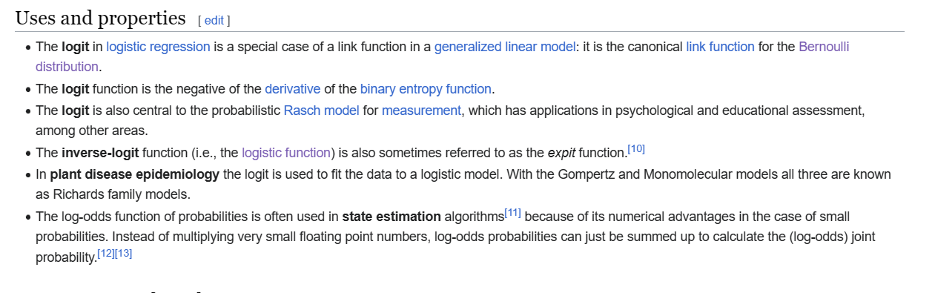

Ref

[Logit - Wikipedia](https://en.wikipedia.org/wiki/Logit)