國立虎尾科技大學資訊工程系
專題製作報告

指導教授：簡銘伸老師

Unity仿生視覺模擬

參與成員：黃奕捷

中華民國 112 年 5 月 23 日

目 錄
一、 摘要 3
二、 專題緣由與目的 3
三、 結論 3
四、 團隊分工 3
五、 參考文獻 3
國立虎尾科技大學資訊工程系專題報告
題目：Unity仿生視覺模擬
指導老師：簡明伸老師
專題參與人員： 40843245 黃奕捷
班級： 四資工四乙
摘要
中文
摘要:
先簡單介紹仿生視覺技術，再簡單介紹VR和AR，最後再簡單介紹Unity並敘述它們間的關聯。
簡單來說，仿生視覺技術是模仿動物看東西的一個技術。
VR 是Virtual Reality的縮寫。簡單來說，VR指在虛擬世界中模擬真實世界的樣子。
AR 是Augment Reality的縮寫。簡單來說，VR指結合在虛擬世界中的樣子和真實世界中的樣子，來把虛擬世界擴增至真實世界。
Unity 這間公司專門開發Real-time APP包括行動裝置APP、VR APP、AR APP等。
那它們有甚麼關聯?剛剛提到Unity 可以開發VR APP、 AR APP。而仔細想想仿生視覺和VR的敘述，就不難發現VR一定用到仿生視覺技術，然而VR技術不只這些，他還牽扯到戴上VR頭盔的樣子。（在仿生視覺技術中不一定會戴VR頭盔）。而AR則需要更多進階和先進的技術。可以這麼說，仿生視覺技術是VR的子集合。VR是AR的子集合。因敝人的能力有限及手邊資源有限（硬體部分只有一台可用的筆電、一支可用的手機和其他老師送我的Google VR 頭盔(該頭盔用紙盒做得)），所以無法製作VR專案及開發VR相關產品，當然更不用說AR。在此說聲抱歉。ごめんと言って。
中文關鍵字：
仿生
視覺
視覺模擬
仿生視覺模擬
Unity
Unity Editor
Unity Hub
英文
摘要:
Notice that for the following paragraph, it is translated by Google Translator.
However, I had modified it.

First, I briefly introduce bionic vision technology, then VR and AR, and finally Unity and describe the relationship between them.
Simply put, bionic vision technology is a technology that imitates animals to see objects.
VR stands for Virtual Reality. Simply put, VR refers to simulating the appearance of the real world in a virtual world.
While AR stands for Augment Reality. Simply put, AR refers to combining the appearance in the virtual world with the appearance in the real world to amplify the virtual world into the real world.
Unity is a company specializing in the development of Real-time APP, including mobile device APP, VR APP, AR APP, etc.
So what is their relationship? I had discussed that Unity can develop VR APP and AR APP. And if you think about the description of bionic vision and VR carefully, it is not difficult to find that VR must involve bionic vision technology, however, VR also involves the appearance of wearing a VR headset. (Wearing a VR headset is not necessary in bionic vision technology). On the other hand, AR requires more advanced and advanced technologies. It can be said that bionic vision technology is a subset of VR. VR is a subset of AR. Due to my poor ability and limited resources at hand (For the part of hardware, I only have an usable notebook, an usable mobile phone and the Google VR headset offered by other teachers (the headset is made of carton)), it is impossible to make a VR project and develop VR related products, not to mention AR of course for me. Sorry for this. ごめんと言って.
英文關鍵字：
Bionics
Visual
Visual stimulation Bionics
Unity
Unity Editor
Unity Hub

- 專題緣由與目的
<詳細敘述專題製作之過程、功能、目的>
(一)、功能：
以version 2 (demo_2_1.unity和demo_2_2.unity場景檔)為例。
Functionality | Description | Available in
Change position and rotation of camera | Change position and rotation of camera with script. | Unity Editor mode  UWP  Android plaform
Set how many cameras. | Set how many cameras with script. | Unity Editor mode  UWP  Android plaform
Set all cameras’ view. | Set camera’s view with script. | Unity Editor mode  UWP  Android plaform
Open file dialog | With method  UnityEditor.EditorUtility.OpenFilePanel .  Since it is supported in Unity Editor mode, the func is NOT supported in Android platform and UWP. | Unity Editor mode
Read File | Same as above. | Unity Editor mode
Write File | With method  UnityEditor.EditorUtility.SaveFilePanel.  Since it is supported in Unity Editor mode, the func is NOT supported in Android platform and UWP. | Unity Editor mode
Background | Can play background music. | Unity Editor mode  UWP  Android plaform
Range constraint for TMP_InputField | Constraint the range for TMP_InputField.  If the value is out of range,  Then it is changed to range input. | Unity Editor mode  UWP  Android plaform

Functionality | When to Invoke
Change position and rotation of camera | Once submit button or read button  was pressed.
Set how many cameras. | At start.
Set all cameras’ view. | At start.
Open file dialog | Once the read button was pressed.
Read File | Once the read button was pressed.  (see 注意區塊第一點)
Write File | Once the write button was pressed.  (see 注意區塊第一點)
Background | At start.
Range constraint for TMP_InputField | 1.Once the TMP_Inputfield was deselected  (see 注意區塊第三點)  2.After reading one group of values of the text file.
注意:
1.讀入檔案和寫入檔案功能只能正常運作在Unity Editor mode，
在其他模式會被忽略掉。
2.數值轉換:
一行資料代表一組測資。每組測資的數值以空白區隔。
正常來說，每組測資要有3*3=9個數值。
根據C# 內建的Float.TryParse方法轉換。
Case 1:若文字檔裡包含不合法字元，使字元無法轉成數值。
如:123txt124,124.2345.123。
則會被轉換成0。
Case 2: 若該組測資的數值少於9個數值。
則缺少的欄位裡的數值維持不變。
Case 3: 若該組測資的數值多於9個數值。
則多餘的數值會被捨棄掉。
3. 當該文字欄沒被選擇時，會一起檢查這三個文字欄的數值，而不是只有該文字欄。
(二)、過程：
(1) 主要過程:
(1.1) 開發一個的專案主要步驟為

前置準備:
1.下載 IDE (stands for Integrated Development Environment)。有時我建議更新它至最新版。
2.選擇適合的版本，新建一個專案。
3.開啟專案檔。
4.一旦開啟專案檔後，先檢查環境設定並建置專案可以正常運作。來確認有沒有意外發生。

主要步驟:
開發專案，包括寫腳本(俗稱寫code)和設計介面等。詳見下區 (1.2)。

(1.2) 寫一個腳本的主要步驟為
開發，測試(建置專案然後執行專案)，修改，新增。
流程圖如下:
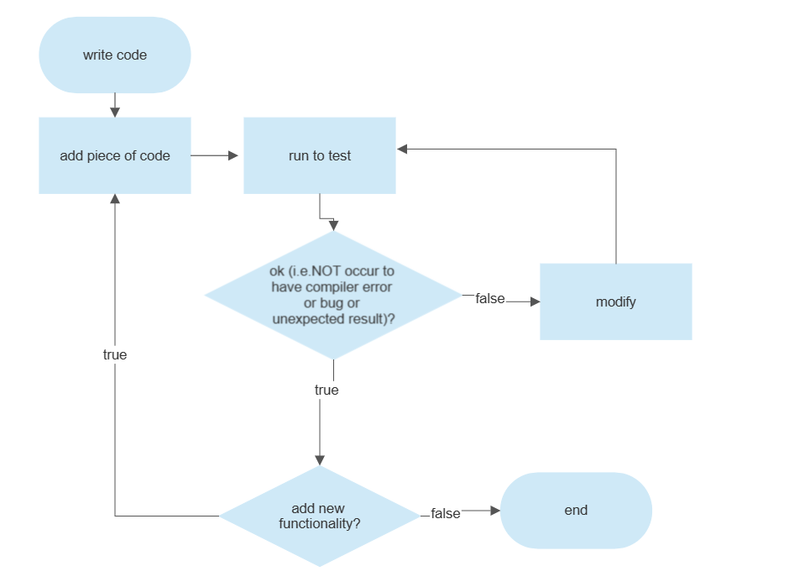
(2) 詳細過程:
下圖為類似流程圖畫法的階層圖。
下圖簡單說明了我在遇到bug時如何除錯和上網找資料的來源。
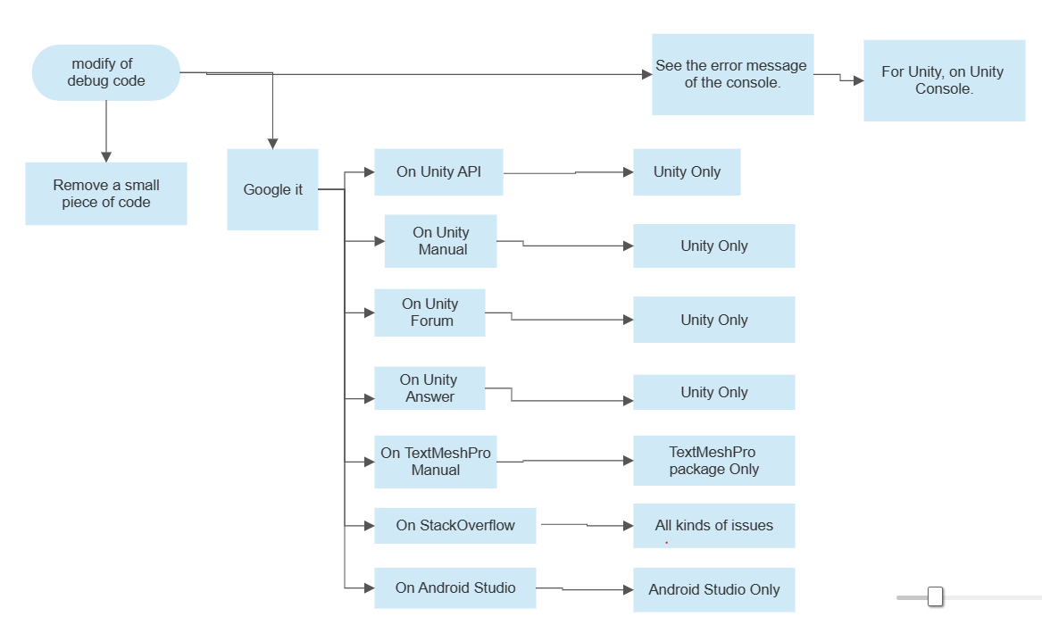

Source | That solve issue about
Unity API | Unity Only
Unity Manual | Unity Only
Unity Forum | Unity Only
TextMeshPro Manual | Unity TextMeshPro Only
StackOverflow | All
Android Studio developer manual | Android Studio Only
For the websites of source, see the following reference in Reference section.
(3) 專案:
(3.1) About Unity

(3.1.1) 創建一個Unity專案
詳見我的GitHub筆記。
Game_Development/Unity/Create Project at main · 40843245/Game_Development · GitHub

(3.1.2) 建置一個 Unity 專案
詳見我的GitHub筆記。
Game_Development/Build Project.md at main · 40843245/Game_Development · GitHub

(3.1.3) 下載 Unity packages
From Package Manager in Unity Project,
詳見我的GitHub筆記。
Game_Development/Unity/Packages/Download Package/Package Manager at main · 40843245/Game_Development · GitHub

From Unity Asset Store,
詳見我的GitHub筆記。
Game_Development/UnityAssetStore.md at main · 40843245/Game_Development · GitHub

(3.2) Android Studio
詳見我的GitHub筆記。
PhoneDevelopment/Android/Android Studio at main · 40843245/PhoneDevelopment · GitHub

(三)、目的：
為了提供仿生視覺技術的應用及其延伸。還打算把它放到Unity Asset store以供大家免費使用。
順便更了解仿生技術的應用、Unity 開發、用Android Studio 手機開發。
- 結論及我的心得
簡單來說，用Unity 可以達成仿生視覺技術，甚至可以開發VR APP和AR APP。
這次實務專題製作對我有些幫助，我從中學到了Unity的IDE使用、Unity Version(Version of Unity Editor、Version of Unity Package )、C#、JAVA、Android Studio IDE 及其開發。
真心希望這幾篇文件檔對讀者的你有幫助(不只是對這些技術的相關基礎知識、對這行動裝置開發的基本知識及下載網址、對C#和JAVA的基本認識等)。
也希望我以後還有機會接觸這些領域。

- 團隊分工
40843245 黃奕捷 -- all

- 參考文獻
Unity Manual and API
Unity Manual Docs (version 2021.3)
Unity - Manual: Unity User Manual 2021.3 (LTS) (unity3d.com)
Unity API Docs (version 2021.3)
Unity - Scripting API: (unity3d.com)

Unity Learn
An overview of Unity and startup guide for Unity Project.
Learn game development w/ Unity | Courses & tutorials in game design, VR, AR, & Real-time 3D | Unity Learn
Unity Package
TextMeshPro package (version 1.3.0)
Class TMP_InputField | TextMesh Pro | 1.3.0 (unity3d.com)

Programming Language
C#
MSDS (stands for Microsoft Docs) – C#
C# Programming Guide | Microsoft Learn
Java
Java Language Basics - Dev.java

Apps download website and startup guide website
Unity Editor and Unity Hub – startup guide
Real-Time 3D Development Platform & Editor| Unity
VSC (stands for Visual Studio Code) – VSC guide
Documentation for Visual Studio Code
VS (stands for Visual studio) – VS guide
Getting started with Visual Studio (microsoft.com)

App Development with Android Studio
Android App Development with Android Studio – Android Studio API guide
Android API reference | Android Developers

Package
Unity Asset store – A website to download Unity package
Unity Asset Store - The Best Assets for Game Making

Forum
StackOverflow with result of the keyword Unity
Posts containing 'unity' - Stack Overflow
Unity Forum (Especially for Unity)
Unity Forum
Unity Answers (Especially for Unity)
The best place for answers about Unity - Unity Answers

Bionics
Bionics - Wikipedia
VR

除摘要及參考文獻為必填外，其餘內容由指導教授訂定

書背範例
國立虎尾科技大學
資訊工程系
專題製作報告 Unity仿生視覺 112
覺 112
學
年

