# Main deliverables

Object 360 view mode

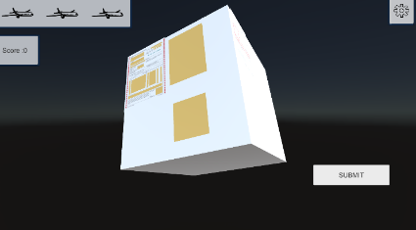The basic coding is done, able to move the object around to view different faces. This can keep testing and do the fin-tuning.

Life point UI

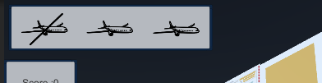The basic coding and demo outlook is done, can be testing with the demo question.

The UI will show how many chances are left.

The basic submit button is ready, able to submit answer, able to test the live point UI but the answer getting coding is still debugging.

Demo setting, 3 chances will be given to the player submit wrong answer.

After 3 times the Game Over UI will show text “Game Over” and press any button to move on to the Summarize UI.

The questions are not yet ready. Testing with demo question, recent demo question number is 1.

More demo questions will be ready for testing before the real one is ready.

Game Over UI

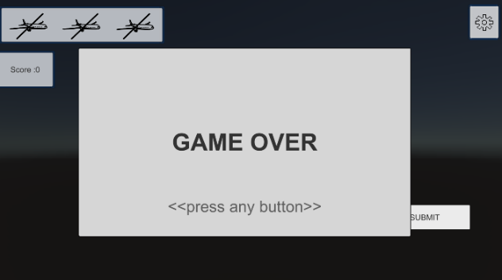The Game Over UI is done, can be testing.

It able to show after running out of life point and press any button can show the Summarize UI. This can keep testing and do the fin-tuning.

Summarize UI

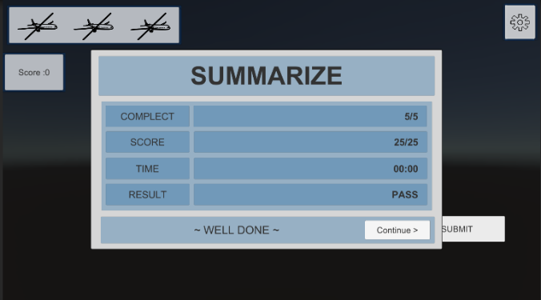Working On. Demo outlook is ready. Output state not ready yet.

Recently, it can show after the game over UI is showed and pressed any button. By pressing the “Continue” button on the Summarize UI to back to the Level Manuel Scene.

Aner selection

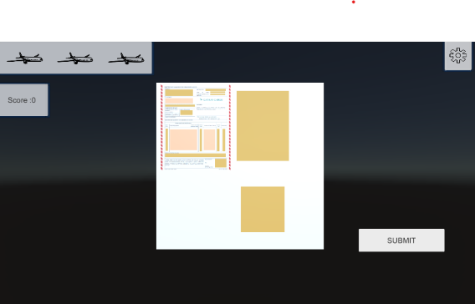 Working on but can be testing with the demo question.

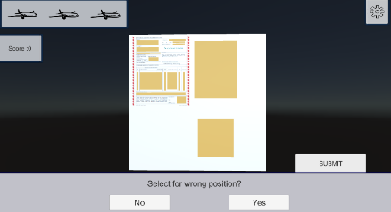Recently, able to highlight the selected answer item and judge the answer after pressing the “submit” button.

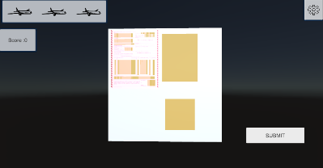If select the hole position wrong, it will jump up an asking bar to ask if the select the position. If “Yes” the hole plan will be highlighted. If “No” the bar will close.

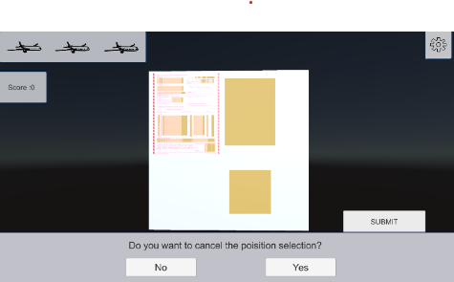If click the empty plan again the asking bar will ask if player want to cancel the position selection. If “Yes” the highlight will be canceled. If “No” the asking bar will close.

Anyway, only one demo question ready for testing it, for move on to the next question after one question is not ready yet.

More demo question will be ready for this test before the real one are ready.

In Game Call Setting Button

The basic coding and demo outlook is ready, can be testing. This can keep testing and do the fin-tuning.

By pressing this button, player will be able to see 3 more buttons, the information button, the pause button, and the restart button.

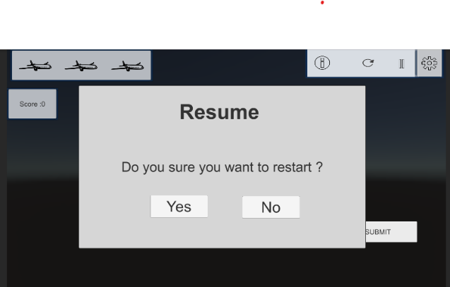The restart button is able to show the restart UI. It will ask if player want to restart the game stage. If press the “yes” button the game stage will restart. If

“no” the game stage will continue.

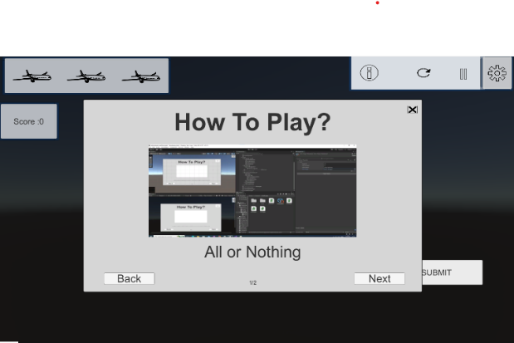The information button can show the information of how to play the game, the date is not ready but can be test with the demo date. The “Next,” “Back” and the “Close” button can be able to test with the demo.

The pause button is able to open the pause UI and pause the game stage.

Pause UI

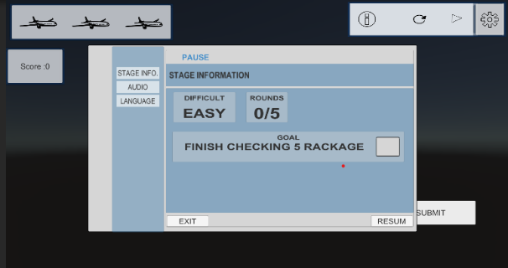Working on but can be test. Demo outlook is done. Recently, able to pause the game and show the pause UI. By pressing the resume button to close the pause UI and continue the stage. By pressing the exit button to back to open the Exit UI.

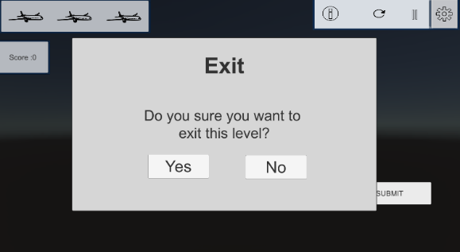The Exit UI will ask if player want to exit recent stage. If player press “Yes” player will back to the level manual selection. If “No” the exit UI will be closed.

The pause UI including audio setting, languages setting and stage information. The “close” button can be test by the demo.

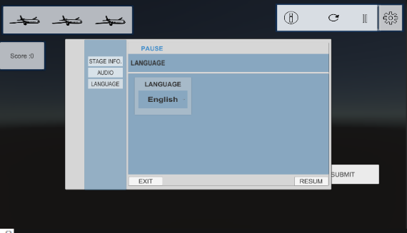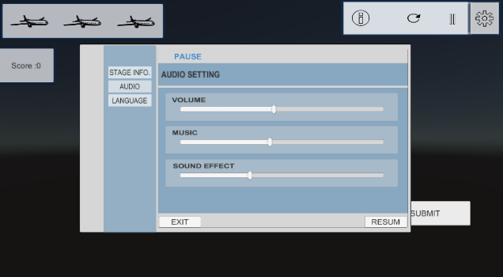In the audio setting, there are 3 sliders to control the volume. They are sound effect, background music and the total volume. By moving the sliders player can control the volume. This can test by the demo audio.

The languages setting and stage information only the demo outlook is done, will work on it very soon.

Level Manuel Scene

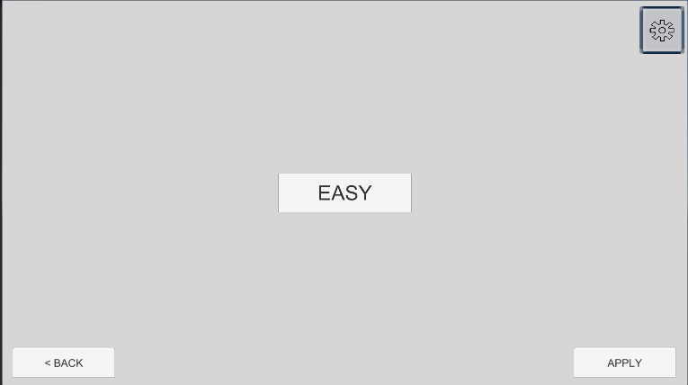 Working on. A demo one will be using until it is ready.

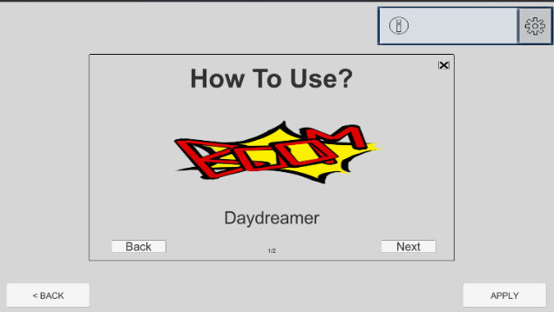Recently, it is able to test with the level selection and getting in the game stage by “Apply” button. The   
“Back” button is able to return to the home page. The setting button is only can test the information button. It supposes to give the information of level selection scene, such as how to select stage or the different of the level. Anyway, the data is not ready yet, only can test the “Back,” “Next” and the “close” button with the demo data.

Home page

Working on. A demo one will be using until it is ready.

This scene will be the first scene of the game. It will show the game title and able to enter the game.

Recently, 3 buttons are ready for the home page, including “Start”, “Option” and “Quit Game”.

The start button will bring player to the level manual and the quit game button.

will quit the hole game application. This two button is ready and can be testing. Anyway, the option button is not yet ready, as the option scene or UI is not ready yet.