**EXPERIMENT-4**

**AIM**

To design and deploy a simple Car Booking Reservation System as a cloud-based application using a Cloud Service Provider (CSP) and demonstrate the concept of Software as a Service (SaaS).

**PROCEDURE**

Step 1: Create Forms

Cars Form:

- Car_ID → Auto Number

- Car_Model → Single Line

- Price_Per_Day → Number

- Availability → Yes/No (default = true)

Users Form:

- User_ID → Auto Number

- Name → Single Line

- Email → Email

- Role → Dropdown (Admin, Customer)

Bookings Form:

- Booking_ID → Auto Number

- Car → Lookup (from Cars → Car_Model)

- User → Lookup (from Users → Name)

- Start_Date → Date

- End_Date → Date

- Total_Price → Number

Step 2: Workflows

Bookings Form → On Validate

car_rec = Cars[ID == input.Car.toLong()];

if(input.Start_Date == null || input.End_Date == null)

{

alert "Start Date and End Date are required.";

cancel submit;

}

days = daysBetween(input.Start_Date, input.End_Date);

if(days <= 0)

{

alert "End Date must be after Start Date.";

cancel submit;

}

// For Yes/No field use true/false

if(car_rec.Availability == false)

{

alert "This car is already booked. Please choose another.";

cancel submit;

}

Bookings Form → On Success

// Fetch car record

car_rec = Cars[ID == input.Car.toLong()];

// Calculate days

days = daysBetween(input.Start_Date, input.End_Date);

// Update Total Price

booking_rec = Bookings[ID == input.ID];

booking_rec.Total_Price = days * car_rec.Price_Per_Day;

booking_rec.update("Bookings", booking_rec.ID);

// Mark car unavailable

car_rec.Availability = false;

car_rec.update("Cars", car_rec.ID);

Step 3: Lookup Filter (Car Field in Bookings Form)

Open Car (lookup) field → Properties → Filter

Set Criteria:

Availability == true

(If Availability is a Dropdown “Yes/No”, use Availability == "Yes")

Step 4: Reports

- Cars Report → List of all cars (available/unavailable).

- Bookings Report → List of all bookings with total price.

- Users Report → Manage customers.

**OUTPUT**

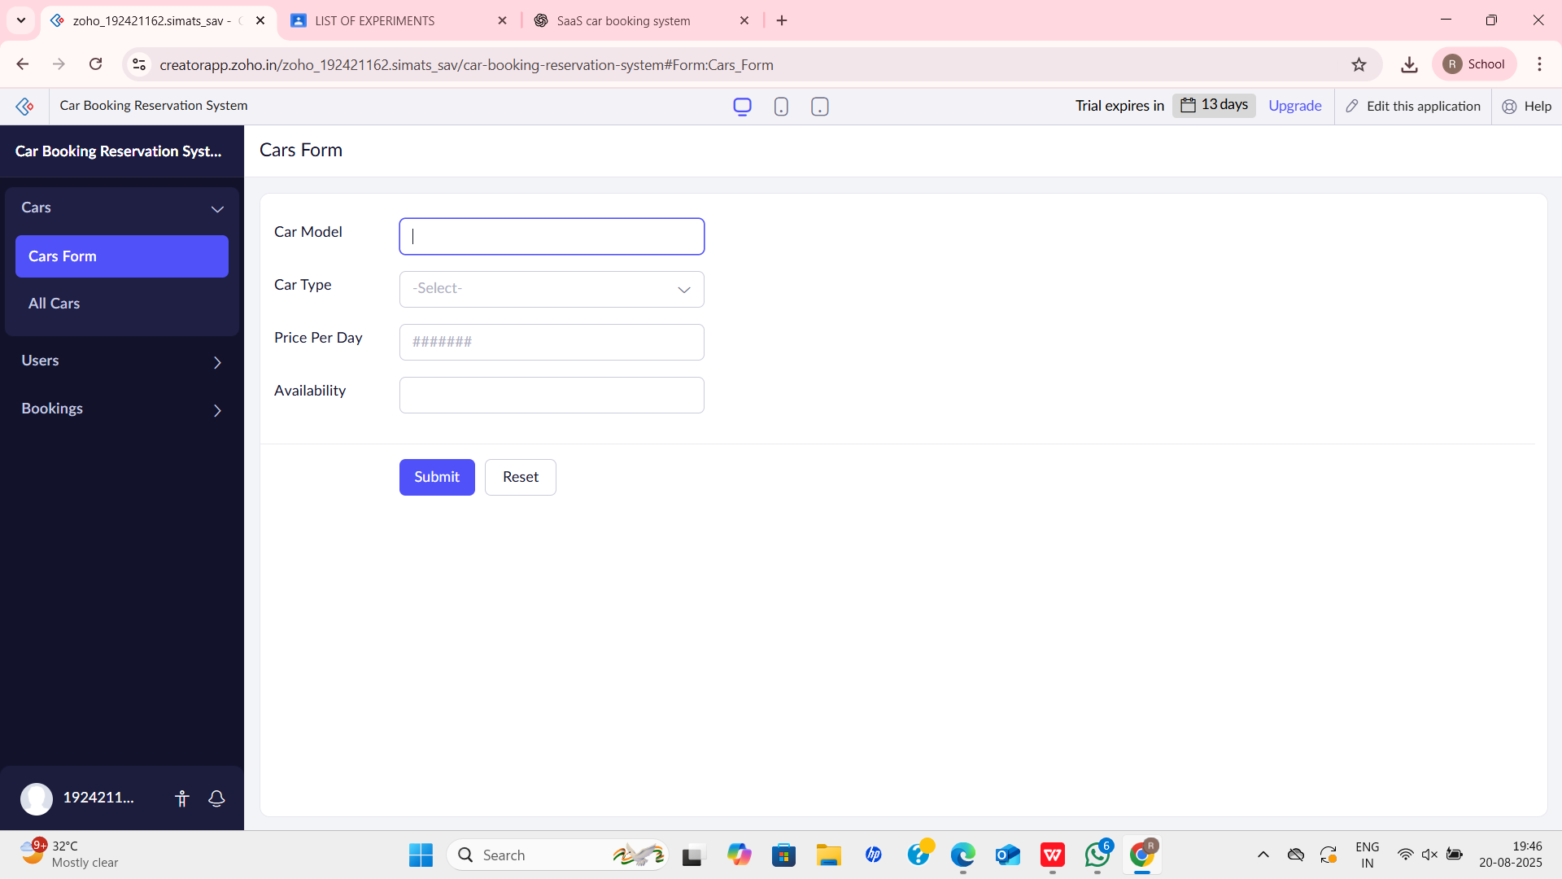

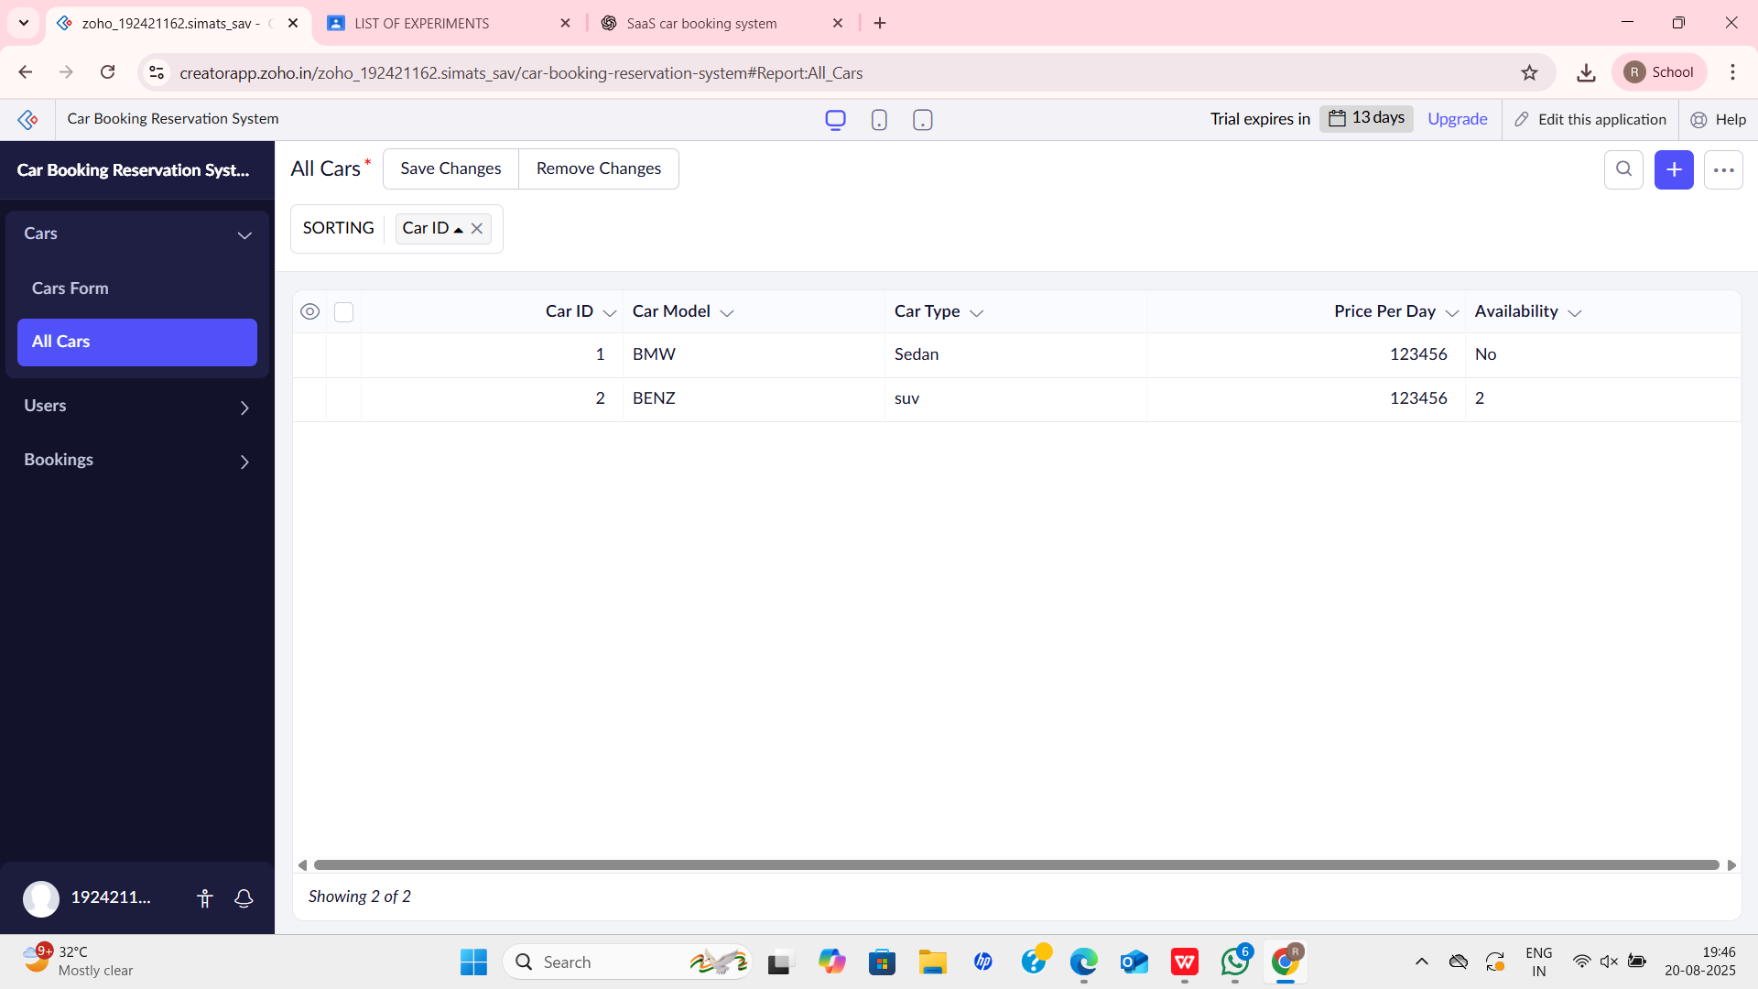

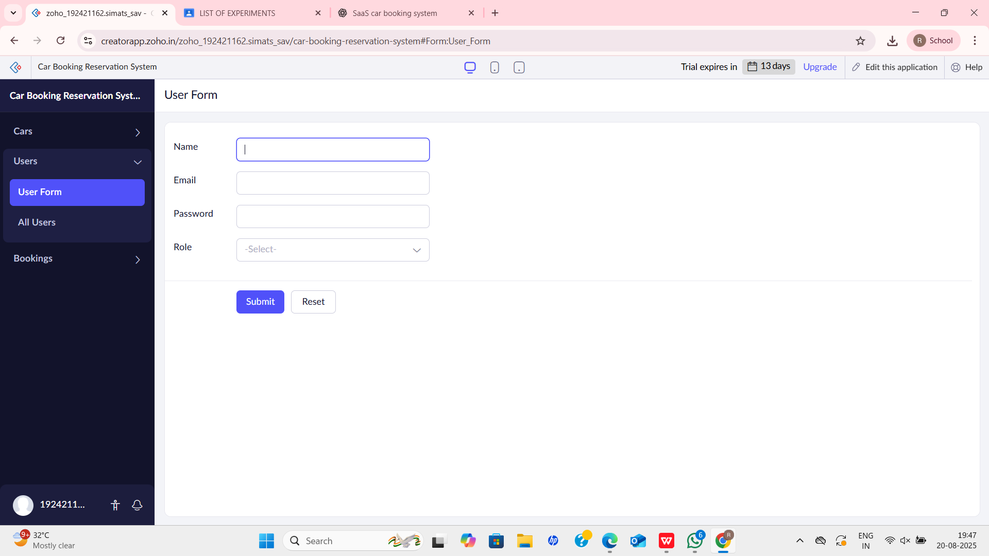

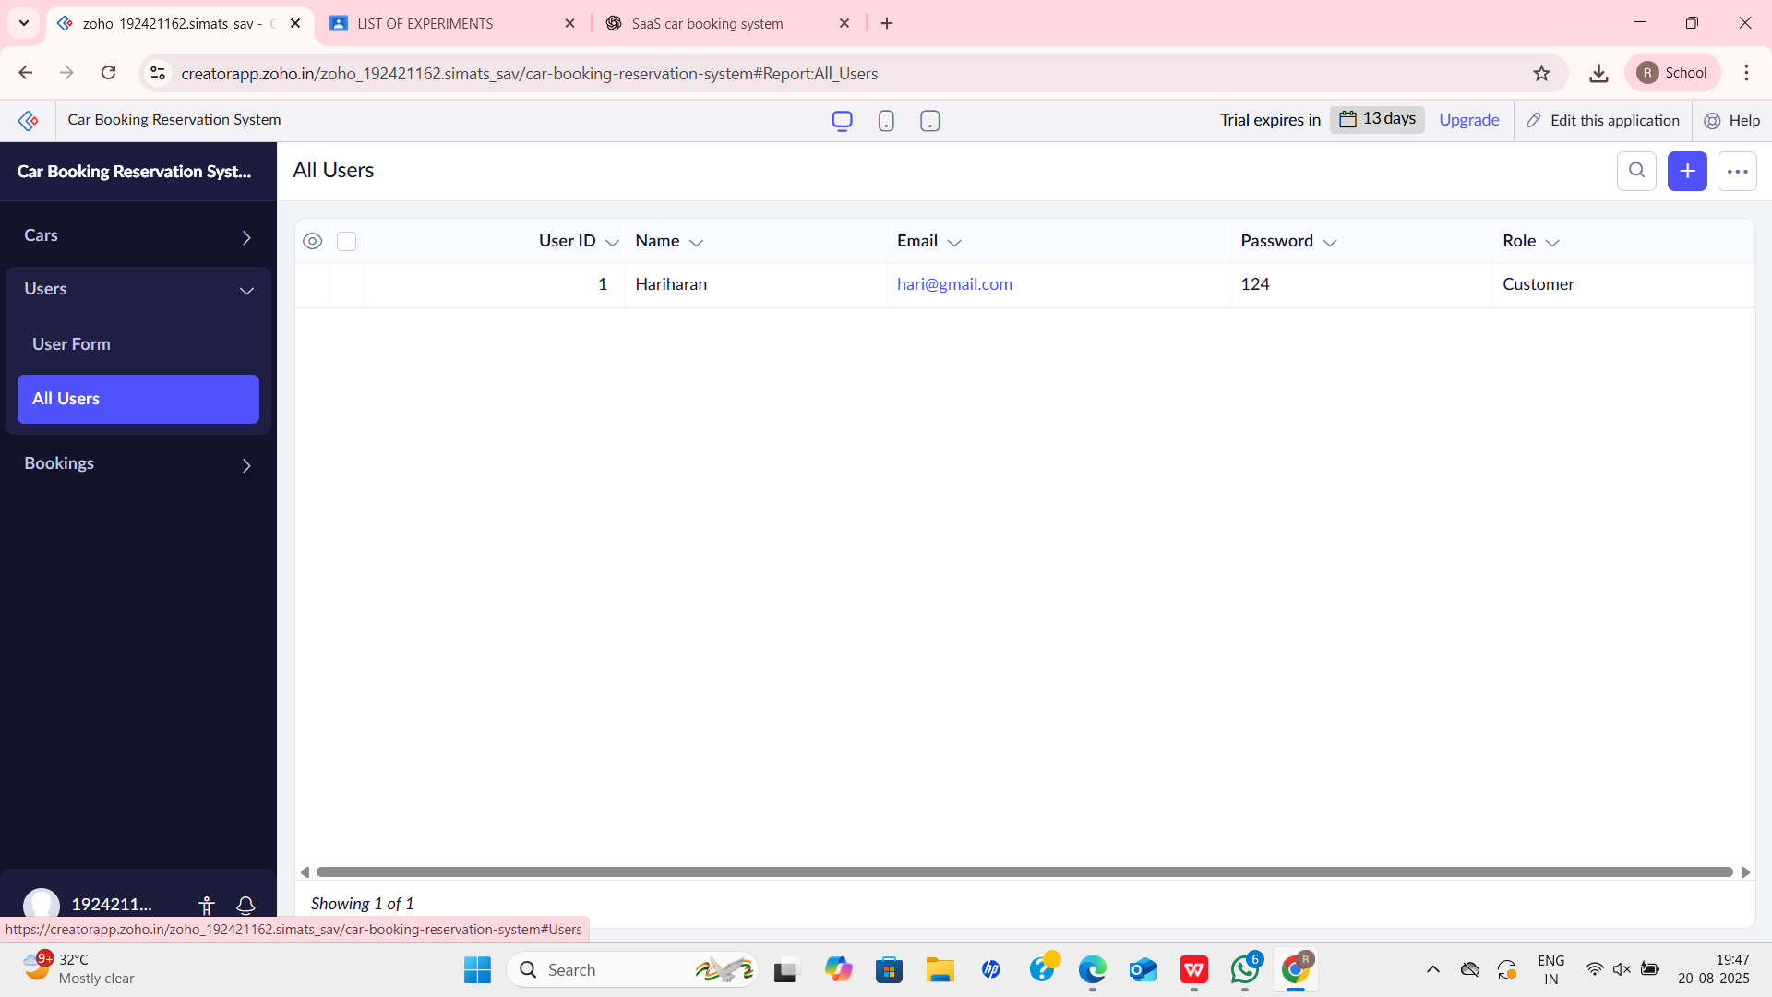

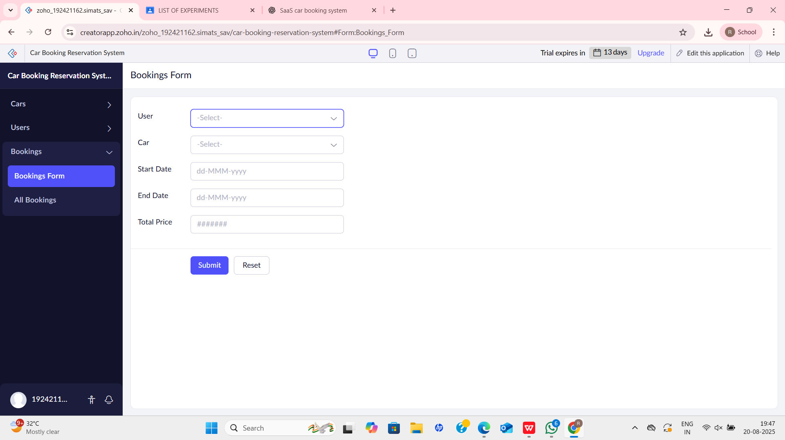

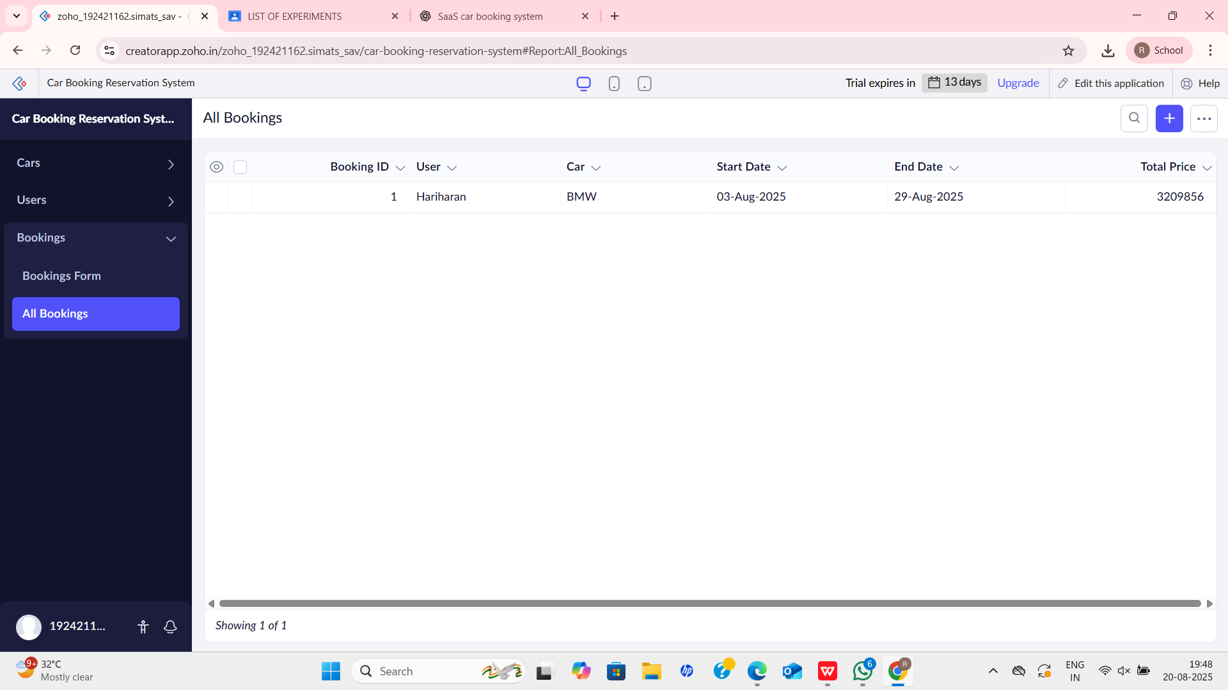

**RESULT**

A Car Booking Reservation System was successfully created and deployed on the cloud. The application allows customers to book cars online without local installation, demonstrating the concept of Software as a Service (SaaS).