**NANDITA PANDEY**

**EXPERIMENT NUMBER-1**

**INSTALLATION OF ANACONDA**

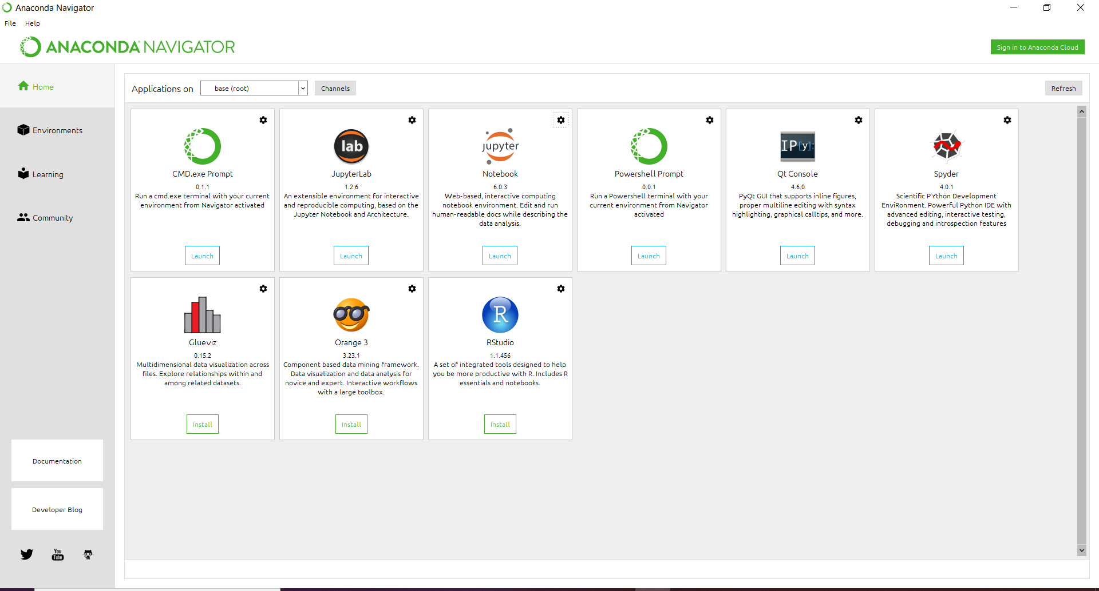

**LAUNCHING OF JUPYTER NOTEBOOK**

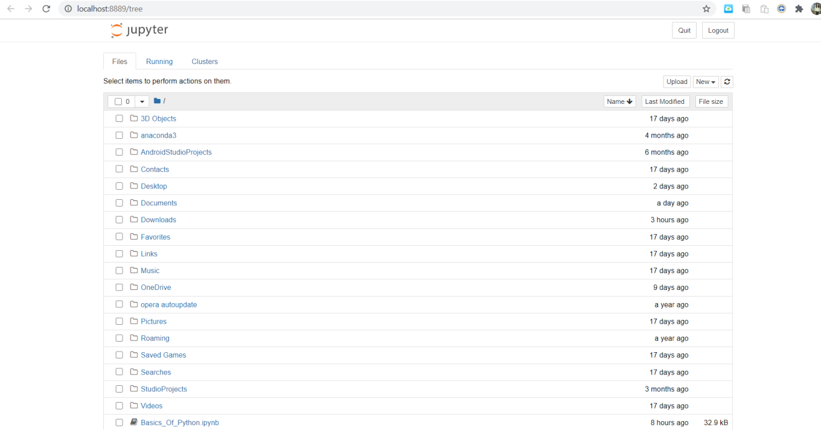

**GITHUB ACCOUNT AND PROFILE**

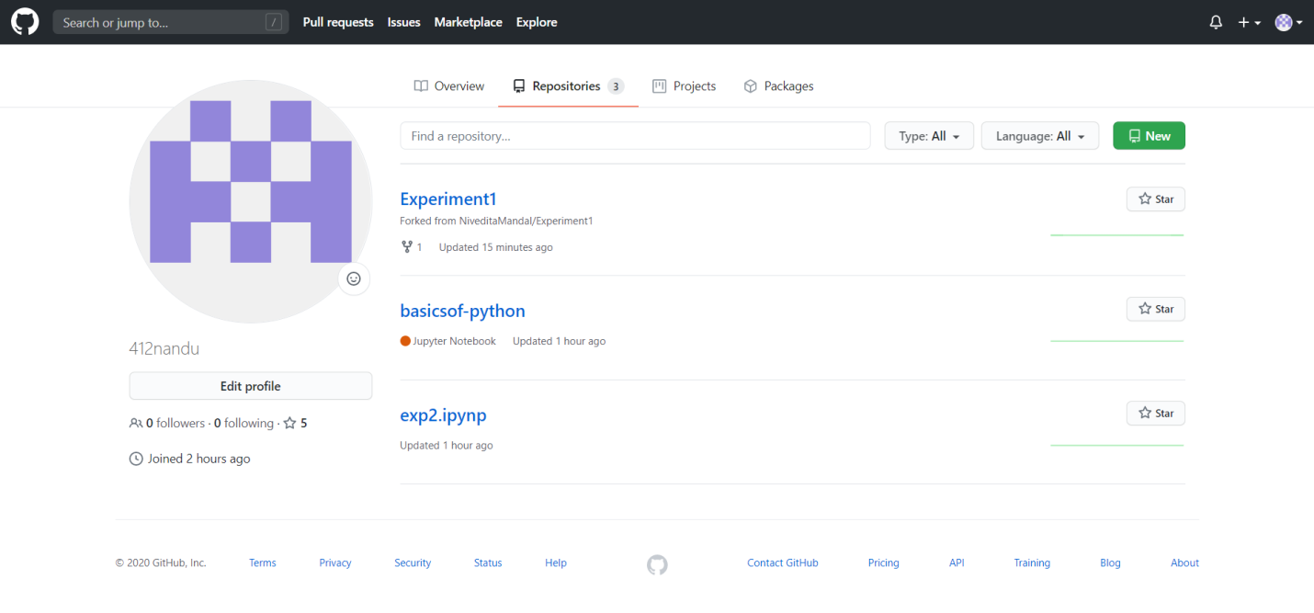

**GITHUB MACHINE LEARNING REPOSITORY**

