- TA自編題目_112下-5: (pointer, array)_基本陣列操作
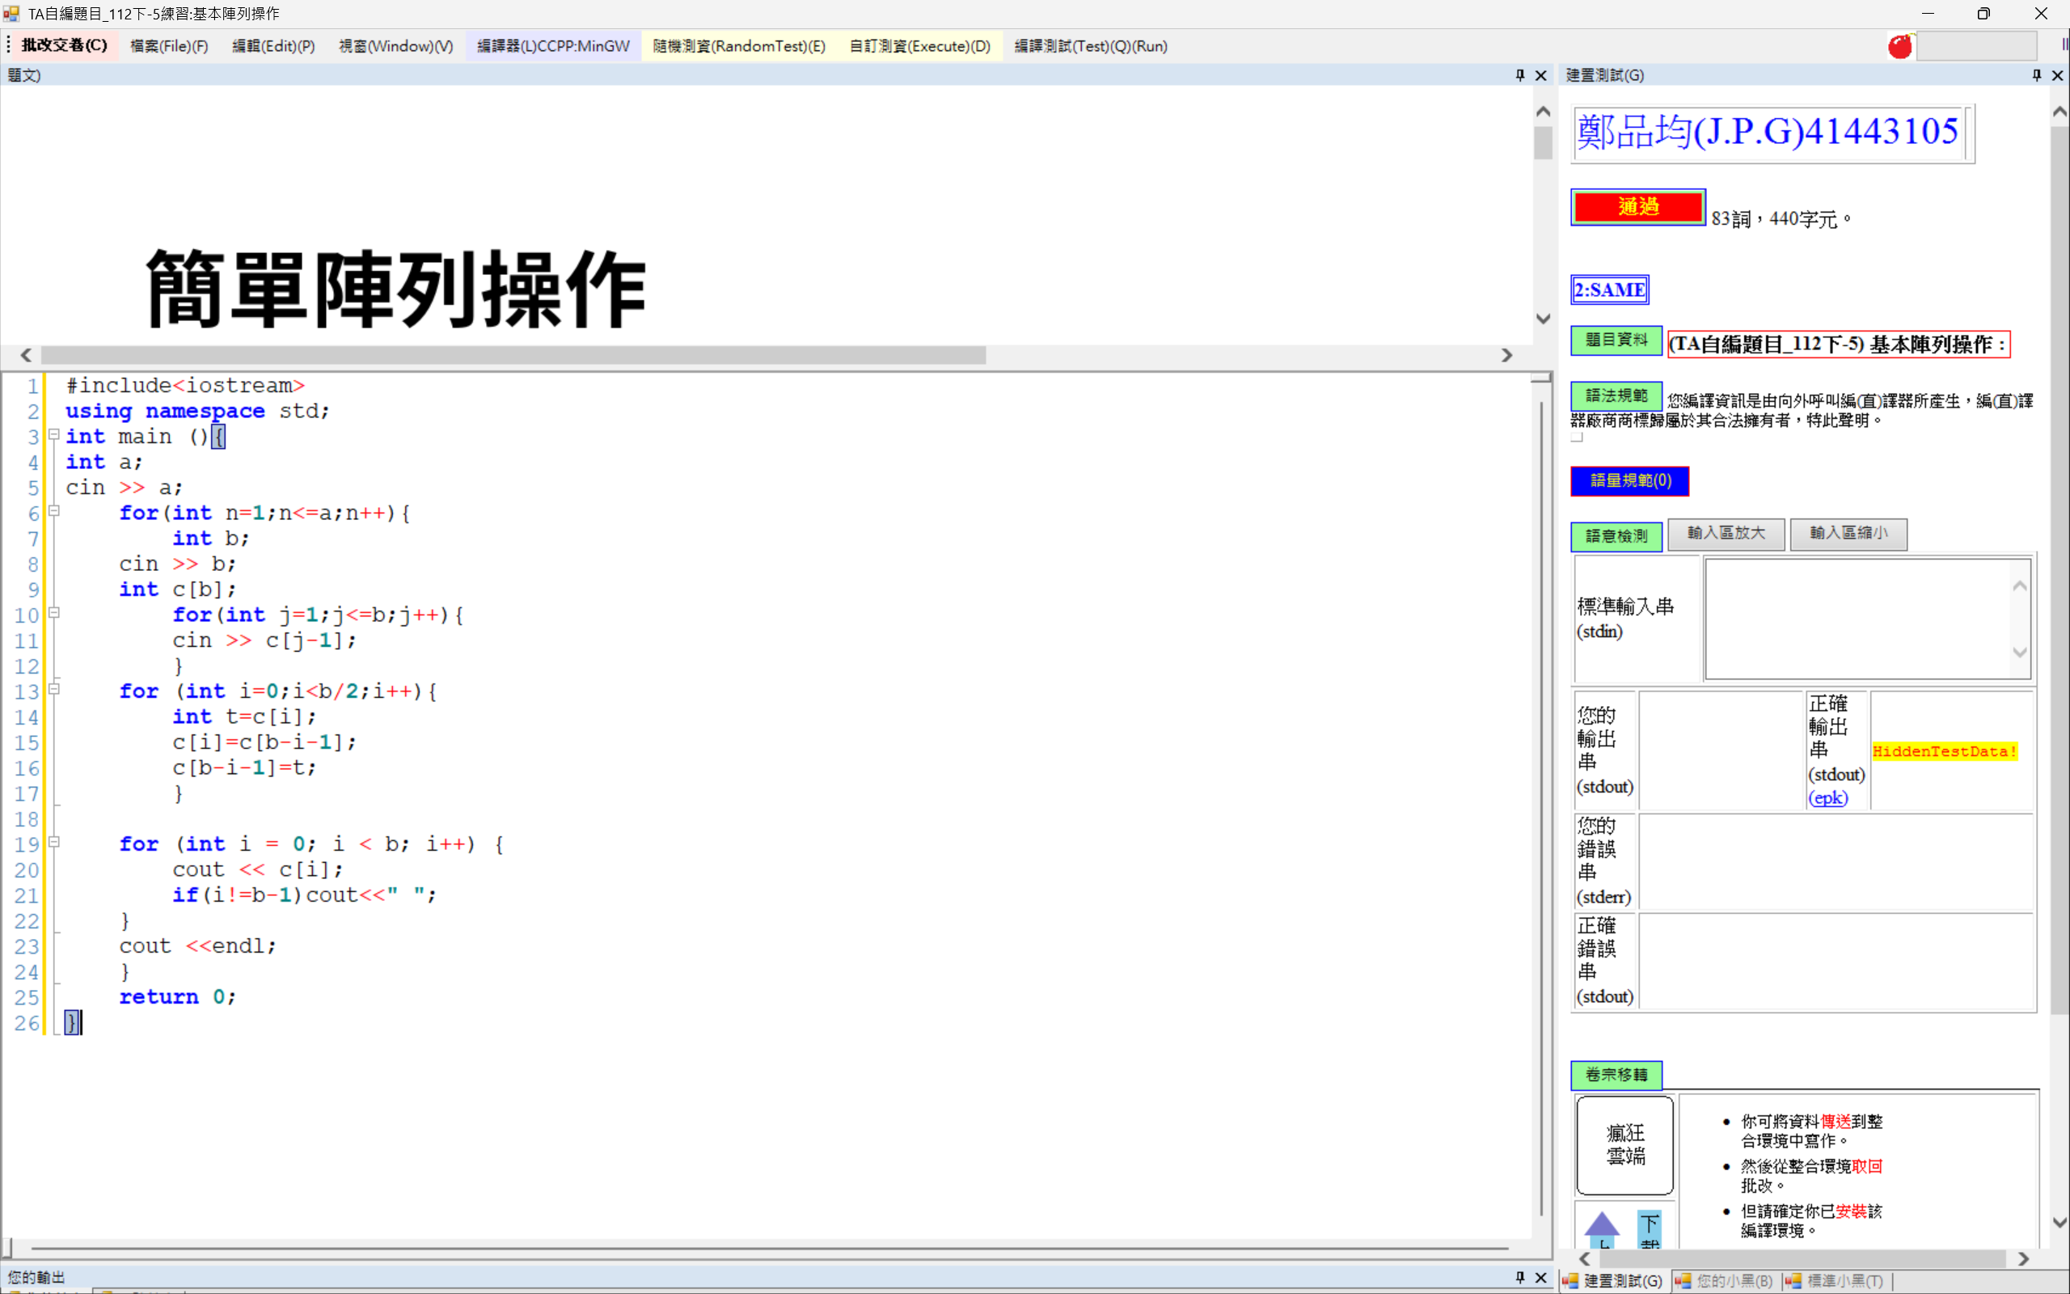
- TA自編題目_112下-28: (recursion)_GCD
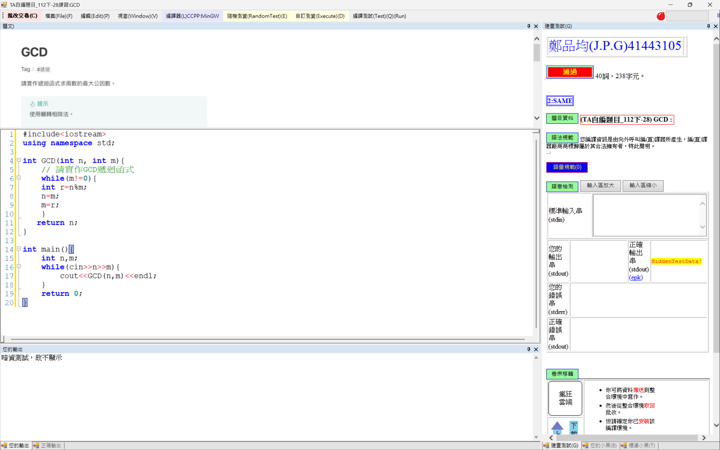

- TA自編題目_112下-26: (binary search)_Binary Search
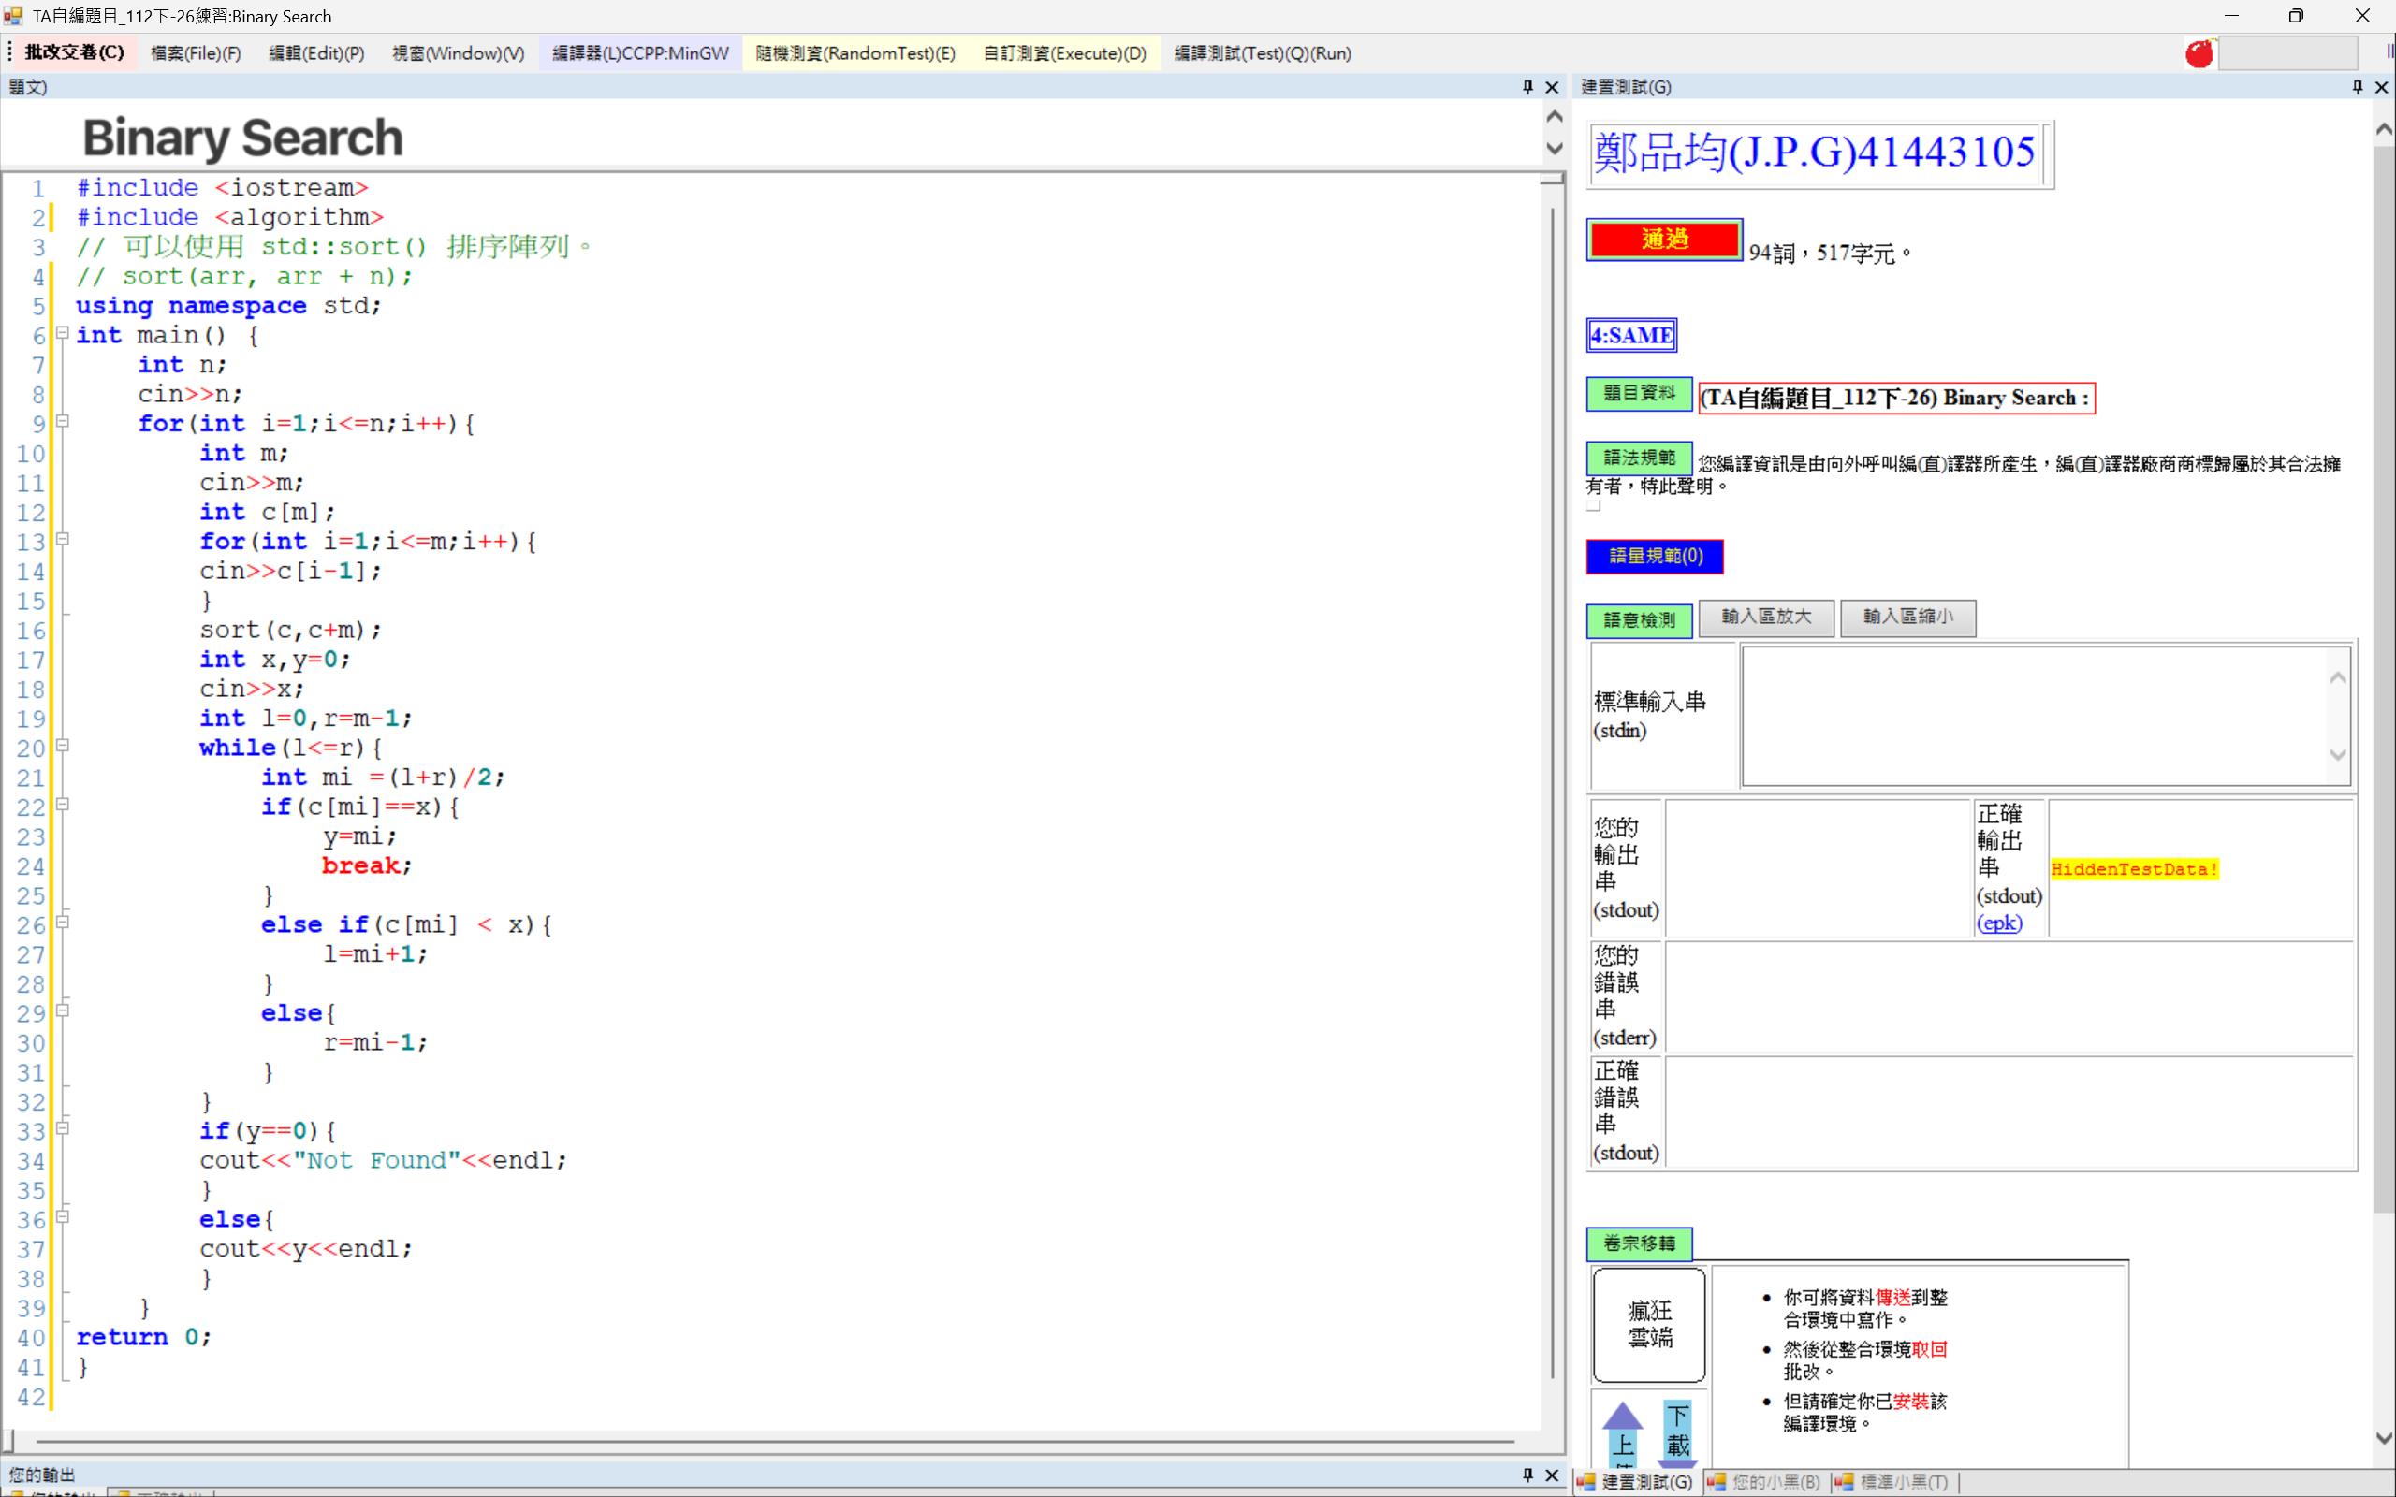
- TA自編題目_112下-15: (recursion)_Ackermann's Function
