1. (TA自編題目_112下-5) 基本陣列操作 :
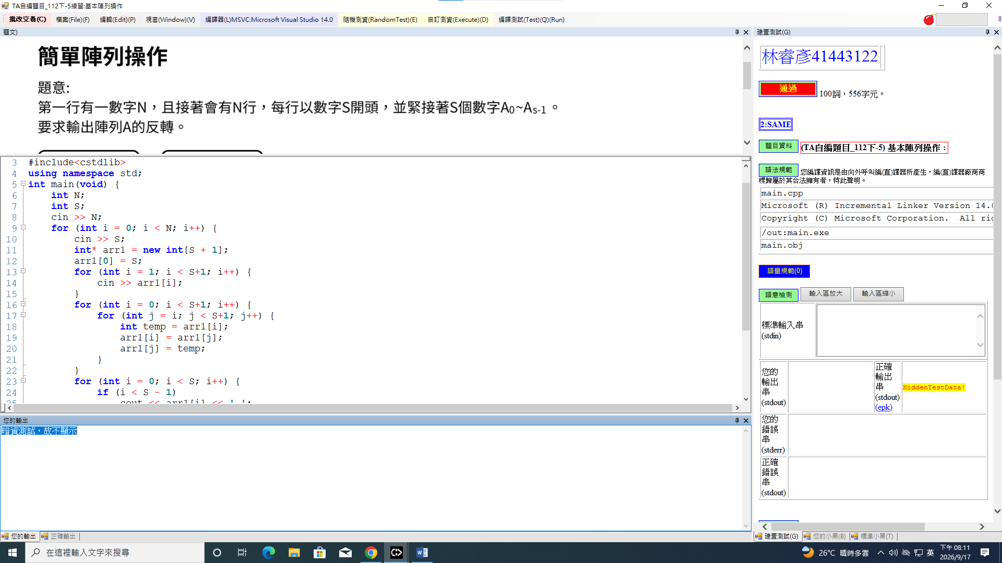
2. (TA自編題目_112下-28) GCD :
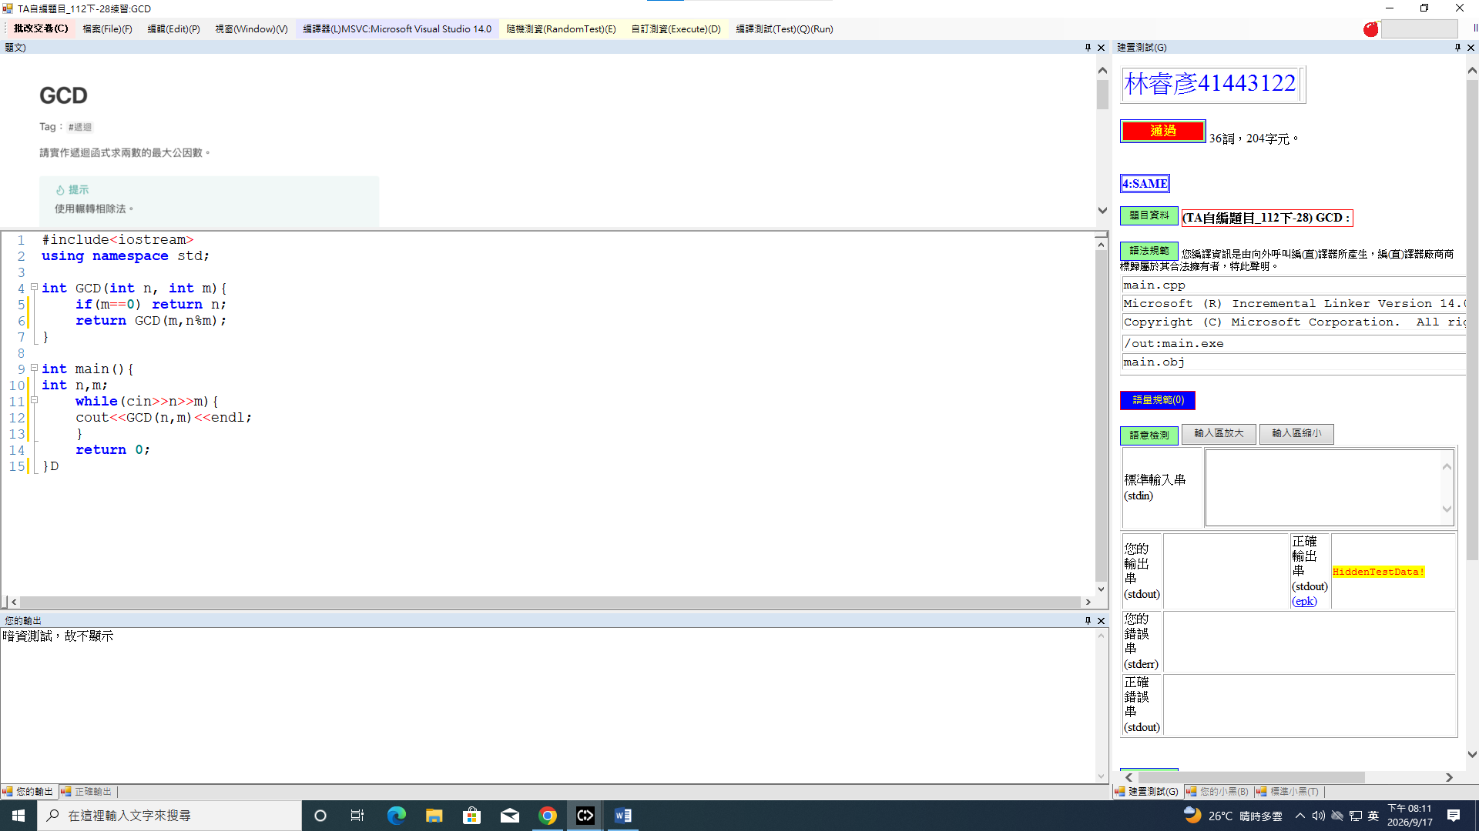

3. (TA自編題目_112下-26) Binary Search :
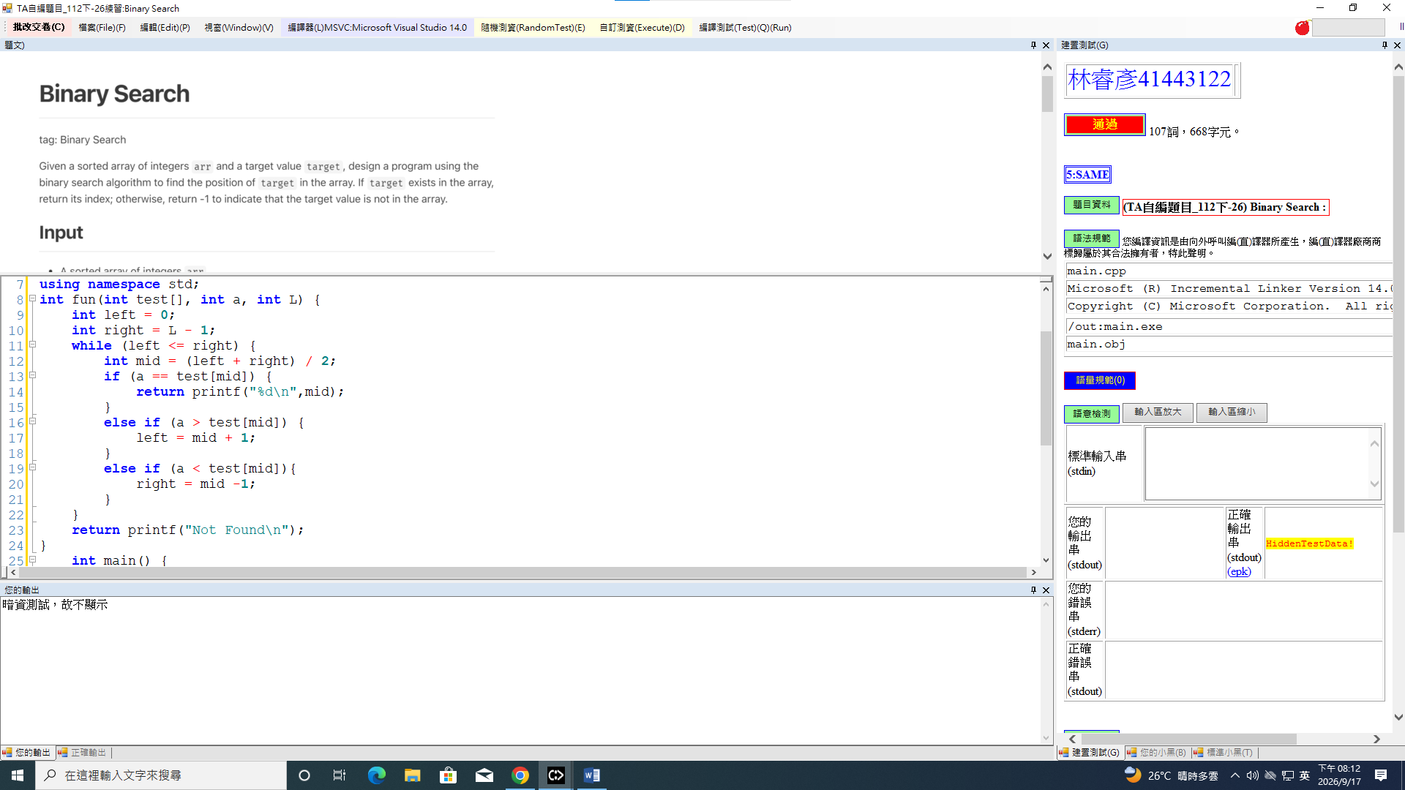
4. (TA自編題目_112下-15) Ackermann's Function :
