1.TA自編題目_112下-5：(pointer, array)_基本陣列操作
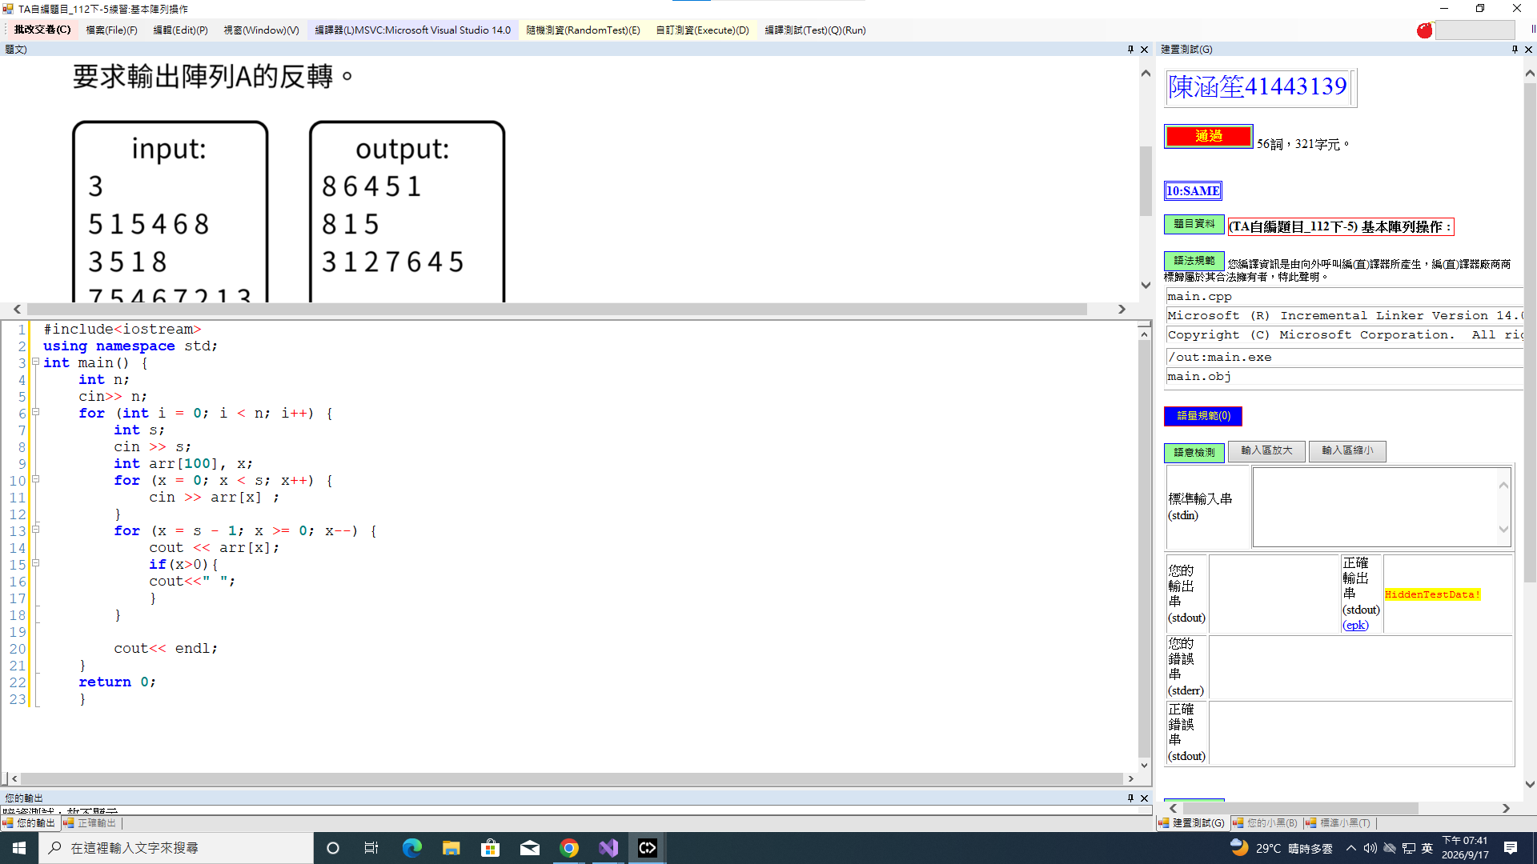

2.TA自編題目_112下-28：(recursion)_GCD
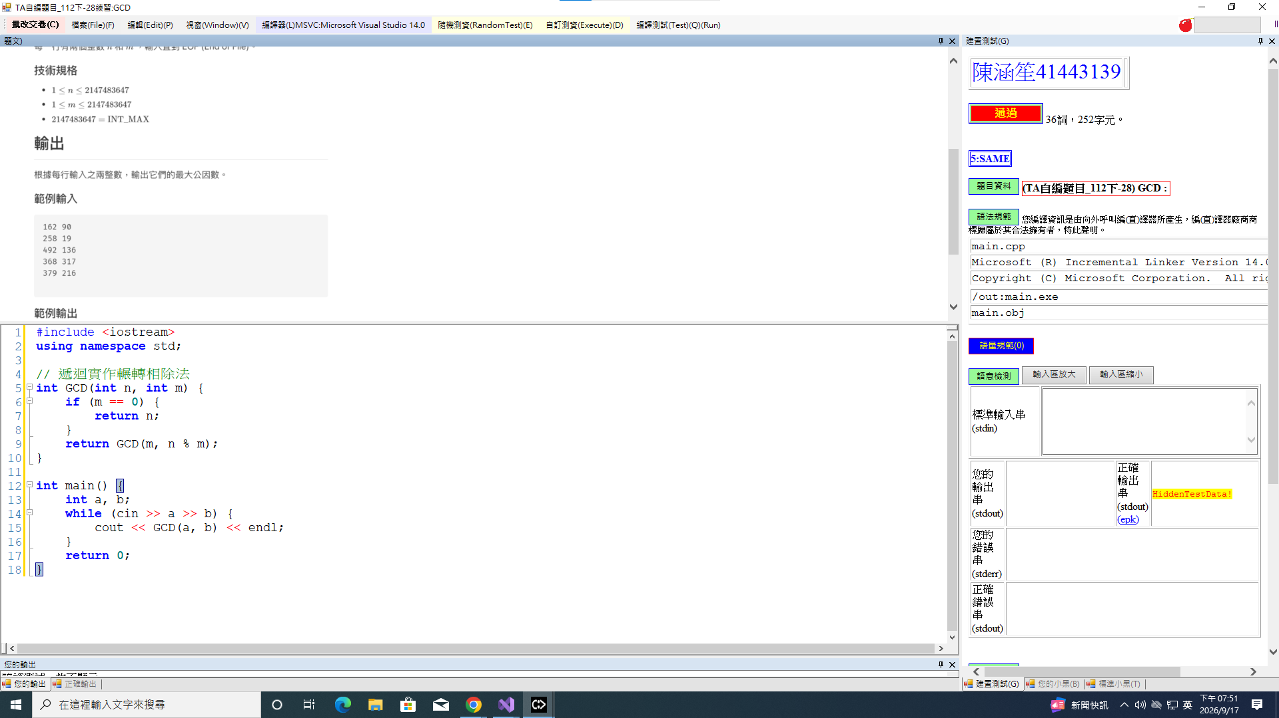

3.TA自編題目_112下-15：(recursion)_Ackermann’s Fuction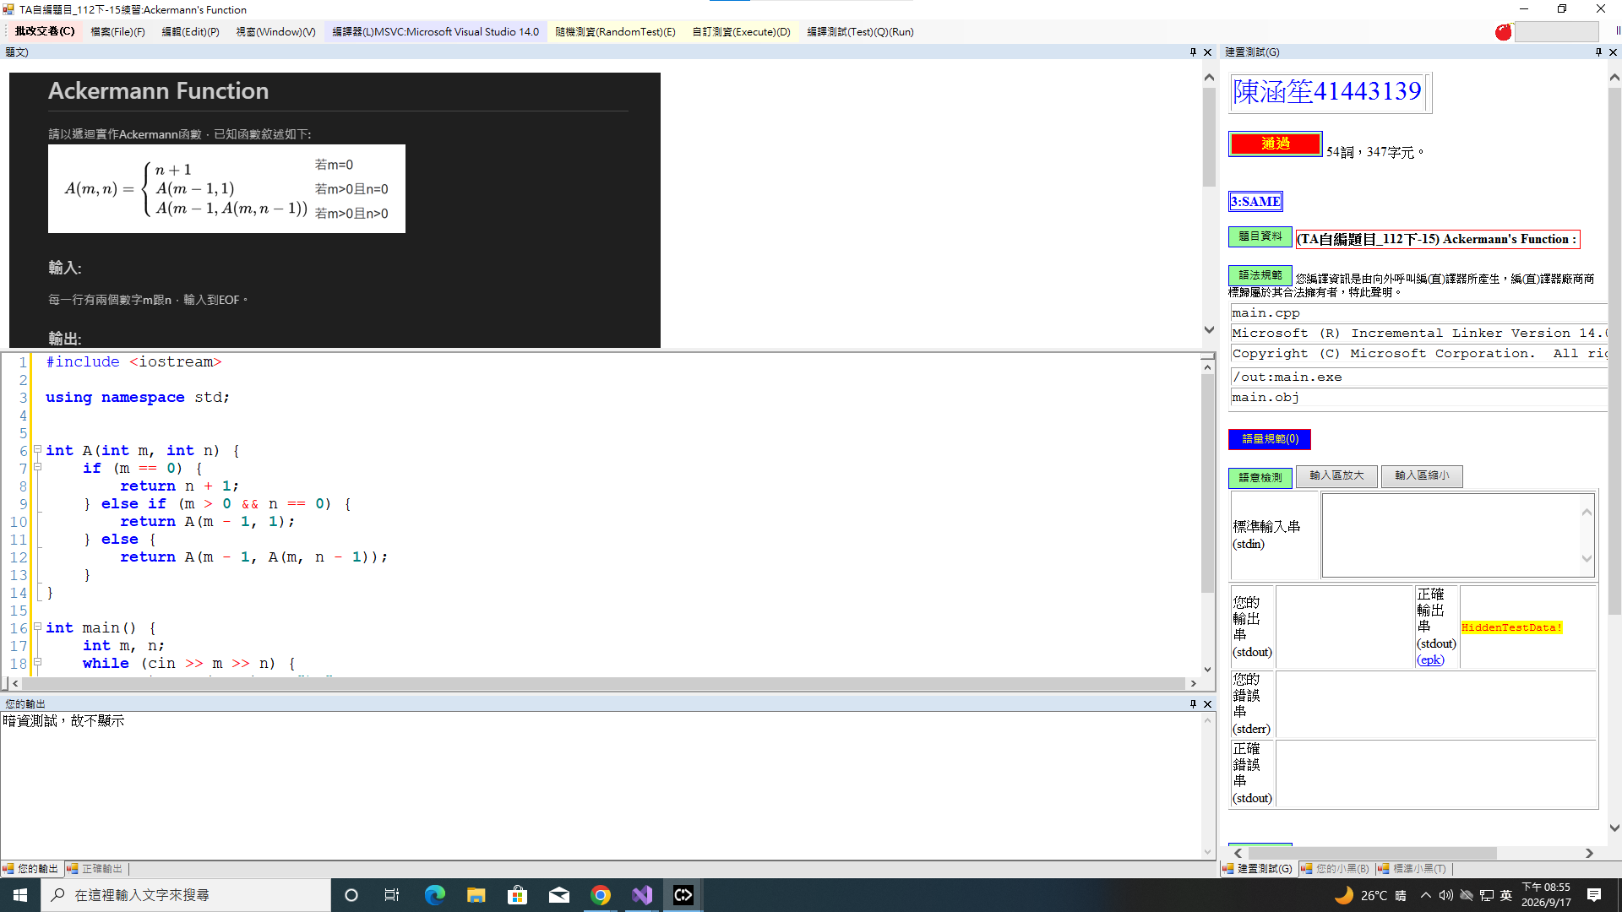

4.TA自編題目_112下-26：(binary aearch)_Binary Search
