**Hacking the Windows Experience**

Navigate to local disc c: then click on windows/performance/WinSAT/database. After that the various files are shown. Now open Formal Assessment file.

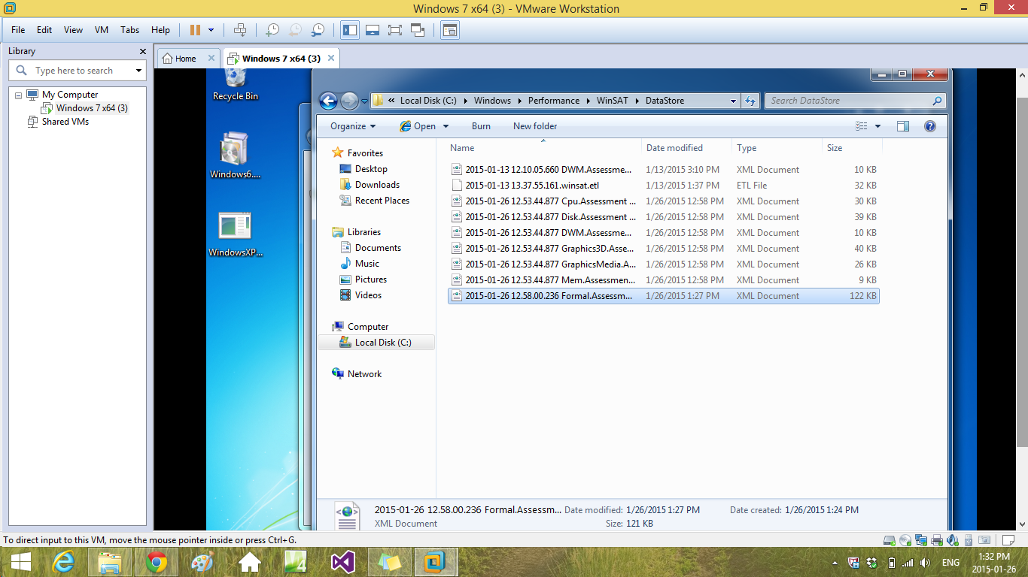

Now find <WinSPR>. The text is highlighted and change the value of systemscore 4.5 to 7.1

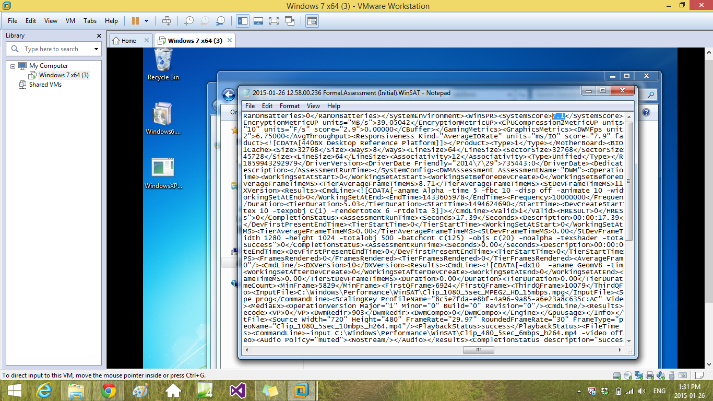

Save the file on desktop. Cut it and paste it in C:\windows/performance/WinSAT/database. Open the Window Experience and see the changes.

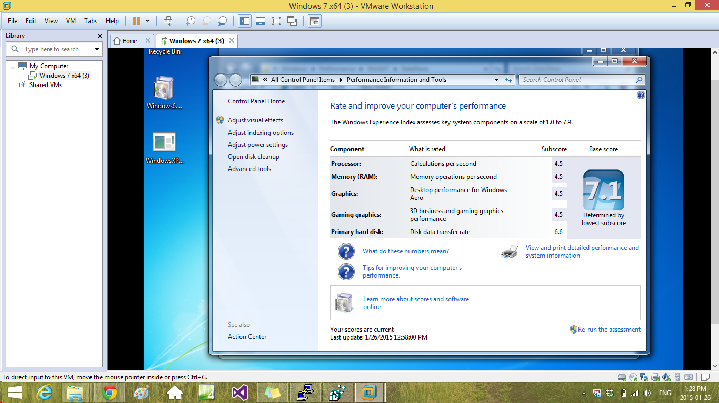

**Installation of ScreenFetch**

Step 1: Install Ubuntu on VM Workstation

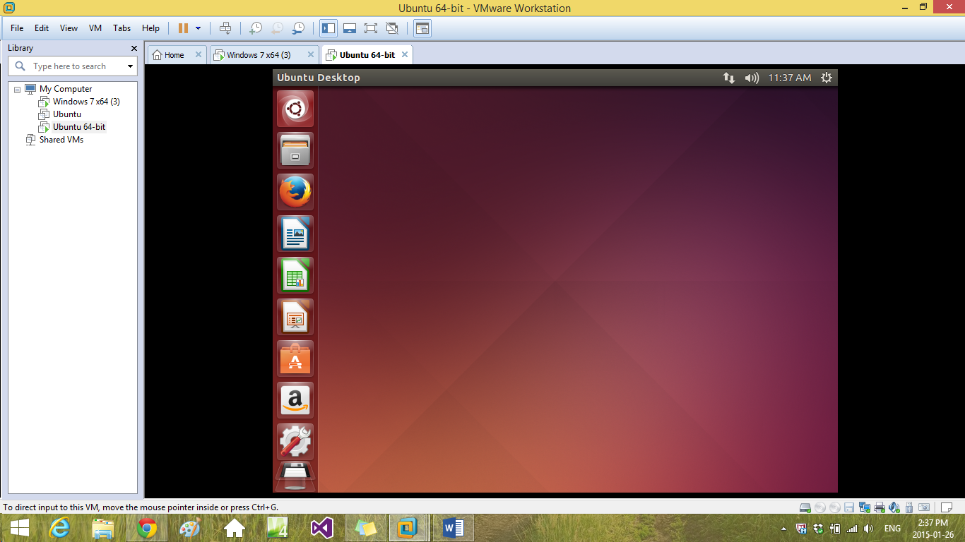

Step 2: In terminal run all the ScreenFetch Commands.

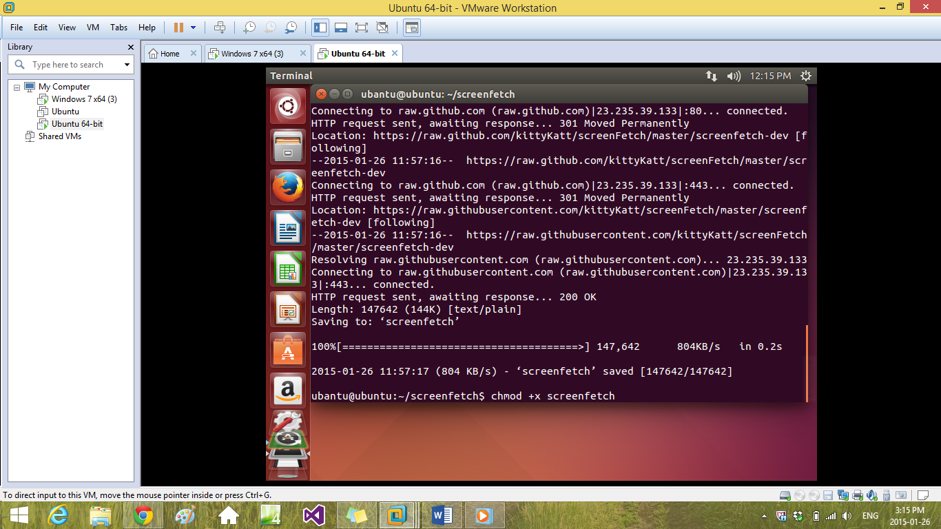

Step 3: The screen Installed ScreenFetch.

