Week 3 Exercises

# Exercise 1

1. A) You can uncheck Auto-Commit Transactions Flag on the Query tab of your MySQL Workbench but it probably will not have any effect if you will execute statement by statement anyway because MySQL . Workbench starts new transaction with any new statement executed by coursor.
2. Execute the Create_General_Store_Database.sql script to have the same initial data.
3. Select CustNum, City from customer where CreditLimit is equal to 1000. Export recordset into 1_1_C.csv (or Display the screen – **Alt-PrtSc should allow to grab a screen**) and attach it here.

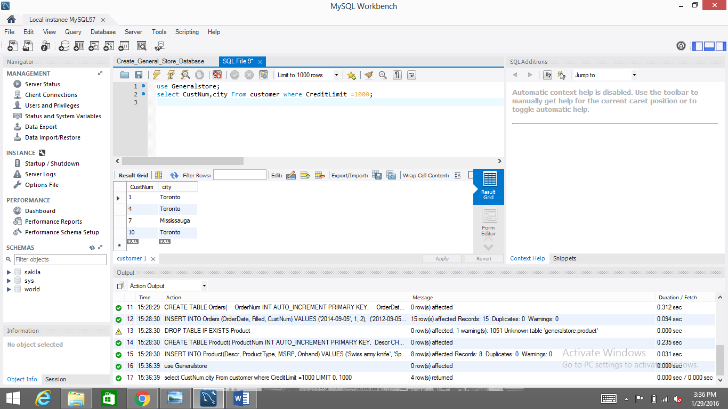

1. Update only first two two records in the customer table where the credit limit is equal to 1000.0 that the city field is changed to Brampton. (Hint: Limit your query to 2 rows). Attach the screen shot here.

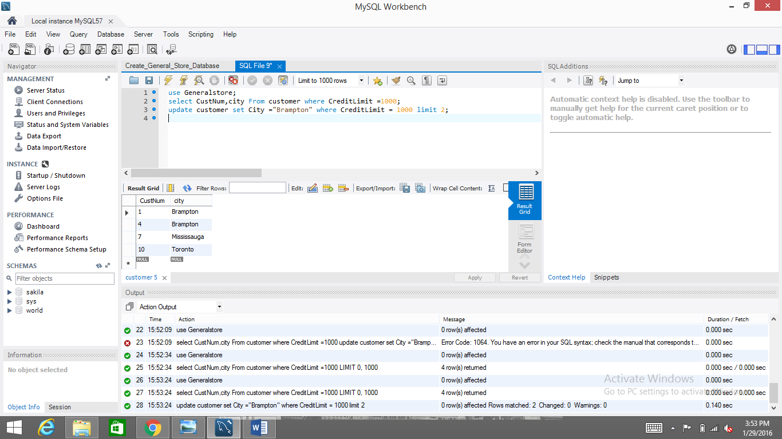

1. Select CustNum, City from customer where CreditLimit is equal to 1000. Export recordset into 1_1_E.csv (or Display the screen) and attach it here. (Hint: You already have a query).

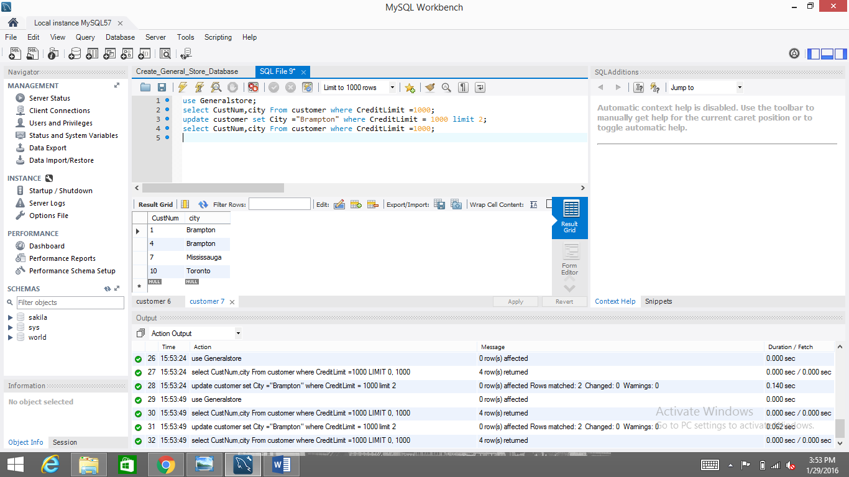

1. A) Insert a record to the customer table using field values of your choosing, but do not include the custnum field. Attach a screen shot here.

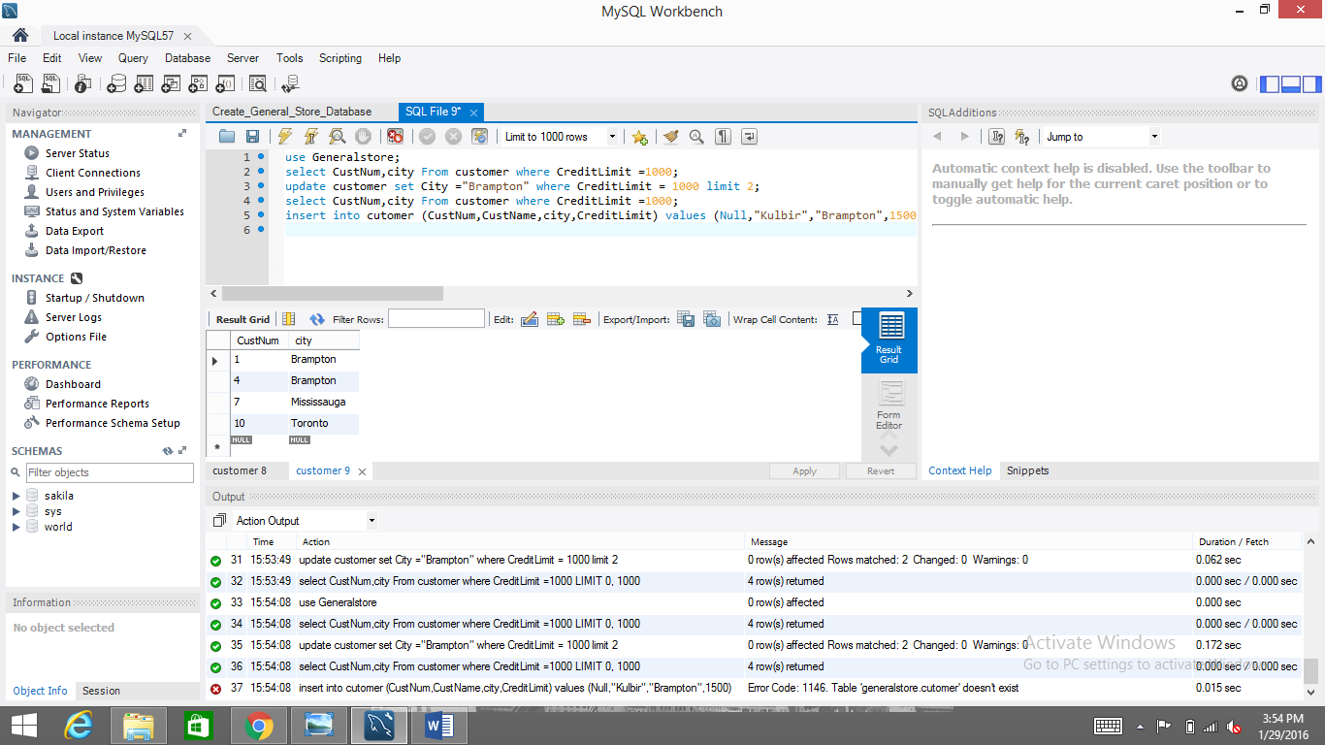

1. Select the record you have just inserted. Export recordset into 1_2_B.csv (or Display the screen) and attach it here. What number is automatically inserted into custnum? Does it make sense?

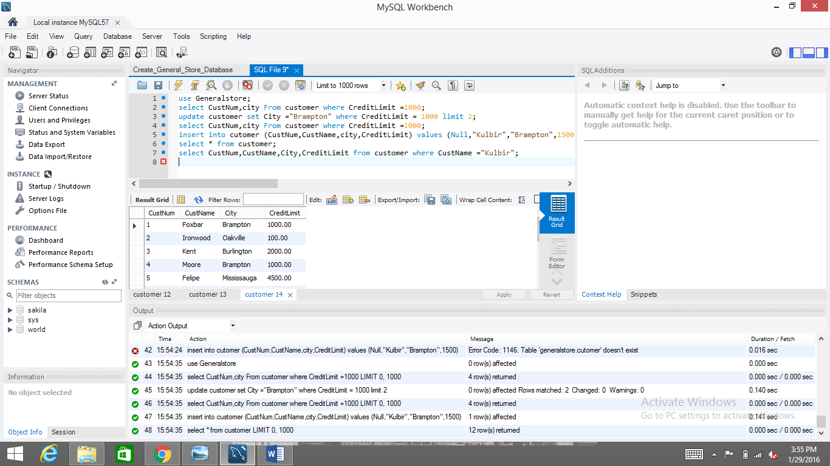

1. Delete all records where the custnum is equal to the value that was just inserted. Limit your query to 1 row.

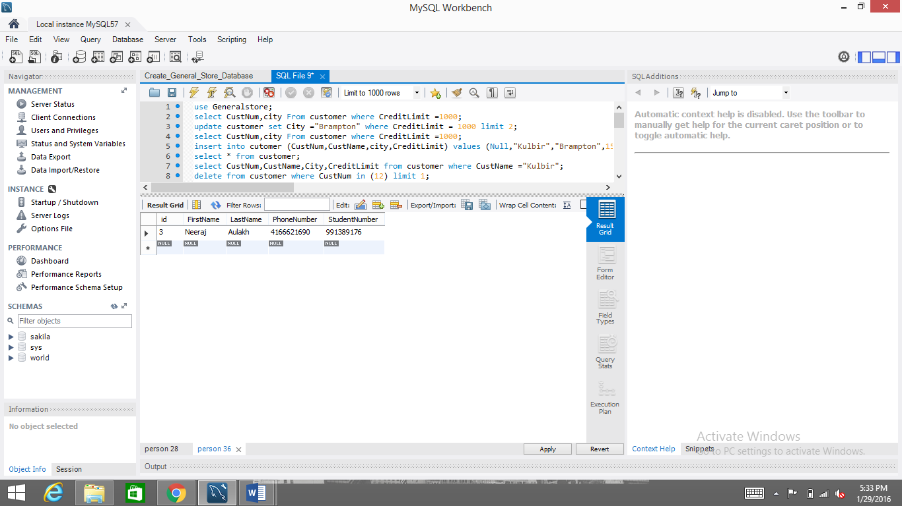

# Exercise 2

1. Create a database named People.
2. Use your new database. (Hint: create a new database connection if you would like MySQL to use auto-completion feature.)
3. Create a table that stores personal information called Person. You should have an id field that is a primary key and is auto_incremented. You should also store the first name, last name, phone number, and the student number in appropriately named and typed fields. The student number cannot be null and must be UNIQUE, and as a tip, the phone number should be a VARCHAR to handle ()’s and –‘s just in case.
4. Describe the table to verify your work. Export recordset into 2_4.csv and attach it here.

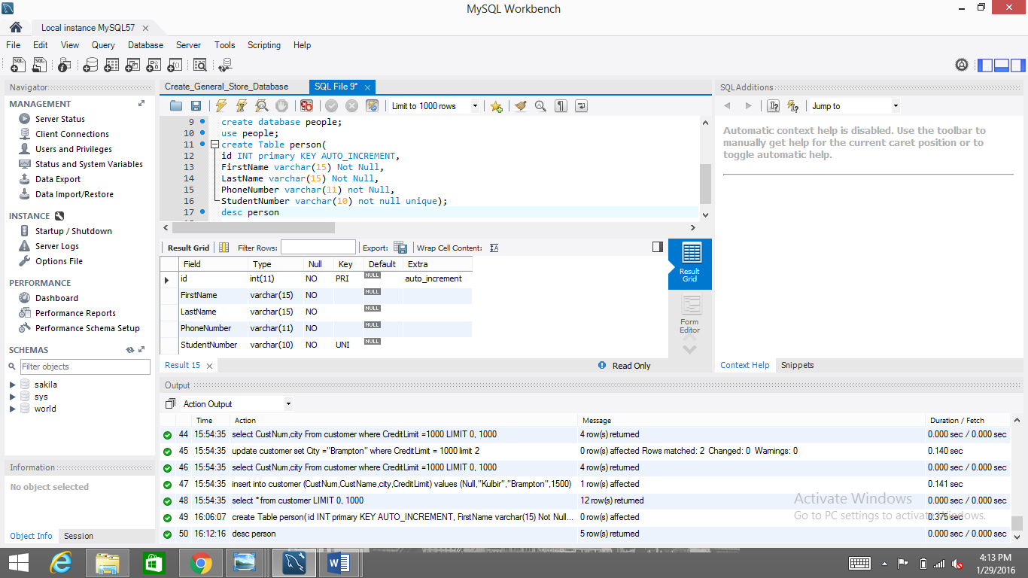

# Exercise 3

1. Display the screen at each step below to verify your work.
2. Insert two records into your table! One of your records must be your name, a null phone number, and your student number.

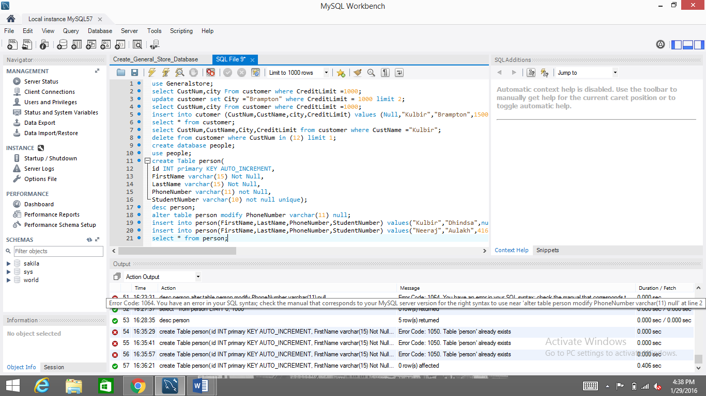

1. Update your table so that any records where the phone number is null have the phone number field set to 9054597533. Note: that is Sheridan’s number. ☺

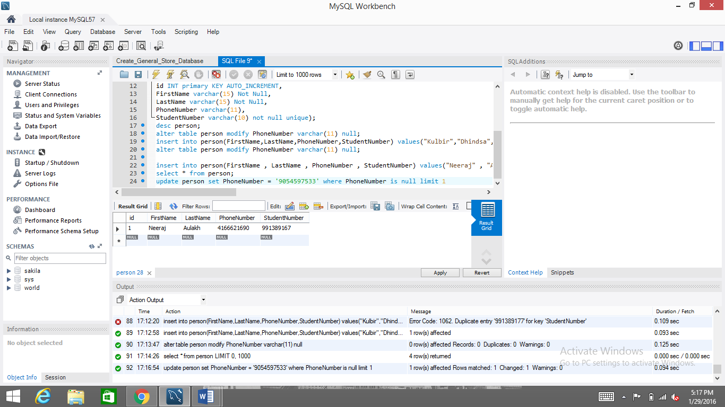

1. Delete any records where the phone number is not equal to 9054597533.

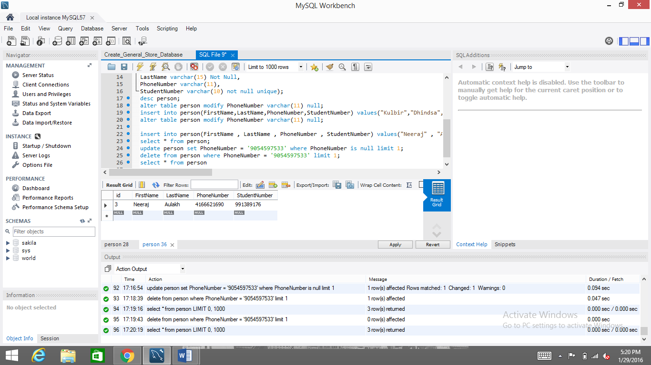

1. Drop the table.

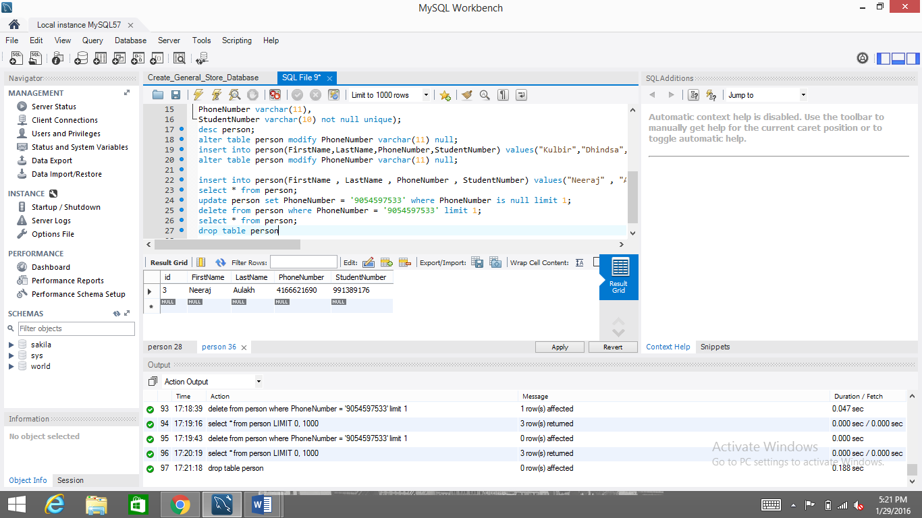

1. Drop the database.

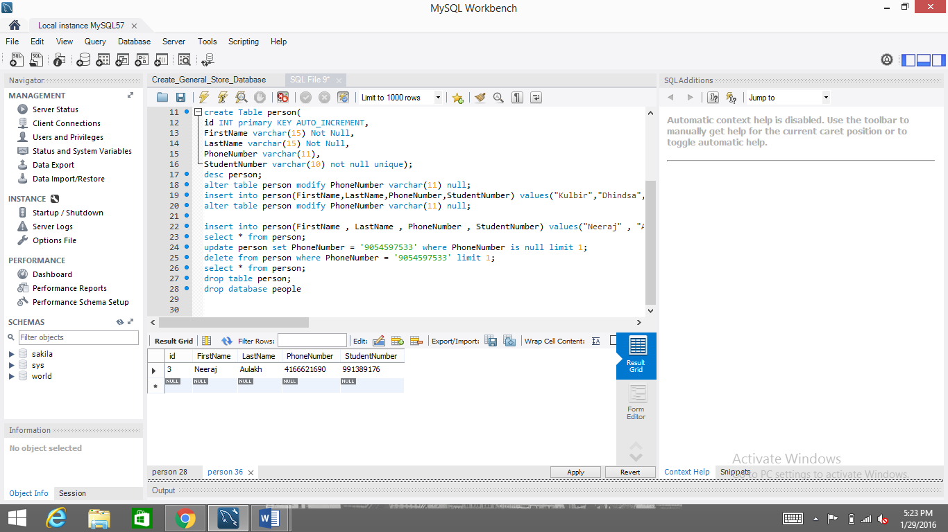

1. Go back to using the GeneralStore database.