Week 4 Exercises

# Exercise 1 – Dates and Math

* Research the links included in this lecture – at bare minimum, read about the SQL commands you were given for homework using the links on the MySQL site:

<http://dev.mysql.com/doc/refman/5.7/en/date-and-time-functions.html>

* Find out what day of the week were you born on? (Please provide the screenshot for the query execution!!)

**select dayname("1996-11-06");**

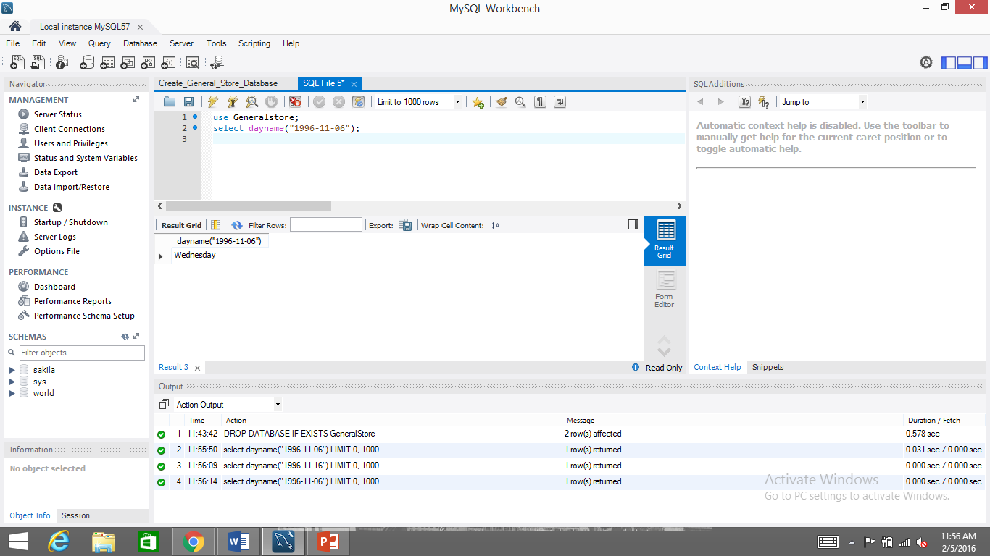

* Write a query that will retrieve all records from the orders table where the order date day of the month is equal to the fifth (5)

**select orderdate,dayname(orderdate) from orders where day(orderdate)=5;**

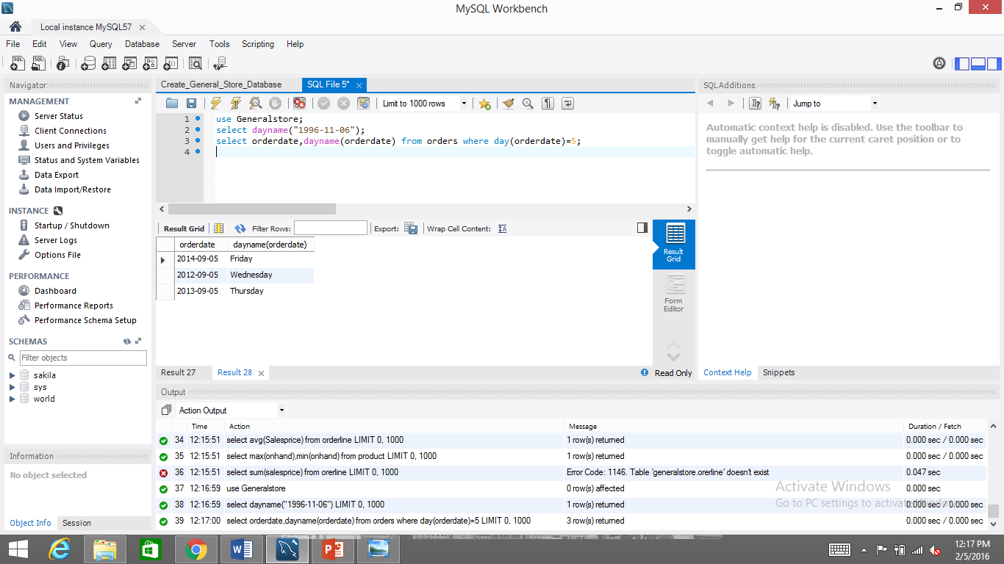

* Using a calculator or paper, evaluate 3 * 10 + 5 / 2 – 2.5. Watch out for arithmetical order of operations! Check your work with a query.

**select 3*10+5/2-2.5;**

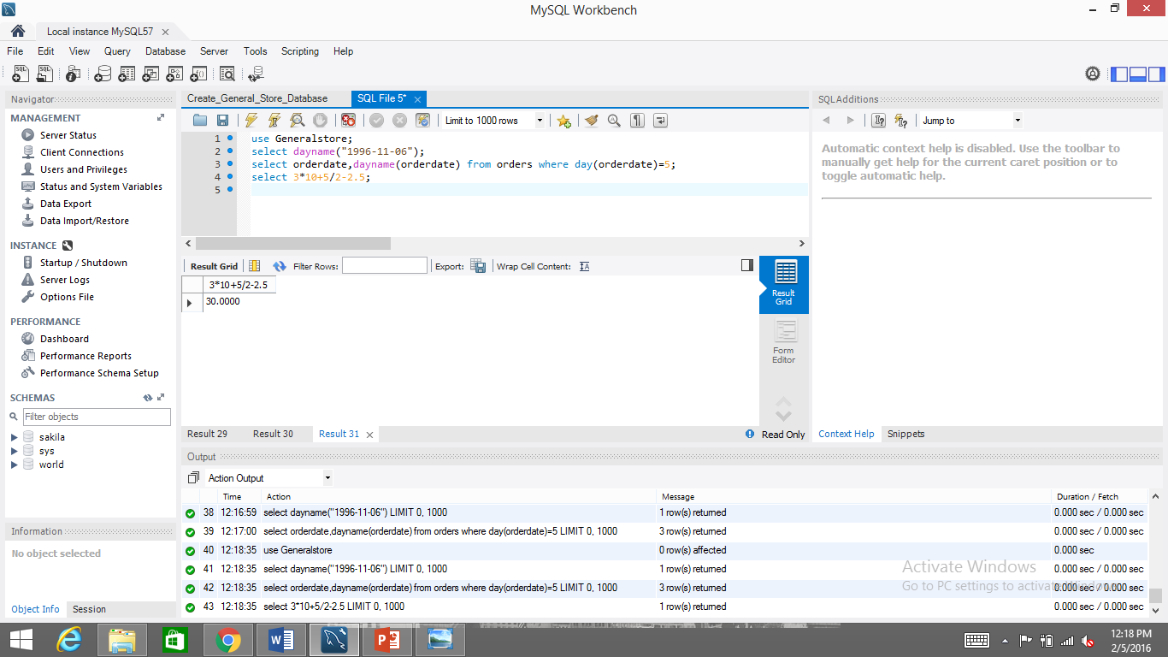

# Exercise 2 – Aggregate Queries

* Find the average salesprice in the orderline table.

**select avg(Salesprice) from orderline;**

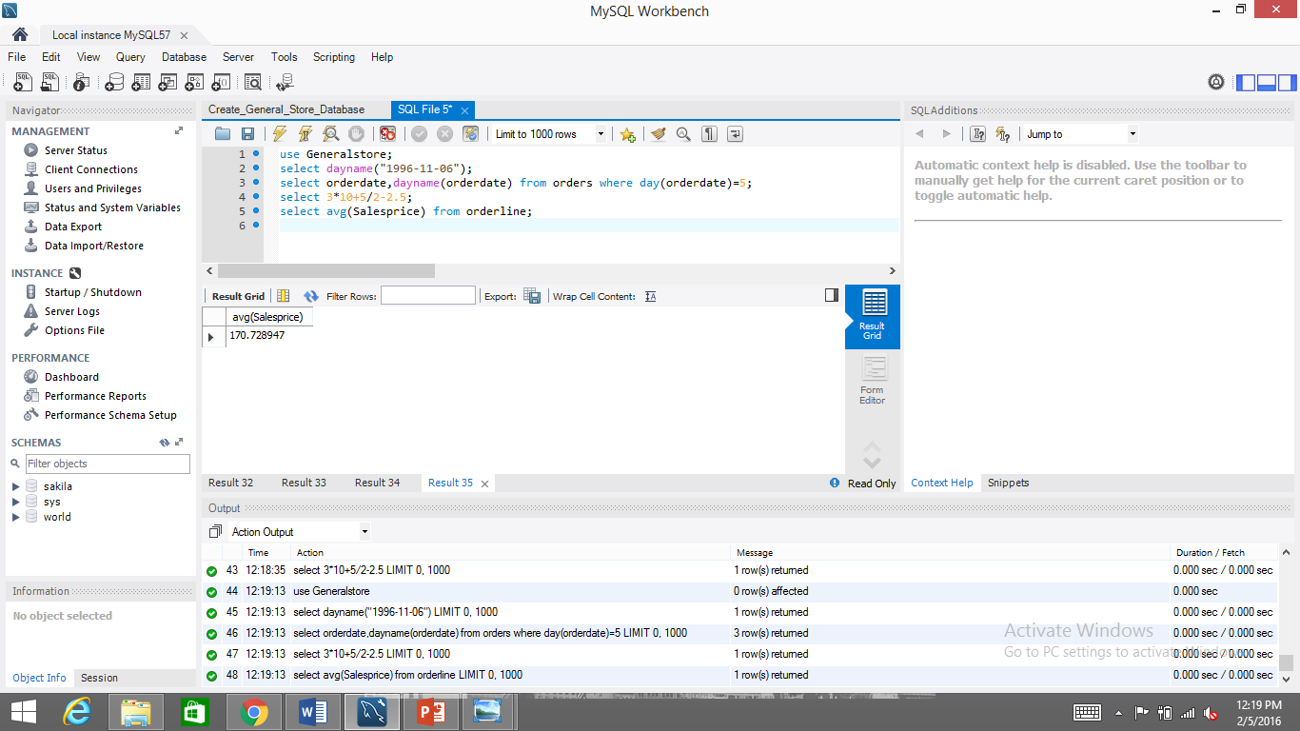

* Find the largest and smallest values for the onhand column of the product table. Do so in a single query.

**select max(onhand),min(onhand) from product;**

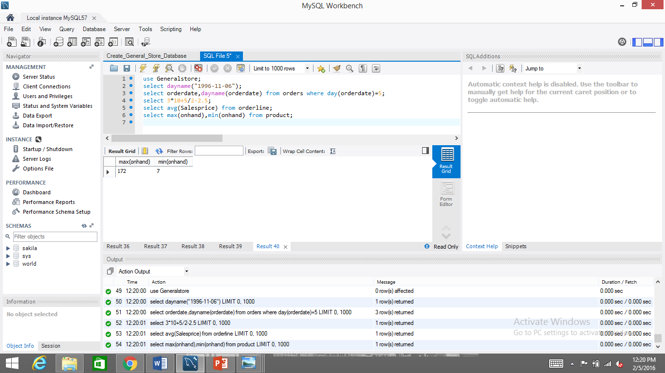

* Select * and the sum of the salesprice in the orderline table. What data was returned?

**Select*,sum(salesprice) from orderline;**

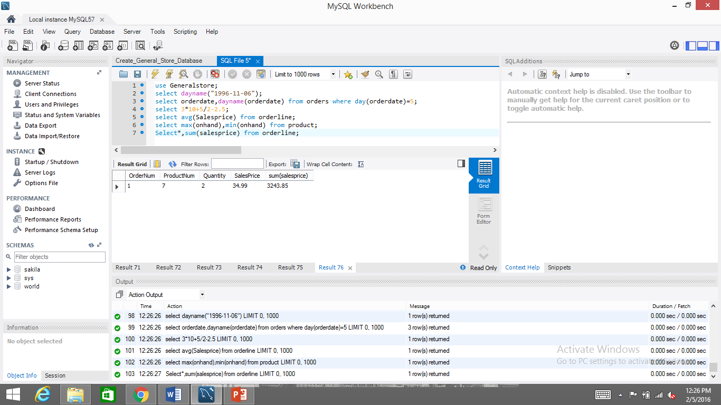

# Exercise 3 – String Comparisons

* Write a query that will retrieve all records from customer where the city begins with ‘B’ and ends with ‘ton’

**Select*from customer where city like "B%ton%";**

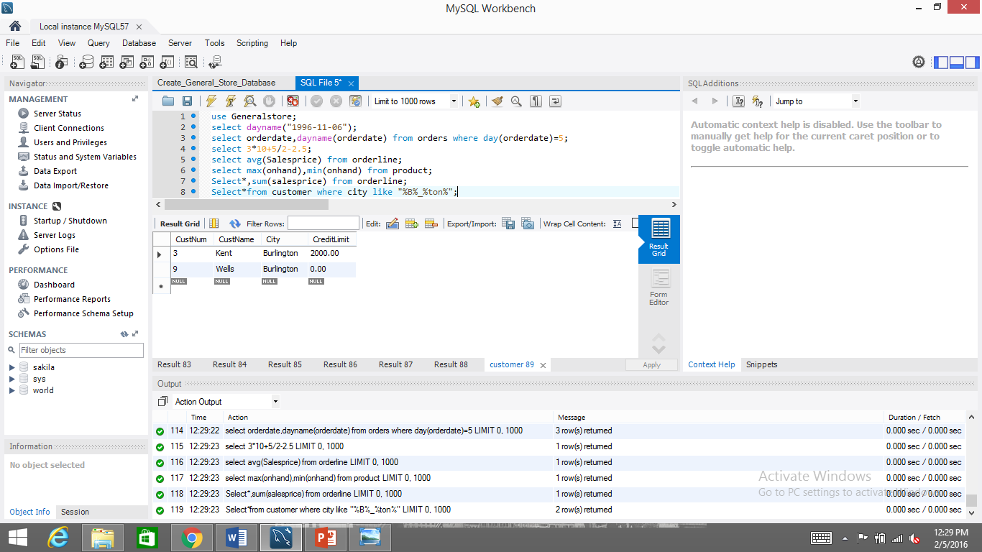

* Expand the query with an additional OR clause in the WHERE which will also retrieve cities that match _akville. If such a record existed, would this query also return Takville? Would it return Teakville? **No,it would not return teakville.**

**Select* from customer where City like "B%ton%" OR city like'_akville';**

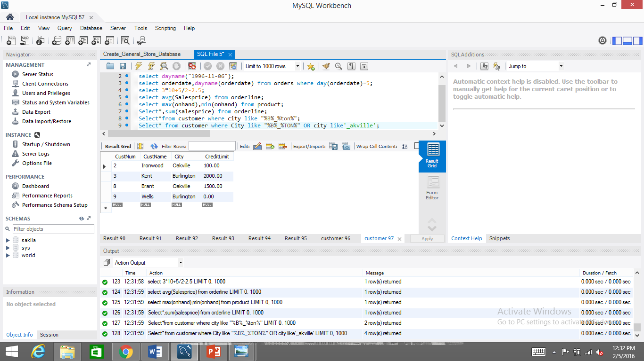

* Put brackets around the String comparison clauses using the OR, and add an AND restriction that the credit limit must also be greater than 1500. This is tricky – read carefully! You want it to return any records which match either String comparison that also have a credit limit greater than 1500.

**Select* from customer** **where (City like "B%ton%" OR city like'_akville') and CreditLimit > 1500;**

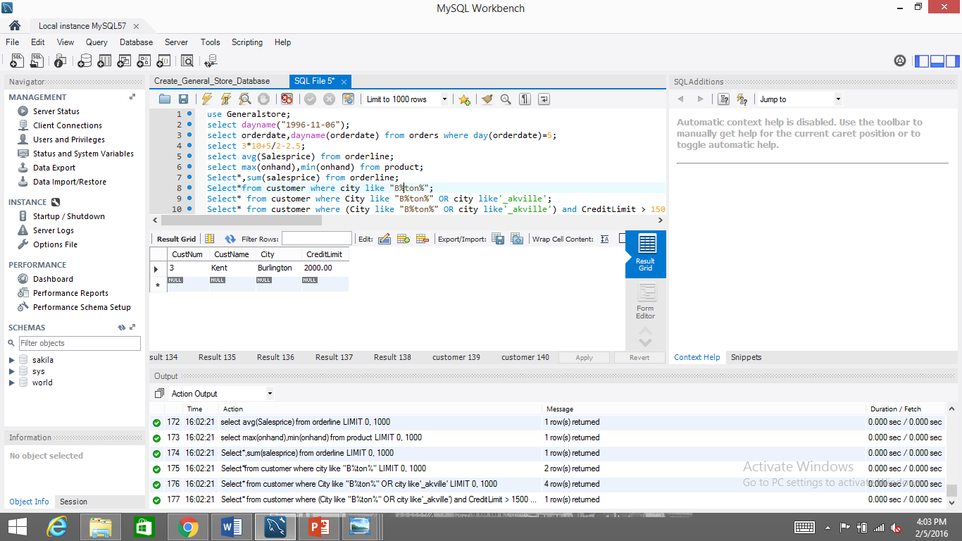

Submit the file in Dropbox now! The Exercise 4 is a bonus, which will not be marked today!

# Exercise 4 – Tutorials

* You should now know how to execute all the commands in the W3C SQL Basic tutorial, as well as avg(), count(), max(), min(), first(), last(), sum() in the SQL Functions tutorial, and Like, Wildcards, Not Null, Unique, Primary Key, Drop, Alter, Null Values and SQL Dates in the SQL Advanced tutorials at the following link:

<http://www.w3schools.com/sql/default.asp>

* This tutorial is by the World Wide Web Consortium (or W3C) – the people who create and set standards for the Internet
* Note: we are going to cover aliases, group by, having, joins, and many other topics in future lectures! Get ahead if you want, but at least go over the above sections