Week 5 Exercises

# Exercise 1

* Write a query that will retrieve the filled column from the orders table and the salesPrice from the orderLine table in such a way that both tables are matched on the orderNum

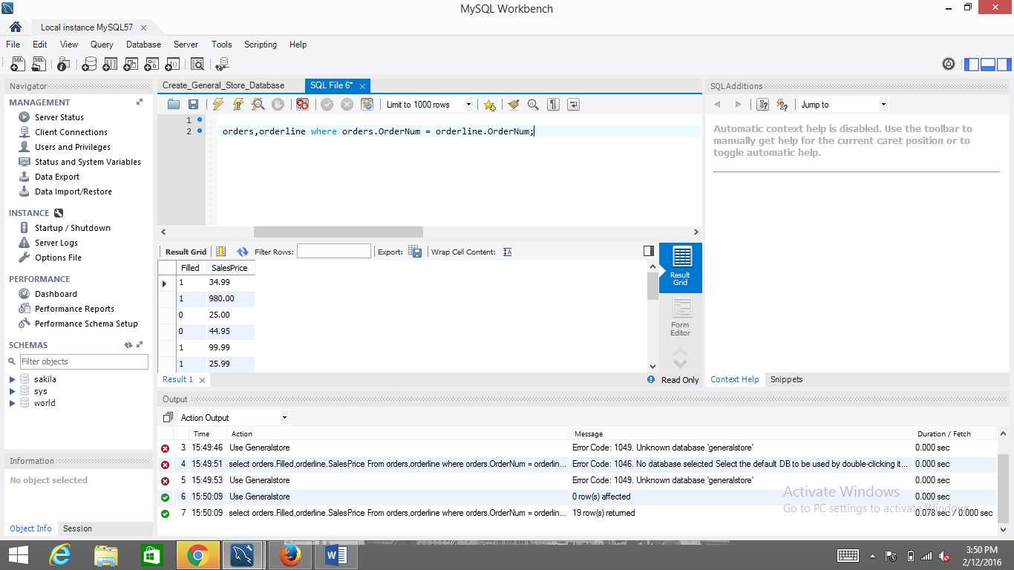

* Write a query that will retrieve the quantity column from the orderLine table and the onHand column from the product table in such a way that both tables are matched on productNum

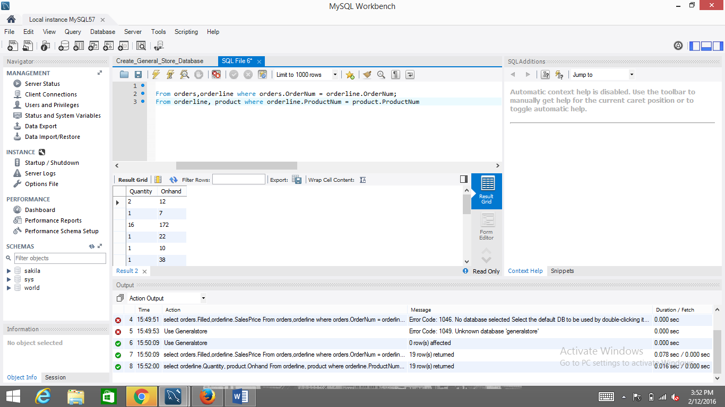

# Exercise 2

* Add a new record to your customer table in such a way that the auto-increment feature adds in the next available custNum value for you. In other words, INSERT a row into customer with only the custName, city, and creditLimit fields

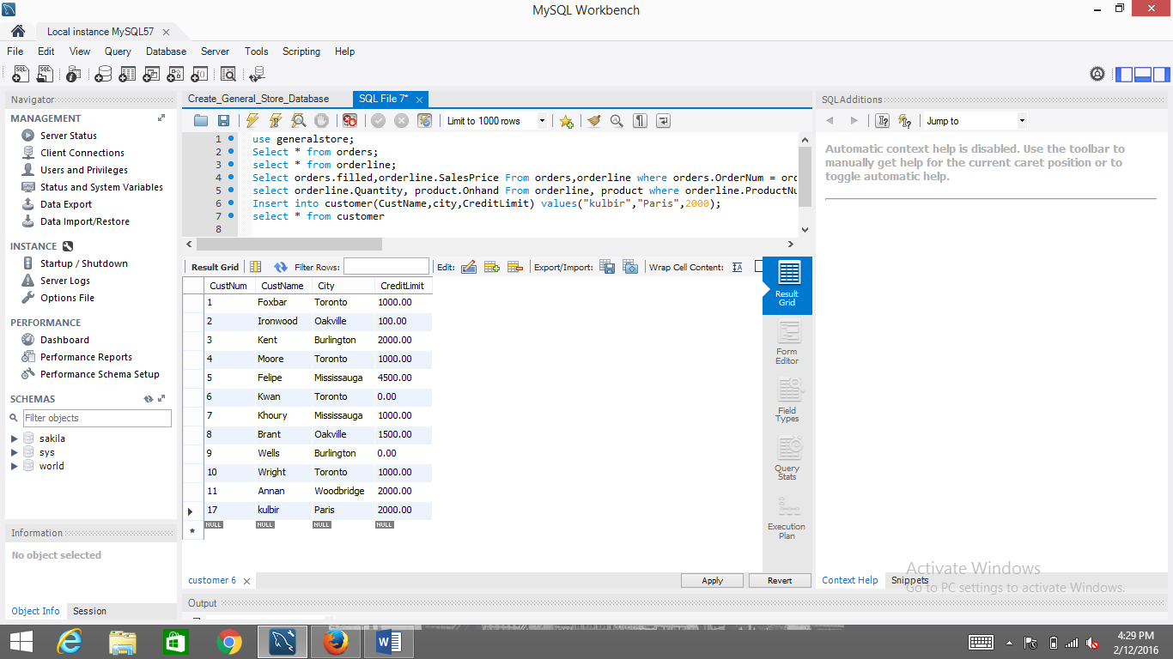

* Write a RIGHT OUTER JOIN query matching customer on orders in such a way that all customers are listed, regardless of whether they have ordered anything

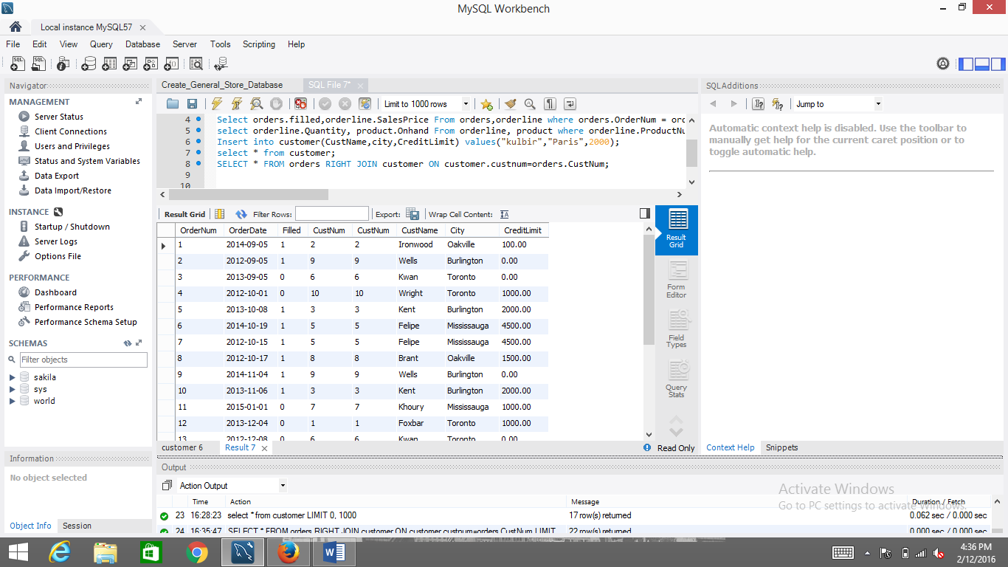

* Write a LEFT OUTER JOIN query matching orders on products in such a way that all products are listed, regardless of whether there are any sales

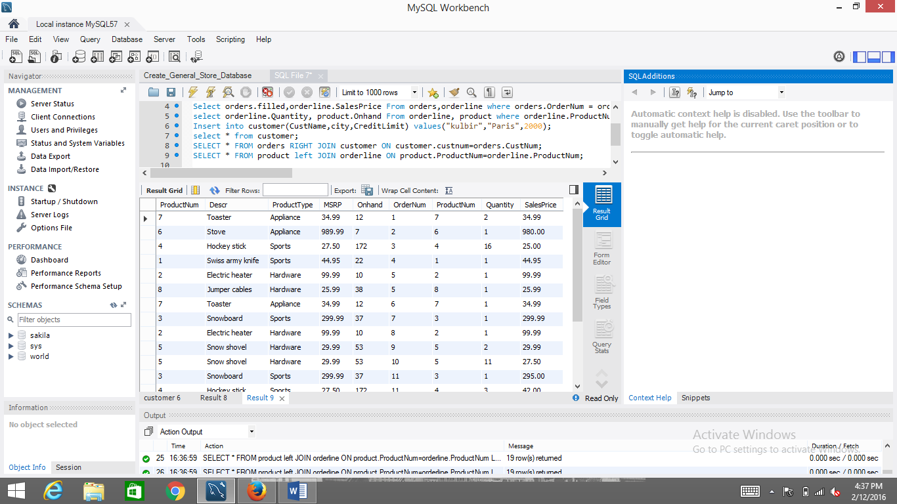

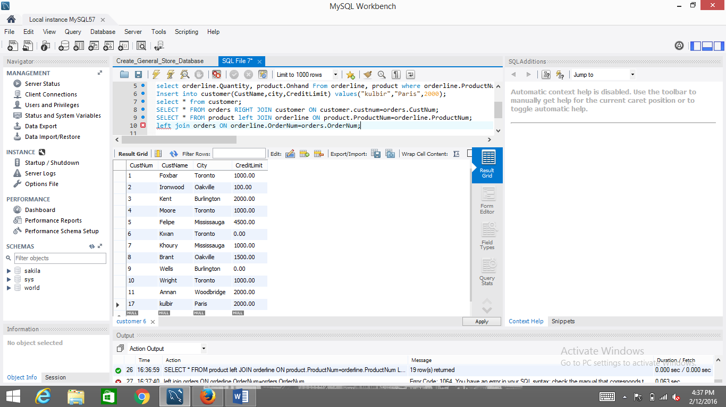

# Exercise 3

Please review chapters 5, 9 and 10 of Alan_Beaulieu-Learning_SQL book recommended for this course, which explain everything we’ve covered today and have a lot of examples!