**Task1: Deprecated HTML Tags**

|  |  |  |  |
| --- | --- | --- | --- |
| **Sr.No** | **Deprecated HTML Tags** | **Description** | **Replacement Tag** |
| 1. | <applet></applet> | Insert embedded applet | <object></object> |
| 2. | <basefont></basefont> | Set font styles | font style sheets |
| 3. | <center></center> | Center elements | <div style=”text-align:center”> |
| 4. | <u> | underline | text style sheets |
| 5. | <isindex></isindex> | Add search field | <form></form> |
| 6. | <em> | Emphasize text | <i></i> |
| 7. | <s></s> | Strike through | text style sheets |
| 8. | <menu></menu> | Menu list | <ul></ul> |
| 9. | <dir></dir> | Directory list | <ul></ul> |
| 10. | <font> | Applies font styles | font style sheets |
| 11. | <strong></strong> | Bold | <b></b> |
| 12. | <strike></strike> | Strike through | text style sheets |
| 13. | <acronym></acronym> | Acronym | <abbr></abbr> |
| 14. | <plaintext></plaintext> | Specifies plaintext | <pre> |
| 15. | <width> | Width of column element | Related to <col> |
| 16. | <embed></embed> | Embed an applications in a document. | <object></object> |

**Task 2: Webpage**

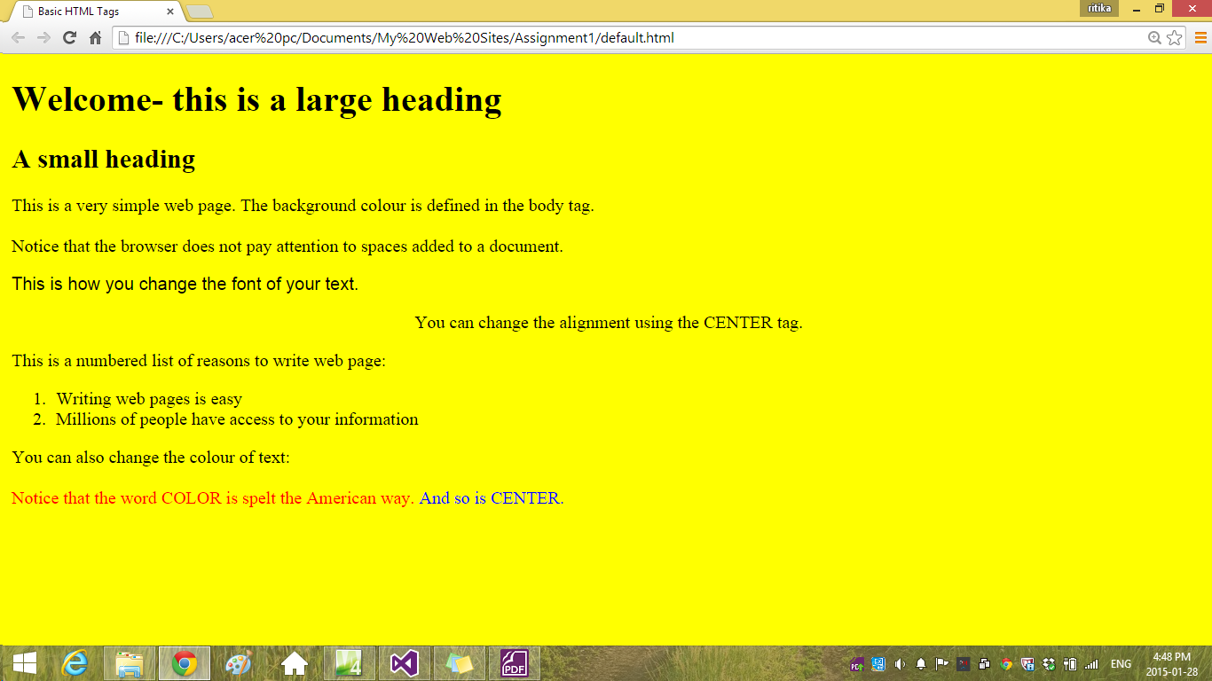

**HTML Code of the above Webpage:**

<!DOCTYPE html PUBLIC "-//W3C//DTD XHTML 1.0 Transitional//EN" "http://www.w3.org/TR/xhtml1/DTD/xhtml1-transitional.dtd">

<html xmlns="http://www.w3.org/1999/xhtml">

<head>

<meta content="text/html; charset=utf-8" http-equiv="Content-Type" />

<title>Basic HTML Tags</title>

</head>

<body bgcolor="yellow">

<h1>Welcome- this is a large heading</h1>

<h2>A small heading</h2>

This is a very simple web page. The background colour is defined in the body tag.<br/><br/>

Notice that the browser does not pay attention to spaces added to a document.<br/>

<p style="font-size:medium; font-family:Arial, Helvetica, sans-serif">

This is how you change the font of your text.

</p>

<p align="center">

You can change the alignment using the CENTER tag.

</p>

This is a numbered list of reasons to write web page:

<ol type="1">

<li>Writing web pages is easy</li>

<li>Millions of people have access to your information</li>

</ol>

You can also change the colour of text:<br/><br/>

<span style="color:red">Notice that the word COLOR is spelt the American way.</span><span style="color:blue"> And so is CENTER.</span>

</body>

</html>