**Sheridan College**

**Faculty of Science & Technology**

**Mid-term Examination**

**Subject: APPL10302( Web Design)**

**Max. Marks: 20 Time: 1Hr.**

**Student Id:991389177_ StudentName: KULBIR DHINDSA**

**Note:**

* All questions are compulsory and carry equal marks.
* The examination is online and of type closed-book. The students will not be allowed to refer to their class notes/programs and internet.
* Please upload the answer file (.txt/doc/pdf) on SLATE.

**Q.No. 1: Create a webpage that displays following information as output (use appropriate HTML tags)**:

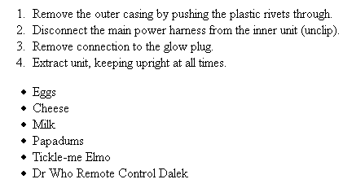

**Code of Question 1:**

<!DOCTYPE html PUBLIC "-//W3C//DTD XHTML 1.0 Transitional//EN" "http://www.w3.org/TR/xhtml1/DTD/xhtml1-transitional.dtd">

<html xmlns="http://www.w3.org/1999/xhtml">

<head>

<meta content="text/html; charset=utf-8" http-equiv="Content-Type" />

<title>Question 1 of Mid-Term Exam</title>

</head>

<body>

<ol type="1">

<li>Remove the outer casing by pushing the plastic riverts through.</li>

<li>Disconnect the main power harness from the inner unit(unclip).</li>

<li>Remove connection to the glow plug.</li>

<li>Extract unit, keeping upright at all times.</li>

</ol>

<ul type="square">

<li>Eggs</li>

<li>Cheese</li>

<li>Milk</li>

<li>Papadums</li>

<li>Tickle-me Elmo</li>

<li>Dr Who Remote Control Dalek</li>

</ul>

</body>

</html>

**Q.N.2:**

**Create the following webpage layout with the help of div tag.**

You can use appropriate colors for each section. All CSS styles should be internal.

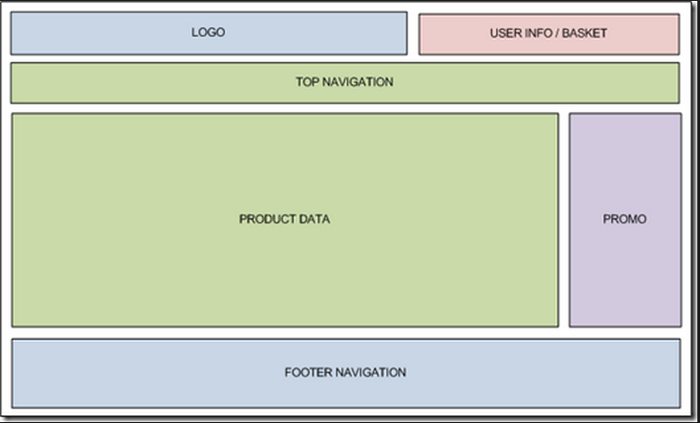

**Code of Question 2:**

<!DOCTYPE html PUBLIC "-//W3C//DTD XHTML 1.0 Transitional//EN" "http://www.w3.org/TR/xhtml1/DTD/xhtml1-transitional.dtd">

<html xmlns="http://www.w3.org/1999/xhtml">

<head>

<meta content="text/html; charset=utf-8" http-equiv="Content-Type" />

<title>Question 2 of Mid-term Exam</title>

<style>

#container

{

height:720px;

width:1000px;

text-align:center;

border:4px solid;

font-size:20px;

}

#container #header #left

{

height:30px;

width:500px;

background:#BCF3EB;

border:3px solid;

float:left;

margin-top:5px;

margin-bottom:5px;

margin-left:5px;

margin-right:5px;

padding-top:10px;

}

#container #header #right

{

height:30px;

width:470px;

background:#FDC4F9;

border:3px solid;

float:right;

margin-top:5px;

margin-bottom:5px;

margin-right:5px;

padding-top:10px;

}

#container #navig

{

height:30px;

margin:5px;

background:#C5F1C6;

clear:both;

border:3px solid;

padding-top:10px;

}

#container #content #side1

{

height:310px;

width:750px;

border:3px solid;

float:left;

margin-left:5px;

margin-right:2px;

margin-bottom:5px;

background:#CAF2BF;

padding-top:200px;

}

#container #content #side2

{

height:310px;

width:220px;

border:3px solid;

float:right;

margin-left:2px;

margin-right:5px;

margin-bottom:5px;

background:#D1D5E7;

padding-top:200px;

}

#container #footer

{

height:50px;

clear:both;

margin-left:5px;

margin-right:5px;

margin-top:5px;

background:#BCF3EB;

border:3px solid;

padding-top:30px;

}

</style>

</head>

<body>

<div id="container">

<div id="header">

<div id="left">LOGO</div>

<div id="right">USER INFO/BASKET</div>

<div id="navig">TOP NAVIGATION</div>

<div id="content">

<div id="side1">PRODUCT DATA</div>

<div id="side2">PROMO</div>

</div>

<div id="footer">FOOTER NAVIGATION</div>

</div>

</div>

</body>

</html>