**Assignment 1 – 10% - Due Feb 9 by 3 a.m. (in the morning)**

**Creating OUs, Users, and Security Groups with PowerShell**

All of the following must be done using PowerShell commands. Submit the PowerShell commands and any files you used for each of these steps. Put all your entries in YELLOW and screenshots into this document for submission (Microsoft Word format) to SLATE Dropbox. The **"Creating OUs, Security Groups, and Users - Using PowerShell.docx"** is a sample file that may be an aid to you. It is stored in SLATE under ‘Assignments’. As you work, use the history feature in Powershell to record all the commands you used in this assignment into the file ‘A1.history.txt’ (it must also be submitted).

**Assumption:** Your Windows Server 2012 R2 VM is a DC, with a domain name of your own choosing.

1. Create a Staff OU in your domain. Put a screenshot of ADUC with this new OU here. Also put a screenshot of your Powershell window with the cmdlet you used and any output returned by that cmdlet.

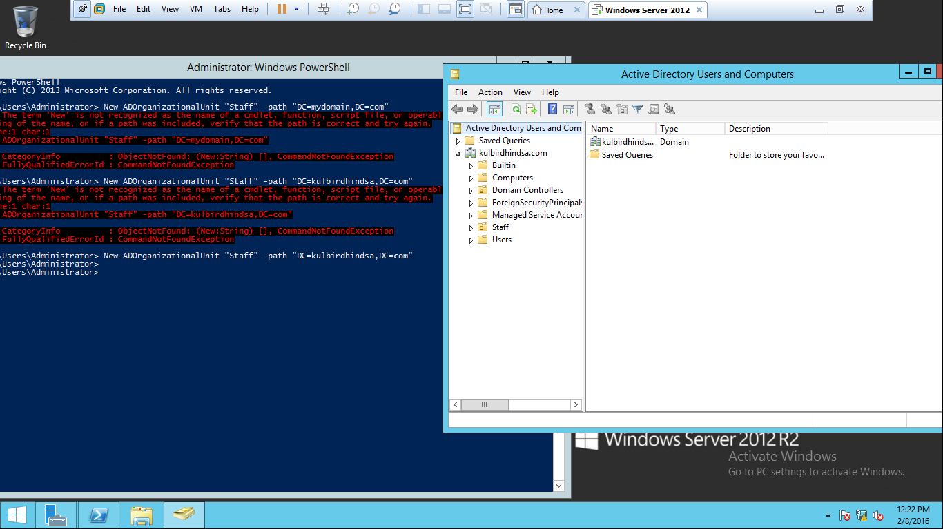

1. Under the Staff OU, create three OUs, named HR, Ops, and Finance. Put a screenshot of the Powershell window with the cmdlets you used.

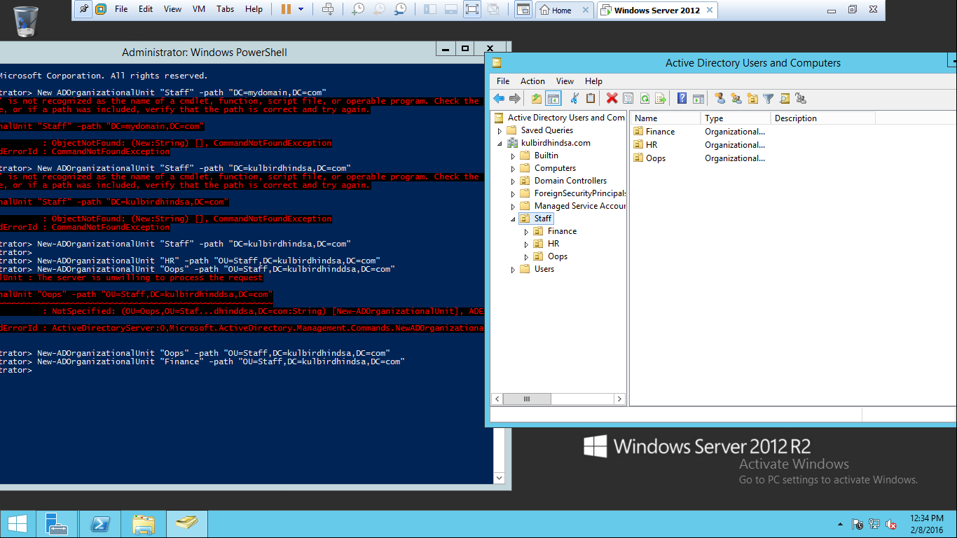

1. Under the Staff OU, create four security groups, one each for HR, Ops, Finance, and Managers. Use an appropriate naming convention and correct type of security group. Insert here a screenshot showing the 4 OUs and the security groups. Insert another screenshot of your Powershell cmdlets.

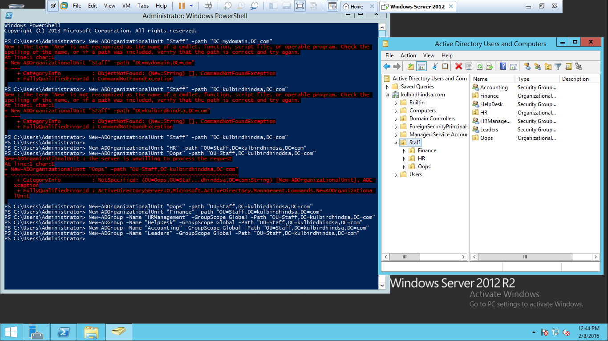

1. a) Create 36 users using ‘import-csv’ in Powershell, placing 12 in each of the HR, Ops, and Finance OUs. Put a screenshot of Powershell cmdlets used.

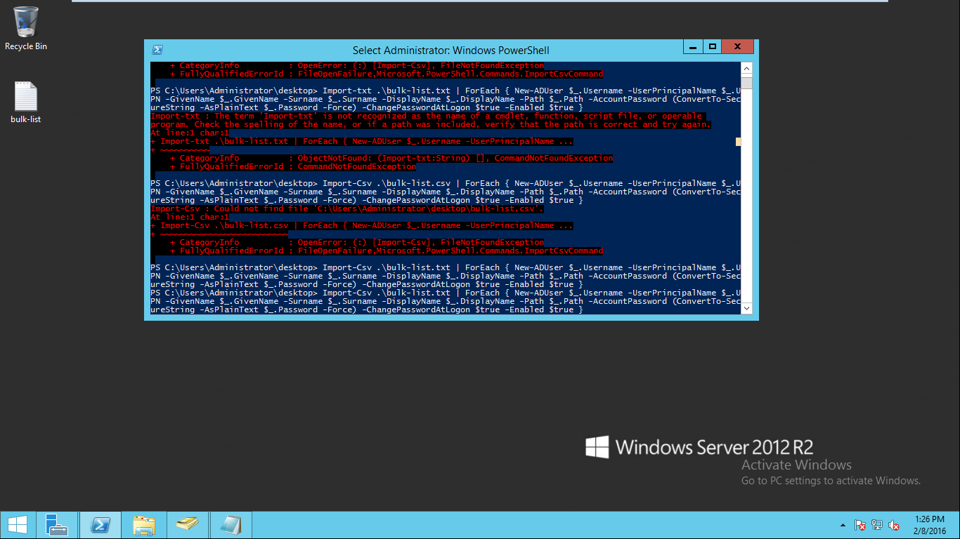

b) Put a screenshot of ADUC showing the user accounts in the HR OU.



c) Use Powershell to make the users members of their departmental groups. Insert a screenshot of the cmdlets.

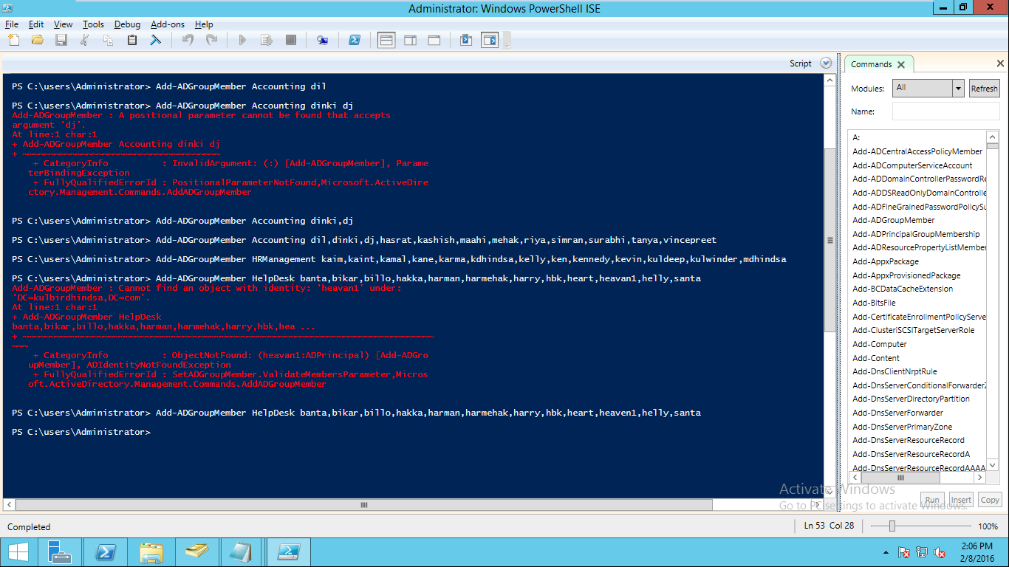

d) Make three of the users, one from each department, a member of the Managers group. Use real names for the users (not user1, user2, etc.). The accounts should be enabled and have correct UPN and password settings. Insert a screenshot of the cmdlets.

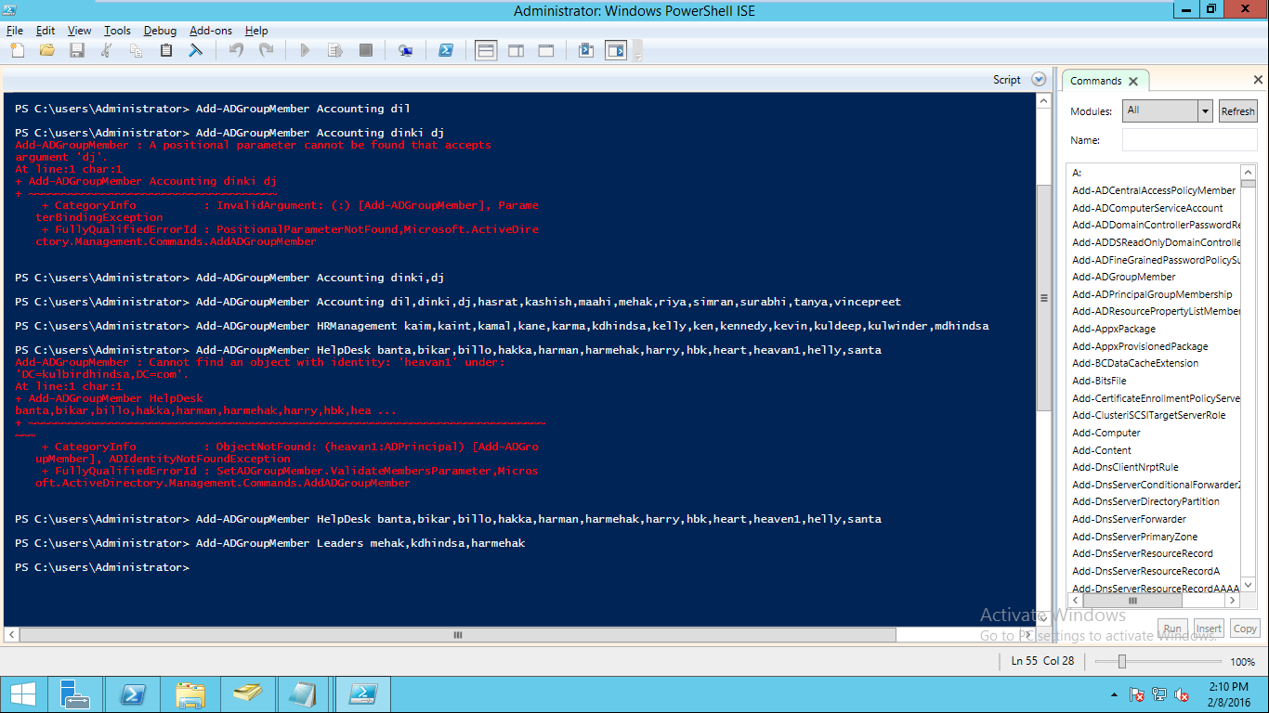

e) Use Powershell to list the members of the Managers group. Insert a screenshot showing the cmdlet(s) plus the output.

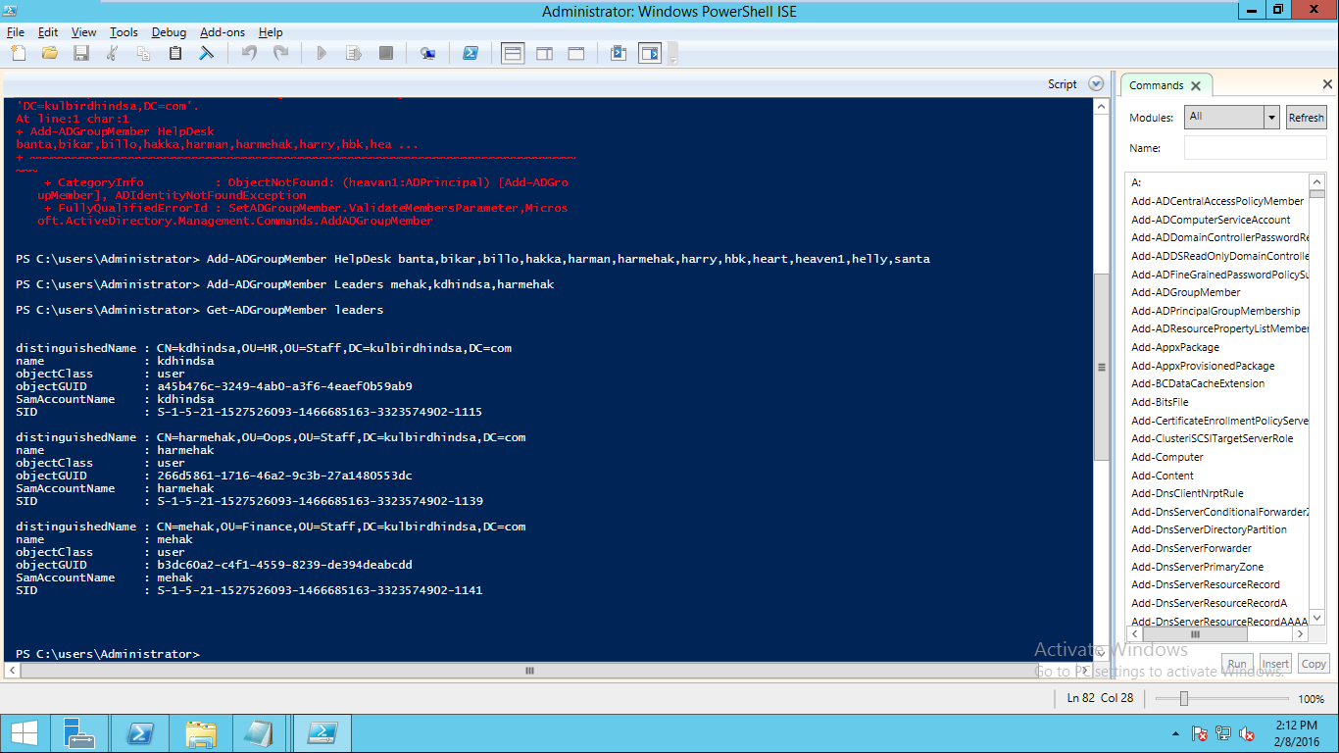

5. Run a Powershell cmdlet to get basic information about your AD domain.

a) Give a screenshot of the entire cmdlet you executed plus the output it displayed to screen.

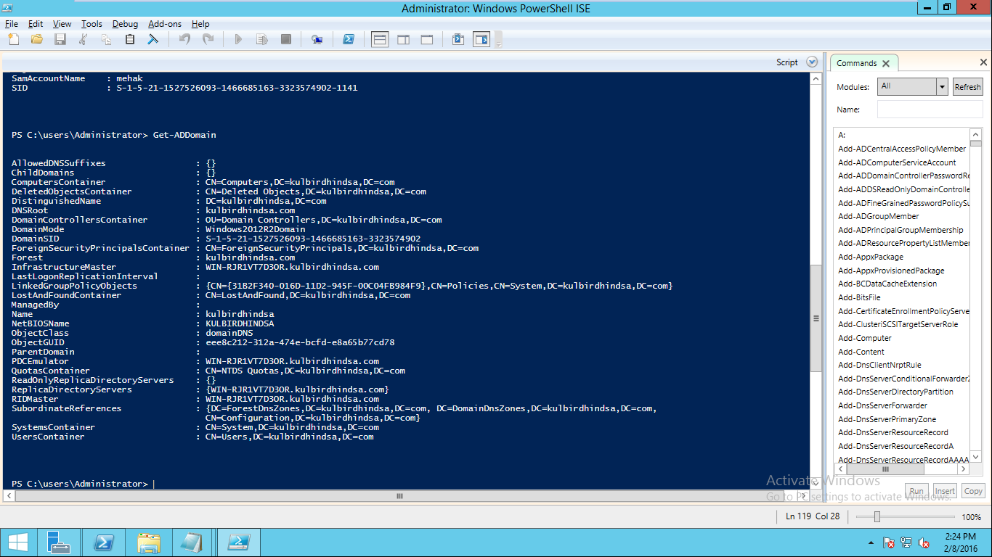

c) Run a cmdlet to query the AD database to see if one of your newly created user accounts exist (from Q4), but use a filter to search for it using last name (ex.: you might search for the name “Smith”). Give a screenshot showing the cmdlet and the result on the screen.

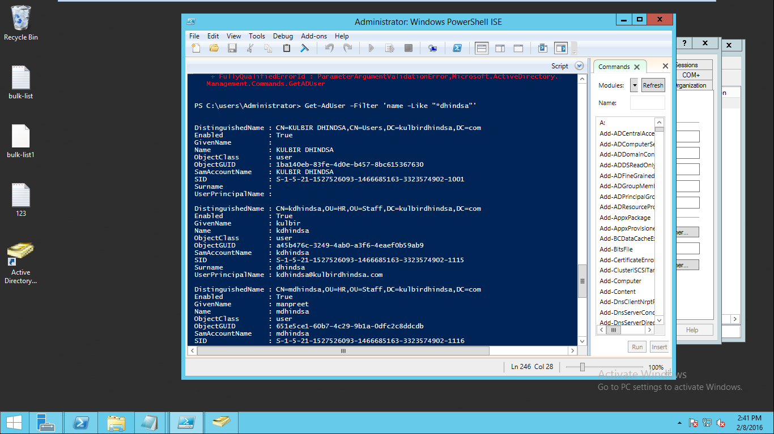

d) Run a cmdlet to remove that user from the group that he/she belongs to. Give a screenshot showing the cmdlet and the result on the screen.

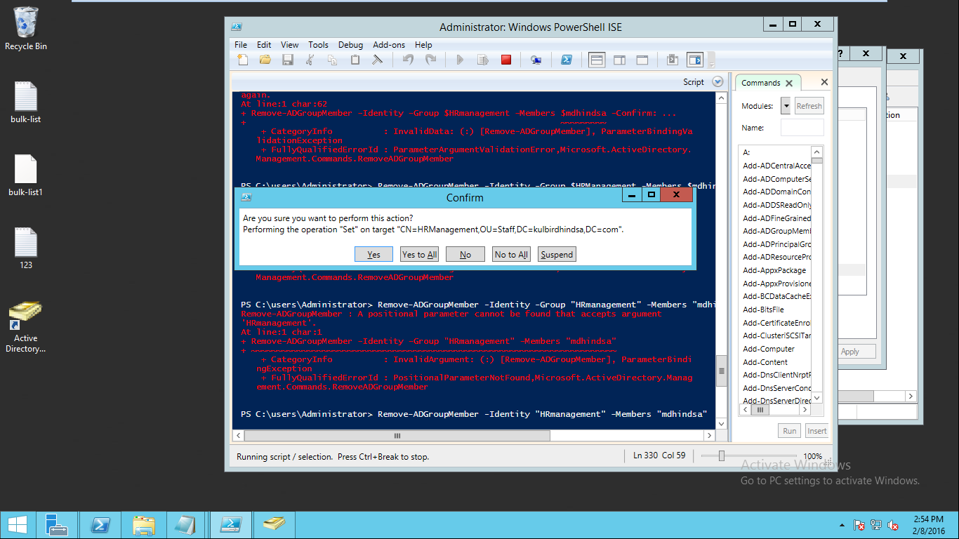

**Other Commands**

6.From your current folder, navigate to the ‘\Downloads’ folder, in Powershell. What command did you use? Write it here:

Cd downloads

7. Take this Assignment document, save it as a text file (with ‘.txt’ extension – any name will do). Put it in the ‘\Downloads’ folder of your WS 2012 machine.

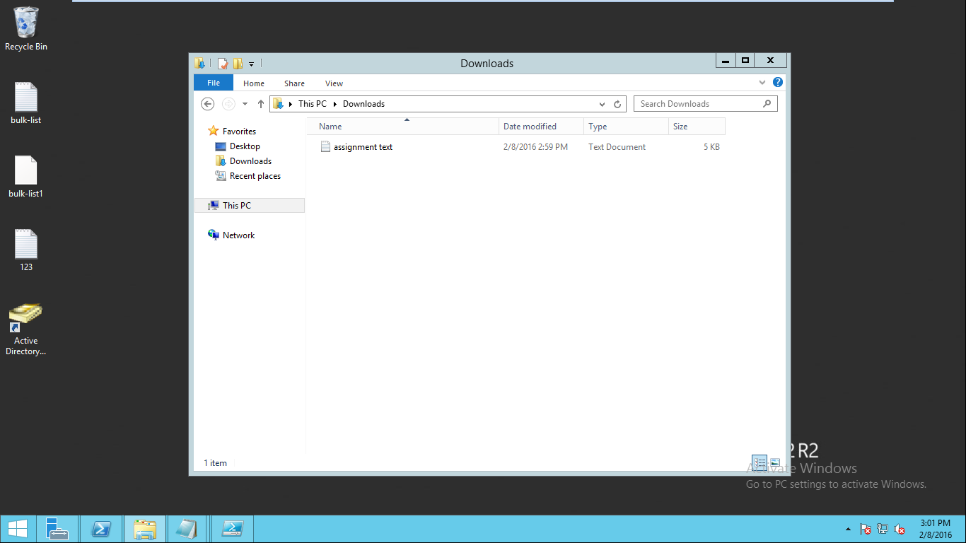

8. a) Using Powershell, extract the 1st three lines and the bottom three lines of the text file and write them to the file ‘A1.lines.txt’. Write your cmdlet(s) here:

Get-Content '.\assignment text.txt' | select -First 3 | select -Last 3 | Out-File "C:\A1.lines.txt"

b) Paste the entire contents of this ‘A1.lines.txt’ file in between these two lines here:

Assignment 1 – 10% - Due Feb 9 by 3 a.m. (in the morning)

Creating OUs, Users, and Security Groups with PowerShell

9. a) Use the ‘Test-NetConnection’ command to store diagnostic information about your computer’s connection to the file ‘A1.netinfo.txt’. Put your cmdlet here:

Test-NetConnection | out-file "C:\A1.netinfo.txt"

b) Put the ‘A1.netinfo.txt’ file in these two lines:

ComputerName : internetbeacon.msedge.net

RemoteAddress : 204.79.197.200

InterfaceAlias : Ethernet0

SourceAddress : 192.168.94.129

PingSucceeded : True

PingReplyDetails (RTT) : 78 ms

10. Using the history feature in Powershell, record all the commands you used in this assignment into the file ‘A1.history.txt’. Put your cmdlet:

Get-History | Out-File "C:\A1.history.txt"

You are done. Submit your file, and any other file you used in Q4 to Dropbox. Only one set of files is to be submitted, so make sure you are completely done before submitting. Extra files result in marks deduction.