**Assignment 2** - Due Feb 17 by 3 a.m. **Name:KULBIR DHINDSA STUDENT NO.991389177**

The questions here involve topics which have not necessarily been discussed in class. The intent is for some research to be done to find the answers. After the due date, there will be a review of this assignment. Submit this document to Dropbox, with your answers highlighted in Yellow. Do not delete the questions. All screenshots and diagrams must be inserted into this document.

**Q1.** Suppose we have a fictitious company, 'Pretendco', which has various departments, like 'Labs’ and ‘Sales'. Then within ‘Sales’, there is a ‘U.S.’ branch and a ‘European (eu)’ branch. It wants to set up an Active Directory domain based on these departments or units.

To ensure understanding of the topics and definitions up until now, you are going to do the following:

a) Spend a few moments to look at diagrams at this link: ["Active Directory Domains"](https://www.google.ca/search?hl=en&site=imghp&tbm=isch&source=hp&biw=1067&bih=517&q=active+directory+domains&oq=active+directory+domains&gs_l=img.3..0l2j0i24l3j0i10i24j0i24l4.2681.7231.0.10694.24.14.0.10.10.0.81.865.13.13.0....0...1ac.1.64.img..1.23.896.rnYP9aQGfvk%23imgrc=_) as well as the ones in your Week 3 PowerPoint. Using a drawing tool (like ‘Visio‘ - available from Dreamspark, or 'Word' [go to 'Insert' tab]), diagram the logical layout of:

**pretendco.ca, sales.pretendco.ca, labs.pretendco.ca, us.sales.pretendco.ca, eu.sales.pretendco.ca**

Your diagram must clearly show the hierarchical nature of any relationship among the domains. Insert the drawing here:

Forest Root Domain

Child and Parent Trust

Child and Parent Trust

Child and Parent Trust

Child and Parent Trust

b) Of the domains listed in part a), which one is the “forest root domain”? Label it on your diagram.

Ans:Pretendco.ca is the Forest Root Domain in the diagram.

c) What is an organizational unit (OU)? Where would it exist in the drawing you made in part a)?

Ans: An Organizational Unit is the smallest unit by using which you can assign to group policy settings or delegate administrative authority.You can also create containers within a domain that represent logical structures within your organization. In the structure it would be in the root domain in the root domain controller(Pretendco.ca)

d) In your diagram, include any trust relationships that are formed. Label clearly which are the relationships and the direction of each trust.

e) With respect to Windows Server, what is a trust?

Ans:.Trust relationship is established between domains which makes easy for users in one domain to be authenticated by a domain controller in other domain.

f) How many domain controllers (DC’s) would you need to satisfy part a)?

Ans: 4

g) The active directory database is a file that resides where on your file system? What is the full name of the file?

Ans: The Path is :

%SystemRoot%\ntds\NTDS.DIT. The full name is NT Directory Services & Directory Information Tree.

h) Define replication within Active Directory.

Ans:.In the Replication process,changes are done on one controller and are synchronized with all the other domain controllers in the domain or forest which also stores copies of the same information.

**Q2.** You should by now have an AD DS role installed on your Windows Server 2012 R2 VM. If not, you will

need to have it installed for this question. Also you should have at least one Windows client joined to

the domain. If not, perform this join operation before continuing.

a) Take 1, 2 or 3 screenshots showing clearly that your VM is a DC. Include your Computer's name in one

of the shots. Insert the screenshots here.

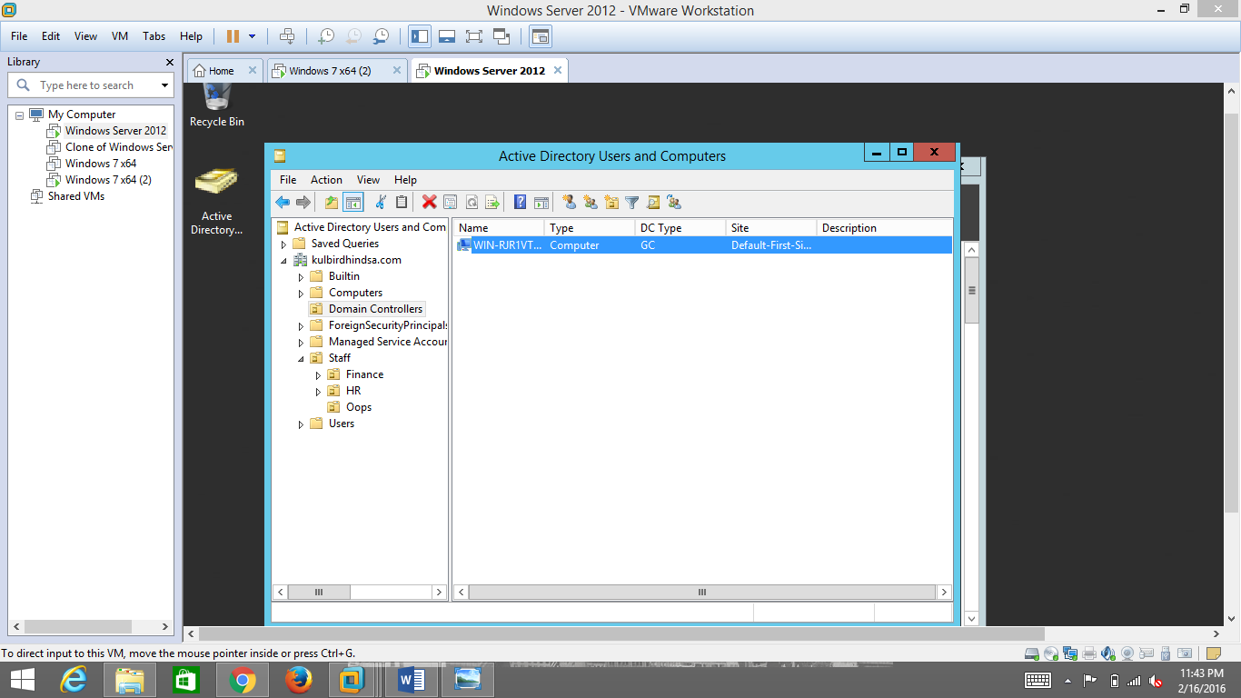

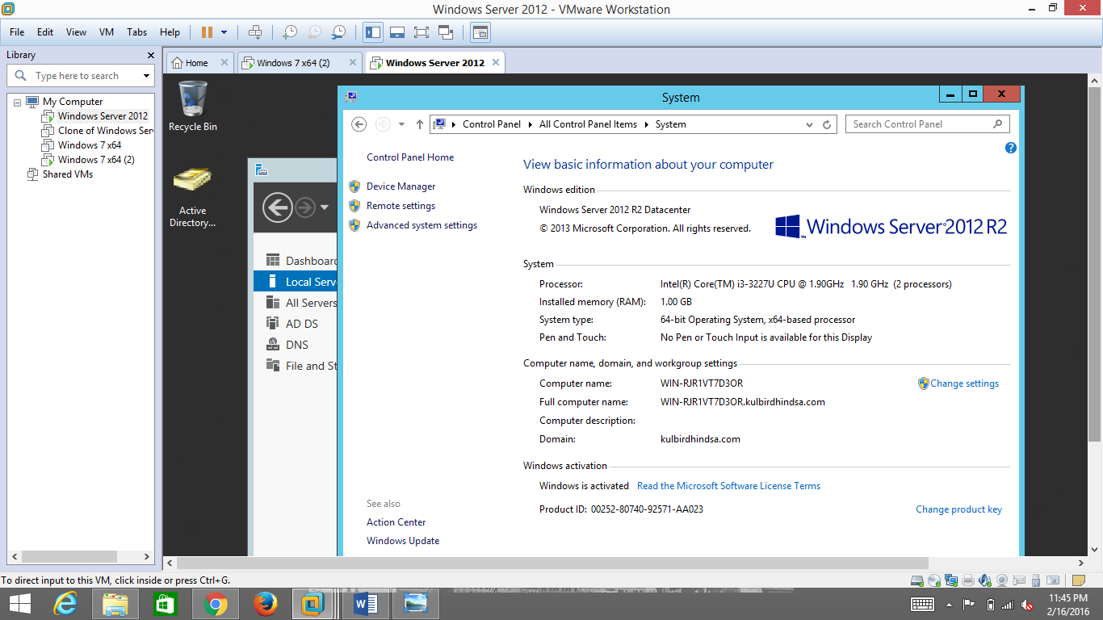

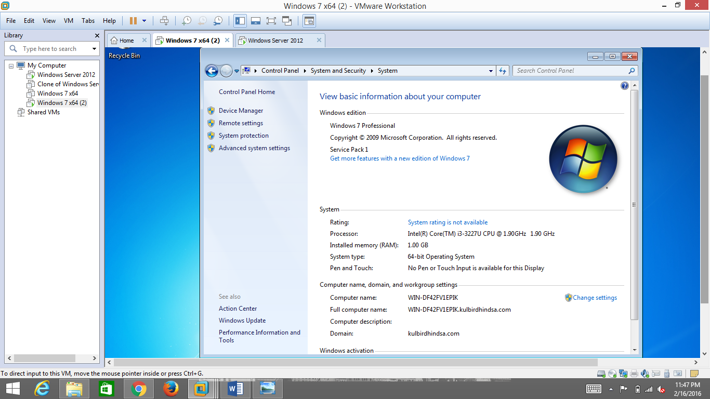

b) Take 1 or 2 screenshots showing all computers that are joined to your DC.

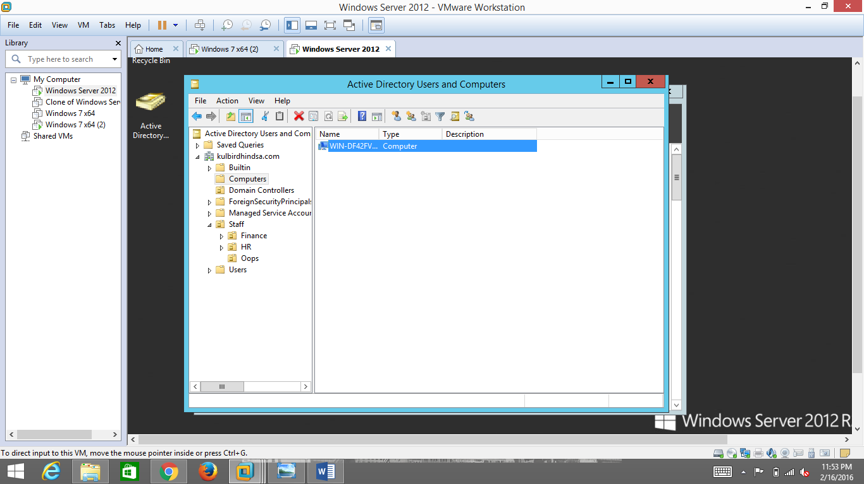

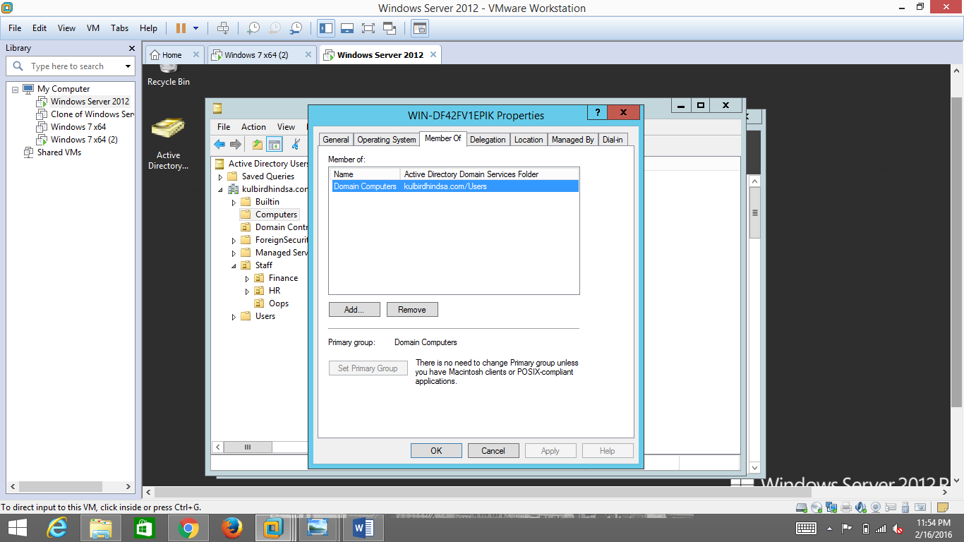

c) Now you are going to 'unjoin' one of the computers from the domain. Document the steps you took to do this operation, ie.: click this, click that, enter this,... be specific, spell out any user accounts/passwords used, on which machine(s) you did each step. Your goal is to make it clear enough that a novice could read it & be able to perform the operation.

Ans:The following are the steps to unjoin computer from domain:

a)Firstly,in have window 7 in my vmware.So,in vmware open window 7.

b)So,in window 7 go to the my computer.

c)Then in my computer click right click and go to properties where we can see all configurations.

d)Here then click on the Change settings.

e)Then in the dialog box,click on the “Change” option.

f)So,we can see Computer Name/Domain Change dialogue box.Here click on Workgroup and give the new name to workgroup.

g)Then finally give the password to local administrator account.

When done, take 1 or 2 screenshots showing the computer is no longer joined to the domain.

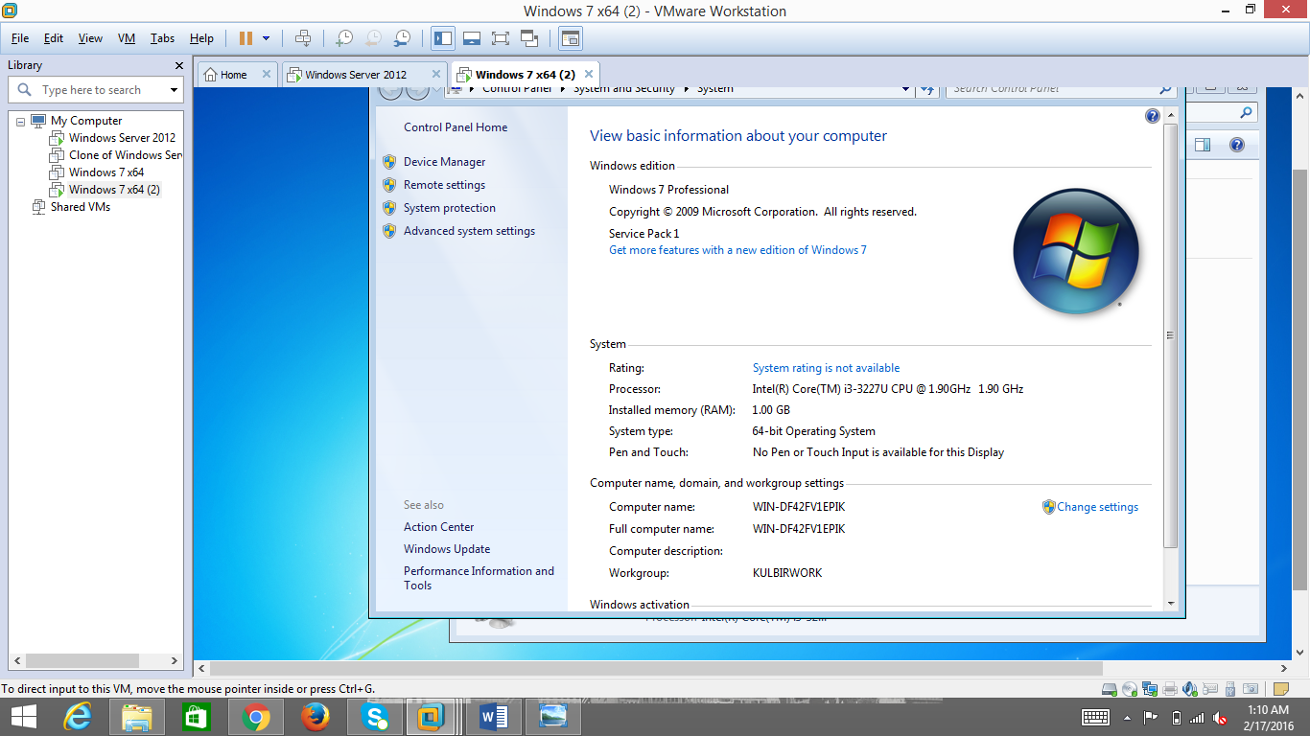

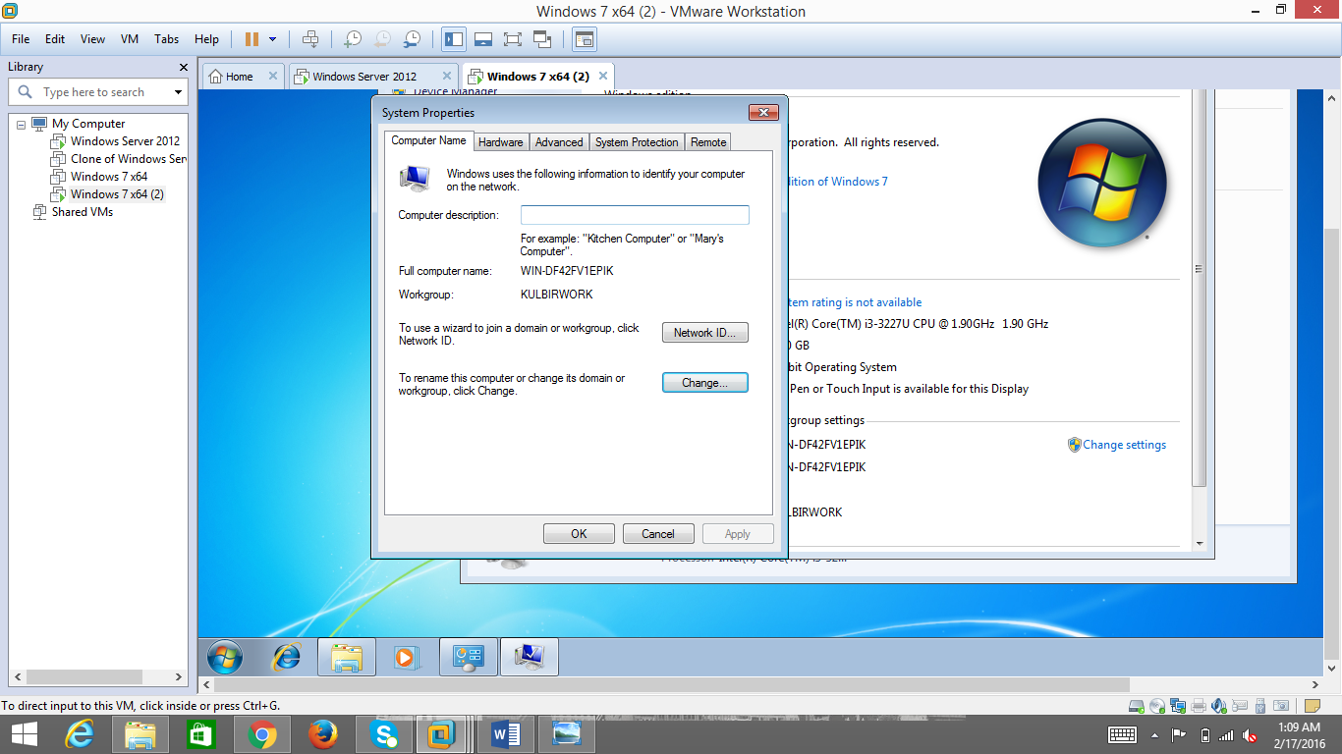

d) If you have other computers joined to the domain, 'unjoin' them now. You do not have to document this.

Ans:No,I did not join any computer to domain.

**Q3.** Now you are going to remove the AD DS role for your server. (**CAUTION:** In Week 5, you will have a quiz where the AD DS role is useful in your Windows Server. Be sure that your work here will not affect your server's readiness for the quiz).

Document your steps. Again, be detailed with your description, such that a novice could perform your steps. When done, take 1 or 2 screenshots showing your server no longer has the AD DS role. Include your ‘Computer Name’ in the screenshot.

Ans:The following are the steps to remove AD-DS from server:

1)Firstly go to Server Manager in Window Server.

2)Here go to Manage option and click on Remove and roles feature wizard.

3)After that click on next option twice and then uncheck the option Active Directory Domain Service and then click on Remove features.

4)Here we should need to Demote the the Directory Domain Controller before AD-DS role can be removed and then click on OK.

5)After that check mark the last domain controller and click ok.

6)In the next step,I checked proceed with removal,then click next.

7)Then check mark both options:Remove DNS zone and Remove Application partition then click next button.

8)Now,give the New Password.

9)Here we have to click on Demote option and then PC will go on Restarting.

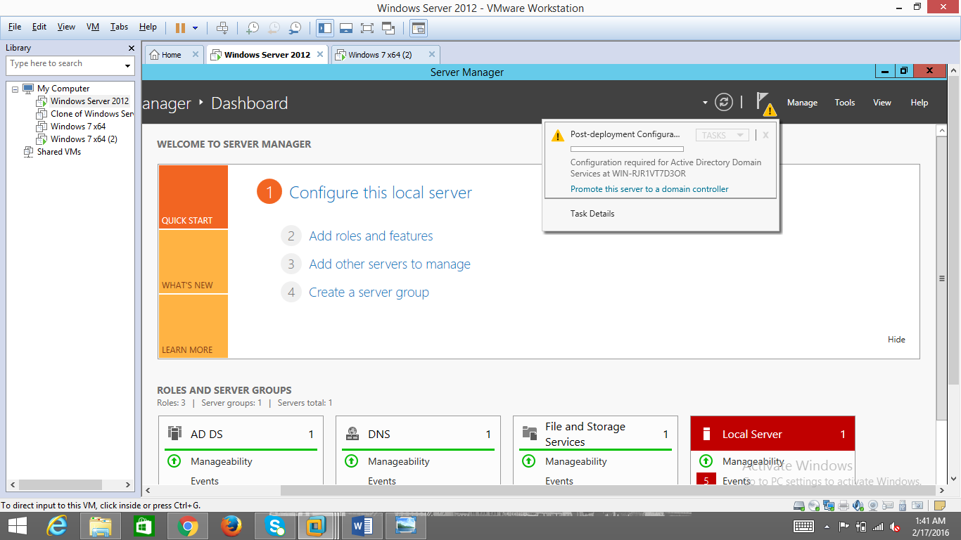

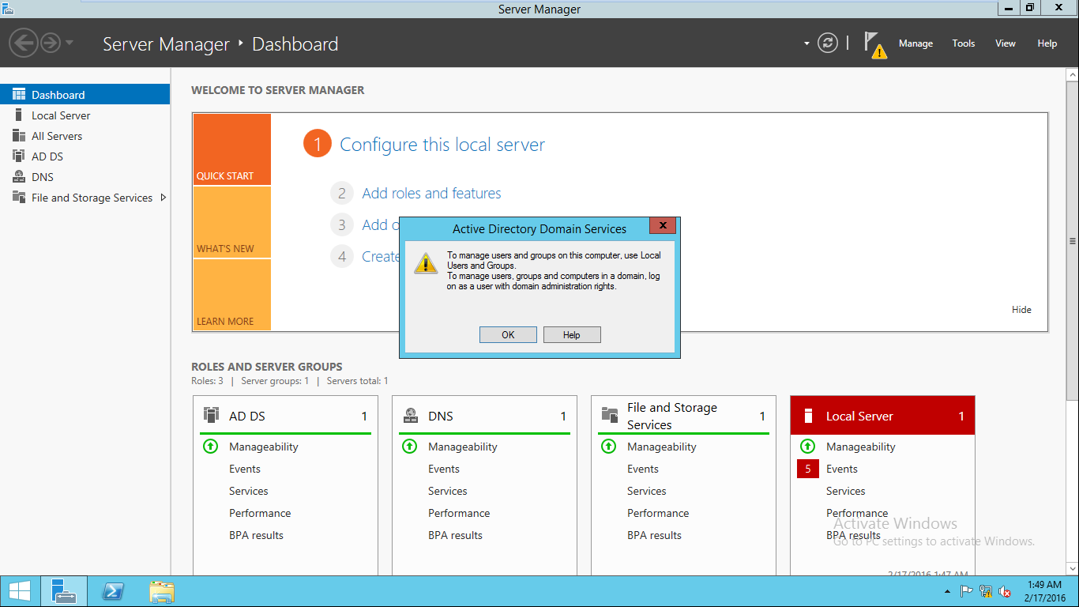

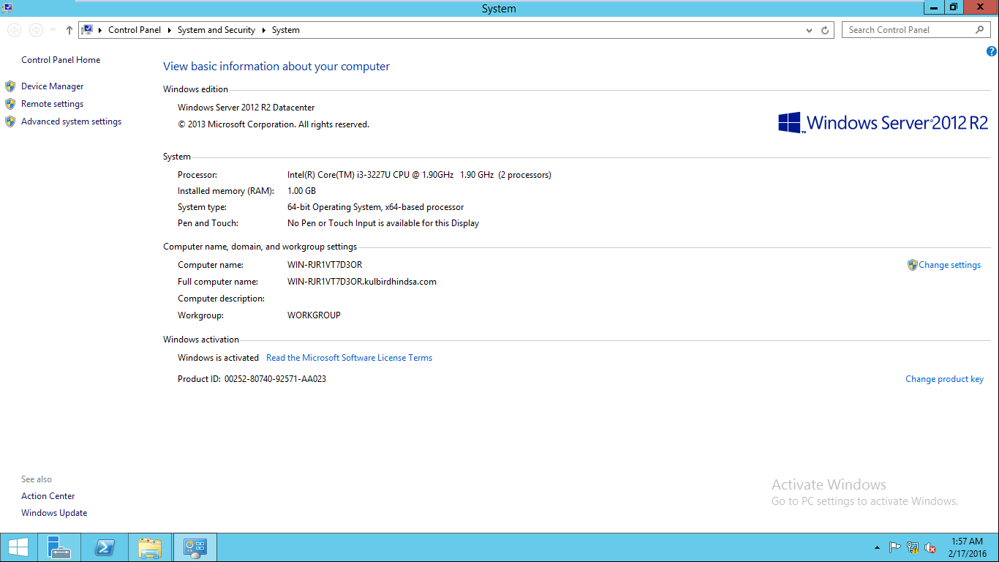

Re-install the AD DS role and join the computers back to the domain. This step need not be documented, as it will not be marked. It is to update your server so that you can be prepared for future classes.

Submit your file to 'Assignment 2' in DropBox before the due date.