

|  |  |  |  |  |  |  |
| --- | --- | --- | --- | --- | --- | --- |
| [Home](http://iopscience.iop.org/) | [Search](http://iopscience.iop.org/search) | [Collections](http://iopscience.iop.org/collections) | [Journals](http://iopscience.iop.org/journals) | [About](http://iopscience.iop.org/page/aboutioppublishing) | [Contact us](http://iopscience.iop.org/contact) | [My IOPscience](http://iopscience.iop.org/myiopscience) |

Global quantum correlations in finite-size spin chains

This article has been downloaded from IOPscience. Please scroll down to see the full text article.

2013 New J. Phys. 15 043033   
(http://iopscience.iop.org/1367-2630/15/4/043033)

View [the table of contents for this issue](http://iopscience.iop.org/1367-2630/15/4), or go to the [journal homepage](http://iopscience.iop.org/1367-2630) for more

Download details:   
IP Address: 142.51.1.212   
The article was downloaded on 27/04/2013 at 17:16

Please note that [terms and conditions apply.](http://iopscience.iop.org/page/terms)



**Global quantum correlations in finite-size spin chains**

**S Campbell**1*,*2*,*6**, L Mazzola**3**, G De Chiara**3**, T J G Apollaro**3*,*4*,*5**, F Plastina**4*,*5**, Th Busch**1*,*2**and M Paternostro**3   
1 Quantum Systems Unit, Okinawa Institute of Science and Technology Graduate University, 1919-1 Tancha, Onna-son, Okinawa 904-0495, Japan 2 Department of Physics, University College Cork, Republic of Ireland 3 Centre for Theoretical Atomic, Molecular, and Optical Physics, School of Mathematics and Physics, Queen’s University, Belfast BT7 1NN, UK 4 Dipartimento di Fisica, Universit`   
a della Calabria, 87036 Arcavacata di Rende (CS), Italy   
5 INFN—Gruppo collegato di Cosenza, Italy   
E-mail: [steve.campbell@oist.jp](mailto:steve.campbell@oist.jp)

*New Journal of Physics* **15** (2013) 043033 (15pp) Received 4 February 2013   
Published 19 April 2013   
Online at <http://www.njp.org/>

doi:10.1088/1367-2630/15/4/043033

**Abstract.** We perform an extensive study of the properties of global quantum correlations in finite-size one-dimensional quantum spin models at finite temperature. By adopting a recently proposed measure for global quantum correlations (Rulli and Sarandy 2011 *Phys. Rev.* A **84** 042109), called *global discord*, we show that critical points can be neatly detected even for many-body systems that are not in their ground state. We consider the transverse Ising model, the cluster-Ising model where three-body couplings compete with an Ising-like interaction, and the nearest-neighbor XX Hamiltonian in transverse magnetic field. These models embody our canonical examples showing the sensitivity of global quantum discord close to criticality. For the Ising model, we find a universal scaling of global discord with the critical exponents pertaining to the Ising universality class.

6 Author to whom any correspondence should be addressed.

Content from this work may be used under the terms of the [Creative Commons Attribution 3.0 licence](http://creativecommons.org/licenses/by/3.0). Any further distribution of this work must maintain attributio[n to the author(s) and the title of the work,](http://creativecommons.org/licenses/by/3.0) journal citation and DOI.

*New Journal of Physics* **15** (2013) 043033 1367-2630/13/043033+15$33.00

© IOP Publishing Ltd and Deutsche Physikalische Gesellschaft

2 

**Contents**

**1. Tools for quantifying quantum correlations 3**  1.1. Quantum discord . . . . . . . . . . . . . . . . . . . . . . . . . . . . . . . . . 3 1.2. Global quantum discord . . . . . . . . . . . . . . . . . . . . . . . . . . . . . . 4

**2. Quantum correlations and criticality in quantum spin chains 5**  2.1. Transverse field Ising model . . . . . . . . . . . . . . . . . . . . . . . . . . . 5 8 2.2. Cluster-Ising model . . . . . . . . . . . . . . . . . . . . . . . . . . . . . . . .

2.3. Open-chain XX model . . . . . . . . . . . . . . . . . . . . . . . . . . . . . . 11

**3. Conclusions 12**

**Acknowledgments 13**

**Appendix 13**

**References 14**

Entanglement and criticality in quantum many-body systems have been shown to be strongly and intimately connected concepts [1, 2]. The body of work performed with the aim of grasping the implications that critical changes in the ground state of a given Hamiltonian model have for the sharing of entanglement by the parties of a quantum many-body systems is now quite substantial [3]. This has resulted in important progress in our understanding of the interplay between critical phenomena of interacting many-body systems and the setting up of genuinely quantum features. In turn, such success has proven the effectiveness of the cross-fertilization of quantum statistical mechanics by techniques and interpretations that are typical of quantum information theory.

Yet, it has recently emerged that the way correlations of non-classical nature manifest themselves is not necessarily coincident with entanglement, and a much broader definition of quantum correlations should be given [4, 5]. This is encompassed very effectively in the formulation of so-called quantum discord as a measure striving to capture the above-mentioned broadness of quantum correlations [6]. In analogy with the case of entanglement, the relation between quantum discord and the features of quantum many-body models is fundamentally interesting for the understanding of the role that the settlement of quantumness of correlations play in determining the critical properties of such models. A systematic analysis in this sense, which has only recently been considered [7–13], is thus highly desirable. This is even more important given that some of the investigations performed so far have indicated that quantum discord is more sensible than entanglement in revealing quantum critical points [9], even for systems that are not at zero temperature [14].

This is a particularly relevant result, whose validity should also be checked for models that are both finite sized and at finite temperature. The motivations for such an endeavor stem from the fact that, likely, the properties of quantum many-body systems will be addressed experimentally in systems consisting of, for instance, cold atoms loaded in optical potentials or trapped ions, as in very recent ground-breaking experiments [15–19]. At variance, the studies performed so far have mostly dealt with systems at the thermodynamic limit. Moreover, intuitively, one would expect global measures of general quantum correlations to be well suited to reveal the subtle features at hand here, given that some of the critical changes occurring in the

*New Journal of Physics* **15** (2013) 043033 (<http://www.njp.org/>)

3 

lowest-energy state of many-body systems truly involve (quasi-)long-range influences among the parties. Such an analysis is made very difficult, both at a theoretical and computational levels, by the lack of unambiguous measures of multipartite entanglement in mixed states.

In this paper, we study the relation between criticality and global quantum correlations in finite-size systems at non-zero temperature by using a measure of global quantum correlations recently put forward in [20] and employed by some of us in [11] for a quantum many-body system at zero temperature. As canonical examples, we study one-dimensional models that are of genuine physical interest due to the non-trivial features of their phase diagrams, such as the transverse-field Ising model, the open-boundary XX model in transverse magnetic field [21], and the so-called cluster-Ising model introduced in [22]. The latter interpolates between the standard antiferromagnetic Ising Hamiltonian and a topologically ordered *cluster* phase. Our study shows the ability of global discord to detect critical points. Moreover, for specific cases among the examples addressed in our work, we bring evidence of a finite-size scaling for global discord and its derivative that are closely related to the behavior of macroscopic features such as the magnetization.

The rest of this paper is organized as follows. In section 1, we start our study by introducing both quantum discord and its global version. In section 2 we then move to the description of a set of physically relevant interacting quantum many-body models that will be studied against the content of global quantum correlations of equilibrium states at temperature *T* ̸= 0 and present our results. Finally, in section 3 we draw up our conclusions and discuss a few open questions that are left to be addressed in the future.

**1. Tools for quantifying quantum correlations**

In this section we introduce the fundamental mathematical tools used in our study. We recall the definition of global discord given in [20], and present a more agile expression for the case of multipartite qubit systems. For the sake of completeness we briefly review the original formulation of quantum discord valid in the bipartite scenario.

*1.1. Quantum discord*

We begin by recalling that, as originally proposed in [4], quantum discord is linked to the discrepancy between two quantum extensions of the concept of conditional entropy that are classically equivalent. Let us consider a bipartite system described by the density operator *ρAB* with *ρA* (*ρB*) denoting the reduced state of system *A* (*B*). The total correlations between *A* and *B* are quantified by the mutual information

*I (ρAB)* = *S(ρA)* −*S(ρA*|*ρB),*  (1)

where *S(ρA)* = −Tr[*ρA*log2 *ρA*] is the von Neumann entropy and *S(ρA*|*ρB)* = *S(ρAB)* −*S(ρB)* is the conditional entropy. By using a measurement-based approach, a second definition of conditional entropy can be formulated. The application of a local projective measurement, *j*   
described by the set of projectors { ˆ*B*} on part *B* of the system, results in the conditional post-measurement density operator *ρAB*| *j* = *(*ˆˆ*B)ρAB*] is the probability associated with the measurement outcome *j*. We can thus 1*A* ⊗ˆ*B)ρAB(* ˆ1*A* ⊗ˆ*B)/p j*, where *p j* = Tr[*(* ˆ1*A* ⊗

*New Journal of Physics* **15** (2013) 043033 (<http://www.njp.org/>)

4 

*j*   
define the measurement-based conditional entropy *S(ρAB*| ˆ*j B)* = *jp j S(ρA*| *j)* with *ρA*| *j* = Tr[ˆ*BρAB*]*/p j*, which leads us to the so-called one-way classical information [5]

*j*   
*J(ρAB)* = *S(ρA)* −*S(ρAB*| ˆ*B).*  (2)

The difference between quantum mutual information and classical correlations, minimized over the whole set of orthogonal projective measurements performed on *B*, defines quantum discord as

D*B*→*A(ρAB)* = inf { ˆ*B*} [*I (ρAB)* −*J(ρAB)*]*.* (3)

By noticing that the original definition of discord [4] can be rewritten in terms of relative entropy *S(ρ*1||*ρ*2*)* = Tr[*ρ*1log2 *ρ*1] −Tr[*ρ*1log2 *ρ*2] between two generic states *ρ*1 and*ρ*2 [20] and by symmetrizing its definition through the introduction of bilateral measurementsˆ*A*⊗ˆ *j*  *k B*[23], we introduce

D*AB(ρAB)* = { ˆ min *A*⊗ˆ *j k*  *B*} [*S(ρAB*||*(ρAB)*] − *j*=*A,B*  *S(ρ j*|| ˆ*j(ρ j))* (4)

with difference between the content of quantum correlations ascribed to a multi-local measurement *(ρAB)* =ˆ *j,k(* ˆ*A*⊗ˆ *j*  *k*  *B)ρAB(* ˆ*A*⊗ˆ *j*  *k B)*. Equation (4) expresses discord as the

process and the sum of the relative entropies for each reduced state of the system. The minimization is required, clearly, to remove any dependence on the local measurement bases.

The absence of global quantum correlations would make equation (4) identically null.

*1.2. Global quantum discord*

Equation (4) is the starting point for the formulation of global discord (GD) [20]

which quantifies the global content of non-classical correlations in the state *ρT* of an *N*-party GD*(ρT)* = min { ˆ*k*}*S* *ρT*|| ˆ*(ρT)* − *j*=1 *S* *ρ j*|| ˆ*j(ρ j)* *,*  (5) *N*

system. Here *ρ j* = Tr′[*ρT*] is the reduced state of qubit *j* (we use Tr′for the trace over all the qubits but the *j*th),ˆfor the string of indices *(k*1*, . . . , kN)*. The minimization inherent in equation (5) is performed *j(ρ j)* = *l*ˆ*jρ j* ˆ*j*, ˆ*(ρT)* = *k*ˆ*kρT*ˆ*k*,ˆ*k*= ⊗*N l*=1ˆ*l*, and *k* stands

over all possible multi-local projectorsˆvalue depending on the dimension of the total Hilbert space at hand. Recently, a monogamy *k*. In [20] it is shown that GD*(ρT)* ⩾0, its maximum

relation relating global quantum discord in a multipartite setting and pairwise correlations evaluated by quantum discord has been introduced in [24].

The explicit computation of the formula in equation (5) is in general a difficult problem. However, the task can be greatly simplified by writing the multi-qubit projective operators asˆ*k*= ˆR|**k**⟩⟨**k**| ˆR†. Here {|**k**⟩} are separable eigenstates ofˆ*z* = ⊗*N j*=1ˆ*σz j*with ˆ*σq j*the *q* = *x, y, z* Pauli operator, andˆR is a local multi-qubit rotationˆR = ⊗*N j*=1ˆ*R j(θ j, φ j)* withˆ*R j(θ j, φ j)* = cos *θ j*ˆthe *j*th qubit. Analogously, the set of local projective operators on the *j*th qubit is written as 1 + i sin *θ j* cos *φ j* ˆ*σy* + i sin *θ j* sin *φ j* ˆ*σx* the rotation operator (of angles *θ* and *φ j*) acting on

ˆ*l j*= ˆ*R j*|*l*⟩⟨*l*| ˆ*R*†*j*with |*l*⟩(*l* = 0*,* 1) the eigenstates of ˆ*σz j*and where, for convenience, we have

*New Journal of Physics* **15** (2013) 043033 (<http://www.njp.org/>)

5 

dropped the dependence of the rotation operators on their respective angles. As shown in some detail in the appendix, the introduction of these quantities allows us to reformulate GD as

GD*(ρT)* = min

with ˜*ρkk T*= ⟨**k**| ˆ { ˆ*k*}R†*ρT*ˆ *j*=1   
 *N*

R |**k**⟩and ˜  
*l*=0   
 1  
 *ρll*˜*j*log2˜

*ρll*  
*ρll*

*j*= ⟨*l*| ˆ  
*j*−  
 2*N*−1

*k*=0

*R*†*jρ j* ˆ  
 *ρkk*˜*T*log2˜

*R j*|*l*⟩. Despite its involved form, equation (6) *ρkk T*+ *j*=1   
 *N*

*S(ρ j)* −*S(ρT)* (6)

greatly reduces the computational efforts needed to evaluate GD*(ρT)*.

**2. Quantum correlations and criticality in quantum spin chains**

To examine the qualitative and quantitative features of quantum correlations in spin systems, we will focus on three different models: the *Ising*, *cluster-Ising* and the *XX* models. Here we are interested not only in the zero temperature case, but also in exploring the thermal effects on such finite sized quantum systems that exhibit critical behavior. For the size of the systems we will be considering, the explicit thermal state can be directly calculated via its canonical ensemble

|  |
| --- |
| and is given by the Gibbs state (throughout this paper we take units such that ¯*h* = *kB* = 1):  *ϱ(T )* =e−ˆZ (7)  H*/T*  with  Tr[e−ˆH*/T*] the partition function. H the Hamiltonian describing the interaction, *T* the effective temperature, and Z = |

*2.1. Transverse field Ising model*

We start our analysis considering the quantum Ising model in the zero-temperature case. The behavior of bipartite and global correlations in the transverse spin-1*/*2 Ising model has attracted considerable interest so far. Entanglement [2, 25, 26], non-locality [27] and bipartite quantum discord [11] have been studied for this model. More recently, the scaling of entanglement spectrum of a finite-size spin-1*/*2 Ising chain near its critical point has been studied [28].

Here, in line with some of the studies mentioned above, we shall consider a one dimensional system with periodic boundary conditions. The Hamiltonian for a chain of *L* spin-1*/*2 particles reads

*L L*

HI = −*J* *σx*ˆ*i*ˆ*σx i*+1+ *Bσz*ˆ*i* (8)

*i*=1 *i*=1   
with the condition *L* + 1 ≡1. In the limit *B/J* →0, the ground state of this model is locally equivalent to an *L*-spin GHZ state [25]. As *B* increases, the entanglement in the ground state soon disappears, as the spins tend to align along the direction set by the magnetic field and, in the thermodynamic limit, the system undergoes a quantum phase transition at *B/J* = 1. The non-local nature of the quantum correlations within the ground state of this model has been studied in [27] and found to be extremely sensitive to temperature, a feature shared with the entanglement. Needless to say, this does not imply that all non-classical features in the correlations shared among all the spins disappear with temperature and we shall demonstrate that global quantum discord is indeed able to signal the structural changes in the sharing of quantum correlations even at *T* ̸= 0.

*New Journal of Physics* **15** (2013) 043033 (<http://www.njp.org/>)

|  |  |
| --- | --- |
| 6 | 4.0  2.0  1.5  1.0  0.5  0.0  3.5  3.0  2.5  GD  0.0 0.5 1.0 1.5 2.0 2.5 3.0 |

B/J

**Figure 1.** GD for the Ising model at zero temperature. From bottom to top curve,

GHZ (corresponding to the ferromagnetic case with no symmetry breaking), thus *L* goes from 3 to 11 spins. At *B* = 0 the ground state of the spin model is a

giving GD = 1 [20]. In the paramagnetic configuration (*B* ≫*J*), GD goes to zero together with any non-trivial spin correlation.

Technically, the evaluation of GD for the Ising model enjoying the symmetries mentioned above offers room for a few interesting considerations. Firstly, as the model in equation (8) is characterized by a real symmetric Hamiltonian, GD is completely independent on the set of*φ j* angles, which do not play any role in the minimization necessary to calculate equation (5). Secondly, as we have taken periodic boundary conditions, the system is translational invariant. Such invariance has consequences on the relation among *θ j*, making GD invariant under cyclic permutations of such variables. Finally, we have gathered numerical evidence of even a higher degree of symmetry of the GD function, at all lengths and values of the temperature, in that the optimal *θ j* all take the same value *θ*, which depends on the magnetic field. We have *θ* = 0 (*π/*4) for small (large) values of *B*. The transition between these two values is sharp and happens in proximity of the critical point, thus showing how the changes induced at criticality are reflected in the structure of GD. We have run our simulations by minimizing over all the possible different angle configurations, finding perfect agreement with the results corresponding to this explicit choice of angles.

Figure 1 shows the amount of quantum correlations, quantified by GD, as a function of the ratio *B/J* between the magnetic field intensity and the Ising interaction constant. We study rings with *L* = 3*, . . . ,* 11 whose GD curves share the same value at zero magnetic field. This agrees with the ground state being an *L*-spin GHZ, for which GD = 1 regardless of the system size. As *B/J* tends to 1 the global discord increases reaching a maximum at different positions depending on the length of the chain. In the paramagnetic phase achieved for *B* ≫*J*, all the spins align along the direction of the magnetic field, so that all quantum correlations disappear. At smaller values of *B*, however, the global sharing of quantum correlations undergoes significant changes which result in the appearance of a maximum, whose height and position is a clear function of the size of the system.

*New Journal of Physics* **15** (2013) 043033 (<http://www.njp.org/>)

7 

(a) 4.0

2.0 1.5 1.0 0.5 0.0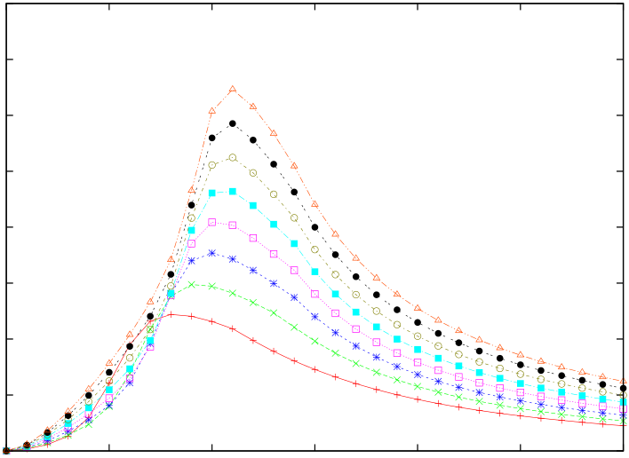

3.5   
3.0   
2.5   
GD

0.0 0.5 1.0 1.5 2.0 2.5 3.0

(b) 4.0

2.0 1.5 1.0 0.5 0.0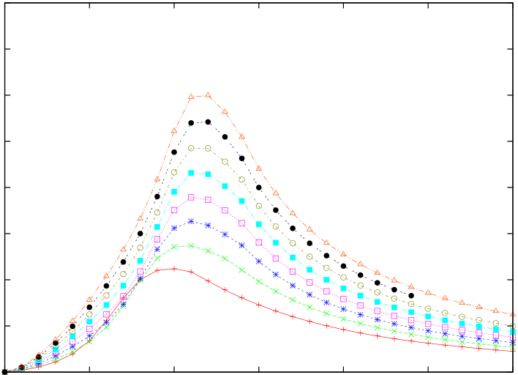

3.5   
3.0   
2.5   
GD

0.0 0.5 1.0 1.5 2.0 2.5 3.0

B/J B/J

**Figure 2.** GD for Ising rings containing from 3 to 10 spins at non-zero temperature: (a) *T* = 0*.*05 and (b) *T* = 0*.*1. GD is null at zero magnetic field. For increasing temperatures the maximum values of the curves decrease.

The core part of our analysis consists of the study of the changes in the behavior of GD for rings prepared in thermal states. We consider two different cases with effective temperature equal to *T* = 0*.*05 (cf figure 2(a)) and *T* = 0*.*1 (cf figure 2(b)). At non-zero temperature, the quantum correlations that are present in the ground state at *B* = 0 are destroyed and GD*(ρT)* = 0 ∀*L*. This is due to the fact that as *B* →0 the ground and first excited states approach degeneracy. These states are both of GHZ-type [25] and therefore even small *T* is sufficient to completely mix the ground and first excited states and destroy all quantum correlations [27]. Overall the height of the curves decreases with increasing temperature. At low temperatures (cf figure 2(a)), the position of the maxima of GD*(ρT)* is extremely close to those at *T* = 0, while higher temperatures induce a shift in the maxima of each curve (the effect is already visible in figure 2(b)). The optimal angles for the GD of thermal states are the same as those for *T* = 0. In line with the studies performed on the scaling of entanglement in quantum spin systems [29], it is interesting to study the way global quantum correlations scale against the number of elements of the multipartite systems that we are addressing here. To this end, we perform a finite-size scaling analysis of GD in the proximity of the critical point *B*m*/J* for a finite-size transverse Ising model at *T* = 0. We thus study the derivative of GD with respect to

satisfying the scaling ansatz [10, 30] *B* finding that, in proximity of the finite-size critical point, it is a function of *Lν(B* −*B*m*)/J*

*∂*  
*∂B*GD = *L*−*ω f* [*Lν(B* −*B*m*)/J*]*,*  (9)

where *ν* = 1 is the correlation length divergence critical exponent of the corresponding Ising universality class. There is clear indication of data collapse already for very small lengths (*L* ⩽11) and we obtain *ω* ≈−1*.*5 while *f (x)* is approximately quadratic for *x* ∼0 (cf figure 3). This is quite a remarkable result, as it shows that GD appears to scale with universal critical exponents in the proximity of a quantum phase transition.

*New Journal of Physics* **15** (2013) 043033 (<http://www.njp.org/>)

|  |  |  |
| --- | --- | --- |
| 8 | 0.125  0.100 0.095 0.090 0.085 0.080  0.120  0.115  L−1.5 ∂GD/∂B  0.110  0.105  -0.20 -0.15 -0.10 -0.05 0.00 0.05 0.10 0.15 0.20 | |
| L(B | Bm)/J |
| **Figure 3.** Derivative of GD with respect to the magnetic field for the Ising model at zero temperature. The data points (for *L* = 4*, . . . ,* 11) are scaled according to the number of spins of the rings. *B*m is the critical value of the magnetic field for  a finite-size chain of length *L*. Close to the critical point the curves at all values | |

of *L* collapse to a common function, witnessing universality.

*2.2. Cluster-Ising model*

We now consider a model, recently proposed and studied in [22], which combines competing effects coming from an antiferromagnetic Ising and a three-body cluster interaction according to the Hamiltonian (with periodic boundary conditions)

*L*  *L*

HCI = −*Jσx*ˆ*i*−1ˆ*σz i*ˆ*σx i*+1+ *λ* *σy*ˆ*i*ˆ*σy i*+1*.*  (10)

*i*=1 *i*=1   
The three-body term in equation (10) is responsible for the setting of long-range entanglement, which has been recently related to topologically ordered states [31], while the second term tends to localize entanglement to nearest-neighbor pairs of spins. Such competition makes the model undergo a second-order quantum phase transition at *J/λ* = 1 with the ground state of the system passing from an Ising antiferromagnetic phase (for *J/λ* ≪1) to a *cluster-like* one (achieved at

transition, which is not in the Ising universality class, has been characterized in [22, 32, 33] by *J/λ* ≫1) endowed, as said above, with long-range entanglement and topological order. Such a

means of a global geometric measure of entanglement and entanglement spectrum.

An interesting point to note is that, for a cluster-Ising model at non-zero temperature, neither the two-spin nor the multipartite entanglement (as measured by tangle) is able to signal the quantum phase transition, as they are either identically null (two-spin entanglement) or equal to a constant (multipartite tangle). Here we will make use of global quantum discord to study the occurrence of critical structural changes in the correlation-sharing structure of the model even at finite temperature, showing the effectiveness of GD in the task of revealing such modifications at criticality. Technically, the problem of finding the minimum in equation (5) is more difficult to tackle than in the Ising case. In fact, the model is characterized by a lower degree of symmetry (due to the presence of all the Pauli spin operators in equation (10)) which

*New Journal of Physics* **15** (2013) 043033 (<http://www.njp.org/>)

|  |  |
| --- | --- |
| 9 | 4.0  3.0  2.0  1.0  0.0  7.0  6.0  5.0  GD  0.0 0.5 1.0 1.5 2.0 2.5 3.0 |

J/λ

**Figure 4.** GD for the cluster-Ising model at zero temperature. We took *L* = 3*, . . . ,* 10, growing from the bottom to the top curve as they appear in the

increasing number of spins starting from 3 is equal to 1, 2, 3, 3, 4, 4. *J/λ* ≫1 part of the plot. In the second case GD for cluster states with an

forces us to minimize equation (6) using all angles {*θ j*} and {*φ j*}. For *J/λ* ≪1 (Ising phase) the optimal angles are {*θ j* = *π/*4} and {*φ j* = *π/*2} analogously to the ferromagnetic phase of the Ising model (the value of the phases *φ j* is due to the different Ising coupling of this model). In the opposite regime *J/λ* ≫1 (cluster phase) the optimizing angles depend on the number of spins.

We start the description of our result by analyzing figure 4, where we plot the GD as a function of the ratio *J/λ* for *L* = 3*, . . . ,* 10 and at *T* = 0. In the limit of vanishing cluster-like contribution, the model contains the Ising two-body interaction and we correspondingly recover the results obtained in section 2.1 for zero transverse magnetic field: the ground state is locally equivalent to an *L*-spin GHZ state and GD = 1 regardless of the size of the chain. In the opposite asymptotic regime, where the three-body model dominates over the Ising term, the ground states are cluster states on an *L*-site ring lattice [34]. Even at moderately large choices of *J/λ*, the value taken by GD agrees very well with the expectations for size-*L* cluster states, which are equal to 1*,* 2*,* 3*,* 3*,* 4*,* 4 for *L* going from 3 to 8, respectively. Away from such limits, GD behaves in a peculiar way with the size of the system. Most of the cases that we have considered in our analysis display a non-monotonic behavior with a peak occurring in proximity of the critical point. However, among the values of *L* considered in our calculations, the cases of *L* = 3 and 6*,* 9 behave differently, with the GD being practically constant or with a sharper maximum at values of *J/λ* significantly away from the critical point. Moreover, these special cases give rise to a few crossings with the curves associated with both lower and larger rings (for instance, the curve corresponding to *L* = 6 crosses both those for 5 and 7 spins).   
We believe that the occurrence of such *pathological* behavior when *L* is a multiple of 3 should not be regarded as accidental, but rather as a signature of the distinctive features of the cluster-Ising model for these lengths of the system. In fact, the study (at finite size) conducted in [32] shows that, differently from the thermodynamic limit, the *x*- and *z*-correlations in the

*New Journal of Physics* **15** (2013) 043033 (<http://www.njp.org/>)

10 

(a)

4.0

3.0

2.0

1.0

0.0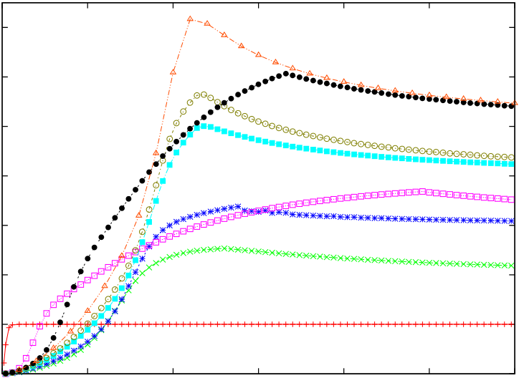

7.0

6.0

5.0

GD

0.0 0.5 1.0 1.5 2.0 2.5 3.0

(b)

4.0

3.0

2.0

1.0

0.0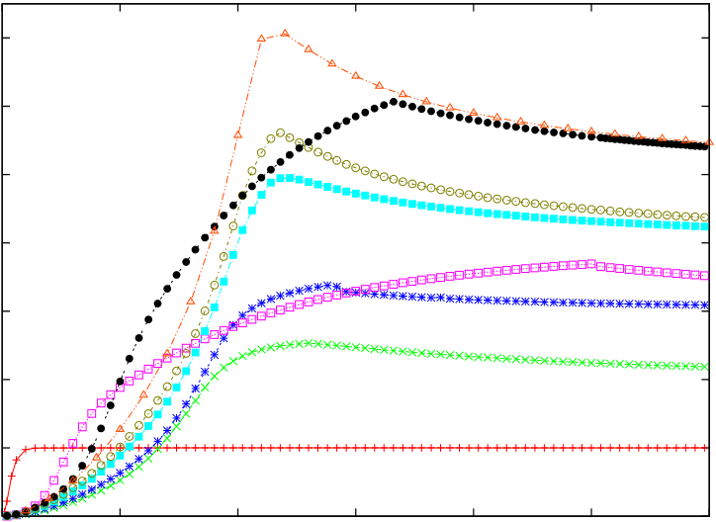

7.0

6.0

5.0

GD

0.0 0.5 1.0 1.5 2.0 2.5 3.0

J/λ J/λ

**Figure 5.** GD for the cluster-Ising model at non-zero temperature. We took *L* = 3*, . . . ,* 10, growing from the bottom to the top curve as they appear in the *J/λ* ≫1 part of the plot. In panel (a) ((b)) we took *T* = 0*.*05 (*T* = 0*.*1).

model, as well as the magnetization along *z*-axis, vanish for *L* that is a multiple of 3 ([32] discusses explicitly the case of *L* = 6 and 12). Although, given the complexity of the task, it is implausible to formulate an analytic expression of GD from which the role played by such correlations can be clearly extracted, we conjecture their relevance in the determination of the functional form of GD at moderate values of *J/λ*, where the differences with respect to any other system-size appear to be more striking. In turn, given the agreement between the calculated GD and the predictions valid for the ground state of the Ising and cluster models at all values of *L*, this analysis suggests that the above mentioned correlators are not heavily relevant for the calculation of GD deep in both such phases. While this observation could help in studying this figure of merit analytically, a less phenomenological approach to this interesting points goes beyond the scopes of this work and remains to be addressed in further studies on this matter.

in figure 5. While GD vanishes in the antiferromagnetic phase, it persists to the effects of We conclude our analysis of this model by addressing now the case of *T* ̸= 0, as done

temperature in the cluster one. This is in line with what has been found for thermal cluster states, for which an *L*-dependent critical temperature exists, below (above) which distillable and long-range (bound) entanglement is found in the cluster state [35].7   
 Even more strikingly, though, the structure observed at *T* = 0 survives, qualitatively unaltered, at *T* ̸= 0. Actually, the quantitative differences between the results associated with the *L*-spin ground state and the corresponding thermal equilibrium state are negligible (in terms of both the position of the maximum of GD on the *J/λ* axis and their actual value, cf figures 5(a) and (b)) even at values of *T* for which the GD of an Ising chain was found, in section 2.1, to be sensibly different from that of the *T* = 0 case. Needless to say, at much larger values of the temperature the peaks close to the critical point are smeared out into a broad and flat GD curve. This demonstrates the claimed effectiveness of the figure of merit addressed here in signaling the effects of criticality on the sharing of quantum correlations in thermal-equilibrium states, thus reinforcing the significance of the analysis conducted so far along the lines of combining quantum many-body physics and discord-related quantifiers [7, 10, 11].

7 The determination of such critical temperature for an *L*-element cluster state is a difficult task [35].

*New Journal of Physics* **15** (2013) 043033 (<http://www.njp.org/>)

11 

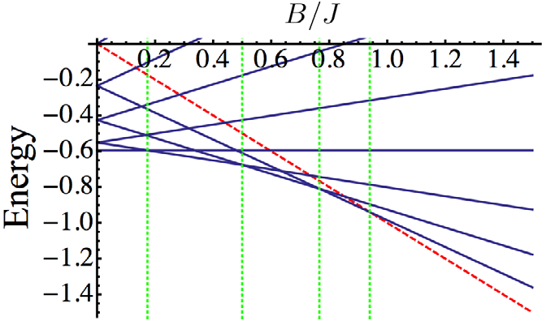

**Figure 6.** Spectrum of the model defined in equation (11) against the ratio *B/J* for *L* = 8 spins. The red dashed line represents the final ground state of the model after all energy crossings. Dashed vertical lines identifies the points of occurrence of level crossings in the model.

*2.3. Open-chain XX model*

Finally, we address the case of an open-ended chain interacting via an XX term in the presence of a transverse magnetic field

|  |
| --- |
| *L*−1 *L*  HXX = −*J (* ˆ*σx i*ˆ*σx i*+1+ ˆ*σy i*ˆ*σy i*+1*)* −*Bσz*ˆ*i.*  (11)  *i*=1 *i*=1  As studied in [36] and shown for *L* = 8 in figure 6, the energy spectrum of this model is quite rich and encompasses quite an interesting series of crossings among its energy eigenstates |

occurring as the ratio *B/J* is varied. Correspondingly, the ground state of the system changes and can be classified in terms of the number of such level crossings. In the thermodynamic limit *L* →∞,ˆfrom a critical phase, characterized by in-plane quasi-long range order, to a paramagnetic one. HXX exhibits a Berezinskii–Kosterlitz–Thouless (BKT) transition at *B/J* = 1

Correspondingly, two-spin quantum entanglement (as measured by concurrence) reduces as the distance between the spins is increased, and vanishes at the critical point, leaving a fully factorized ground state.

Figure 7 shows GD as a function of the external magnetic field over the two-body interaction constant. As discussed above, for high magnetic field the system is in the paramagnetic phase and no correlations are present. For low magnetic field the GD displays a step-wise behavior, jumps occurring in correspondence of the level-crossings that redefine the ground state of the system (which are evident from the spectrum of the model). That is, GD tracks the structural changes in the ground state of the spin system as *B/J* varies. Moreover, as *L* grows, GD goes to zero at values of *B/J* increasingly closer to the critical point. Already for the modest value of *L* = 9, the difference between the value of *B/J* at which GD = 0 and

in GD and reduces its amplitude as shown in figure 8. Yet, the series of level crossings at which *B/J* = 1 is only 5%. A non-zero temperature smoothens the sharpness of the jumps occurring

the ground state changes, as well as the BKT point are still clearly visible as dips between quasi-plateaux and a gradual yet quick decrease of GD, respectively, thus proving the effectiveness of GD as a figure of merit for signaling criticality at *T* ̸= 0. It should be noted that, for *B* = *T* = 0, the ground state is doubly degenerate. In order to evaluate GD we have thus taken the linear

*New Journal of Physics* **15** (2013) 043033 (<http://www.njp.org/>)

|  |  |
| --- | --- |
| 12 | 6  3  2  1  0  5  4  GD  0.0 0.2 0.4 0.6 0.8 1.0 1.2 1.4 1.6 |

B/J

**Figure 7.** GD for the XX model at *T* = 0. We have taken *L* = 3*, . . . ,* 9 (from bottom to top curve).

(a)

6

3

2

1

0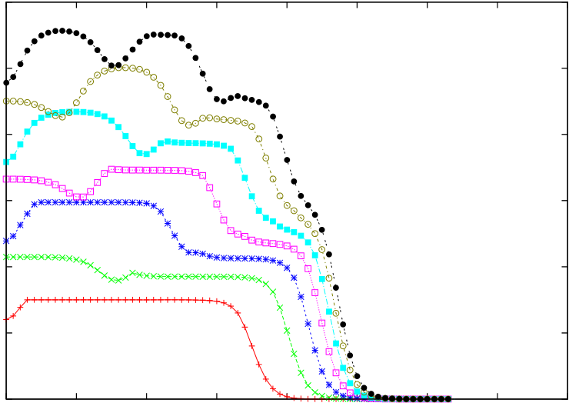

5

4

GD

0.0 0.2 0.4 0.6 0.8 1.0 1.2 1.4 1.6

(b)

6

3

2

1

0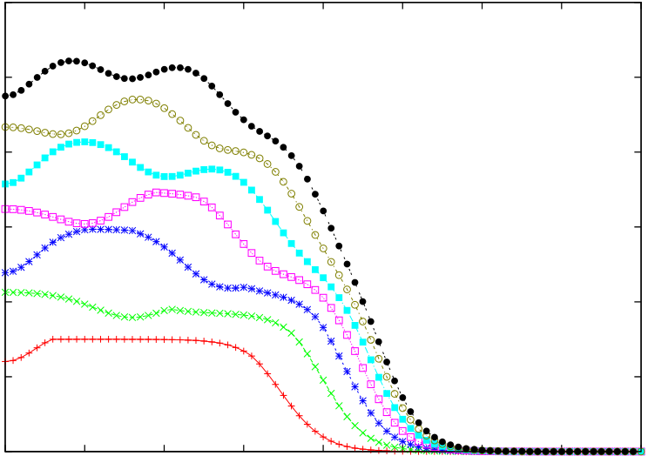

5

4

GD

0.0 0.2 0.4 0.6 0.8 1.0 1.2 1.4 1.6

B/J B/J

**Figure 8.** GD for the XX model at non-zero temperature. In panel (a) ((b)) we have taken *T* = 0*.*05 (*T* = 0*.*1). In both panels we have *L* = 3*, . . . ,* 9 (from bottom to top curve, respectively).

combination of such degenerate states that smoothly provides the values associated to *T* ̸= 0, where the degeneracy is lifted.

**3. Conclusions**

We investigated the behavior of a measure of global quantum correlations in three finite-size one-dimensional quantum many-body systems close to their critical points. We have manipulated the expression for global quantum discord so as to adapt it to the case of quantum spin chains. This has allowed us to study the global quantum discord in thermal states of moderately large quantum spin models, demonstrating its effectiveness in spotting the critical changes in the state of the system as a function of relevant parameters. Furthermore, for the Ising model we have been able to put forward evidences of a finite-size scaling behavior characterized

*New Journal of Physics* **15** (2013) 043033 (<http://www.njp.org/>)

13 

by universal critical exponents of the Ising universality class. For the cluster-Ising model, GD provides an alternative and powerful tool for the signaling of criticality superior to entanglement measures in both reduced and global forms. Finally, for an open XX chain, we have been able to track the discrete number of structural changes for the ground state as the transverse magnetic field varies.

The relation between the symmetries in a given model and the calculation of the correlations present is highly non-trivial [37]. Our analysis sheds light also on technical aspects related to the calculation of global discord in multipartite spin systems enjoying some degree of symmetry. For the transverse Ising model with periodic boundary conditions, we have provided strong numerical evidence that identical local projections should be implemented in order to attain the global maximum inherent in the definition of GD. Moreover, the azimuthal angles *φ j* are shown to be immaterial for this task. Differently, for the cluster-Ising model in equation (10), deep in the cluster phase, more complicated combinations of minimizing angles are found. Although, it would be interesting to find a relation between the symmetries of the model in consideration and the angles minimizing the global discord, a comprehensive solution seems highly non-trivial and goes beyond the scope of this study.

**Acknowledgments**

We are grateful to L Amico, G L Giorgi, V Vedral and A Xuereb for invaluable discussions. We acknowledge funding from the EU under the Marie Curie IEF Fellowship scheme, the European Commission, the European Social Fund, the Region Calabria through the program POR Calabria FSE 2007-2013—Asse IV Capitale Umano-Obiettivo Operativo M2, Science Foundation Ireland under project number 10/IN.1/I2979, the UK EPSRC through a Career Acceleration Fellowship and the ‘New Directions for EPSRC Research Leaders’ initiative (EP*/*G004579/1).

**Appendix**

Here we present the main steps of the derivation of the expression of the global discord for *N* spin-system presented in equation (6). The starting point is writing the multi-local projectors asˆthe operatorˆthe terms of the relative entropy of the form Tr[*ρ*1log2*ρ*2] (we call it here mixed terms) in *k*= ˆR |**k**⟩⟨**k**| ˆ*z* = ⊗*N* R†where we remind that {|**k**⟩} are multi-local (separable) eigenstates of *j*=1ˆ*σz j*and ˆR is a multi-local rotationˆR = ⊗*N j*=1ˆ*R j*. With this definition

equation (5) can be rewritten as

Tr[*ρT* log2ˆ*(ρT)*] = Tr *ρT* log2

*k*  R |**k**⟩⟨**k**| ˆR†*ρT*ˆR |**k**⟩⟨**k**| ˆR†

= Tr*ρT* log2ˆR **k** |**k**⟩˜*ρkk T*⟨**k**|ˆR† (A.1)

= Tr*ρT*˜*k*  log2 ˜*ρkk T*|**k**⟩⟨**k**|

= *k* *ρkk*˜*T*log2˜*ρkk T,*

*New Journal of Physics* **15** (2013) 043033 (<http://www.njp.org/>)

14 

where we define R *f (A)*ˆfor the mixed terms of the relative entropy for the *j*th qubit we find that R†= *f (*˜*A)* and the cyclic property of the trace. Using exactly the same line of reasoning*ρT* = ˆR†*ρT*ˆR, *ρkk*˜*T*= ⟨**k**| ˆR†*ρT*ˆR |**k**⟩, we use that if R*A*ˆR†= ˜*A* then

1

|  |  |  |  |  |  |
| --- | --- | --- | --- | --- | --- |
| Tr[*ρ j* log2ˆ | *j(ρ j)*] = Tr | *ρ j* log2 | *l*=0 | *R j*|*l*⟩⟨*l*| ˆ*R*†*jρ j* ˆ*R j*|*l*⟩⟨*l*| ˆ*R*†*j* | (A.2) |

1

= *ρll*˜*j*log2˜*ρll j,*   
 *l*=0   
where ˜together and taking into account the minimization, we obtain the expression for global discord *ρll j*= ⟨*l*| ˆ*R*†*jρ j* ˆ*R j*|*l*⟩and |*l*⟩being the two eigenstates of ˆ*σz j*. By putting all the terms

given in equation (6).

**References**

[1] Osterloh A, Amico L, Falci G and Fazio R 2002 *Nature* **[416](http://dx.doi.org/10.1038/416608a)** [608](http://dx.doi.org/10.1038/416608a)   
[2] Osborne T J and Nielsen M A 2002 *Phys. Rev.* A **[66](http://dx.doi.org/10.1103/PhysRevA.66.032110)** [032110](http://dx.doi.org/10.1103/PhysRevA.66.032110)   
[3] Amico L, Fazio R, Osterloh A and Vedral V 2008 *Rev. Mod. Phys.* **[80](http://dx.doi.org/10.1103/RevModPhys.80.517)** [517](http://dx.doi.org/10.1103/RevModPhys.80.517)   
[4] Ollivier H and Zurek W H 2001 *Phys. Rev. Lett.* **[88](http://dx.doi.org/10.1103/PhysRevLett.88.017901)** [017901](http://dx.doi.org/10.1103/PhysRevLett.88.017901)   
[5] Henderson L and Vedral V 2001 *J. Phys. A: Math. Gen.* **[34](http://dx.doi.org/10.1088/0305-4470/34/35/315)** [6899](http://dx.doi.org/10.1088/0305-4470/34/35/315)   
[6] Modi K, Brodutch A, Cable H, Paterek T and Vedral V 2012 *Rev. Mod. Phys.* **[84](http://dx.doi.org/10.1103/RevModPhys.84.1655)** [1655](http://dx.doi.org/10.1103/RevModPhys.84.1655) [7] Dillenschneider R 2008 *Phys. Rev.* B **[78](http://dx.doi.org/10.1103/PhysRevB.78.224413)** [224413](http://dx.doi.org/10.1103/PhysRevB.78.224413)   
[8] Giorgi G L, Bellomo B, Galve F and Zambrini R 2011 *Phys. Rev. Lett.* **[107](http://dx.doi.org/10.1103/PhysRevLett.107.190501)** [190501](http://dx.doi.org/10.1103/PhysRevLett.107.190501)   
 Giorgi G L 2011 *Phys. Rev.* A **[84](http://dx.doi.org/10.1103/PhysRevA.84.054301)** [054301](http://dx.doi.org/10.1103/PhysRevA.84.054301)   
[9] Werlang T, Trippe C, Ribeiro G A P and Rigolin G 2010 *Phys. Rev. Lett.* **[105](http://dx.doi.org/10.1103/PhysRevLett.105.095702)** [095702](http://dx.doi.org/10.1103/PhysRevLett.105.095702)  Werlang T, Ribeiro G A P and Rigolin G 2011 *Phys. Rev.* A **[83](http://dx.doi.org/10.1103/PhysRevA.83.062334)** [062334](http://dx.doi.org/10.1103/PhysRevA.83.062334)   
[10] Tomasello B, Rossini D, Hamma A and Amico L 2011 *Europhys. Lett.* **[96](http://dx.doi.org/10.1209/0295-5075/96/27002)** [27002](http://dx.doi.org/10.1209/0295-5075/96/27002)   
 Tomasello B, Rossini D, Hamma A and Amico L 2012 *Int. J. Mod. Phys.* B **[26](http://dx.doi.org/10.1142/S0217979212430023)** [1243002](http://dx.doi.org/10.1142/S0217979212430023) [11] Campbell S, Mazzola L and Paternostro M 2011 *Int. J. Quantum Inform.* **[9](http://dx.doi.org/10.1142/S0219749911008404)** [1685](http://dx.doi.org/10.1142/S0219749911008404)   
[12] Maziero J, C´eleri L C, Serra R M and Sarandy M S 2012 *Phys. Lett.* A **[376](http://dx.doi.org/10.1016/j.physleta.2012.03.029)** [1540](http://dx.doi.org/10.1016/j.physleta.2012.03.029)   
[13] ¸Cakmak B, Karpat G and Gedik Z 2012 *Phys. Lett.* A **[376](http://dx.doi.org/10.1016/j.physleta.2012.09.007)** [2982](http://dx.doi.org/10.1016/j.physleta.2012.09.007)   
[14] Sarandy M S, de Oliveira T R and Amico L 2013 *Int. J. Mod. Phys.* B **[27](http://dx.doi.org/10.1142/S0217979213450306)** [1345030](http://dx.doi.org/10.1142/S0217979213450306)   
[15] Simon J, Bakr W S, Ma R, Tai M E, Preiss P M and Greiner M 2011 *Nature* **[472](http://dx.doi.org/10.1038/nature09994)** [307](http://dx.doi.org/10.1038/nature09994) [16] Friedenauer A, Schmitz H, Glueckert J T, Porras D and Schaetz T 2008 *Nature Phys.* **[4](http://dx.doi.org/10.1038/nphys1032)** [757](http://dx.doi.org/10.1038/nphys1032) [17] Lanyon B P *et al* 2011 *Science* **[334](http://dx.doi.org/10.1126/science.1208001)** [57](http://dx.doi.org/10.1126/science.1208001)   
[18] Britton J W *et al* 2012 *Nature* **[484](http://dx.doi.org/10.1038/nature10981)** [489](http://dx.doi.org/10.1038/nature10981)   
[19] Islam R *et al* 2011 *Nature Commun.* **[2](http://dx.doi.org/10.1038/ncomms1374)** [377](http://dx.doi.org/10.1038/ncomms1374)   
[20] Rulli C C and Sarandy M S 2011 *Phys. Rev.* A **[84](http://dx.doi.org/10.1103/PhysRevA.84.042109)** [042109](http://dx.doi.org/10.1103/PhysRevA.84.042109)   
[21] Katsura S 1962 *Phys. Rev.* **[127](http://dx.doi.org/10.1103/PhysRev.127.1508)** [1508](http://dx.doi.org/10.1103/PhysRev.127.1508)   
 Lieb E, Schultz T and Mattis D 1961 *Ann. Phys.* **[16](http://dx.doi.org/10.1016/0003-4916(61)90115-4)** [407](http://dx.doi.org/10.1016/0003-4916(61)90115-4)   
 De Pasquale A *et al* 2008 *Eur. Phys. J. Spec. Top.* **[160](http://dx.doi.org/10.1140/epjst/e2008-00716-9)** [127](http://dx.doi.org/10.1140/epjst/e2008-00716-9)   
[22] Son W, Amico L, Fazio R, Hamma A, Pacazio S and Vedral V 2011 *Europhys. Lett.* **[95](http://dx.doi.org/10.1209/0295-5075/95/50001)** [50001](http://dx.doi.org/10.1209/0295-5075/95/50001) [23] Girolami D, Paternostro M and Adesso G 2011 *J. Phys. A: Math. Theor.* **[44](http://dx.doi.org/10.1088/1751-8113/44/35/352002)** [352002](http://dx.doi.org/10.1088/1751-8113/44/35/352002)   
[24] Braga H C, Rulli C C, de Oliveira T R and Sarandy M S 2012 *Phys. Rev.* A **[86](http://dx.doi.org/10.1103/PhysRevA.86.062106)** [062106](http://dx.doi.org/10.1103/PhysRevA.86.062106) [25] ˇ  
Stelmachoviˇc P and Buˇzek V 2004 *Phys. Rev.* A **[70](http://dx.doi.org/10.1103/PhysRevA.70.032313)** [032313](http://dx.doi.org/10.1103/PhysRevA.70.032313) [26] Igl´oi F and Lin Yu-C 2008 *J. Stat. Mech.*[P06004](http://dx.doi.org/10.1088/1742-5468/2008/06/P06004)   
 Igl´oi F and Juh´asz R 2008 *Europhys. Lett.* **[81](http://dx.doi.org/10.1209/0295-5075/81/57003)** [57003](http://dx.doi.org/10.1209/0295-5075/81/57003)

*New Journal of Physics* **15** (2013) 043033 (<http://www.njp.org/>)

15 

[27] Campbell S and Paternostro M 2010 *Phys. Rev.* A **[82](http://dx.doi.org/10.1103/PhysRevA.82.042324)** [042324](http://dx.doi.org/10.1103/PhysRevA.82.042324)   
[28] De Chiara G, Lepori L, Sanpera A and Lewenstein M 2012 *Phys. Rev. Lett.* **[109](http://dx.doi.org/10.1103/PhysRevLett.109.237208)** [237208](http://dx.doi.org/10.1103/PhysRevLett.109.237208)   
[29] Latorre J I and Riera A 2009 *J. Phys. A: Math. Theor.* **[42](http://dx.doi.org/10.1088/1751-8113/42/50/504002)** [504002](http://dx.doi.org/10.1088/1751-8113/42/50/504002)   
[30] Fisher M E and Barber M N 1972 *Phys. Rev. Lett.* **[28](http://dx.doi.org/10.1103/PhysRevLett.28.1516)** [1516](http://dx.doi.org/10.1103/PhysRevLett.28.1516)   
[31] Chen X, Gu Z-C and Wen X-G 2010 *Phys. Rev.* B **[82](http://dx.doi.org/10.1103/PhysRevB.82.155138)** [155138](http://dx.doi.org/10.1103/PhysRevB.82.155138)   
[32] Smacchia P, Amico L, Facchi P R, Fazio Florio G, Pascazio S and Vedral V 2011 *Phys. Rev.* A **[84](http://dx.doi.org/10.1103/PhysRevA.84.022304)** [022304](http://dx.doi.org/10.1103/PhysRevA.84.022304) [33] Cui J, Amico L, Fan H, Gu M, Hamma A and Vedral V 2013 arXiv:[1304.2279](http://arxiv.org/abs/1304.2279)   
[34] Briegel H, Browne D E, D¨  
ur W, Raussendorf R and Van den Nest M 2009 *Nature Phys.* **[5](http://dx.doi.org/10.1038/nphys1157)** [19](http://dx.doi.org/10.1038/nphys1157) [35] Raussendorf R, Bravyi S and Harrington J 2005 *Phys. Rev.* A **[71](http://dx.doi.org/10.1103/PhysRevA.71.062313)** [062313](http://dx.doi.org/10.1103/PhysRevA.71.062313)   
 Hadjuˇsek M and Vedral V 2010 *New J. Phys.* **[12](http://dx.doi.org/10.1088/1367-2630/12/5/053015)** [053015](http://dx.doi.org/10.1088/1367-2630/12/5/053015)   
[36] Son W, Amico L, Plastina F and Vedral V 2009 *Phys. Rev.* A **[79](http://dx.doi.org/10.1103/PhysRevA.79.022302)** [022302](http://dx.doi.org/10.1103/PhysRevA.79.022302)   
[37] Amico L, Rossini D, Hamma A and Korepin V E 2012 *Phys. Rev. Lett.* **[108](http://dx.doi.org/10.1103/PhysRevLett.108.240503)** [240503](http://dx.doi.org/10.1103/PhysRevLett.108.240503)

*New Journal of Physics* **15** (2013) 043033 (<http://www.njp.org/>)