

**APPITS**

16

**FXWEBKIT**

**Manage, Analyze & Trade**

**Mohammad Galya**

# FXWEBKIT

# Introduction

# About FXWEBKIT

## Admin area

This area to manage the software, accounts of all users with their trading’s reports and filter their requests to MT4 server, you can also manage Agents and their users with commissions and money .

To manage the pubic web site content you can use CMS (Content Management System) module to edit and add content to the public web site .

### Admin Dashboard

Here you can display statistics for clients, MT4 users and too many trading statistics and analysis .

### Settings

Settings module contains the main settings for the system in general but each module contains his own configurations.

Admins profiles with full control to their details can be access from this module , emails configurations and mass mail with specialize groups of users to send emails for them , you can also change any word on the system with its translate and manage translation .

#### Features:

1. Easy access to many of the software settings.
2. Full control for emails template and notifications
3. Translate whole of the words in the software.
4. Configuration of the MT servers in one place .
5. Social media Apps to let clients login throw their social media.

#### Settings Menu Sections

As we see this module contains varies of section :

##### Admins List

The admins who are can get in admin area and control it .

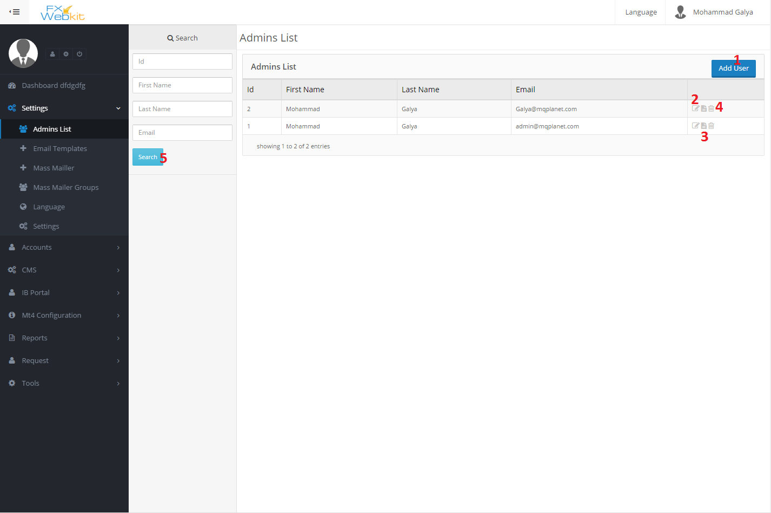

As we see the list of all admins listed here this window contain:

1. **Add User(admin) :** add new admin to the system to control admin list .
2. **Edit User details** : to change password and all personal details .
3. **User details** : to see user details click this icon .
4. **Delete User:** If you want to delete the admin ,the admin will be no longer exist and cannot get into the system again.
5. **Search panel :** use this panel to find a specific admin using his ID or part of his first name , last name and email the result will be listed to the right.

##### Email Templates

In this system there is too many of notifications types and emails send to the users when someone do some action on the system and the email should has specific template .

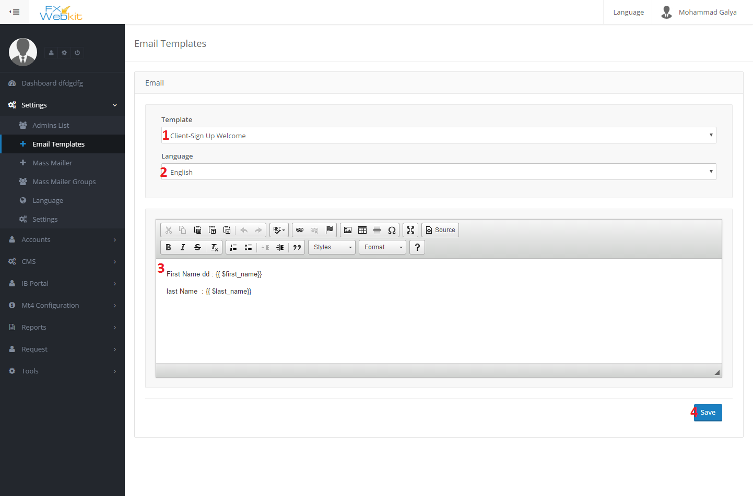

This form just to edit the email templates if the body of email does not appear you have to add the file of the template on templates folder or change language and template name to get the template and edit it:

1. **Template name :** in this case we have email template if new client sign in this email will sent to his email to welcome him .
2. **Language** of the template you have to have template for each language in your system if you donot have template in the files for specific language the body will not be appear so add the file then try to get this template.
3. **Template body :** the email body which will be sent as we see there is variables look like this

**{{ $name }}** this will be replaced with the name of the user before sent it , you have not to change theme just use theme where ever you want to put name of user .

Each template has his own variables donot change anything between brackets just move whole brackets and put them in the right place .

##### Mass Mailer

From time to time Admin need to send emails to the users or group of users here come mass mailer part ,the admin write his email or get the saved emails and send the email to users emails in the database or mt4 users emails or to group of users he can select the group from **mass mailer groups** .

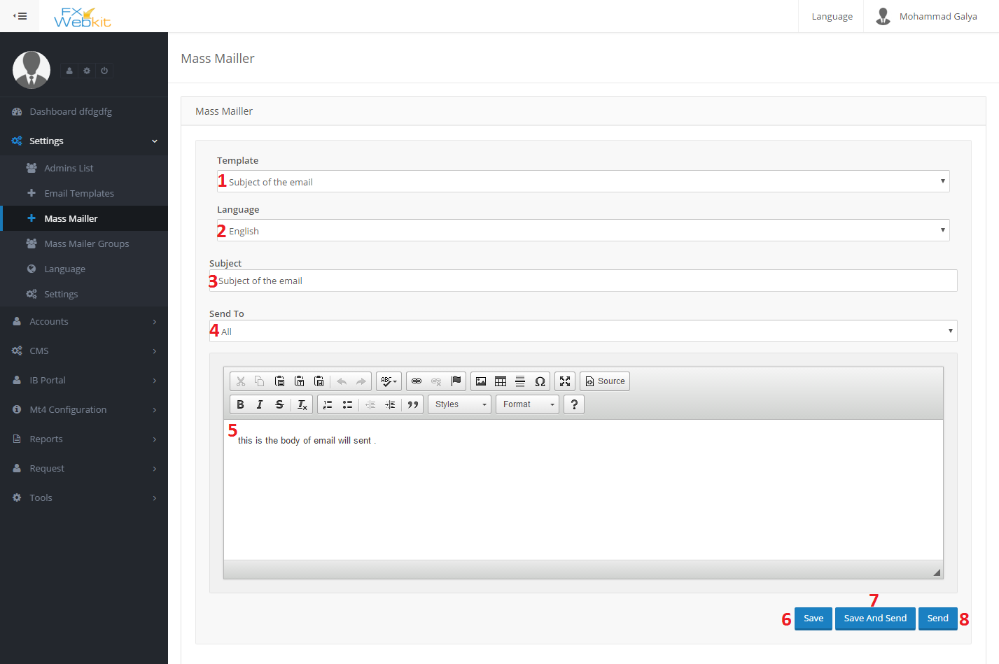

This form to write and send email or get saved email from database and send it.

1. Template name : the template come

##### Mass Mailer Groups

##### Language

##### Settings

### Accounts

### CMS

### IBPortal

### Mt4 Configuration

### Reports

### Request

### Tools

## Client area