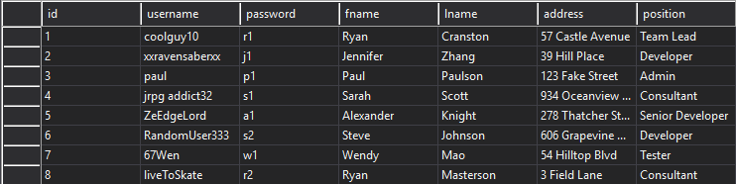

Use this data to test the app. It is also included as a .png file in the zip file containing the program.

Upon starting the application you will see something like this.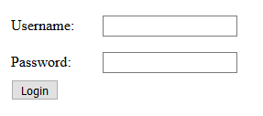

Use the records from the data table to login, all that is required is username and password. Depending on your position when you login you will either see the admin version of the page or the non-admin version of the page.

Login Example

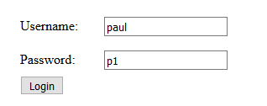

Non-Admin Page – Only has one advanced search field and the label name for it cannot be changed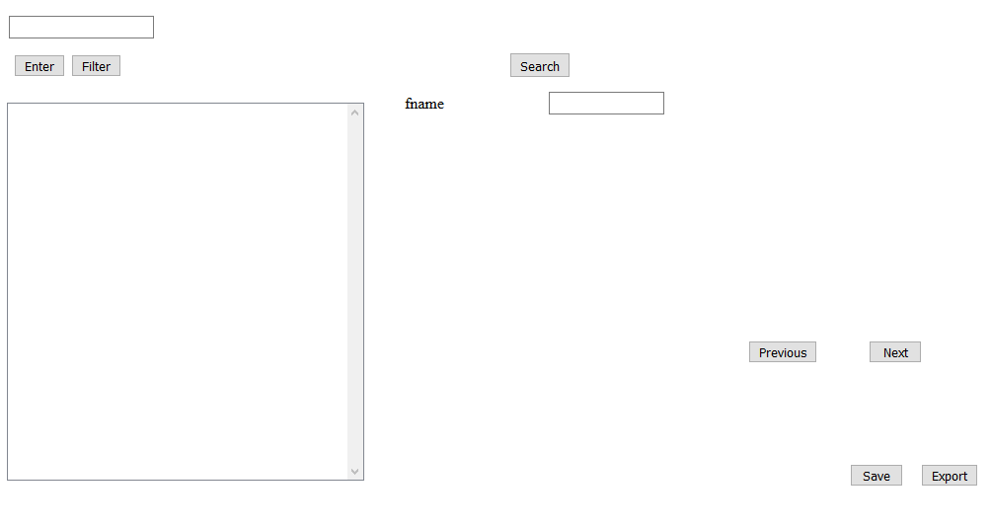

Admin Page – Can add up to 3 additional search fields and change the label field name.

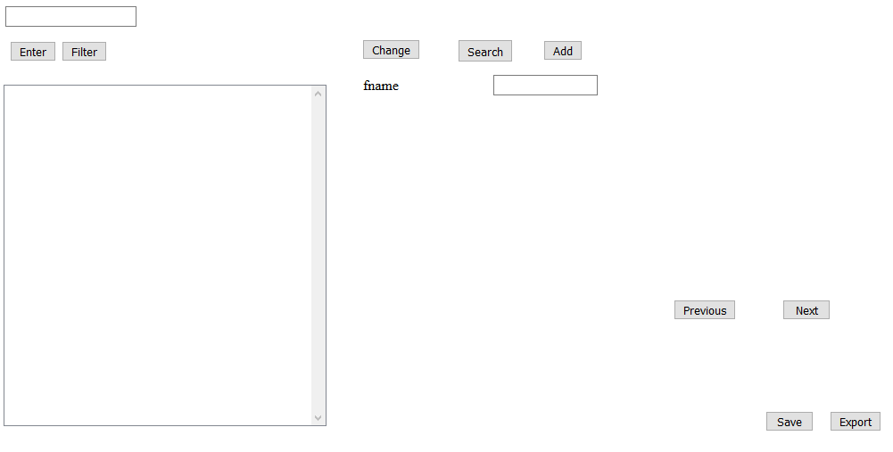

This is the basic search function that allows a user to search by first name, last name, or position. Input search criteria then click “Enter”.

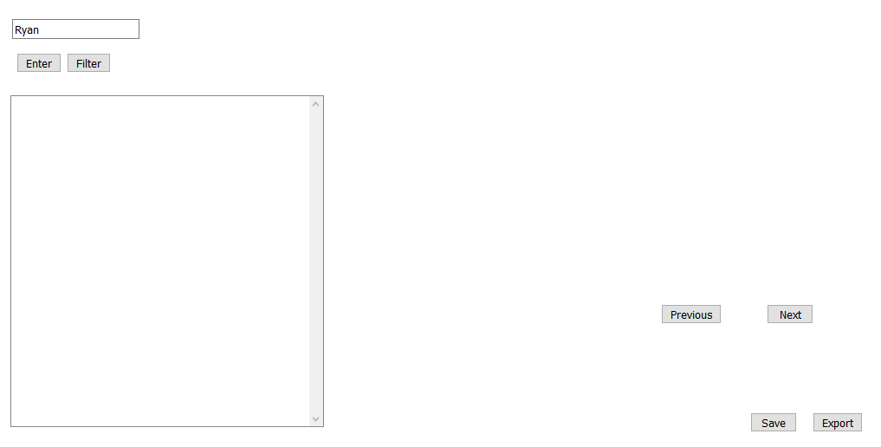

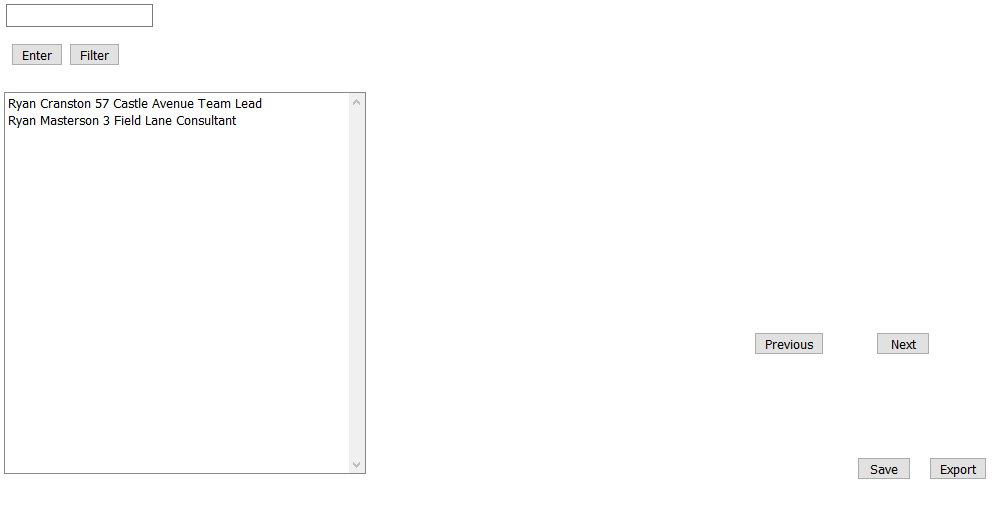

To use the advanced search click “Filter.”

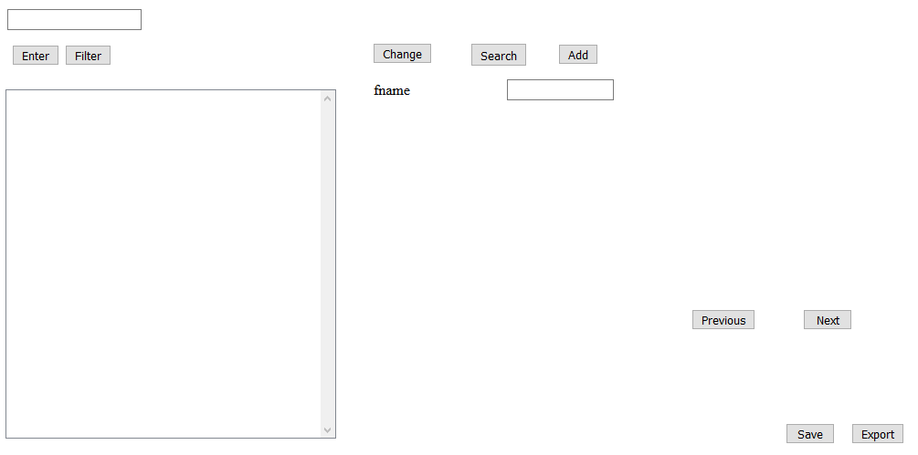

If you click “Add” additional search fields will appear

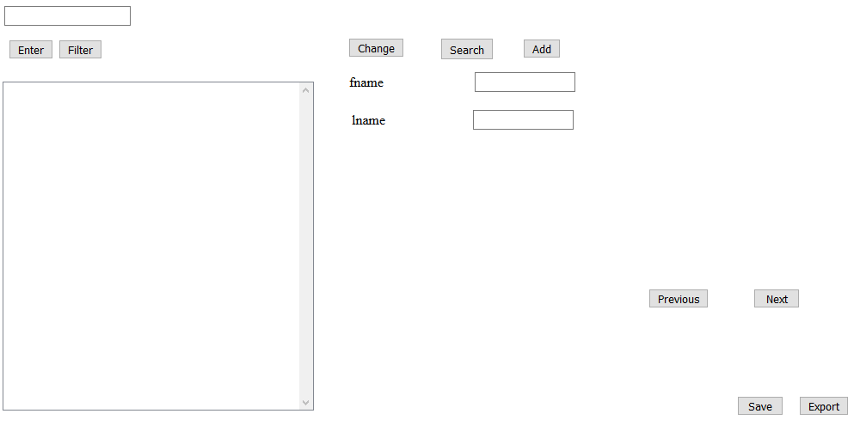

If you input the name of a data field into the text box and click “Change” the label name will update to reflect that.

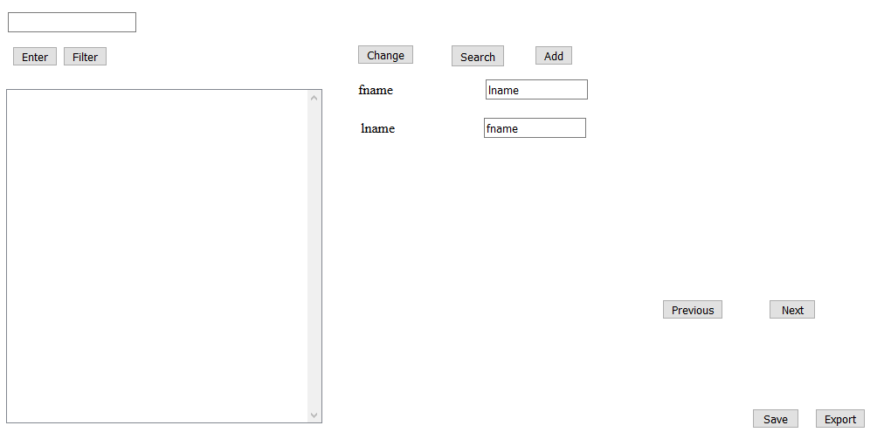

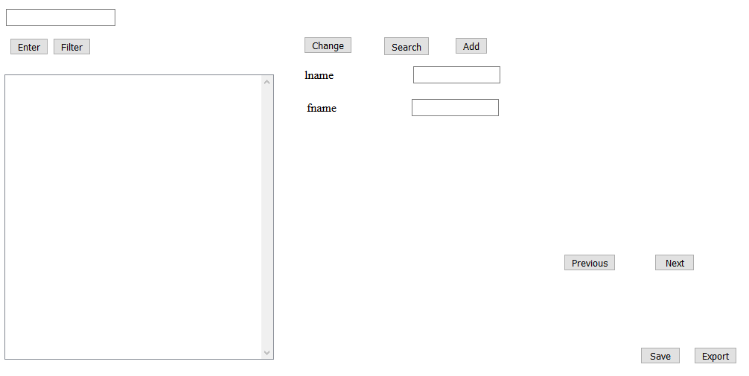

Enter corresponding data into the proper search fields and click “Search.”

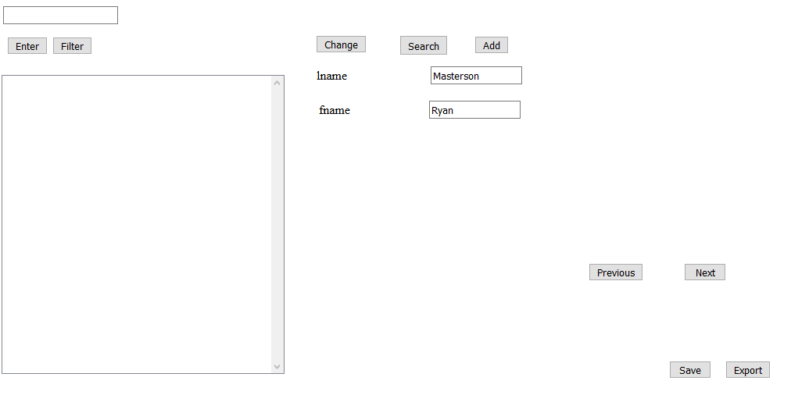

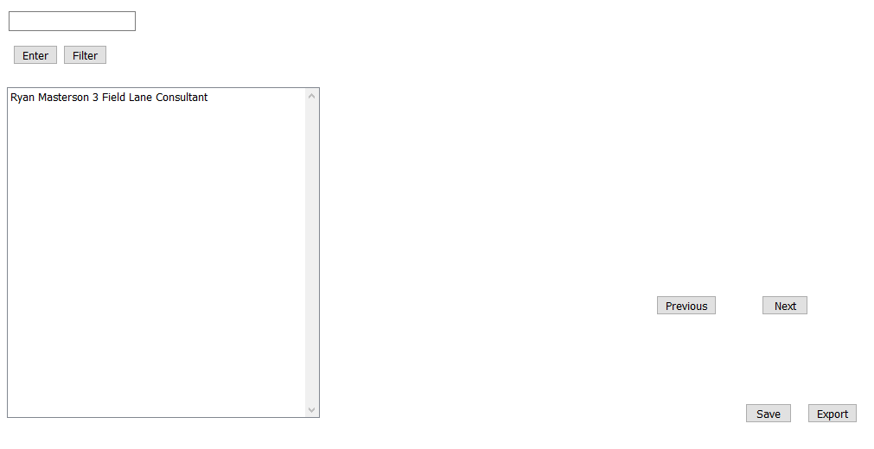

After the search has been processed the advanced search panel will again hide itself.

If you click Export you can export current search results as a .csv file

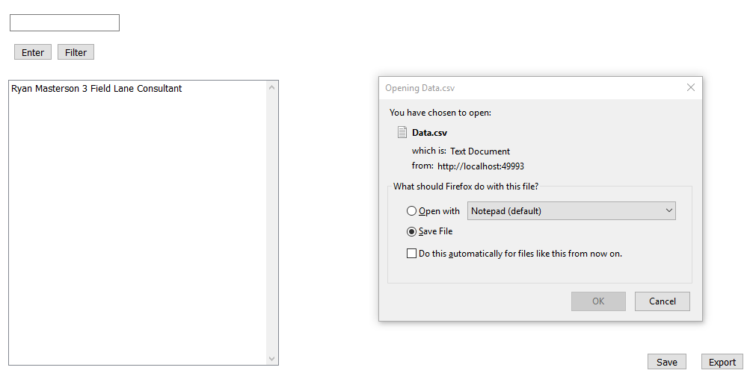

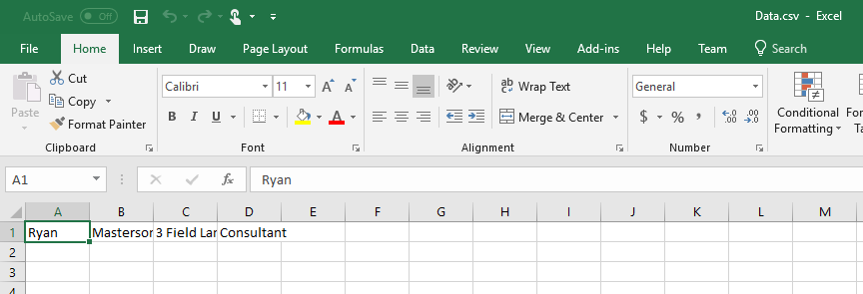

If you click “Save” you are prompted to print the web page.

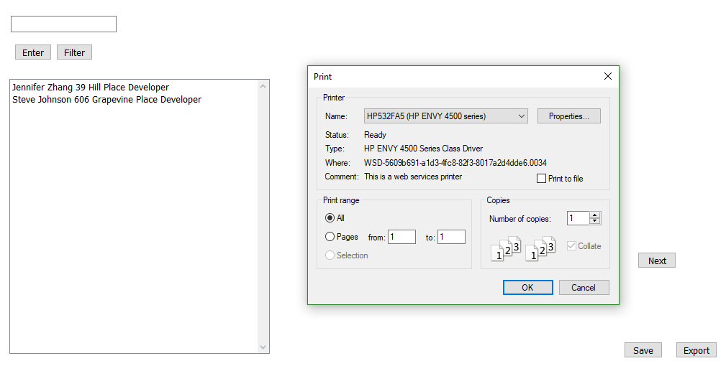

Tried many different implementations of the Image Control to add pictures, but due to unfamiliarity with the programming language and various other bugs it was unable to be added successfully.