

**Instructor Name:** Lec. Samia Yasmeen **Department:** Computer Science

**Batch: CS 2022** **PBL  
Group Member:  
 Taha Khan F22605041**

**Tayyba Afzaal F22605025**

**Mohid Shakir F22605050**

**Chaudary Muhammad Aqdas F22605052**

**Food Ordering Management System**

**Entities:**

1. **Users:**
   * Attributes: UserID (Primary Key), Name, Email, Phone, Address, UserType, etc.
   * Description: Stores information about the users of the app. UserType can differentiate between regular users and restaurant owners.
2. **Restaurants:**
   * Attributes: RestaurantID (Primary Key), Name, Address, Phone, OwnerID (Foreign Key), CuisineType, Rating, etc.
   * Description: Contains details about the restaurants available on the platform. OwnerID establishes a connection to the Users table, indicating the owner of the restaurant.
3. **Menu Items:**
   * Attributes: ItemID (Primary Key), RestaurantID (Foreign Key), Name, Description, Price, Category, etc.
   * Description: Represents the various food items offered by each restaurant. RestaurantID links each item to its respective restaurant.
4. **Orders:**
   * Attributes: OrderID (Primary Key), UserID (Foreign Key), RestaurantID (Foreign Key), Date, TotalAmount, Status, etc.
   * Description: Stores information about the orders placed by users. UserID connects to the Users table, while RestaurantID links to the Restaurants table.
5. **Order Details:**
   * Attributes: OrderDetailID (Primary Key), OrderID (Foreign Key), ItemID (Foreign Key), Quantity, Subtotal, etc.
   * Description: Contains the details of each item ordered within an order. OrderID links to the Orders table, and ItemID connects to the Menu Items table.

**Relationships:**

* **Users to Orders:** One-to-Many relationship. Each user can place multiple orders.
* **Users to Restaurants:** Many-to-Many relationship (if users can have favorite restaurants or multiple restaurants they order from). Could be implemented with an intermediary table.
* **Restaurants to Menu Items:** One-to-Many relationship. Each restaurant can offer multiple menu items.
* **Orders to Order Details:** One-to-Many relationship. Each order can consist of multiple items.
* **Order Details to Menu Items:** One-to-One relationship. Each order detail corresponds to one menu item.

ERD:

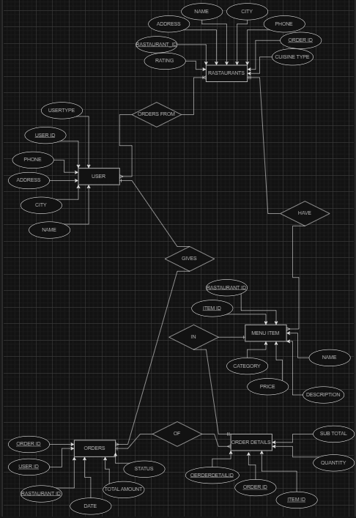

Creating tables and inserting data:  
User Table:  
  
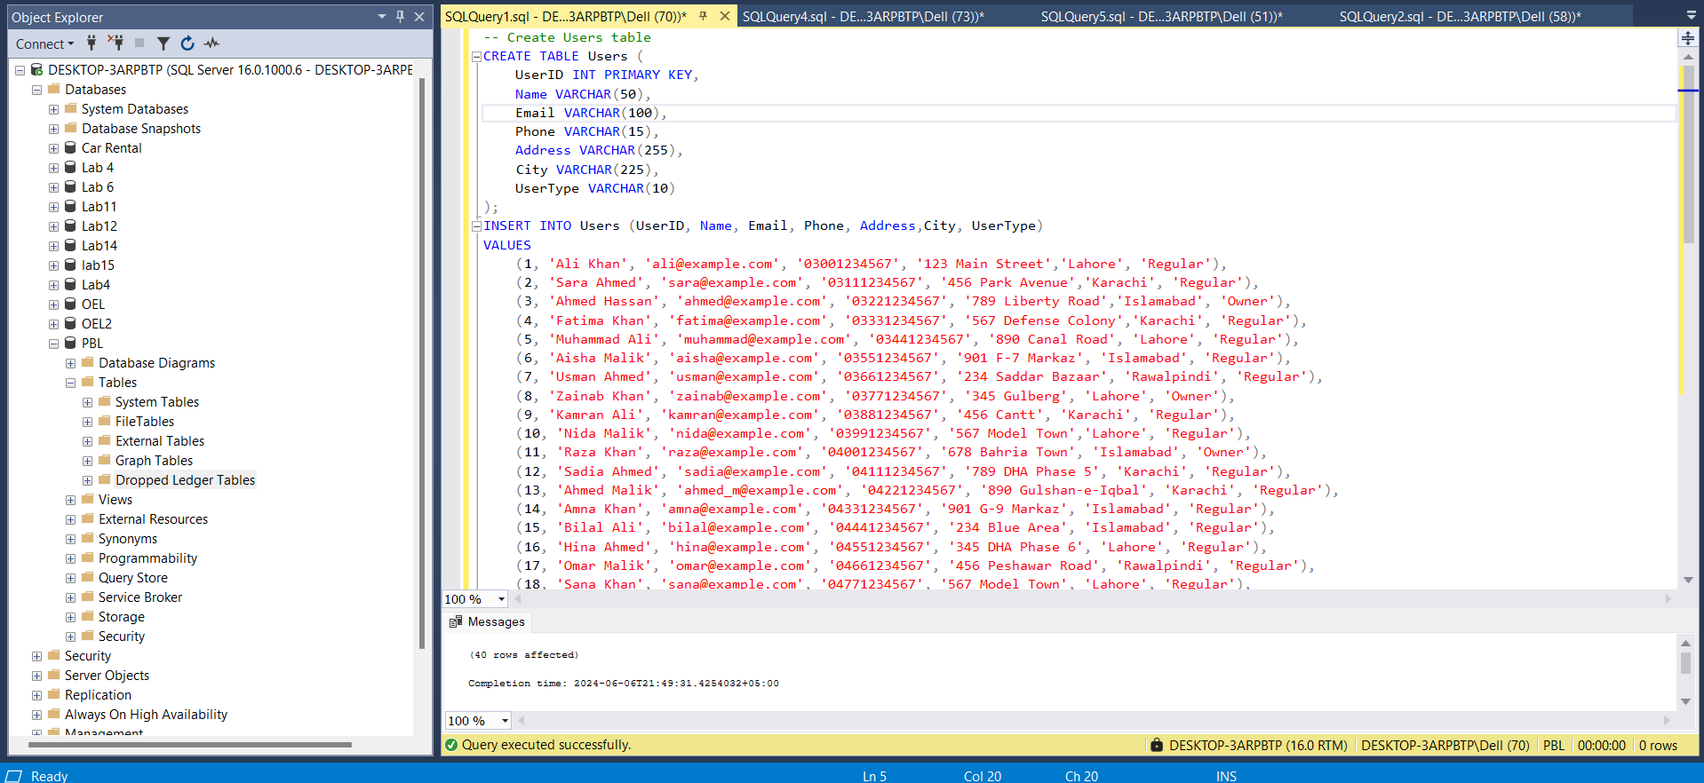

Restaurant Table:

Menu Table:

Order Table:

OrderDetails Table:

Performing Some demo operations to check the performance of the database:

1. **Select all restaurants in Islamabad**

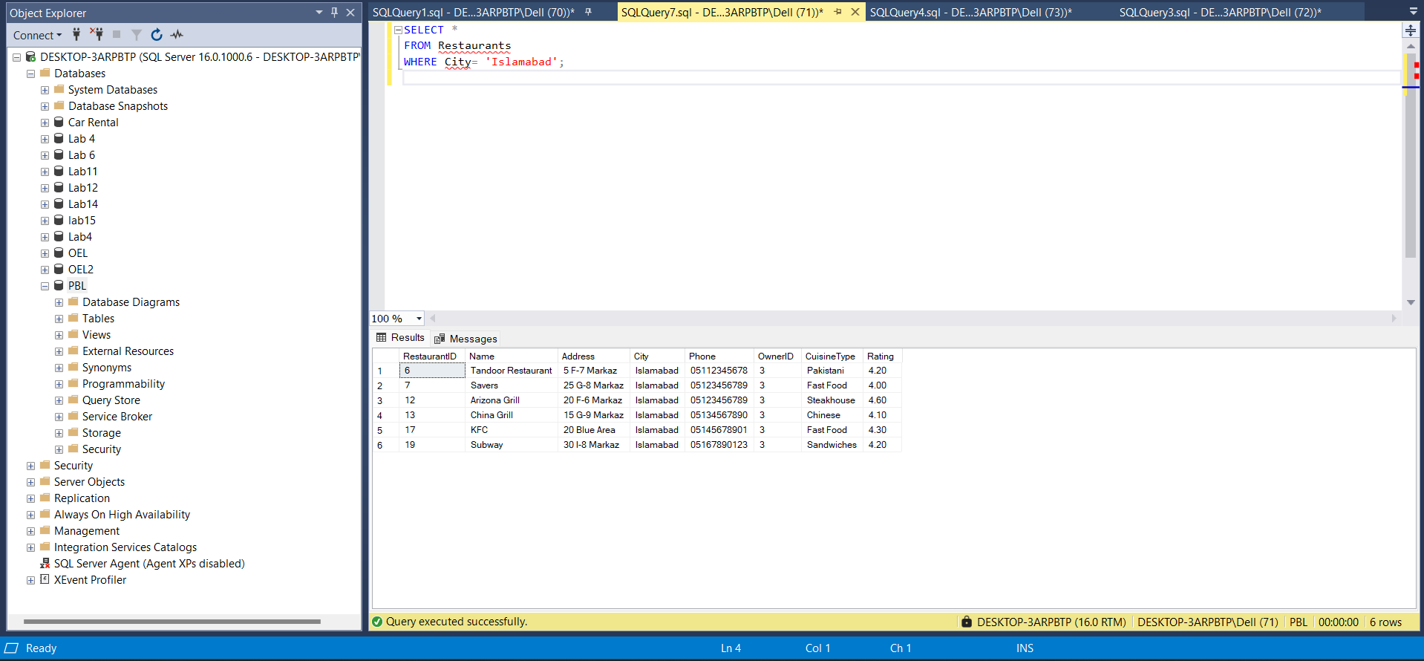

1. **Select all restaurants of cuisine type Pakistani or Afghani**

1. **Select all users grouped by usertype**

1. **Select all the dishes that are the main course along with the restaurant name**

1. **Select all the orders subtotal > 1000 grouped by user name**

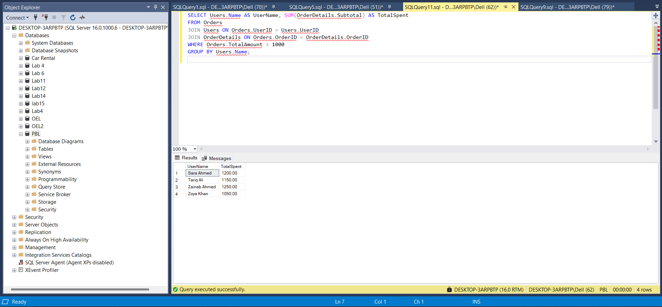

1. **Select all the orders that are delivered along with user and the restaurant name**

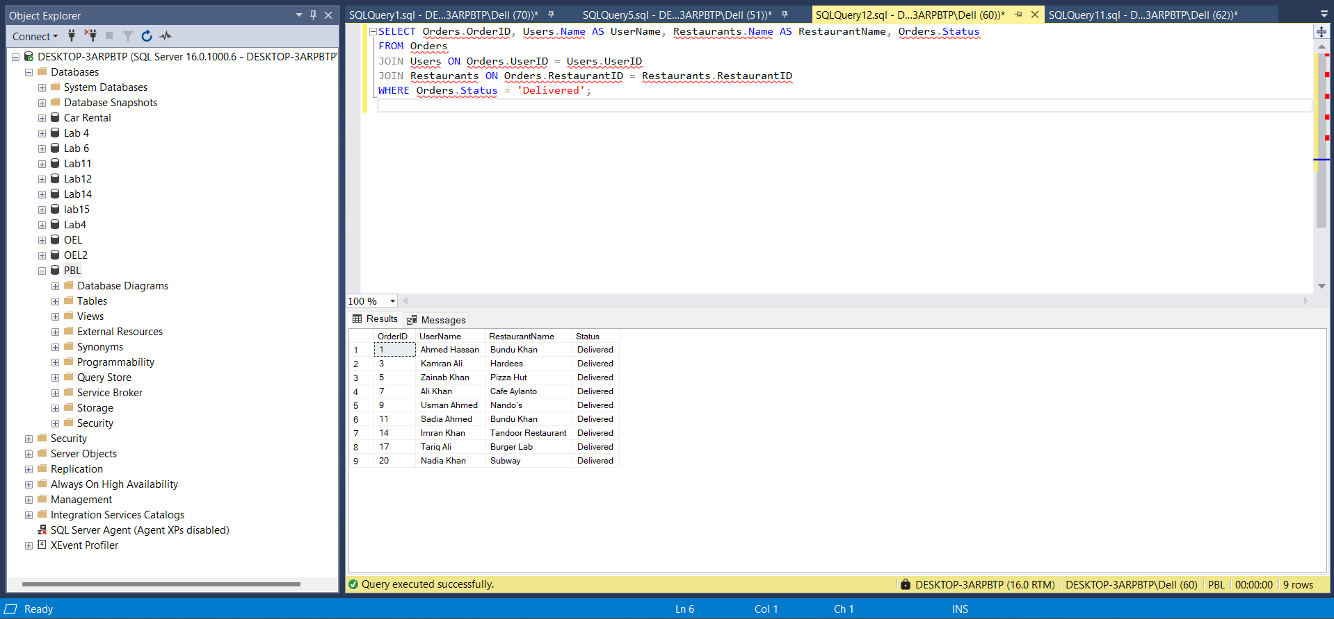

1. **Select all users and all restaurants in Karachi**

1. **Select all users that are from Rawalpindi and their orders are pending**

1. **Select owners in Rawalpindi**

1. **Select all main courses of the restaurants in Lahore with rating more than 4.8 and cuisine Pakistani or Afghani along with the address of the restaurant and its name**

1. **Select all the names of the restaurants with cuisine type fast food and price less than 600 in Rawalpindi or Islamabad grouped by the restaurant names**

1. **Select all the names of the users that ordered the appetizers and have been delivered before 2024-06-12**

