AssureX Claim Engine
Project Report
TechWiz 7 · NextWave AI and ML · Theme: AI-Powered Document Ops
Team: [TO FILL: team name]
Members: [TO FILL: names and roles]
Date: 29 September 2026
GitHub: https://github.com/41ss/AssureX-Claim-Engine

Team note: This file is the skeleton for the report the SRS asks for in section 1.10.1. Every heading below is one of the items the SRS lists, in the same order. Grey 'Team note' boxes explain what to write and where the facts are; yellow [TO FILL] marks need real content. Delete all notes and highlights before exporting to PDF. Numbers already written in come from files in the repo (named next to them) - if the code changes, re-run the script and update the number.

Contents

Team note: In Google Docs: Insert > Table of contents to regenerate this after editing. In Word: right-click > Update field.

1. Introduction

1.1 Problem definition
Team note: Half a page. What goes wrong when warranty claims are checked by hand: slow, inconsistent decisions, missed exclusions, duplicate claims, fraud with reused receipts. Use SRS 1.1 as the source but write it in your own words.
[TO FILL: problem definition]

1.2 Background and business necessity
Team note: Who has this problem (manufacturers, service centres), what it costs them, why automation helps. Mention the iWarranty reference platform only as background; the SRS says it must not be copied.
[TO FILL: background and business necessity]

1.3 Proposed solution
AssureX is a web application where a customer or service-centre employee registers a product, uploads the receipt and evidence, and submits a warranty claim. Each claim is checked two independent ways: a Python classification model reads the structured claim data, and a Google Teachable Machine image model reads a Claim Summary Card drawn from the same data. The application compares the two predictions and their confidence scores, applies the warranty rules for that product category, and returns Likely Valid, Likely Invalid or Manual Review Required with an explanation. Uncertain or conflicting claims go to a reviewer.
Team note: Edit freely. Keep it to what the app really does on submission day.

1.4 Purpose of the document
[TO FILL: purpose - who reads this report (evaluators, developers, service-centre staff) and what it covers]

1.5 Scope of the project
In scope: account and role management, product and warranty records, document upload with OCR, claim submission and evaluation by both models, rule validation, manual review, dashboards, reports and export. Out of scope (SRS 1.4): integration with live manufacturer databases, payment systems or enterprise warranty platforms.
[TO FILL: anything the team added or dropped]

1.6 Assumptions
Team note: List what the system assumes. Starting points below - keep the true ones, add more.
- Warranty length is counted in 30-day months (warranty_months x 30 days).
- One product category maps to one policy file in policies/.
- The training dataset is synthetic: no real customer data was available or used.
- Uploaded receipts are clear enough for Tesseract OCR; the user corrects anything it misreads.
[TO FILL: more assumptions]

1.7 Constraints
Team note: From SRS 1.5 plus your own: dataset size and balance, synthetic data, differences between the two models' confidence, privacy of customer data, one-week build, TensorFlow size makes free hosting hard.
[TO FILL: constraints]

2. Requirements

2.1 Functional requirements
Team note: All 50 functional requirements from SRS 1.6. Fill the last two columns at the end, when the code is final: where it lives in the code and whether it is Done / Partial / Not done. Be honest - evaluators check.
No. | Requirement (SRS 1.6) | Where implemented | Status
i | User Registration and Authentication | [TO FILL] | [TO FILL]
ii | User Profile Management | [TO FILL] | [TO FILL]
iii | Product Registration | [TO FILL] | [TO FILL]
iv | Warranty Record Management | [TO FILL] | [TO FILL]
v | Receipt and Invoice Upload | [TO FILL] | [TO FILL]
vi | Receipt Scanning and Data Extraction | [TO FILL] | [TO FILL]
vii | Extracted Data Verification | [TO FILL] | [TO FILL]
viii | Warranty Tracking | [TO FILL] | [TO FILL]
ix | Warranty Expiry Alerts | [TO FILL] | [TO FILL]
x | Claim Registration | [TO FILL] | [TO FILL]
xi | Claim Information Collection | [TO FILL] | [TO FILL]
xii | Fault and Damage Evidence Upload | [TO FILL] | [TO FILL]
xiii | Repair History Management | [TO FILL] | [TO FILL]
xiv | Document Organization | [TO FILL] | [TO FILL]
xv | Data Validation | [TO FILL] | [TO FILL]
xvi | Data Pre-Processing | [TO FILL] | [TO FILL]
xvii | Common Warranty Claim Dataset | [TO FILL] | [TO FILL]
xviii | Python Classification Model | [TO FILL] | [TO FILL]
xix | Python Confidence Score Generation | [TO FILL] | [TO FILL]
xx | Claim Summary Card Generation | [TO FILL] | [TO FILL]
xxi | Google Teachable Machine Classification | [TO FILL] | [TO FILL]
xxii | Model Prediction Comparison | [TO FILL] | [TO FILL]
xxiii | Confidence Score Comparison | [TO FILL] | [TO FILL]
xxiv | Model Consistency Status | [TO FILL] | [TO FILL]
xxv | Warranty Rule Validation | [TO FILL] | [TO FILL]
xxvi | Configurable Warranty Policies | [TO FILL] | [TO FILL]
xxvii | Serial-Number Verification | [TO FILL] | [TO FILL]
xxviii | Contradiction Detection | [TO FILL] | [TO FILL]
xxix | Missing Document Detection | [TO FILL] | [TO FILL]
xxx | Duplicate Claim Detection | [TO FILL] | [TO FILL]
xxxi | Document Duplicate Detection | [TO FILL] | [TO FILL]
xxxii | AI-Generated Claim Summary | [TO FILL] | [TO FILL]
xxxiii | Claim Preparation Assistance | [TO FILL] | [TO FILL]
xxxiv | Final Claim Decision | [TO FILL] | [TO FILL]
xxxv | Decision Explanation | [TO FILL] | [TO FILL]
xxxvi | Manual Review Workflow | [TO FILL] | [TO FILL]
xxxvii | Reviewer Comments and Decision Override | [TO FILL] | [TO FILL]
xxxviii | Claim Status Tracking | [TO FILL] | [TO FILL]
xxxix | Notification and Alerts | [TO FILL] | [TO FILL]
xl | Claim Dashboard | [TO FILL] | [TO FILL]
xli | Administrator Dashboard | [TO FILL] | [TO FILL]
xlii | Search and Filtering | [TO FILL] | [TO FILL]
xliii | Data Analysis and Reporting | [TO FILL] | [TO FILL]
xliv | Downloadable Claim Report | [TO FILL] | [TO FILL]
xlv | Data Export | [TO FILL] | [TO FILL]
xlvi | Data Storage | [TO FILL] | [TO FILL]
xlvii | Audit Trail | [TO FILL] | [TO FILL]
xlviii | Model Version Tracking | [TO FILL] | [TO FILL]
xlix | Error Handling | [TO FILL] | [TO FILL]
l | Monitoring and Anomaly Alerts | [TO FILL] | [TO FILL]

2.2 Non-functional requirements
Requirement | Target (SRS 1.7) | How we meet it / measured result
Performance | Both predictions within 5 seconds | Teachable Machine: about 0.2 s per card (reports/teachable_evaluation.md). [TO FILL: full claim time]
Scalability | 10,000+ claims, many manufacturers and users | [TO FILL]
Usability | Intuitive web UI for all four roles | [TO FILL]
Accuracy | >= 85% on unseen test claims for both models | Python 95.11%, Teachable Machine 90.67% (test split)
Availability | 99% uptime in business hours | [TO FILL]

3. System design

3.1 Application architecture
FastAPI serves the Jinja pages and the API. Claim evaluation runs in-process: features are built once, then sent separately to the Python model and to the card renderer and Teachable Machine model. The decision engine reads rules from policies/*.yaml and thresholds from config/thresholds.yaml, so they can change without code changes. Data is stored in SQLite through SQLAlchemy.
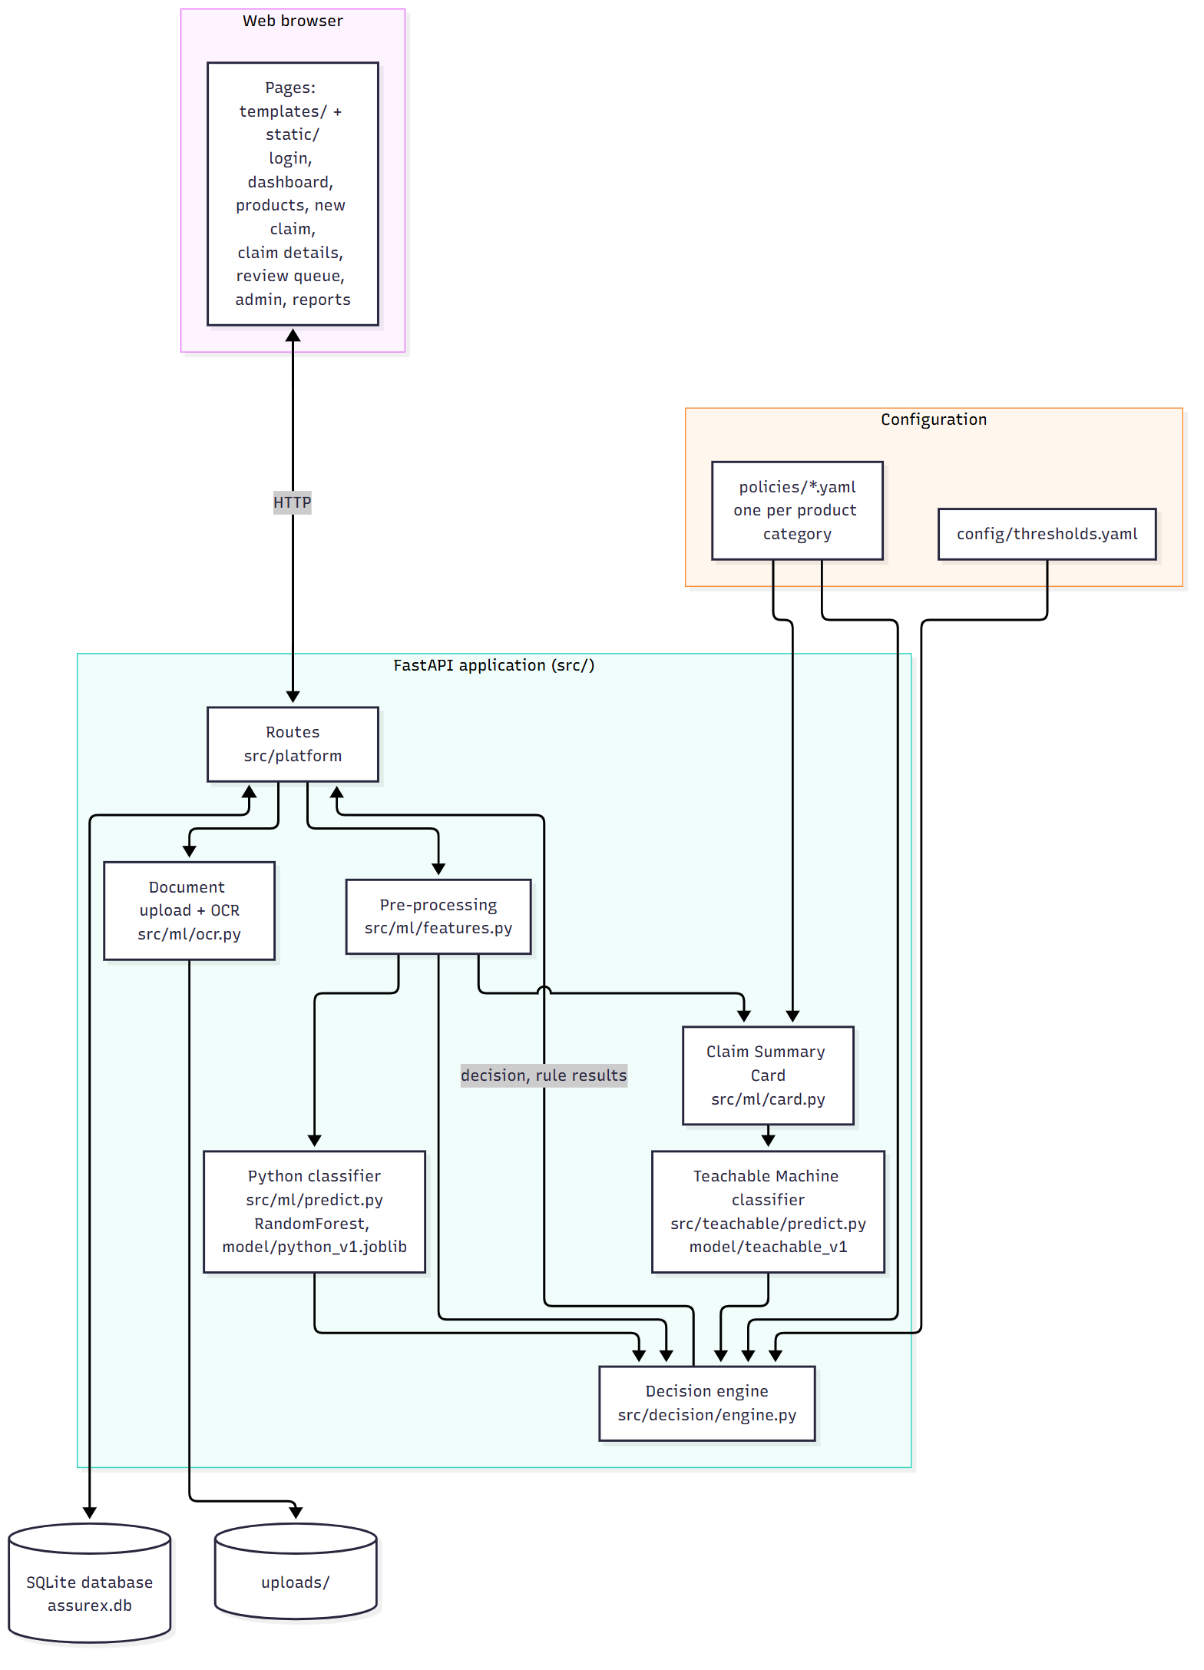
Figure 1: Application architecture (source: documentation/diagrams/architecture.mmd)

3.2 Module descriptions
Team note: Fill the owner column once the team settles who presents what. Each member must be able to explain their modules (SRS 1.8).
Module | Path | What it does | Owner
Web pages | templates/, static/ | All screens, shared app shell, charts, filters | [TO FILL]
Routes | src/platform/ | HTTP endpoints for accounts, products, documents, claims, review, admin | [TO FILL]
Data model | src/core/models.py, db.py | Database tables and sessions | [TO FILL]
Contracts | src/core/contracts.py | Shapes passed between modules: ClaimFeatures, ModelPrediction, DecisionResult | [TO FILL]
Pipeline | src/core/pipeline.py | Runs one claim through both models and the decision engine | [TO FILL]
OCR | src/ml/ocr.py | Reads receipt text with Tesseract and pulls out fields | [TO FILL]
Pre-processing | src/ml/features.py | Turns database records into ClaimFeatures | [TO FILL]
Python model | src/ml/predict.py, src/ml/scripts/train_model.py | Training and prediction for the tabular classifier | [TO FILL]
Claim Summary Card | src/ml/card.py | Draws the card image from ClaimFeatures | [TO FILL]
Teachable Machine | src/teachable/predict.py, evaluate.py | Loads the exported model, classifies cards, evaluation report | [TO FILL]
Dates | src/teachable/dates.py | Date parsing in several formats, warranty status | [TO FILL]
Decision engine | src/decision/engine.py | Model comparison, rules, contradictions, final decision, explanation | [TO FILL]
Dataset generator | dataset_generator/ | Generates the 1,500 claims, splits, cards and statistics | [TO FILL]
Policies and config | policies/, config/ | Warranty rules per category, comparison thresholds | [TO FILL]
Database scripts | database/ | Create tables, seed demo users, products and claims | [TO FILL]

3.3 Database design
Relational database (SQLite via SQLAlchemy). Thirteen tables: users, products, warranties, documents, claims, repair_records, model_versions, predictions, rule_results, review_actions, notifications, alerts and audit_log. Every prediction row points to the model_versions row of the model that made it (SRS xlviii), so retraining never changes old results. Documents keep a SHA-256 hash for duplicate detection (SRS xxxi).
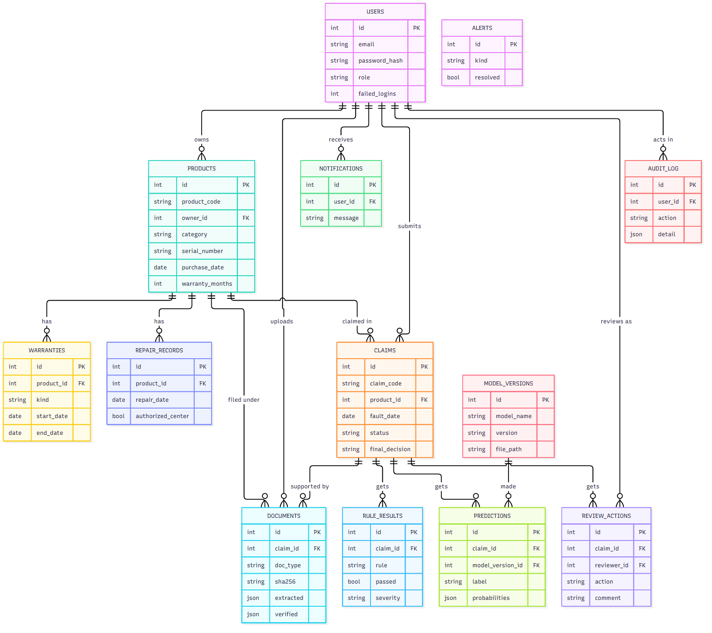
Figure 2: Entity-relationship diagram (main columns only) (source: documentation/diagrams/database_er.mmd)

3.4 Data dictionary

Claim dataset fields
Source: data/data_dictionary.md. The same fields are used in the CSV rows, the ClaimFeatures object and the Claim Summary Card.
Field | Type | Meaning
claim_code | text | Unique claim ID, CLM-#####
product_category | text | consumer_electronics, mobile_devices or small_appliances
product_age_days | int | Days from purchase to the claim
warranty_months | int | Coverage length from the category policy (12 or 24)
warranty_days_left | int | warranty_months x 30 - product_age_days; negative once expired
fault_category | text | Reported fault
days_purchase_to_fault | int | Days from purchase to fault; negative is a contradiction
previous_repairs | int | Number of earlier repairs
product_replaced_before | bool | Product already replaced once
physical_damage / water_damage | bool | Excluded damage flags
receipt / warranty_card / product_image / repair_report _present | bool | Which documents are attached
serial_matches | bool | Entered serial matches the documents
missing_documents | int | Mandatory documents missing, per the category policy
label | text | Valid Claim, Invalid Claim or Manual Review

Database tables
[TO FILL: one short table per database table (column, type, meaning) - copy from src/core/models.py, the comments there describe each column]

3.5 Data Flow Diagram
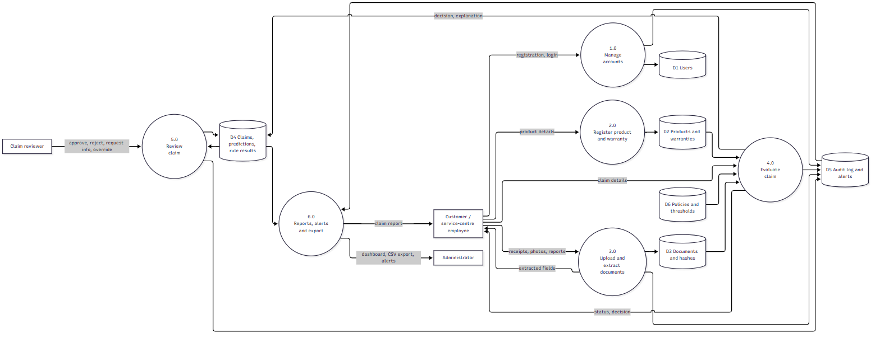
Figure 3: Level 1 data flow diagram (source: documentation/diagrams/data_flow.mmd)

3.6 Use Case Diagram
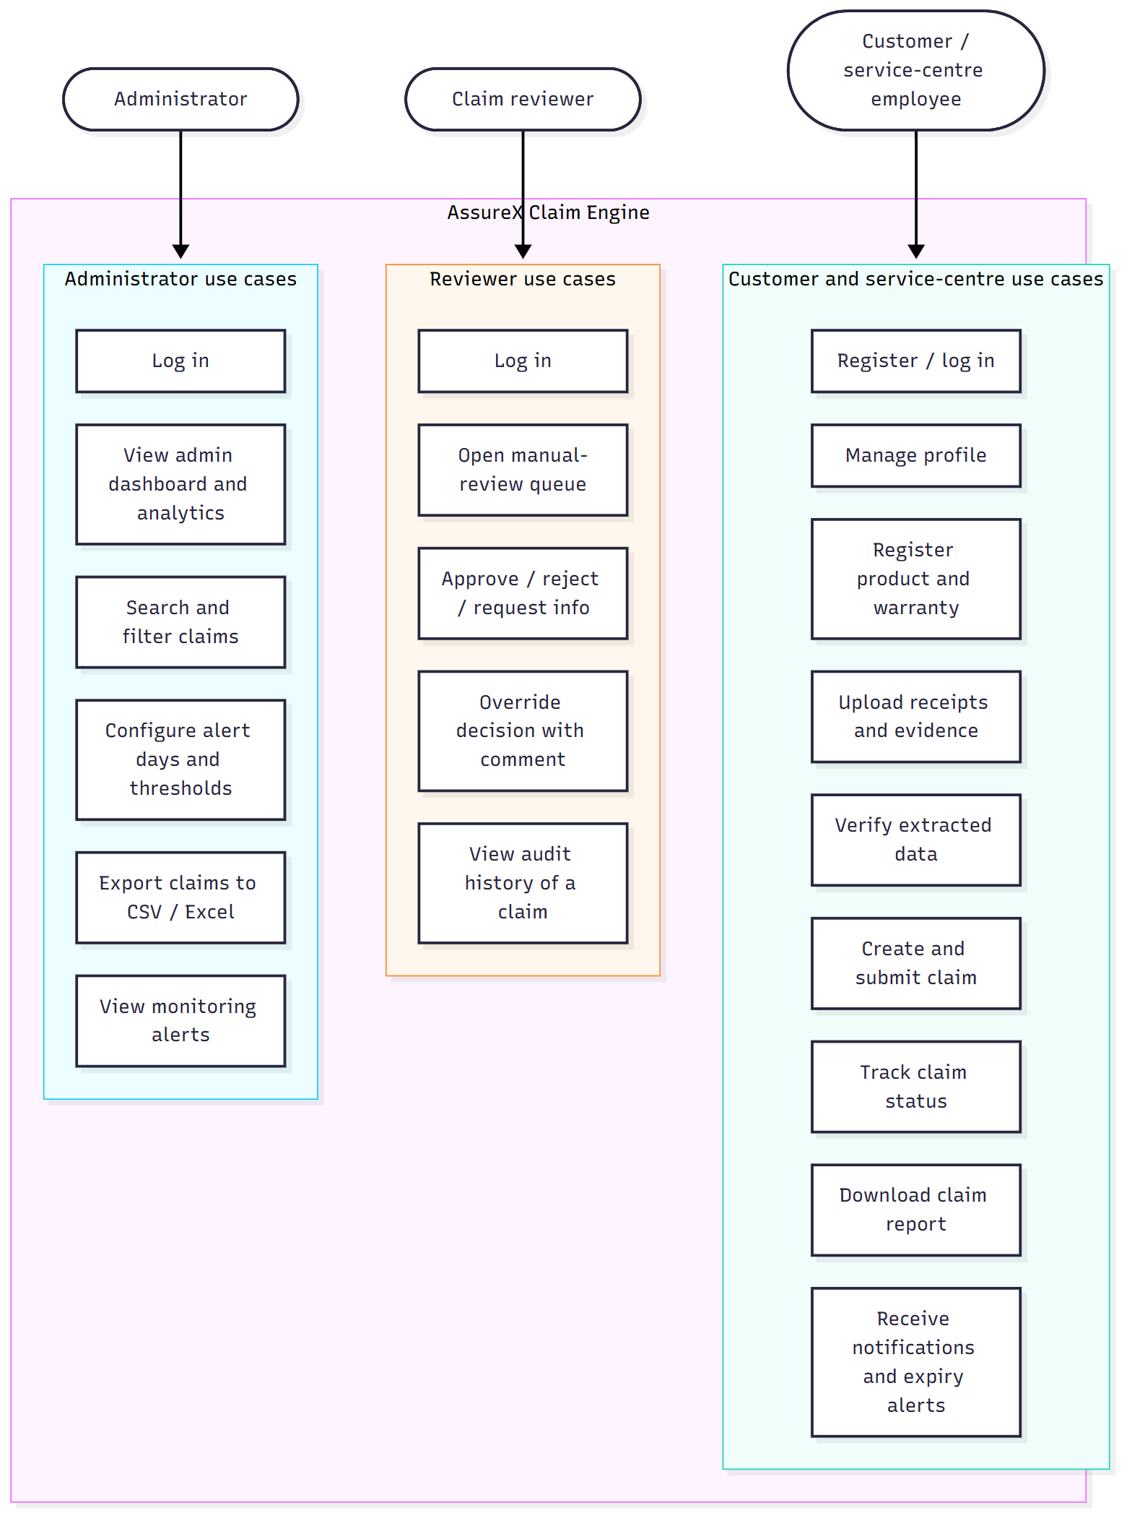
Figure 4: Use cases by role (source: documentation/diagrams/use_case.mmd)

3.7 Activity Diagram
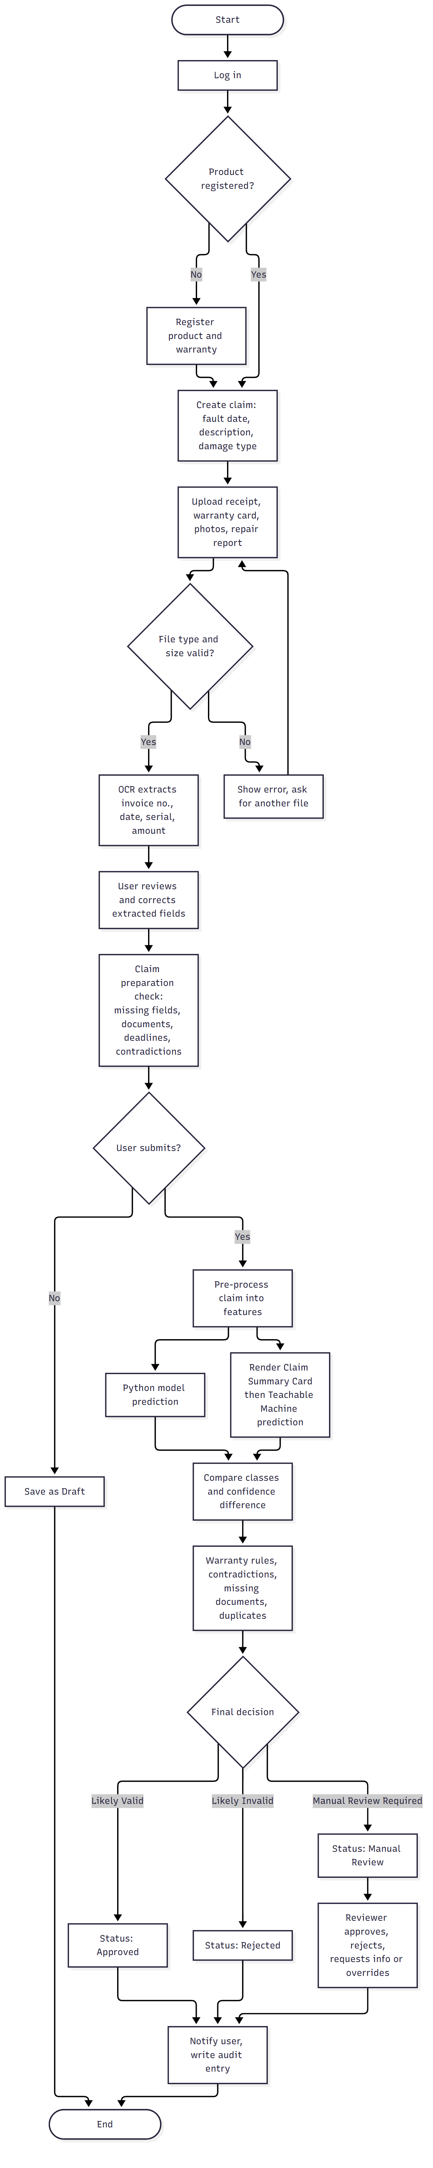
Figure 5: Activity diagram: preparing and submitting a claim (source: documentation/diagrams/activity_claim.mmd)

3.8 Sequence Diagram
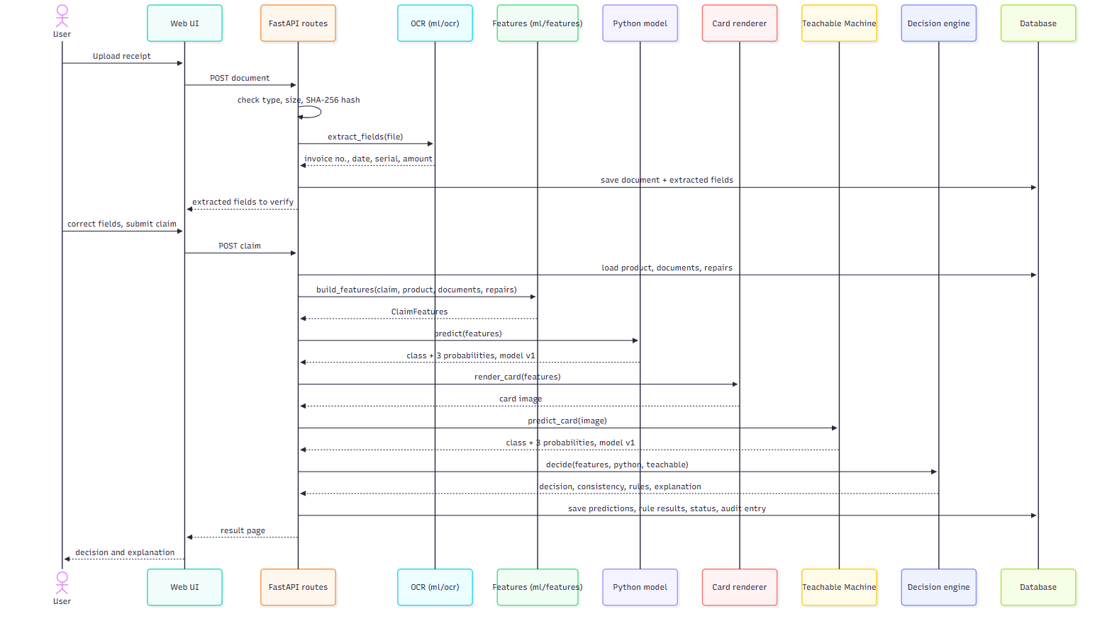
Figure 6: Sequence diagram: document upload and claim evaluation (source: documentation/diagrams/sequence_claim.mmd)

3.9 Decision Flow Diagram
Team note: Check this against src/decision/engine.py on submission day. If rules are added (unauthorized repair, reporting period, duplicates), update decision_flow.mmd and re-render the PNG.
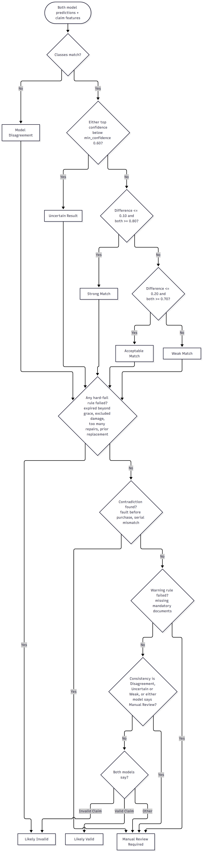
Figure 7: Decision flow: consistency status, then rules, then final decision (source: documentation/diagrams/decision_flow.mmd)

3.10 Rule-engine design
Rules live in one YAML file per product category in policies/. Each file holds the coverage length, warranty start condition, grace period, claim-reporting period, covered faults, exclusions, repair and replacement conditions, authorised service-centre requirement, mandatory and optional documents, and three rule lists: hard-fail, warning and manual-review. Comparison thresholds live in config/thresholds.yaml. The engine (src/decision/engine.py) reads both at run time, so changing a threshold or adding an exclusion is a file edit, not a code change.
Each rule check returns a RuleFinding with a severity: info (passed), warning (needs attention) or blocking (hard fail). Contradictions are collected separately. The final decision order is: any blocking finding gives Likely Invalid; a contradiction or warning gives Manual Review Required; otherwise the model consistency status and both predictions decide (Figure 7).
Policy file | Coverage | Grace period | Max covered repairs
consumer_electronics.yaml | 12 months | 14 days | 3
mobile_devices.yaml | 12 months | 0 days | 2
small_appliances.yaml | 24 months | 7 days | 2
[TO FILL: list of every rule the engine checks, its severity and the SRS requirement it covers - fill from engine.py when the rules are final]

4. Dataset and models

4.1 Dataset description
One common dataset of 1,500 unique synthetic claims, 500 per class (Valid Claim, Invalid Claim, Manual Review). It is stored twice: as CSV rows for the Python model (data/claims_train.csv, claims_val.csv, claims_test.csv) and as Claim Summary Card images for Teachable Machine (data/cards/). data/cards/card_mapping.csv links every Claim ID to its image files.
Split | Claims | CSV rows | Card images
Training (70%) | 1,050 | 1,050 | 2,100 (two variations per claim)
Validation (15%) | 225 | 225 | 225
Testing (15%) | 225 | 225 | 225
Total | 1,500 | 1,500 | 2,550
Statistics: data/dataset_statistics.md (generated by dataset_generator/report.py).

4.2 Dataset-generation method
dataset_generator/generator.py builds every claim from a named scenario, never from an unconstrained random draw. Each scenario is a written rule applied against the real values in policies/*.yaml. There are ten scenarios:
Class | Scenarios
Valid Claim | normal_valid, valid_with_repair_history, valid_near_expiry
Invalid Claim | expired_warranty, excluded_damage, excessive_repairs
Manual Review | missing_documents, serial_mismatch, contradiction_bad_dates, borderline_disagreement
The split is stratified (350 / 75 / 75 claims per class) and made before any card is drawn, so no claim appears in more than one split. About 4% of labels in each split are then flipped to another class on purpose, so the models cannot score 100% by memorising the rules. Full definitions: data/scenarios.md.

4.3 Data pre-processing and feature-engineering steps
- Dates are parsed in several formats (src/teachable/dates.py) and turned into day counts.
- Derived features: product age, warranty days left, days from purchase to fault, count of missing mandatory documents.
- Missing values: no fault date gives 0 days; missing serial on either side counts as a match (the rule engine flags it separately); unknown fault category becomes 'unknown'.
- Categorical encoding: one-hot for product_category and fault_category (unknown values ignored).
- Scaling: StandardScaler on the six numeric features; the eight yes/no flags pass through as 0/1.
- All of this is one scikit-learn Pipeline saved inside model/python_v1.joblib, so training and prediction use the same steps.
[TO FILL: check this list against src/ml/features.py on the final day]

4.4 Python classification model design
Input: 16 features (6 numeric, 2 categorical, 8 boolean). Output: one of three classes plus a probability for each. Three algorithms were compared; RandomForest was selected and saved as model/python_v1.joblib (version v1).
Algorithm | Hyperparameters | Test accuracy | Weighted F1
Random Forest | 150 trees, max depth 12 | 95.11% | 0.9512
Gradient Boosting | 120 trees, learning rate 0.1, depth 5 | 94.22% | 0.9422
Logistic Regression | max_iter 1000 | 76.89% | 0.7709
Source: model/metrics.json, written by src/ml/scripts/train_model.py.

4.5 Python model-training procedure
Run python src/ml/scripts/train_model.py. It loads the three CSV splits, fits each candidate pipeline on training + validation data, scores it on the test split, keeps the best one and writes model/python_v1.joblib, model/metrics.json and reports/model_comparison.md.
[TO FILL: cross-validation results, validation-set results and feature importance - not produced by the script yet; add once they are]

4.6 Google Teachable Machine model design
A standard image project with three classes named exactly Valid Claim, Invalid Claim and Manual Review. Input is the 448 x 448 Claim Summary Card, which Teachable Machine resizes to 224 x 224. The card shows claim facts only: warranty status, fault, damage, fault timing, repairs against the policy limit, replacement, serial check, missing-document count and each document's presence. Every fact has a coloured status chip (green fine, amber borderline, red problem, blue for the fault type). The card never shows the Python prediction, a confidence score or the final decision.
Exported as Keras (model/teachable_v1/keras_model.h5 + labels.txt) and loaded in the app with tf-keras by src/teachable/predict.py.
Project link: https://drive.google.com/file/d/1ruZkYKbzm37YkyMXrzRzUZW-X4I73XdM/view?usp=sharing

4.7 Google Teachable Machine training procedure
- Uploaded data/cards/train/<class>/ only: 700 Valid, 704 Invalid, 696 Manual Review images. Validation and test cards were never uploaded.
- Settings: 50 epochs, batch size 16, learning rate 0.001 (defaults).
- Run 1 (first card design): 73% on Teachable Machine's holdout (Valid 0.95, Invalid 0.68, Manual Review 0.57). Most errors were Invalid or Manual Review claims called Valid.
- Why: repair count and fault-before-purchase were shown only as small grey text, unreadable at 224 px. A logistic regression on the card pixels failed on exactly the same claims (69%).
- Fix: redesigned the card so every fact has a coloured status chip. The same pixel check then reached 96%.
- Run 2 (new cards, same settings): 94% on Teachable Machine's holdout (Valid 0.98, Invalid 0.93, Manual Review 0.91).
- Validation, test and live claims use the dark card variation: 92.9% on dark validation cards against 81.3% on light ones.
Team note: Add the screenshots from screenshots/teachable/ here: run1_* and run2_* (classes, settings, under the hood, test predictions).

4.8 Model evaluation
Model | Validation accuracy | Test accuracy | Source
Python (Random Forest) | [TO FILL] | 95.11% | model/metrics.json
Teachable Machine | 92.89% | 90.67% | reports/teachable_evaluation.md

4.9 Confusion matrix

Python model (Random Forest), test split
Actual \ Predicted | Invalid Claim | Manual Review | Valid Claim
Invalid Claim | 70 | 2 | 2
Manual Review | 1 | 72 | 2
Valid Claim | 1 | 3 | 72

Teachable Machine, test split
[TO FILL: copy the test confusion matrix from reports/teachable_evaluation.md]

4.10 Accuracy, precision, recall and F1-score
[TO FILL: per-class precision, recall and F1 for both models - Teachable Machine figures are in reports/teachable_evaluation.md; Python per-class figures still to be added to metrics.json]

4.11 Model prediction and confidence comparison
For each claim the application checks whether both models predicted the same class and calculates Confidence Difference = |Python top-class confidence - Teachable Machine top-class confidence|. The consistency status is then set from config/thresholds.yaml:
Status | Condition (checked in this order)
Model Disagreement | The predicted classes differ
Uncertain Result | Either model's top confidence is below 0.60
Strong Match | Difference <= 0.10 and both confidences >= 0.80
Acceptable Match | Difference <= 0.20 and both confidences >= 0.70
Weak Match | Same class, anything else
Model Disagreement, Uncertain Result and Weak Match send the claim to manual review.
[TO FILL: summary of the comparison report on 30+ unseen test claims (reports/) - match rate, average difference, main disagreements and why]

5. Testing

5.1 Testing strategy
Team note: Automated tests are in tests/ and run with pytest. The SRS (1.10.8) lists the test types it expects: functional, integration, boundary, negative, security, database, OCR, Python model, Teachable Machine, model comparison, rule engine, contradiction, missing document, duplicate claim, serial mismatch, low confidence, model disagreement, plus a hidden-test readiness checklist. Map each to a test file or a manual test case below.
Test type | Where / how | Result
Unit and model tests | tests/ (pytest) | [TO FILL: pass count on final run]
Teachable Machine evaluation | python -m src.teachable.evaluate | val 92.89%, test 90.67%
Rule engine / contradiction / missing documents | tests/test_decision.py | [TO FILL]
Duplicate claim, serial mismatch | [TO FILL] | [TO FILL]
Security (login, roles, file upload) | [TO FILL] | [TO FILL]
Hidden-test readiness checklist | [TO FILL] | [TO FILL]
Demonstration claims required by SRS 1.10.8:
Case | Claim ID used | Result
valid claim | [TO FILL] | [TO FILL]
invalid claim | [TO FILL] | [TO FILL]
manual-review claim | [TO FILL] | [TO FILL]
expired warranty | [TO FILL] | [TO FILL]
missing documents | [TO FILL] | [TO FILL]
duplicate claim | [TO FILL] | [TO FILL]
contradictory claim | [TO FILL] | [TO FILL]
serial-number mismatch | [TO FILL] | [TO FILL]
unauthorised repair | [TO FILL] | [TO FILL]
tricky boundary date | [TO FILL] | [TO FILL]
the two models disagree | [TO FILL] | [TO FILL]

6. Security, privacy and limitations

6.1 Security considerations
Team note: Write only what is really implemented on the day: role-based access, password hashing method, file type and size checks, SHA-256 document hashes, failed-login monitoring, no technical details in error messages, the final decision never comes from an external AI API.
[TO FILL: security considerations]

6.2 Privacy considerations
Team note: Synthetic data only, no real customer information in the repo; uploads kept out of git; what personal data is stored and who can see it per role.
[TO FILL: privacy considerations]

6.3 Limitations
- The dataset is synthetic; real claims will contain situations the ten scenarios do not cover.
- Teachable Machine reads the card as a picture, so it depends on the card design; the light card variation scored clearly lower (81.3% on validation).
- The Teachable Machine model needs TensorFlow, which is too large for most free hosting plans.
[TO FILL: more limitations (OCR quality, anything not finished)]

6.4 Future enhancements
[TO FILL: future enhancements]

Appendix A. Screenshots
[TO FILL: screenshots of the working application from screenshots/]

Appendix B. Links
Item | Link
GitHub repository | https://github.com/41ss/AssureX-Claim-Engine
Teachable Machine project | https://drive.google.com/file/d/1ruZkYKbzm37YkyMXrzRzUZW-X4I73XdM/view?usp=sharing
Demonstration video | [TO FILL]
Technical blog | [TO FILL]
Deployed application | [TO FILL or 'local installation only']

Appendix C. Team contributions
Member | Modules | Deliverables
[TO FILL] | [TO FILL] | [TO FILL]
[TO FILL] | [TO FILL] | [TO FILL]
[TO FILL] | [TO FILL] | [TO FILL]
[TO FILL] | [TO FILL] | [TO FILL]
[TO FILL] | [TO FILL] | [TO FILL]

