QUESTION-08

PART-1

// PROGRAM USING FOR LOOP

#include <stdio.h>

int main() {

int i;

for (i = 1; i < 11; ++i)

{

printf("%d ", i);

}

return 0;

}

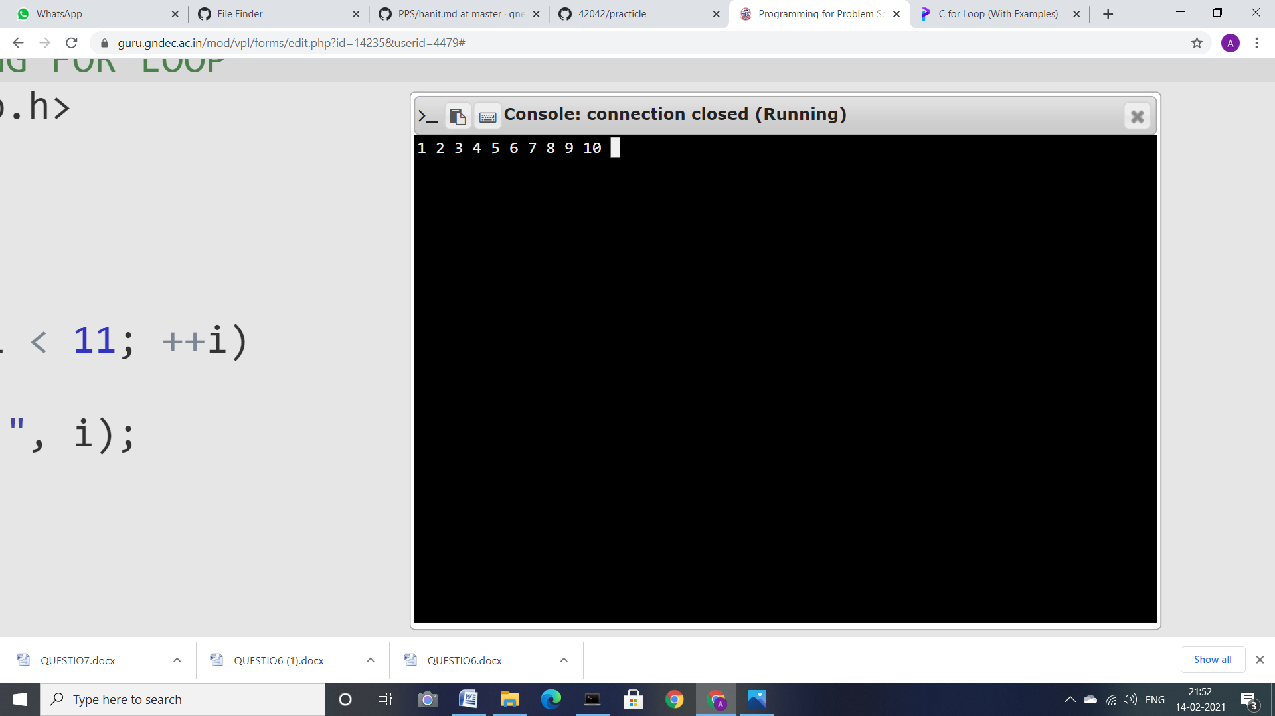

PART-2

//PROGRAM USING NESTED FOR LOOP

#include <stdio.h>

int main()

{

int a, b;

for(a = 1; a <= 5; a++)

{

for(b = 1; b <= 5; b++)

{

printf("%d ", b);

}

printf("\n");

}

return 0;

}

