QUESTION-09

PART-1

// PROGRAM USING WHILE LOOP

#include <stdio.h>

int main()

{

int i = 1;

while (i <= 5)

{

printf("%d\n", i);

++i;

}

return 0;

}

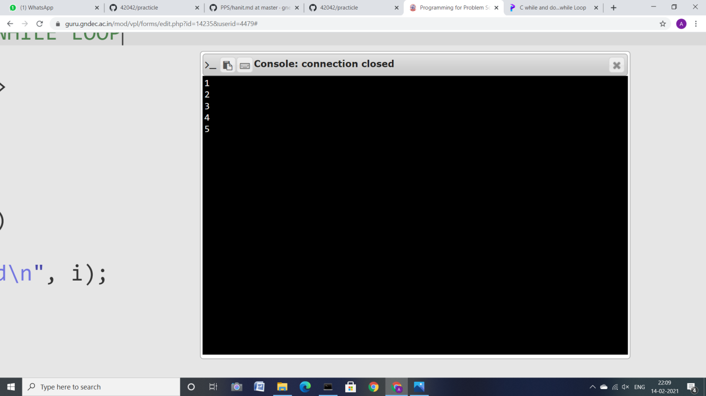

PART-2

//PROGRAM USING DO WHILE LOOP

#include <stdio.h>

int main()

{

int j=0;

do

{

printf("Value of variable j is: %d\n", j);

j++;

}

while (j<=3);

return 0;

}

