**Contents**

HSPEXP+ Version 1.0 User’s Manual 1

Disclaimer 2

Acknowledgements 2

User Assistance and Feedback 3

Introduction 3

Background 3

Capabilities of HSPEXP+ 4

Hydrologic Calibration 4

Water Quality Calibration 5

Automated Graph Generation 5

Caveats 6

Using HSPEXP+ 6

User Interface 6

Setting up the Project 7

Setting up UCI and Other Files 7

Setting up EXS File(s) 9

Setting up graph specification file for generating additional graphs 11

Setting up BASINS Observed Water Quality Data File 13

Running HSPEXP+ 14

Resolving Errors 14

References 15

January 2015

HSPEXP+ Version 1.0 User’s Manual

Anurag Mishra, Paul B. Duda, Mark Gray, Brian R. Bicknell, Anthony S. Donigian, Jr., Rebecca Zeckoski*

AQUA TERRA Consultants, Mountain View, California 94043 

*Biological Systems Engineering Virginia Tech, Virginia 24061

**Disclaimer**

HSPEXP+ has been developed by AQUA TERRA Consultants to support calibration of watershed models that are developed using HSPF. It is an open source project similar to US EPA’s BASINS and is released free of cost to support modelers who are using HSPF. Although it is under active development, no active support is available for HSPEXP+ by AQUA TERRA Consultants or any other agency. AQUA TERRA Consultants and the authors do not assume any responsibility for system operation, output, interpretation, or use.

**Acknowledgements**

HSPEXP+ is being developed by AQUA TERRA Consultants for support of watershed modeling projects. Dr. Anurag Mishra is the Project Manager, responsible for the design, implementation, testing, and continued development of the program. Technical and administrative guidance is provided by Mr. Paul Duda, Mr. Mark Gray, Mr. Brian Bicknell, and Mr. Tony Donigian. HSPEXP+ is under continuous development, and new capabilities are added to meet the priority needs of the user community, as and when additional resources are available.

The Load Allocation Reports were supported by the Minnesota Pollution Control Agency through its Clean Water Fund. 

Dr. Rebecca Zeckoski from Virginia Tech provided assistance in developing the initial user interface, and coding the expert guidance.

AQUA TERRA Consultants thanks the modelers who tested the initial versions of HSPEXP+ and provided valuable feedback.

**User Assistance and Feedback**

As indicated earlier, active support for HSPEXP+ is not available, however feedback may be provided at [hspexpplus@aquaterra.com](mailto:hspexpplus@aquaterra.com).

**Introduction**

HSPEXP stands for Expert System for Calibration of HSPF. The legacy version of HSPEXP was developed by the USGS (Lumb et al., 1994). HSPEXP+ is the next generation of HSPEXP.

HSPEXP+ has been completely re-designed, and shares only the legacy input file format, mathematical formulae, and algorithms from HSPEXP. HSPEXP+ can perform several additional functions, and it is evolving into a comprehensive hydrologic and water quality calibration tool for HSPF.

**Background**

HSPEXP interactively allows the user to edit the input User Control Input (UCI) file for the Hydrologic Simulation Program--Fortran (HSPF), run HSPF simulations, produce plots of HSPF hydrology output compared to observed values, compute error statistics for a simulation, and provide the user with expert advice on which parameters should be changed to improve the calibration. In general, use of HSPEXP is an interactive process that requires repeating the cycle of simulation, computing statistics, reviewing plots, getting advice, and modifying parameters.

HSPEXP uses over 35 rules involving over 80 conditions to recommend parameter adjustments. The rules are divided into four groups -- annual volumes, low flows, storm flows, and seasonal flows. Rules in subsequent groups are not tested until all rules in the previous group ‘pass.’ The rules are based on the experience of experts in the use of HSPF in a range of climates and physiographic regions.

Artificial intelligence (AI) was first used with HSPF on a project at the Stanford Research Institute (SRI), in Menlo Park, California, to estimate initial values for model parameters. HSPEXP is the result of a USGS project to create an expert system to assist with the calibration of a watershed model. The prototype was developed with AI software tools, and when properly refined was converted to ANSI standard Fortran using the Graphical Kernel System (GKS) for portability.

Meteorological records of precipitation and estimates of potential evapotranspiration in a Watershed Data Management (WDM) file are required for watershed simulation using HSPF. Air temperature, dew point temperature, wind, and solar radiation also are required for simulation of snow accumulation and melt. Air temperature, wind, solar radiation, humidity, cloud cover, tillage practices, point sources, and (or) pesticide applications may be required for water quality simulation. Physical measurements and related parameters are required to describe the land area, channels, and reservoirs.

Output options include tables of statistics comparing observed data and simulated results, ten different types of graphical presentations, and tables of the expert advice. Time-series output from the simulation is written to the WDM file. Output may be viewed interactively or written to text files for printing or analysis in a spreadsheet program.

HSPEXP has been used to support HSPF application to numerous watersheds including, the Patuxent River, Maryland, the Lesueur River Basin, Minnesota, and the Truckee River Basin, California/Nevada.

HSPEXP was developed for older operating systems, and it has been reported by multiple users that it is not suitable for current computers. The USGS has stopped active development of HSPEXP.

Building on the capabilities of HSPEXP, HSPEXP+ was developed at AQUA TERRA Consultants to facilitate hydrologic and water quality calibration projects. The software is available free of cost at the AQUA TERRA Consultants website, and its source code is available along with the BASINS source code.

**Capabilities of HSPEXP+**

HSPEXP+ can help in hydrologic and water quality calibration of a watershed model that is developed using HSPF. HSPEXP+ produces several graphs for hydrologic calibration. HSPEXP+, can also be used to generate additional graphs (timeseries, frequency duration, and scatter plots) using its automated graph generation capability.

Unlike its predecessor HSPEXP, HSPEXP+ cannot be used to edit HSPF UCI files interactively, and it cannot generate the BASINS Specifications (EXS) file. HSPEXP+ users must prepare the EXS file in a text editor, and edit the UCI file using WinHSPF or a text editor (based on the calibration results and advice generated by HSPEXP+).

**Hydrologic Calibration**

HSPEXP+ uses the Basin specification file (EXS file, extension “*.exs”) to obtain information about the calibration site, observed flow time series dataset, simulated time series datasets, drainage area, storm periods, error criteria, etc. The format of the EXS file is consistent with that used in HSPEXP. To read more about this file, please refer to the HSPEXP manual (Lumb et al., 1994). The content and format of the EXS file is also described at the end of this document.

HSPEXP+ does not have the capability to produce the EXS file (it is currently under development). Please refer to the HSPEXP manual and/or start with an existing EXS file to make a file for your watershed.

Listed below are HSPEXP+ capabilities for hydrologic calibration:

1. Produce land use and watershed area reports to provide a quick check of watershed segment connectivity.
2. Produce Expert Statistics for hydrology calibration (using the computations from the original HSPEXP) at multiple sites in the watershed, in simple text files. The EXS file can list more than one site, or the folder containing the model calibration files can have multiple EXS files, for multiple locations.
3. Produce advice for model calibration for each calibration site.
4. Produce additional statistics including annual, monthly, and daily flow comparisons.
5. Produce overall, annual, and monthly timeseries graphs, flow frequency duration graphs, cumulative flow graphs, and timeseries graphs of other components such as potential evapotranspiration, lower zone storage, upper zone storage, etc.
6. By default, HSPEXP+ (and its predecessor, HSPEXP) considers May, June, July to be the summer months, and December, January, February to be the winter months for calculating seasonal statistics. In HSPEXP+, summer and winter months can be specified in the EXS file, if changes to the default seasons are needed. Please refer to the EXS file section for more details.
7. All graphs produced by HSPEXP+ are high quality PNG format that can be directly inserted into reports and presentations.
8. All reports produced by HSPEXP+ can be directly opened in any spreadsheet program for quick viewing, formatting, and presentation.
9. All graphs and reports are produced in a time-stamped folder with a copy of the UCI file for reference.
10. HSPEXP+ can generate water balance reports in several layouts including overall water balance, annual water balance, and water balance grouped by land use, etc.

**Water Quality Calibration**

For water quality calibration tasks, HSPEXP+ does not require the EXS file.

1. HSPEXP+ generates nutrient balance reports in a variety of layouts for sediment, total nitrogen, and total phosphorus.
2. HSPEXP+ does not calculate statistics to compare observed and simulated water quality data; however, it provides reports and graphs to better understand the water quality simulation, and guide changes in the parameters. It does not provide advice for water quality parameter adjustments.

**Automated Graph Generation**

1. HSPEXP+ can generate additional graphs for water quality, snow depth, frequency duration, scatter plots, etc. The specifications for these graphs must be provided in a comma-separated file (*.csv format) with filename “AutomatedGraphs.csv.”
2. The time series datasets for these graphs can be obtained from a WDM file, HBN file, or a DBF (BASINS Observed WQ file format) file.
3. HSPEXP+ also outputs the dataset used for generating the graphs in tab delimited text files. Users can utilize this data for additional analysis outside of BASINS or HSPEXP+.

**Caveats**

1. HSPEXP+ is under development and although we have tested it on several computers and watersheds, it may not work for your specific computer configuration or for your specific HSPF watershed model.
2. HSPEXP+ needs extensive testing with different projects.
3. HSPEXP+ assumes that observed hydrology data is continuous for the analysis period.
4. HSPEXP+ expects that the model is run with English units.
5. HSPEXP+ expects that the UCI file, and output WDM file are in the same folder.
6. If Automated Graphs are requested, HSPEXP+ expects “AutomatedGraphs.csv” to be in the same folder as the other model files. This graph specification filename is hardcoded.
7. HSPEXP+ expects that the binary (*.hbn) output file(s) contain output from all of the model operations at a one month interval.
8. HSPEXP+ assumes that the Ammonia (NH3+NH4), Nitrate (NO3), Orthophosphate (ORTHO P), and Biochemical Oxygen Demand (BOD) constituents that are simulated in PERLND PQUAL and IMPLND IQUAL have the exact same names as specified in parentheses here, and that they are simulated with the units of lbs.

**Using HSPEXP+**

Using HSPEXP+ for an HSPF project requires some preparation by the user after setting up the model.

**User Interface**

HSPEXP+ has a simple user interface. Basic explanations are provided in the User Interface itself. The user needs to browse to the UCI file for the project. The remaining options can be selected or deselected using check boxes. Any grayed-out options are unavailable, as they are under development. 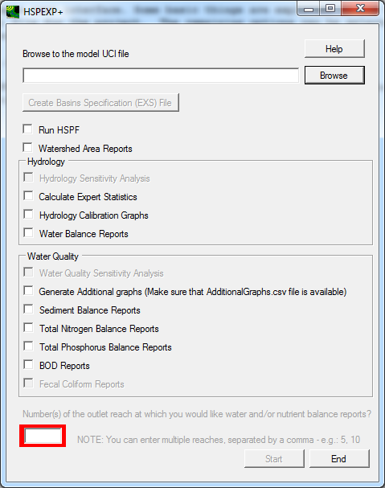

Setting up an HSPF project for analysis using HSPEXP+ is explained in the following sections.

**Setting up the Project**

Using HSPEXP+ requires the user to modify the UCI file, EXS file(s), and optionally, provide a graph specification file.

**Setting up UCI and Other Files**

HSPEXP+ requires that the name of the UCI file and output WDM file be less than eight characters. The output files from HSPF (WDM and HBN files) should be in the same folder as the UCI file. Although HSPF does not require separate WDM files for output and input (there can be as many as four WDM files for each HSPF model), it is recommended to save the output datasets in a different WDM file than the input datasets. When doing hydrologic calibration, the WDM file referred to in the EXS file is used to read the simulated output. The echo (.ECH) file from the HSPF run is used to obtain the time stamp of the most recent HSPF run.

The user must set up HSPF such that the hydrologic calibration output is generated at each location of interest. To generate the hydrologic calibration output at the location of interest, open the UCI file in WinHSPF3.0. Open “Output Manager.” 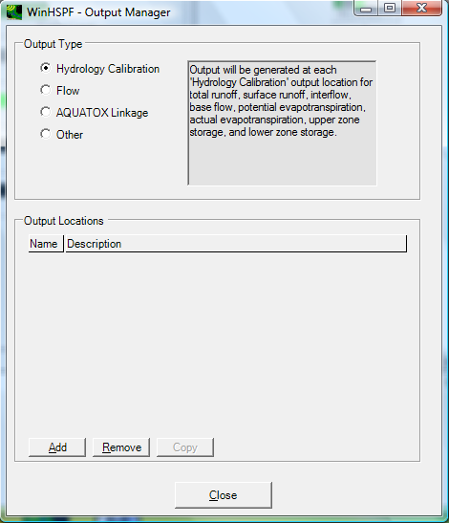

Click the radio button beside “Hydrology Calibration,” and then click “Add.” In the �WinHSPF- Add Output� window, select the output reach of interest. Change the BASE WDM DSN, if needed. 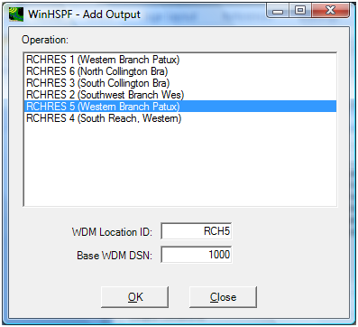

Click “Close” to close the Add Output Window. Save the UCI file, and run it to populate the data in the newly created datasets. The newly created datasets should be included in the EXS file as described in the original HSPEXP manual.

If water balance or nutrient balance reports are requested, then HSPEXP+ requires that the GEN-INFO table should have names for each PERLND, IMPLND, and RCHRES. HSPEXP+ uses this information from the GEN-INFO table to group the output. If the GEN-INFO table does not have a proper land use description or the name of a RCHRES, the output in some of the reports will not be grouped in a user-friendly fashion.

If nutrient balance reports are required, then the user must name their constituents as follows, and the units must be lbs.

1. Ammonia should be named “NH3+NH4”
2. Nitrate should be named “NO3”
3. Orthophosphorus should be named “ORTHO P”
4. Biochemical Oxygen Demand should be named “BOD”

**Setting up EXS File(s)**

HSPEXP+ uses the Basin Specification File (EXS file, extension *.exs) to obtain information about the calibration site, observed flow dataset, simulated datasets, drainage area, storm periods, error criteria, etc. The format of the EXS file is consistent with that used in HSPEXP. To read more about this file, please refer to the HSPEXP manual or see the EXS file information at the end of this document. HSPEXP+ does not have a capability to produce the EXS file. The EXS file can be used for calibration at one to ten separate locations. If a user wants to calibrate at more than ten locations, or if the storm dates are different for different locations, the user can provide a separate EXS file for each location. A user may have as many EXS file as needed.

When used with HSPEXP+, the EXS file can have comments, following the same format as a UCI file. Any line with “***” in the first 80 spaces is treated as a comment by HSPEXP+ (unlike its predecessor, HSPEXP).

As noted in the Hydrologic Calibration section, HSPEXP+ considers May, June, and July to be the summer months, and December, January, February to be the winter months for calculating seasonal statistics. In HSPEXP+, summer and winter months can be specified in the EXS file if needed, using the keyword “Seasons:”, at the end of the EXS file. Add a line with words, “Seasons:”; add a line with numbers for the summer months, separated by commas; and add a second line for the winter months separated by commas.

An example EXS file is shown below. Please refer to the EXS file documentation at the end of this document, or the HSPEXP users manual (page 34) for details about the rest of the format. 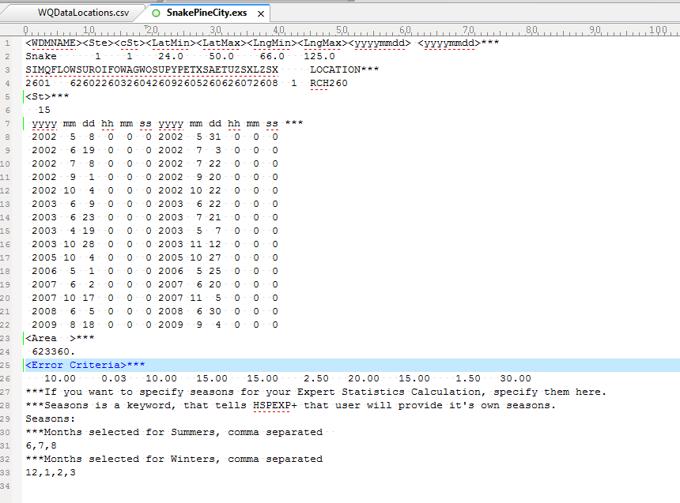

**Setting up Graph Specification File for Generating Additional Graphs**

This file can be used for producing additional graphs, if needed. The graph specification file should be named “AutomatedGraphs.csv,” and should exist in the same folder as the UCI file. The graph specification file is a *comma separated file*, where the user can provide specifications for as many graphs as necessary. In this file, blank lines, lines starting with a comma (“,”), or lines containing “***” are not read by HSPEXP+, i.e., they are comments.

In the graph specification file, there are two types of input required. The first is the general specification of the graph. For this type of input, the user specifies the type of the graph (timeseries, scatter, or frequency duration), name of the output file (in *.png or *.emf format), number of data series (curves) to be plotted for each graph, axis labels, etc. In the second type of input, the user provides information about each curve that will be plotted. HSPEXP+ expects one line of input for each curve that will be plotted. Each input line provides information about the source data file, WDM DSN of the dataset, or location and constituent of the dataset, type (point or line) of the curve, color of the curve, legend of the curve, etc. Once the information about each curve is provided, the specification for the next graph may be provided.

The first two lines of the graph specification file are header lines. The first header line has headings for general specifications of a graph, and the second line has headings for specifications of individual curves.

**General Specification of the Graph**

The list below explains all the headings for the general specifications of the graph. Each graph will have one line for general specifications.

1. Type of Graph: The type of graph can be “Timeseries”, “Frequency” or “Scatter”.
2. Destination File Name: A unique output file name must be provided with an extension of *.png or *.emf.
3. Number of Data Series: An integer value indicating the number of curves in the graph.
4. Y-Axis Label: Label for Y Axis (if one writes deg-, or mu-, it is converted to the appropriate symbol for “degrees” or “micro”.)
5. X-Axis Label: Label for X-Axis (may be blank).
6. Aux-Axis Label: Label for Auxiliary Axis, if needed.
7. Right Axis Label: Label for Right Axis, if needed.
8. Start Date: Start Date in Julian Format. This date will be used to subset the input dataset. If start and end dates are blank, the dates are read from the simulation time span in the UCI file.
9. End Date: End Date in Julian Format. This date will be used to subset the input dataset.
10. Y-Axis Limit (Min): Minimum value for Y-Axis (may be blank).
11. Y-Axis Limit (Max): Maximum value for Y-Axis (may be blank).
12. Aux-Axis Limit (Min): Minimum value for Aux-Axis (may be blank).
13. Aux-Axis Limit (Max): Maximum value for Aux-Axis (may be blank).
14. Right-Axis Limit (Min): Minimum value for Right-Axis (may be blank).
15. Right-Axis Limit (Max): Maximum value for Right-Axis (may be blank).
16. Y-Axis Log?: Should the Y-Axis be a log scale? Please write “yes” or leave it blank.
17. Aux-Axis Log?: Should the Aux-Axis be a log scale? Please write “yes” or leave it blank.
18. Right-Axis Log?: Should the Right-Axis be a log scale? Please write “yes” or leave it blank.
19. Season Start Month/Day: If you want to plot only seasonal data (for example, only winter months for snow depth frequency duration), provide the start day of the season (for example, 10/1).
20. Season End Month/Day: If you want to plot only seasonal data (for example, only winter months for snow depth frequency duration), provide the end day of the season (for example, 4/30).

**Specification for Curve**

This list explains all the headings for the specifications of each individual curve in the graph.

1. Axis for the Curve: The curve can be plotted on “Left”, “Right”, or “Aux” axis. For a frequency graph, only a left axis option is available. For scatter graphs, provide the names of axes as “X-Axis,” or “Y-Axis” to differentiate between dependent and independent variables. For scatter graphs, a regression line and/or a 45-deg line may be generated. Instead of Axis for the curves, write, “Regression” and/or, “45-deg line”. These two lines do not need any source.
2. Data Source: The data source can be a WDM file (absolute path or relative path must be provided), a BASINS Observed WQ file, or a HBN file.
3. DSN Number, if WDM File. Location, if DBF or HBN File: If the dataset is read from a WDM file, provide the DSN number, or else provide the location name.
4. Blank, if WDM File. Constituent, if DBF or HBN File: Leave it blank if the dataset is read from a WDM file, or else provide the constituent name.
5. Plot Type (Line or Point): “line” or “point” indicating the type of the plot.
6. Color of Plot: Write the color of the plot (line or points).
7. StepType: Write “nonstep” for continuous line, and either “forwardstep” or “rearwardstep” for the step type plots.
8. Symbol Type, if Point Graph: The available options are circle, square, plus, diamond, star, hdash, vdash, triangle, triangledown, and xcross. Leave this specification blank for line graphs.
9. Size of Line or Point: Size of line or points can be provided as an integer value.
10. Label for the Curve: User can provide a label for the curve, or leave it blank for HSPEXP+ to generate a default label. User can also write “don’t show” to not show the label and symbol for the curve in the legend
11. Aggregation: User can aggregate the data from the existing time step to daily, monthly, or yearly.
12. Aggregation type: User can select the type of aggregation as average, min, max, or sum.

An example graph specification file, when opened in a spreadsheet program is shown below. 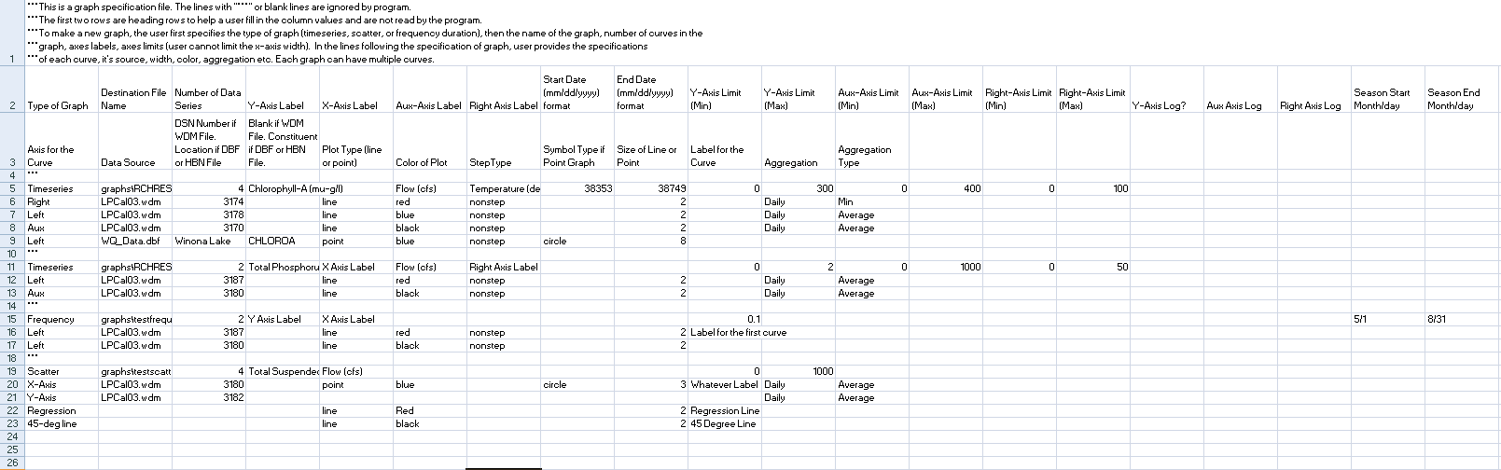

**Setting up BASINS Observed Water Quality Data File**

The observed Water Quality Data can be provided in a DBF file for BASINS or HSPEXP+ to read. This format is useful when the data is at a non-continuous interval. The DBF file can be edited or created in LibreOffice or OpenOffice (Excel 2007 and newer versions do not allow saving to this format). This file format has only five columns, and they should be named exactly as follows.

ID, DATE, TIME, PARM, VALUE

1. ID: This column should identify the location of the collected data
2. DATE: This column should identify the date in text format (mm/dd/yyyy).
3. TIME: This column should identify the time in text format(HHMM).
4. PARM: This column should identify the name of the constituent.
5. VALUE: This column should identify the value recorded at the respective date and time for the respective location and constituent.

There can be as many locations, parameters, and values as the user may wish, limited by the capacity of the software used to create it. Large DBF files may result in longer times to open/close and read the file. Following is part of an example DBF file. 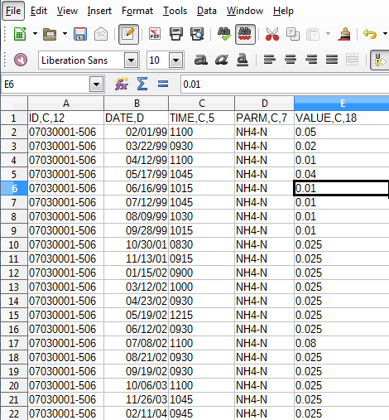

**Running HSPEXP+**

Running HSPEXP+ is straightforward, provided you have followed all the set up procedures. Browse to “HSPEXP+” from the program menu on your computer and click on it to open. Browse to the UCI file and then select options as needed. Click on “Start” to run it.

**Resolving Errors**

HSPEXP+ assumes that the user has provided correct data in all the model set-up files; currently, error checking in HSPEXP+ is minimal and rudimentary. In some cases, HSPEXP+ may generate some common errors as a pop-up (if the format of some input in the EXS file is wrong, or if some required files are missing). HSPEXP+ also produces a log file every time it is run. Referring to the log file may give some indication of the cause of the error.

In most cases, you may have to refer to the help manual, and make sure that all input files are set up correctly.

**Basin-Specification File Content and Format**

**Line Type/ Number Line**

**Content** **of Lines Format Description**

General information 1 A8,2I5,4F8 Name (prefix) of WDM file

Number of sites

Current Site number

Latitude & longitude limits of basin

WDM Data set ID #'s # of sites 10I4,1X,I2, DSN for simulated runoff (inches)

2X, A20 DSN for observed flow (cfs)

DSN for simulated surface runoff (inches)

DSN for simulated interflow (inches)

DSN for simulated baseflow (inches)

DSN for precipitation (inches)

DSN for potential evapotranspiration (inches)

DSN for actual evapotranspiration (inches)

DSN for upper zone storage (inches)

DSN for lower zone storage (inches)

Flag indicating whether statistics have been

calculated for site (not used)

Site name

Number of storms 1 I4 Number of storm periods

Storm periods # of storms I5,5I3,I5,5I3 Storm start and end date/time (yr,mo,dy,hr,min,sec)

Drainage areas 1 10F8 Drainage area (acres) for each site

Error criteria # of sites 10F8 Values for error terms and criteria

Acceptable error in total volume (%)

Acceptable error in low flow recession (-)

Acceptable error in 50% lowest flows (%)

Acceptable error in 10% highest flows (%)

Acceptable error in storm volumes (%)

Ratio of interflow to surface runoff (-)

Acceptable error in seasonal volume (%)

Acceptable error in summer storm volumes (%)

Multiplier on third and fourth error terms

Percent of flows to use in low-flow recession error

Seasons keyword 1 A7 Enter the word "Seasons:"

Summer months 1 csv Enter the months for summer in csv format

Winter Months 1 csv Enter the months for winter in csv format

EXS file notes:

Line formats

A*n* - character input with column width = n columns

I*n* - integer input with column width = n columns

F*n* - real number input with column width = n columns

*n*X - n blank spaces

csv - comma-separated values

Unneeded lines - the last 5 line types in an EXS file used with the original HSPEXP program are not used in HSPEXP+; these are the 3 lines of computed statistics and 2 lines of flags for ancillary data

**References**

Bicknell, Brian R., J.C. Imhoff, J.L. Kittle, T.H. Jobes, A.S. Donigian. 2005. *HSPF Version 12.2 User’s Manual.* Submitted to Office of Surface Water, EPA, Reston, VA.

Lumb, Alan M., R. B. McCammon, and J.L. Kittle, Jr. 1994. *User’s Manual for an Expert System (HSPEXP) for Calibration of the Hydrological Simulation Program-FORTRAN.* Reston, VA: U.S. Geological Survey.