SecureCloud Task & Resource Manager (STRM)

Elijah Exqeciel Dominguez
BSIT 3.8

1. Project Overview
STRM is a cross-platform Flutter application designed to work seamlessly both offline and online. It features a JARVIS-like modern, glassmorphic UI with a purple and black aesthetic.

2. Objectives
- Provide secure user authentication using Firebase Auth.
- Enable robust offline task draft management using SQLite.
- Facilitate real-time cloud data synchronization using Cloud Firestore.
- Integrate responsive REST API data consumption.

3. System Architecture
The app uses a clean layered architecture with Models, Services (DBHelper, AuthService, SyncService, ApiService), and Screens. It employs try-catch error handling at all layers to gracefully manage network disruptions.

4. Technologies Used
- Frontend: Flutter, Dart
- Local Database: sqflite
- Authentication: firebase_auth
- Cloud Storage: cloud_firestore
- API Calls: http
- Architecture: Layered / MVVM styles

5. SQLite Schema
Table: tasks_table
- id: INTEGER PRIMARY KEY AUTOINCREMENT
- title: TEXT
- description: TEXT
- isSynced: INTEGER DEFAULT 0

6. Firestore Structure
Collection: tasks
Documents (Auto-ID):
- title: String
- description: String
- createdAt: Timestamp

7. API Endpoints Used
GET https://jsonplaceholder.typicode.com/posts
Used to fetch dummy posts data to demonstrate network parsing and clean list display.

8. Code Implementation (Important Parts)
Core components include DBHelper.getUnsyncedTasks(), SyncService.syncTasks() for the SQLite -> Firestore flow, and comprehensive FirebaseAuthException try-catch blocks to catch invalid emails/weak passwords.

9. Error Handling Strategy
All async calls specifically wrap network and cloud operations in robust try-catch mechanisms. If `http.get` fails or `Firebase.initializeApp` lacks a network, the UI defaults to graceful fallback (e.g., "No Internet Connection" text widgets and SnackBar alerts).

10. Offline Sync Logic Explanation
1. User creates a task offline.
2. Task saves to `sqflite` with `isSynced = 0`.
3. Upon user clicking "Sync" (or network availability), SyncService queries SQLite for `isSynced = 0` items.
4. Items are queued and pushed to Cloud Firestore.
5. Pushed items are updated with `isSynced = 1` in SQLite to prevent duplication.

11. Screenshots (Placeholders)
[ IMAGE: Login Screen and register]
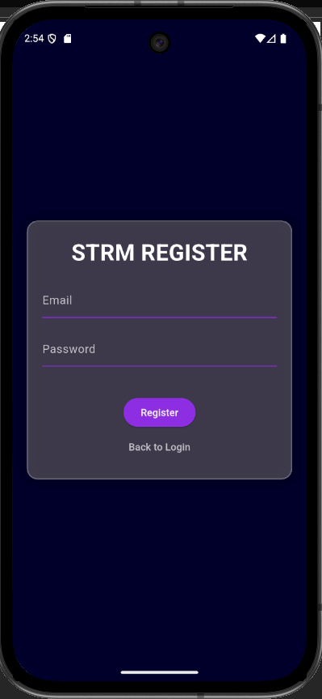
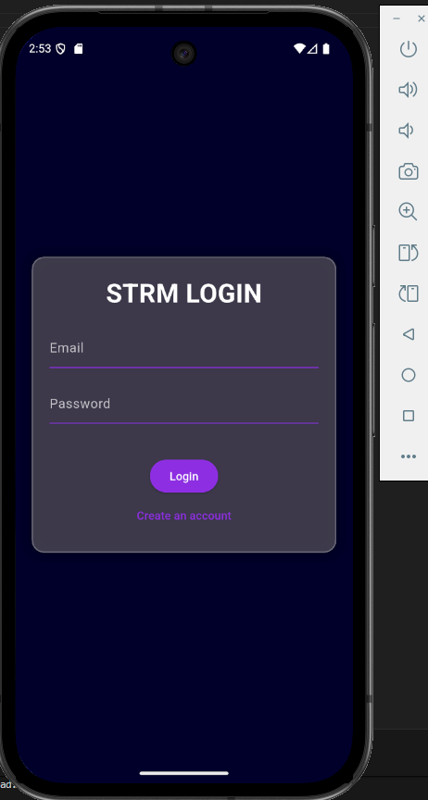

[ IMAGE: Offline Task Entry Interface inside Dashboard ]
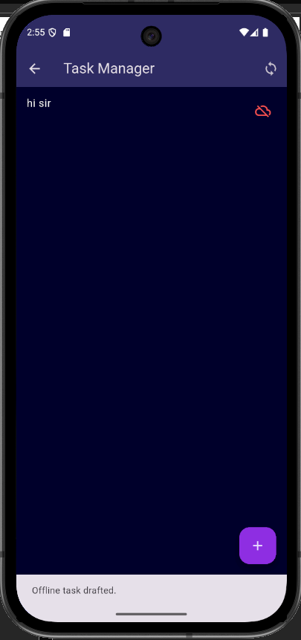

[ IMAGE: Firestore Document verification ]
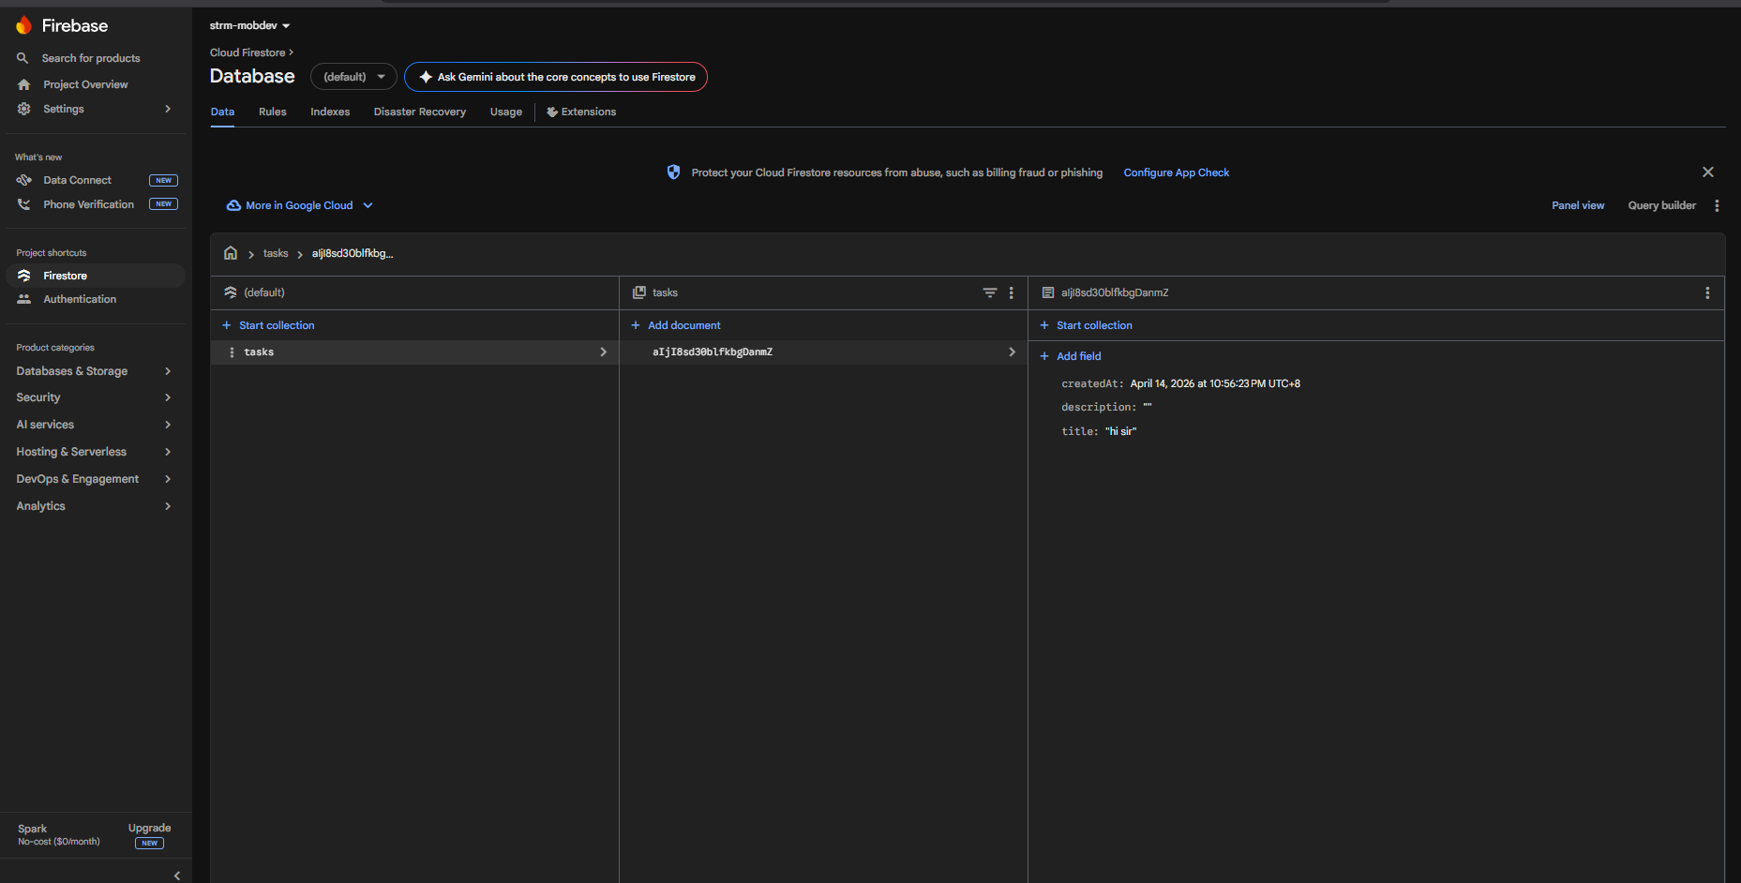

12. Output Results
The application natively handles authentication logic, queues un-synced operations when offline, completely synchronizes databases without duplication upon reconnection, and safely handles generic REST JSON payloads resulting in zero unexpected runtime faults.

