Spatial patterns in soil depth and implications

for OFFSEASON nitrogen dynamics in dryland

Wheat systems in Montana

by

Simon Isaac Fordyce

A thesis submitted in partial fulfillment

of the requirements for the degree

of

Master of Science

in

Land Resources and Environmental Sciences

MONTANA STATE UNIVERSITY

Bozeman, Montana

Juary 2022

# ©COPYRIGHT

b

Simon Isaac Fordyce

2024

All Rights Reserved

# DEDICATION

To Sal, Frank, and Mo.

# ACKNOWLEDGEMENTS

I am grateful to Western Sustainable Research and Education for funding this research. Pat Carr provided invaluable feedback on every single draft of this thesis. I lost track of that number long, long ago. I thank Pat for his dedication to my success. The master’s degree behind this document took four years to obtain. The realistic advice of Clain Jones kept me grounded as those years ticked by. Turns out Clain has a knack for predicting a grad student’s future. I thank Clain for his realism. Conversations with Jed Eberly in the early (and late) days kept me motivated and passionate about this research. I thank Jed for his openness and enthusiasm. Adam Sigler and Stephanie Ewing shaped my career as a scientist by taking a chance on me when I was anything but. Thanks Adam and Stephanie for your willingness to mentor a lost boy of Neverland. I was aided in data collection and analysis by many great scientists, including Rob Payn, Scott Powell, and Eric Sproles. Thank you for the time you’ve given my project. I thank my farmer cooperators, Clint, Steve, Bing, Spike, Wade, and Lowell for their ears and eyes, and my land providers for their generosity. The staff of the Central Agricultural Research Center were critical to the success of this project—none more than Sally Dahlhausen, who picks up my slack with the ease of old practice. I thank Sally for having my back. To my family—grandmas, papas, aunts, uncles, cousins—can’t think of a more eclectic bunch I would want corrupting my kids. I thank you for corrupting them when I’m not looking. To my kids: Frances, thank you for looking after your sister when I’m busy on the computer. You are such a good big sister. And Martha, thank you for not going too easy on her. Last, my wife has shouldered the weight of this undertaking like a champion—thank you Sally for knowing my stress, for helping bear its weight, and for loving me in spite of how clumsily I bear the weight of yours.

# TABLE OF CONTENTS

1. NITROGEN CYCLING IN SHALLOW SOILS AND IMPLICATIONS FOR

FERTILITY MANAGEMENT 1

Introduction 1

References 13

2. EXPLORING RELATIONSHIPS BETWEEN SOIL DEPTH AND MULTI-

TEMPORAL SPECTRAL REFLECTANCE IN A SEMI-ARID AGROECOSYSTEM: EFFECTS OF SPATIAL AND TEMPORAL RESOLUTION 20

Contribution of Authors and Co-Authors 20

Manuscript Information 21

Abstract 22

Introduction 23

Methods 26

Study Area 26

Field Selection 27

Sampling Soil Depth 28

Multispectral Sensors and Images 29

Statistical Analysis 30

Results 31

Discussion 32

Conclusion 34

References 43

3. SPATIOTEMPORAL PATTERNS OF NITROGEN MINERALIZATION IN A

DRYLAND WHEAT SYSTEM 46

Contribution of Authors and Co-Authors 46

Manuscript Information 47

Abstract 48

Introduction 49

Methods 53

Study Area 53

Estimating Soil Depth 54

Soil Sampling 56

Soil Respiration Measurements and Data Cleaning 57

Statistical Analysis 58

Results 60

Effects of Soil Depth on Surficial Soil Properties 60

Soil Respiration Measurements 61

TABLE OF CONTENTS CONTINUED

Discussion 62

Conclusion 66

References 75

4. SUMMARY 79

REFERENCES CITED 81

APPENDICES 93

APPENDIX A: SURVEY TOOL 94

# LIST OF TABLES

Table Page

1. Coordinates, soil depth, elevation, and slope estimates for individual

points, grouped by subfield 37

2. Parameter estimates for non-linear regression models where soil depth (*zf*)

was designated as a predictor and NDVI as a response variable grouped

by sensor, year, acquisition day of year (DOY), and field. Regressions

were performed using NDVI of fields planted to spring wheat in central

Montana. 38

3. Monthly average precipitation (Precip.) and temperature during the study

period. Averages are 111-yr and 109-yr for precipitation and temperature,

respectively. 68

4. Accuracy assessment of classification and regression tree analysis for

apparent soil depth, with reference, reliability, and overall accuracy,

and κ value. 71

5. Number of soil respiration measurements remaining and percent excluded

by individual integrity metrics before (raw) and after imposition and

adjustment (±5% of raw data) of the carbon dioxide standard deviation

threshold (σCO2 > 1.6 mg m-2).. 71

6. Estimated marginal means ± standard errors and significance of mixed

effects models for various soil properties (response), where the categorical

variable soil depth class (class) was designated as a fixed effect and site

(subfield) was designated as a random effect. Results are grouped by

timing of sample collection (fall or spring). Soil depth class (0 = shallow;

1 = deep) was determined based on satellite image reduction (Sentinel 2;

16 June 2020 – 04 September 2020) and supervised classification 72

7. Estimated marginal means ± standard errors and significance of mixed

effects models for various soil properties at sites A and B in fall 2018 and

spring 2020, where the categorical variable sample timing (fall or spring)

was designated as a fixed effect and site (subfield) was designated as a

random effect. Results are grouped by depth class (0 = shallow; 1 = deep),

determined based on satellite image reduction (Sentinel 2; 16 June 2020 –

04 September 2020) and supervised classification 73

LIST OF TABLES CONTINUED

Table Page

8. Estimated marginal means ± standard errors and significance of mixed

effects models for various soil properties (response at site B, where the

categorical variable soil depth class (class) was designated as a fixed effect

and date or year were designated as random effects. Results are grouped by

timing of sample collection (fall or spring). Soil depth class (0 = shallow;

1 = deep) was determined based on satellite image reduction (Sentinel 2; 16

June 2020 – 04 September 2020) and supervised classification 74

# LIST OF FIGURES

Figure Page

1. Spatial heterogeneity in soil depth creates characteristic patterns in crop

growth stage of lentil independent of experimental design (randomized

complete block). Treatment replicate numbers of the small-plot trial are

indicated in black. 35

2. Moccasin Terrace color composite (a) in Judith Basin, Montana with shale

depth (b; adaped from Sigler et al., 2018) and spatially-averaged NDVI (c)

for the 2019 growing season (Sentinel 2). 36

3. Empirical and fitted variogram (a) and cross validation results (b) in m of

ordinary kriging (n = 30) at Central 39

4. Impacts of image resolution and field on non-linear (a-b) and linear (c-d)

regression models for probing depth versus NDVI. Impacts of sensor (a,c)

and field (b,d) on probing depth-NDVI relationships were minimal 40

5. Impacts of image acquisition timing on non-linear (a-c) and linear (d-f)

regression models for probing depth versus NDVI. Probing depth

observations > 50 cm were excluded in linear regressions. Impacts of

acquisition timing on probing depth-NDVI relationships were severe

when acquisition occurred immediately before and immediately after the

beginning of senescence (a,d) but mild thereafter (b,e). Effects of year were

minor for the same Julian day in 2019 and 2020 (c,f). 41

6. Kriged estimates of soil depth (a) with well-timed (i.e., during senescence)

NDVI from an unmanned aerial vehicle (UAV; b), the National Agricultural

Imagery Program (NAIP; c), and Sentinel 2 (d). Black symbols are the 30

initial tile probing locations and white symbols are the 12 locations withheld

for cross validation. 42

7. Moccasin Terrace with study area and subfields. Time-invariant soil

properties were sampled at A, B, and C. Other soil properties were sampled

at A and B in fall 2018 and spring 2020. Other subfields were excluded

based on unplanned changes in crop rotation (i.e., alternative crops, fallow)

or tillage system. 67

LIST OF FIGURES CONTINUED

Figure Page

8. Site B ancillary imagery and predicted depth classes. NDVI of spring wheat

captured during crop senescence by the National Agricultural Imagery

Program (0.6 m) in 2017 (a) and 2019 (b) and an unmanned aerial vehicle

(0.01 m) in 2017 (c), as well as predictions of the classification and regression

trees classifier with 4-band Sentinel 2 imagery (10 m) from 16 June 2020

through 04 September 2020 (d). 69

9. Histograms of log-transformed standard deviations of chamber carbon

dioxide (CO2) concentrations for individual measurement cycles with early

(t0-t13), ‘unstable’ CO2 readings included (a) and excluded (b), grouped by

instrument. 70

# ABSTRACT

Shallow soils (< 50 cm) under dryland wheat (*Triticum aestivum* L.) production lose large amounts of inorganic nitrogen (N) to leaching. Crops grown in shallow soils may be more responsive to N fertilizer due to lower fertilizer recovery and suppressed mineralization, raising questions as to whether standard practices of N fertilizer rate determination can increase risks of leaching and groundwater contamination in these environments. Mineralized N can be a major nutritional supplement for wheat crops in dryland agroecosystems, so accurate estimates of mineralization inputs can have important economic and environmental implications. To assess the potential for suppressed N mineralization in shallow soils, we used spectral reflectance from up to three sensors (unmanned aerial vehicle, National Agricultural Imagery Program, and Sentinel 2) to spatially characterize soil depth on three fields in Central Montana (Chapter 2) and compared surface (0-20 cm) carbon and N cycling indices across soil depth classes (Chapter 3). Carbon dynamics were stable across depth classes while N mineralization was lower in the shallow class. Results confirm multispectral imagery as a valuable tool for non-destructively characterizing fine-scale spatial patterns in soil depth and corroborate previous findings of lower N mineralization in shallow soil environments. Given the potential for heightened fertilizer responsiveness due to lower mineralization in these environments, decision support systems for site-specific fertility management (e.g., variable rate fertilizer application) should assess the environmental consequences of leaching alongside the economic benefits of applied fertilizer rates which maximize responses of yield, quality and same-year net revenue.

# CHAPTER ONE

# NITROGEN CYCLING IN SHALLOW SOILS AND IMPLICATIONS FOR FERTILITY MANAGEMENT

## Introduction

Shallow soils (< 50 cm) account for nearly 4% of the land area in the continental United States, occurring in 10 of the 12 soil orders and in over 1000 soil series (Bockheim, 2015). However, a growing body of evidence suggests government soil databases (e.g., United States Natural Resources Conservation Service SSURGO; USDA, 2020) do not fully capture the spatial variation in soil depth, prompting research into fine-scale soil depth characterization by alternative methods, including kriging (Odeh et al., 1994; Bestwick, 2016) and spectral indices (Tesfa et al., 2009; Rossel et al., 2015; Sigler et al., 2020). Soil depth is a known control on crop yield (Bestwick, 2016; John et al., 2017), and shallow soils contribute disproportionately to groundwater contamination due to higher leaching losses of inorganic nitrogen (N) in these environments (John et al., 2017; Sigler et al., 2020). As a result, accurate spatial characterization of soil depth can have important economic and environmental implications (Lilburne et al., 2003; Jones et al., 2011; Bestwick, 2016; John et al., 2017; Sigler et al., 2020).

Factors affecting nitrate leaching are varied and complex, and consequences for farm sustainability (e.g., degraded soil and water quality) may be undervalued in decision support. Two potential reasons for this undervaluation are the high degree of spatiotemporal variability in leaching (John et al., 2017; Sigler et al., 2018, 2020) and the difficulty with which accurate leaching estimates are obtained. Inorganic N concentrations in soil and the timing and amount of rainfall are the primary determinants of leaching rates in dryland wheat systems, though other factors (e.g., soil texture) also have impacts. However, inorganic N concentrations are controlled by multiple interacting biogeochemical processes and rainfall is notoriously difficult to predict in time and space.

Rates of individual biogeochemical processes may respond differentially to external N inputs, including fertilizers. For example, leaching, denitrification, and uptake typically increase as applied fertilizer increases (Lilburne et al., 2003; Philippot et al., 2007), while mineralization is more likely suppressed by the addition of N (O’Dea et al., 2015; Mahal et al., 2019). Management factors (e.g., fallow, late planting date, overfertilization) and soil physical characteristics (e.g., texture and soil thickness) also impact leaching risks. Soil depth alone can impact multiple N cycling pathways, including N uptake and mineralization, as this property is a known control on water storage (Grylls et al., 1997; Lilburne et al., 2003; Sigler et al., 2020).

Most studies do not measure leaching rates directly. Rather, rates are estimated by coupled water and N mass balance models (Meisinger & Randall, 1991; John et al., 2017), validated either by lysimetry (Sigler et al., 2020), tile drainage monitoring (Drury et al., 2014), or stream monitoring (Jordan et al., 1994; Sigler et al., 2018). Measured soil N change is set equal to the difference between inorganic N inputs and outputs in mass balance models. Under steady state assumptions, leaching is equal to inputs minus non-leaching outputs minus inorganic soil N change. Therefore, estimating leaching typically requires extensive knowledge of the N cycle, including fertilizer application rates, non-fertilizer N inputs (mineralization, deposition, and biological fixation), and losses (denitrification, volatilization, immobilization, and uptake by plants). These processes may respond differently to weather and management changes. Moreover, obtaining accurate measurements can be time consuming, as each process is associated with a unique set of challenges (e.g., labor, expense). Often, wide-sweeping assumptions are required to obtain these estimates. Simulation studies are a promising means of delineating leaching-susceptible areas and identifying appropriate management decisions under different climatic conditions (Jordan et al., 1994; Hansen et al., 2001; Lilburne et al., 2003; Sigler et al., 2020).

Fertilizer application notwithstanding, mineralization is the primary contributor to plant available N in agroecosystems. In this document, nitrification is considered a separate reaction from mineralization. Mineralization is a two-step process involving aminization and ammonification. In broad terms, ammonification is the degradation of organic N compounds to produce ammonia which is very quickly protonated to form ammonium. Some literature describes it as the first step of mineralization (Benbi & Richter, 2002), though this is misleading because complex N-containing proteins must first be hydrolyzed to amides in the process of aminization. However, ammonium-based N fertilizers like urea exist as simple amides at application. The enzyme urease catalyzes the hydrolysis of urea to ammonia (Tabatabai & Bremner, 1972), which in the presence of moisture is protonated to ammonium, the primary form of N assimilated by microorganisms. Under certain conditions, ammonia gas produced from hydrolysis of urea can escape to the atmosphere, representing an economic loss to the farmer (Engel et al., 2017). Urease-driven N loss to the atmosphere in the form of ammonia gas is termed ‘volatilization’ and can be a major N loss pathway in semiarid agroecosystems.

Volatilization losses are largest for urea fertilizer broadcast on a moist soil surface during dry fall conditions (Engel et al., 2017). Nitrification and leaching caused by excessive rates of ammonium-based fertilizers can lead to acidification of surface soils, a growing concern in agroecosystems worldwide (Von Uexküll & Mutert, 1995; Schroder et al., 2011; Dai et al., 2017). This is especially true when nitrate ions derived from ammonium-based fertilizers are leached beyond the root zone, since magnesium, potassium, or calcium cations in solution are often removed with nitrate and replaced by hydrogen ions (Rengel, 2003). Equivalently, bicarbonate and hydroxide ions exuded from plant roots during nitrate uptake serve to neutralize soil acidity.

Nitrification, itself an acidifying process, occurs in multiple steps beginning with the oxidation of ammonia to hydroxylamine by aerobic ammonia oxidizing archaea and bacteria. Ammonia oxidizing archaea are more abundant (Leininger et al., 2006) and more geographically distributed (Liu et al., 2018) than ammonia oxidizing bacteria, and are particularly well adapted to low pH soils (Liu et al., 2018). Nitrification continues in a series of reactions catalyzed by several unidentified enzymes, whereby hydroxylamine is oxidized to nitric oxide, which, in turn, can be oxidized to nitrite (Simon & Klotz, 2013; Kozlowski et al., 2016; Caranto & Lancaster, 2017). Nitrite oxidation to nitrate, the final step of nitrification, is carried out by aerobic nitrite-oxidizing bacteria (Daims et al., 2016) and anoxygenic phototrophs (Griffin et al., 2007; Schott et al., 2010) encoding for the enzyme nitrite oxidoreductase. Nitrite oxidoreductase is the primary control on production of nitrate, the form of N most likely to leach to groundwater. Recently, it was discovered that certain microorganisms (comammox) are capable of oxidizing ammonia all the way to nitrate. This finding upended the long-held belief that ammonia oxidation to nitrite required two separate microbial groups (Daims et al., 2015; van Kessel et al., 2015; Kuypers et al., 2018).

In addition to facilitating the release of N from organic matter, microbes compete with plants for nitrate and ammonium, incorporating these forms of N into microbial biomass through the processes of assimilatory nitrate reduction and assimilation, respectively. Collectively, this process is termed immobilization. Because immobilization and mineralization co-occur, the terms net mineralization and net negative mineralization are used to describe situations where gross mineralization exceeds gross immobilization and vice versa. Many studies have investigated proxies for net N mineralization, most notably Stanford and Smith (1972), who artificially extracted inorganic N from a wide variety of soils before incubating dry soils for 2-8 week intervals under aerobic conditions to estimate potentially mineralizable N. Others used 7- or 14-d incubations at warm temperatures to estimate mineralization (Deng & Tabatabai, 2000; Tabatabai et al., 2010). Schomberg et al. (2009) proposed a net N mineralization index based on a combination of total N and a three-day flush of carbon dioxide as defined in Franzluebbers et al. (2000). Others have argued for mineralization indices based on the activities of certain extracellular enzymes. For example, Tabatabai et al. (2010) showed that β-glucosaminidase, one of several enzymes responsible for the hydrolysis of chitin, was strongly correlated with net N mineralization per Stanford and Smith (1972) in soils of the United States.

Nitrogen inputs to soils from mineralization likely exceed those of deposition and biological fixation, especially in wheat-based cropping systems. As the northern Great Plains (NGP) remain sparsely populated and agricultural systems therein relatively de-intensified, N deposition rates remain low (1.6 kg ha-1; United States Environmental Protection Agency (2014); John et al., 2017) relative to the U.S. Midwest, where average N deposition rates can exceed 10 kg ha-1 (Galloway et al., 2008). Moreover, N-intensive crops such as corn (*Zea mays* L.) are likely to contribute to relatively high deposition rates in the U.S. Midwest. However, N deposition in the NGP and elsewhere is likely to increase in the future, with certain regions exceeding 50 kg ha-1 yr-1 by 2050 (Galloway et al., 2008).

Biological fixation of dinitrogen gas into ammonia, a process carried out by bacteria and archaea carrying the nitrogenase metalloenzyme, is likely to exceed deposition in the NGP, especially where leguminous species are grown. N-fixing microorganisms such as rhizobia often establish symbiotic relationships with legumes, including alfalfa (*Medicago sativa* L.), field pea (*Pisum sativum* L.), and lentils (*Lens culinaris* Medik). Symbiotic fixation occurs in root nodules of legume crops, but N-fixing bacteria have been found in roots, stems, and leaves of cereal crops as well (Bhattacharjee et al., 2008; Rosenblueth et al., 2018). Currently, the quantities of N fixed in cereal crops are too small to support N needs, but efforts are underway to enhance N fixation through genetic modification and other methods (Rosenblueth et al., 2018)

Nitrate can be reduced to nitrite through both assimilatory and dissimilatory processes. Assimilatory nitrate reduction is an energy-intensive process minimized in agricultural soils due to high concentrations of ammonium from synthetic fertilizers (Maier & Pepper, 2015; Kuypers et al., 2018). On the other hand, dissimilatory nitrate reduction is widespread, occurring in many environments and in all domains of life. Nitrate dissimilation itself is not an N loss pathway, although it is the first step of denitrification, the process by which nitrate is converted to nitrous oxide (a greenhouse gas) or dinitrogen gas. Denitrification is carried out by bacteria, archaea, and fungi in both aerobic and anaerobic environments, and can represent a major N-loss pathway in certain agricultural systems. Very few organisms can carry out the entire denitrification process, and an increasingly complex picture of the microbial interactions and metabolic handoffs controlling this process is emerging (Anantharaman et al., 2016; Hug & Co, 2018). Interestingly, there appears to be a high degree of functional redundancy in denitrification when assessed across management systems, despite stark differences in microbial community structure (Mackelprang et al., 2018).

Nitrate dissimilation is also a key source of nitrite for anaerobic ammonia oxidation (anammox). This process, defined as the oxidation of ammonium with nitrite to produce dinitrogen gas, represents another potential N loss pathway (Strous et al., 2006). High N fertilizer inputs in agricultural systems can set up a positive feedback loop in which fertilizers stimulate growth of anammox bacteria, more N is lost to the atmosphere as dinitrogen gas and, thus, more N fertilizer is required to meet yield goals (Nie et al., 2019). Complicating the situation further is the potential for coupled nitrification, denitrification, and anammox processes (Nie et al., 2019). The latter two processes, along with co-denitrification, produce dinitrogen gas, representing a direct economic loss to the farmer. Co-denitrification is carried out by both bacteria and fungi (Tanimoto et al. 1992; Kumon et al., 2002) and occurs when one of several compounds is introduced into the denitrification pathway. For example, the N atom of hydroxylamine can be bound to that of nitrite, resulting in a hybrid nitrous oxide molecule with a ‘co-metabolic character’; hence ‘co-denitrification’ (Spott & Florian Stange, 2011). Co-denitrification produces nitrous oxide and dinitrogen gas when nitrite is reduced by one of several compounds, including hydroxylamine, azide, ammonium, or salicylhydroxamic acid (Tanimoto et al., 1992; Spott & Florian Stange, 2011). Fungal co-denitrification alone can be responsible for > 90% of dinitrogen gas produced from grassland soils (Laughlin & Stevens, 2002; Selbie et al., 2015).

Any soil nitrate that avoids interception by plant roots is susceptible to leaching. Ammonium is at much lower risk of leaching because of its positive (cationic) charge, especially in clay and high organic matter soils, and because it is quickly nitrified to nitrate or immobilized. Leaching losses are possible when inorganic N concentrations are high and there is sufficient soil water to move this N below the root zone (deep percolation). Leaching is a highly episodic and spatially variable phenomenon, occurring most often on shallow and coarse-textured soils without actively growing crops (John et al., 2017; Sigler et al., 2018, 2020). Nitrate loss was at least five times higher from very shallow soils (< 25 cm) than from deep soils (> 100 cm) in Sigler et al. (2020). Thus, despite being restricted in extent, shallow soils are “disproportionately important to whole-system leaching behavior” (Sigler et al., 2020). In addition to being variable in space, leaching is an episodic phenomenon, with annual rates highly dependent on the timing of rainfall and other meteorological events (e.g., freeze-thaw cycles). For example, Sigler et al. (2020) concluded that 56% of leaching occurred in just 2 years of a 14-year simulation period, associated primarily with heavy rain events, raising key questions about the impacts of leaching under future climate scenarios.

Whether leaching will increase or decrease under future climate scenarios is a subject of some debate (Ye & Grimm, 2013; He et al., 2018). However, characterizing physiographic controls on N dynamics may reduce uncertainty in leaching forecasts. Specifically, inclusion of time-invariant factors such as soil depth may improve leaching predictions from climate change impact models. Similar concepts have been proposed in climate adaptation planning for biodiversity preservation (Theobald et al., 2015). Farmers in shallow soil environments may be at higher risk of economic loss from leaching due to uncertainty in leaching forecasts and generally poor awareness of the problem (Appendix A). Controversy surrounding climate-related topics may contribute to some of the awareness issues. For example, a recent survey showed that nearly one-quarter of central Montana farmers challenged scientific findings about changing weather, while none challenged findings about changing soil nitrate concentrations in response to changing weather (Appendix A). Questioning or resisting climate predictions could cause unpreparedness for changing N dynamics related to uncertain weather, leading to misguided or misrepresented climate adaptation goals and leaching mitigation strategies.

Potential leaching mitigation strategies include timely soil testing, judicious fertility management (i.e., proper timing, rate, placement, source), and cropping to perennials, spring and winter cereals (Lilburne et al., 2003; Sigler et al., 2020), spring legumes grown for grain (John et al., 2017), and non-legume cover crops (Thapa et al., 2018), especially when grown in place of summer fallow (i.e., the idling of arable land for 14-21 month periods). However, factors contributing to the timing and magnitude of N leaching are complex, and mitigation strategies vary in their feasibility and effectiveness.

Spring soil testing is not always feasible due to inaccessible fields and heavy workloads, helping to explain why so few farmers (14%) soil test at this time (Appendix A). Moreover, conclusions regarding the effectiveness of fallow replacement in mitigating leaching have not been consistent (Campbell et al., 1994; Zentner et al., 2004; John et al., 2017) although the preservation of net revenue with fallow replacement is more certain. For example, John et al. (2017) found that fallow replacement with field pea reduced leaching in just one year of a two-year study, while net revenue was either maintained or increased with fallow replacement. Similarly, reports on the effectiveness of fertility management practices such as alternative source (e.g., controlled release urea) and timing (e.g., split application) strategies are mixed (Mikkelsen et al. 1994; Nakamura et al. 2004; John et al., 2017). Conclusions regarding the effectiveness of source (e.g., urease inhibitors), timing (e.g., fall vs. spring), and placement (e.g., deep banding) strategies for mitigating volatilization losses are less ambiguous (Engel et al., 2011; Engel et al., 2017), perhaps because *in situ* leaching is relatively challenging to measure.

Despite conflicting reports about the effectiveness of leaching mitigation strategies, the literature is relatively consistent in its support for differential management of deep and shallow soils (Bullock & Bullock, 2000; Zillman et al., 2006; Basso et al., 2011; Vazquez-Amabile et al., 2013; Bestwick, 2016; John et al., 2017; Sigler et al., 2020). While the potential for variable rate fertilization to improve economic returns and mitigate environmental impacts has been studied for decades (Carr et al., 1991; Zillmann et al., 2006; Basso et al., 2011), very few studies have assessed the effectiveness of this technology in shallow soil environments (Zillmann et al., 2006; Basso et al., 2011; Vazquez-Amabile et al., 2013). Many studies regard variable rate technology as a strategy for mitigating environmental impacts of leaching and greenhouse gas emissions (Dampney et al., 1999; Link et al., 2006; Basso et al., 2011; Vazquez-Amabile et al., 2013; Basso et al., 2016), although results of Zillman et al. (2006) and others (Morari et al., 2018) highlight its potential to create environmental problems or exacerbate existing ones, particularly when factors other than N limit yield. There is also the possibility of environmental impacts from variable rate application where shallow soils are N deficient relative to deeper soils, since yield can be more responsive to fertilizer application leading to higher recommended rates in these environments (Grylls et al., 1997), which, in turn, could increase leaching losses to groundwater.

One of the earliest references to differential inputs on deep and shallow soils was given in Bullock & Bullock (2000). The authors of this study did not present data, but instead made assumptions about crop responses to inputs in deep and shallow soil environments to forward a conceptual argument for the complementarity of precision technology and local agronomic information. Remaining intentionally abstract to include both seed and fertilizer inputs in their discussion, Bullock & Bullock (2000) assumed that the optimal input rate (i.e., the rate at which the response of net revenue to an additional unit of input is maximized) would be lower in shallow soils due to a weaker crop response to inputs in these environments. However, Grylls et al. (1997) showed that wheat in shallow soils is more, not less, responsive to N at high fertilizer input levels, likely a result of limited fertilizer recovery and suppressed mineralization in these environments. These results raise questions about whether on-farm precision experiments in shallow soil environments could increase leaching risks and associated environmental impacts by prescribing higher fertilizer rates to shallow soils to offset low N mineralization or by fertilizing beyond yield potential when water limits yield (Zillman et al., 2006).

Delineation of shallow soil areas within fields may help determine the mechanisms of yield limitation and eliminate unintended environmental consequences of variable rate fertilizer technology (Basso et al., 2011; Vazquez-Amabile et al., 2013; Sigler et al., 2020). However, direct soil depth measurement is labor-intensive and costly (Dietrich et al., 1995; Tesfa et al., 2009), creating a need to model spatial patterns by alternative means. Most soil depth mapping projects rely on well-established geomorphological principles of soil production and transport to predict soil depth from digital elevation data in topographically-complex landscapes (Dietrich et al., 1995; Ziadat, 2010; Lacoste et al., 2016; Patton et al., 2018; Zhang et al., 2021). Soil depth in low-relief areas is much more difficult to predict, although some have had success with spectral indices (e.g., normalized difference vegetation index; NDVI) alone (Sigler et al., 2020) or in combination with digital terrain data (Tesfa et al., 2009; Rossel et al., 2015). Key questions remain regarding the importance of image timing and resolution in determining the generalizability of spectral-based soil depth predictions.

This document addresses the potential for image timing and spatial resolution to negatively impact correlations between soil depth and NDVI in a low-relief agroecosystem with shallow soils, and assesses if shallow soils are likely to be N deficient based on suppressed N mineralization relative to their deeper counterparts. The research was conducted in central Montana, a dryland wheat region where present support for variable rate fertilizer application is lacking (Appendix A). In anticipation of growing awareness and increased adoption of site-specific fertility practices, soil depth on three fields was characterized using multispectral imagery from the Sentinel (Copernicus, 2020) satellite system (Chapter 2) and carbon and N mineralization indices were compared in deep and shallow soils (Chapter 3). Results indicate strong potential for satellite imagery in characterizing fine-scale soil depth variation and confirm previous observations of lower N mineralization in shallow soil environments. This research serves to alert precision agriculturalists regarding the potential for suppressed mineralization in shallow soils and heightened responsiveness of crops to N fertilizer at high application rates. This phenomenon could lead to elevated risks of N loss to leaching in these environments.

## References

Anantharaman, K., Brown, C. T., Hug, L. A., Sharon, I., Castelle, C. J., Probst, A. J., ... & Banfield, J. F. (2016). Thousands of microbial genomes shed light on interconnected biogeochemical processes in an aquifer system. Nature Communications, 7(1), 1-11.

Basso, B., Ritchie, J. T., Cammarano, D., & Sartori, L. (2011). A strategic and tactical management approach to select optimal N fertilizer rates for wheat in a spatially variable field. European Journal of Agronomy, 35(4), 215-222.

Basso, B., Fiorentino, C., Cammarano, D., & Schulthess, U. (2016). Variable rate nitrogen fertilizer response in wheat using remote sensing. Precision Agriculture, 17(2), 168-182.

Benbi, D. K., & Richter, J. (2002). A critical review of some approaches to modelling nitrogen mineralization. Biology and Fertility of Soils, 35(3), 168-183.

Bestwick, M. L. (2016). Water stress in Montana cropping systems: effects of cultivar, management, and environment on crop production in dryland systems (Master’s thesis, Montana State University-Bozeman, College of Agriculture).

Bhattacharjee, R. B., Singh, A., & Mukhopadhyay, S. N. (2008). Use of nitrogen-fixing bacteria as biofertiliser for non-legumes: prospects and challenges. Applied Microbiology and Biotechnology, 80(2), 199-209.

Bockheim, J. G. (2015). Classification and development of shallow soils (< 50 cm) in the USA. Geoderma Regional, 6, 31-39.

Bullock, D. S., & Bullock, D. G. (2000). From agronomic research to farm management guidelines: A primer on the economics of information and precision technology. Precision Agriculture, 2(1), 71-101.

Campbell, C. A., Lafond, G. P., Zentner, R. P., & Jame, Y. W. (1994). Nitrate leaching in a Udic Haploboroll as influenced by fertilization and legumes (Vol. 23, No. 1, pp. 195-201). American Society of Agronomy, Crop Science Society of America, and Soil Science Society of America.

Caranto, J. D., & Lancaster, K. M. (2017). Nitric oxide is an obligate bacterial nitrification intermediate produced by hydroxylamine oxidoreductase. Proceedings of the National Academy of Sciences, 114(31), 8217-8222.

Carr, P. M., Carlson, G. R., Jacobsen, J. S., Nielsen, G. A., & Skogley, E. O. (1991). Farming soils, not fields: A strategy for increasing fertilizer profitability. Journal of Production Agriculture, 4(1), 57-61.

Copernicus Sentinel data (2020), processed by ESA.

Dai, Z., Zhang, X., Tang, C., Muhammad, N., Wu, J., Brookes, P. C., & Xu, J. (2017). Potential role of biochars in decreasing soil acidification-a critical review. Science of the Total Environment, 581, 601-611.

Daims, H., Lebedeva, E. V., Pjevac, P., Han, P., Herbold, C., Albertsen, M., ... & Wagner, M. (2015). Complete nitrification by Nitrospira bacteria. Nature, 528(7583), 504-509.

Daims, H., Lücker, S., & Wagner, M. (2016). A new perspective on microbes formerly known as nitrite-oxidizing bacteria. Trends in Microbiology, 24(9), 699-712.

Dampney, P. M. R., Goodlass, G., Froment, M. A., & Stafford, J. V. (1999, January). Environmental and production effects from variable rate nitrogen fertilizer to winter wheat in England. In Proceedings of the Fourth International Conference on Precision Agriculture (pp. 697-708). Madison, WI, USA: American Society of Agronomy, Crop Science Society of America, Soil Science Society of America.

Deng, S. P., & Tabatabai, M. A. (2000). Effect of cropping systems on nitrogen mineralization in soils. Biology and Fertility of Soils, 31(3), 211-218.

Dietrich, W. E., Reiss, R., Hsu, M. L., & Montgomery, D. R. (1995). A process‐based model for colluvial soil depth and shallow landsliding using digital elevation data. Hydrological Processes, 9(3‐4), 383-400.

Drury, C. F., Tan, C. S., Welacky, T. W., Reynolds, W. D., Zhang, T. Q., Oloya, T. O., ... & Gaynor, J. D. (2014). Reducing nitrate loss in tile drainage water with cover crops and water‐table management systems. Journal of Environmental Quality, 43(2), 587-598.

Engel, R., Jones, C., & Wallander, R. (2011). Ammonia volatilization from urea and mitigation by NBPT following surface application to cold soils. Soil Science Society of America Journal, 75(6), 2348-2357.

Engel, R., Jones, C., Romero, C., & Wallander, R. (2017). Late‐fall, winter and spring broadcast applications of urea to no‐till winter wheat I. Ammonia loss and mitigation by NBPT. Soil Science Society of America Journal, 81(2), 322-330.

Franzluebbers, A. J., Haney, R. L., Honeycutt, C. W., Schomberg, H. H., & Hons, F. M. (2000). Flush of carbon dioxide following rewetting of dried soil relates to active organic pools. Soil Science Society of America Journal, 64(2), 613-623.

Galloway, J. N., Townsend, A. R., Erisman, J. W., Bekunda, M., Cai, Z., Freney, J. R., ... & Sutton, M. A. (2008). Transformation of the nitrogen cycle: recent trends, questions, and potential solutions. Science, 320(5878), 889-892.

Griffin, B. M., Schott, J., & Schink, B. (2007). Nitrite, an electron donor for anoxygenic photosynthesis. Science, 316(5833), 1870-1870.

Grylls, J. P., Webb, J., & Dyer, C. J. (1997). Seasonal variation in response of winter cereals to nitrogen fertilizer and apparent recovery of fertilizer nitrogen on chalk soils in southern England. The Journal of Agricultural Science, 128(3), 251-262.

Hansen, S., Thirup, C., Refsgaard, J. C., & Jensen, L. S. (2001). Modelling nitrate leaching at different scales–application of the Daisy model. Modeling Carbon and Nitrogen Dynamics for Soil Management, 511-547.

He, W., Yang, J. Y., Qian, B., Drury, C. F., Hoogenboom, G., He, P., ... & Zhou, W. (2018). Climate change impacts on crop yield, soil water balance and nitrate leaching in the semiarid and humid regions of Canada. PloS One, 13(11), e0207370.

Hug, L. A., & Co, R. (2018). It takes a village: microbial communities thrive through interactions and metabolic handoffs. MSystems, 3(2), e00152-17.

John, A. A., Jones, C. A., Ewing, S. A., Sigler, W. A., Bekkerman, A., & Miller, P. R. (2017). Fallow replacement and alternative nitrogen management for reducing nitrate leaching in a semiarid region. Nutrient Cycling in Agroecosystems, 108(3), 279-296.

Jones, C., Chen, C., McVay, K., Stougaard, B., Westcott, M., Eckhoff, J., Lenssen, A., Weeding, J., & Greenwood, M. (2011). Measured and predicted temporal changes in soil nitrate-N levels from late summer to early spring in Montana. Western Nutrient Management Conference Proceedings, 9, 77-82.

Jordan, C., Mihalyfalvy, E., Garrett, M. K., & Smith, R. V. (1994). Modelling of nitrate leaching on a regional scale using a GIS. Journal of Environmental Management, 42(3), 279-298.

Kozlowski, J. A., Stieglmeier, M., Schleper, C., Klotz, M. G., & Stein, L. Y. (2016). Pathways and key intermediates required for obligate aerobic ammonia-dependent chemolithotrophy in bacteria and Thaumarchaeota. The ISME Journal, 10(8), 1836-1845.

Kumon, Y., Sasaki, Y., Kato, I., Takaya, N., Shoun, H., & Beppu, T. (2002). Codenitrification and denitrification are dual metabolic pathways through which dinitrogen evolves from nitrate in Streptomyces antibioticus. Journal of Bacteriology, 184(11), 2963-2968.

Kuypers, M. M., Marchant, H. K., & Kartal, B. (2018). The microbial nitrogen-cycling network. Nature Reviews Microbiology, 16(5), 263-276.

Lacoste, M., Mulder, V. L., Richer-de-Forges, A. C., Martin, M. P., & Arrouays, D. (2016). Evaluating large-extent spatial modeling approaches: A case study for soil depth for France. Geoderma Regional, 7(2), 137-152.

Laughlin, R. J., & Stevens, R. J. (2002). Evidence for fungal dominance of denitrification and codenitrification in a grassland soil. Soil Science Society of America Journal, 66(5), 1540-1548.

Leininger, S., Urich, T., Schloter, M., Schwark, L., Qi, J., Nicol, G. W., ... & Schleper, C. (2006). Archaea predominate among ammonia-oxidizing prokaryotes in soils. Nature, 442(7104), 806-809.

Lilburne, L. R., Webb, T. H., & Francis, G. S. (2003). Relative effect of climate, soil, and management on risk of nitrate leaching under wheat production in Canterbury, New Zealand. Soil Research, 41(4), 699-709.

Link, J., Graeff, S., Batchelor, W. D., & Claupein, W. (2006). Evaluating the economic and environmental impact of environmental compensation payment policy under uniform and variable-rate nitrogen management. Agricultural Systems, 91(1-2), 135-153.

Liu, J., Yu, Z., Yao, Q., Sui, Y., Shi, Y., Chu, H., ... & Wang, G. (2018). Ammonia-oxidizing archaea show more distinct biogeographic distribution patterns than ammonia-oxidizing bacteria across the black soil zone of northeast China. Frontiers in Microbiology, 9, 171.

Mackelprang, R., Grube, A. M., Lamendella, R., Jesus, E. D. C., Copeland, A., Liang, C., ... & Jansson, J. K. (2018). Microbial community structure and functional potential in cultivated and native tallgrass prairie soils of the midwestern United States. Frontiers in Microbiology, 9, 1775.

Mahal, N. K., Osterholz, W. R., Miguez, F. E., Poffenbarger, H. J., Sawyer, J. E., Olk, D. C., ... & Castellano, M. J. (2019). Nitrogen fertilizer suppresses mineralization of soil organic matter in maize agroecosystems. Frontiers in Ecology and Evolution, 7, 59.

Maier, R. M., & Pepper, I. L. (2015). Bacterial growth. In Environmental Microbiology (pp. 37-56). Academic Press.

Meisinger, J. J., & Randall, G. W. (1991). Estimating nitrogen budgets for soil‐crop systems. Managing Nitrogen for Groundwater Quality and Farm Profitability, 85-124.

Mikkelsen, R. L., Williams, H. M., & Behel, A. D. (1994). Nitrogen leaching and plant uptake from controlled-release fertilizers. Fertilizer Research, 37(1), 43-50.

Morari, F., Zanella, V., Sartori, L., Visioli, G., Berzaghi, P., & Mosca, G. (2018). Optimising durum wheat cultivation in North Italy: understanding the effects of site-specific fertilization on yield and protein content. Precision Agriculture, 19(2), 257-277.

Nakamura, K., Harter, T., Hirono, Y., Horino, H., & Mitsuno, T. (2004). Assessment of root zone nitrogen leaching as affected by irrigation and nutrient management practices. Vadose Zone Journal, 3(4), 1353-1366.

Nie, S., Zhu, G. B., Singh, B., & Zhu, Y. G. (2019). Anaerobic ammonium oxidation in agricultural soils-synthesis and prospective. Environmental Pollution, 244, 127-134.

O’Dea, J. K., Jones, C. A., Zabinski, C. A., Miller, P. R., & Keren, I. N. (2015). Legume, cropping intensity, and N-fertilization effects on soil attributes and processes from an eight-year-old semiarid wheat system. Nutrient Cycling in Agroecosystems, 102(2), 179-194.

Odeh, I. O. A., McBratney, A. B., & Chittleborough, D. J. (1994). Spatial prediction of soil properties from landform attributes derived from a digital elevation model. Geoderma, 63(3-4), 197-214.

Patton, N. R., Lohse, K. A., Godsey, S. E., Crosby, B. T., & Seyfried, M. S. (2018). Predicting soil thickness on soil mantled hillslopes. Nature Communications, 9(1), 1-10.

Philippot, L., Hallin, S., & Schloter, M. (2007). Ecology of denitrifying prokaryotes in agricultural soil. Advances in Agronomy, 96, 249-305.

Rengel, Z. (Ed.). (2003). Handbook of Soil Acidity (Vol. 94). CRC Press.

Rosenblueth, M., Ormeño-Orrillo, E., López-López, A., Rogel, M. A., Reyes-Hernández, B. J., Martínez-Romero, J. C., ... & Martínez-Romero, E. (2018). Nitrogen fixation in cereals. Frontiers in Microbiology, 9, 1794.

Rossel, R. V., Chen, C., Grundy, M. J., Searle, R., Clifford, D., & Campbell, P. H. (2015). The Australian three-dimensional soil grid: Australia’s contribution to the GlobalSoilMap project. Soil Research, 53(8), 845-864.

Schomberg, H. H., Wietholter, S., Griffin, T. S., Reeves, D. W., Cabrera, M. L., Fisher, D. S., ... & Tyler, D. D. (2009). Assessing indices for predicting potential nitrogen mineralization in soils under different management systems. Soil Science Society of America Journal, 73(5), 1575-1586.

Schott, J., Griffin, B. M., & Schink, B. (2010). Anaerobic phototrophic nitrite oxidation by Thiocapsa sp. strain KS1 and Rhodopseudomonas sp. strain LQ17. Microbiology, 156(8), 2428-2437.

Schroder, J. L., Zhang, H., Girma, K., Raun, W. R., Penn, C. J., & Payton, M. E. (2011). Soil acidification from long‐term use of nitrogen fertilizers on winter wheat. Soil Science Society of America Journal, 75(3), 957-964.

Selbie, D. R., Lanigan, G. J., Laughlin, R. J., Di, H. J., Moir, J. L., Cameron, K. C., ... & Richards, K. G. (2015). Confirmation of co-denitrification in grazed grassland. Scientific Reports, 5(1), 1-9.

Sigler, W. A., Ewing, S. A., Jones, C. A., Payn, R. A., Brookshire, E. J., Klassen, J. K., ... & Weissmann, G. S. (2018). Connections among soil, ground, and surface water chemistries characterize nitrogen loss from an agricultural landscape in the upper Missouri River basin. Journal of Hydrology, 556, 247-261.

Sigler, W. A., Ewing, S. A., Jones, C. A., Payn, R. A., Miller, P., & Maneta, M. (2020). Water and nitrate loss from dryland agricultural soils is controlled by management, soils, and weather. Agriculture, Ecosystems & Environment, 304, 107158.

Simon, J., & Klotz, M. G. (2013). Diversity and evolution of bioenergetic systems involved in microbial nitrogen compound transformations. Biochimica et Biophysica Acta (BBA)-Bioenergetics, 1827(2), 114-135.

Spott, O., & Florian Stange, C. (2011). Formation of hybrid N2O in a suspended soil due to co‐denitrification of NH2OH. Journal of Plant Nutrition and Soil Science, 174(4), 554-567.

Stanford, G., & Smith, S. J. (1972). Nitrogen mineralization potentials of soils. Soil Science Society of America Journal, 36(3), 465-472.

Strous, M., Pelletier, E., Mangenot, S., Rattei, T., Lehner, A., Taylor, M. W., ... & Le Paslier, D. (2006). Deciphering the evolution and metabolism of an anammox bacterium from a community genome. Nature, 440(7085), 790-794.

Tabatabai, M. A., & Bremner, J. M. (1972). Assay of urease activity in soils. Soil Biology and Biochemistry, 4(4), 479-487.

Tabatabai, M. A., Ekenler, M., & Senwo, Z. N. (2010). Significance of enzyme activities in soil nitrogen mineralization. Communications in Soil Science and Plant Analysis, 41(5), 595-605.

Tanimoto, T., Hatano, K. I., Kim, D. H., Uchiyama, H., & Shoun, H. (1992). Co-denitrification by the denitrifying system of the fungus Fusarium oxysporum. FEMS Microbiology Letters, 93(2), 177-180.

Tesfa, T. K., Tarboton, D. G., Chandler, D. G., & McNamara, J. P. (2009). Modeling soil depth from topographic and land cover attributes. Water Resources Research, 45(10).

Thapa, R., Mirsky, S. B., & Tully, K. L. (2018). Cover crops reduce nitrate leaching in agroecosystems: A global meta‐analysis. Journal of Environmental Quality, 47(6), 1400-1411.

Theobald, D. M., Harrison-Atlas, D., Monahan, W. B., & Albano, C. M. (2015). Ecologically-relevant maps of landforms and physiographic diversity for climate adaptation planning. PloS One, 10(12), e0143619.

United States Environmental Protection Agency (2014). CASTNET Data. http://epa.gov/castnet/javaweb/index. Accessed 1 February 2015

USDA (2020). Soil Survey Staff, Natural Resources Conservation Service, United States Department of Agriculture. Soil Survey Geographic (SSURGO) Database. Available online at https://sdmdataaccess.sc.egov.usda.gov. Accessed October 2020.

Van Kessel, M. A., Speth, D. R., Albertsen, M., Nielsen, P. H., den Camp, H. J. O., Kartal, B., ... & Lücker, S. (2015). Complete nitrification by a single microorganism. Nature, 528(7583), 555-559.

Vazquez-Amabile, G. G., Gonzalo, M., Pella, M., Galbusera, S., & Cueto, G. B. (2013). Evaluation of the Variable Rate Fertilization in winter crops for shallow soils using soil depth maps and crop simulation models in southeastern Pampas, Argentina. In 2013 Kansas City, Missouri, July 21-July 24, 2013 (p. 1). American Society of Agricultural and Biological Engineers.

Von Uexküll, H. R., & Mutert, E. (1995). Global extent, development and economic impact of acid soils. Plant and Soil, 171(1), 1-15.

Ye, L., & Grimm, N. B. (2013). Modelling potential impacts of climate change on water and nitrate export from a mid-sized, semiarid watershed in the US Southwest. Climatic Change, 120(1), 419-431.

Zentner, R. P., Campbell, C. A., Biederbeck, V. O., Selles, F., Lemke, R., Jefferson, P. G., & Gan, Y. (2004). Long-term assessment of management of an annual legume green manure crop for fallow replacement in the Brown soil zone. Canadian Journal of Plant Science, 84(1), 11-22.

Zhang, S., Liu, G., Chen, S., Rasmussen, C., & Liu, B. (2021). Assessing soil thickness in a black soil watershed in northeast China using random forest and field observations. International Soil and Water Conservation Research, 9(1), 49-57.

Ziadat, F. M. (2010). Prediction of soil depth from digital terrain data by integrating statistical and visual approaches. Pedosphere, 20(3), 361-367.

Zillmann, E., Graeff, S., Link, J., Batchelor, W. D., & Claupein, W. (2006). Assessment of cereal nitrogen requirements derived by optical on‐the‐go sensors on heterogeneous soils. Agronomy Journal, 98(3), 682-690.

# CHAPTER TWO

# EXPLORING RELATIONSHIPS BETWEEN SOIL DEPTH AND MULTI-TEMPORAL SPECTRAL REFLECTANCE IN A SEMI-ARID AGROECOSYSTEM: EFFECTS OF SPATIAL AND TEMPORAL RESOLUTION

## Contribution of Authors and Co-Authors

Manuscript in Chapter 2

Author: Simon Fordyce

Contributions: data collection, analysis, interpretation, writing, revising, editing

Co-Author: Pat Carr

Contributions: data interpretation, revising, editing

Co-Author: Clain Jones

Contributions: data interpretation, revising, editing

Co-Author: Jed Eberly

Contributions: data interpretation, revising, editing

Co-Author: Scott Powell

Contributions: data collection, revising, editing

Co-Author: Adam Sigler

Contributions: data interpretation, revising, editing

Co-Author: Stephanie Ewing

Contributions: data interpretation, revising, editing

## Manuscript Information

Simon Fordyce, Pat Carr, Clain Jones, Jed Eberly, Scott Powell, Adam Sigler, Stephanie Ewing

*Remote Sensing of Environment*

Status of Manuscript:

_ x _ Prepared for submission to a peer-reviewed journal

____ Officially submitted to a peer-reviewed journal

____ Accepted by a peer-reviewed journal

____ Published in a peer-reviewed journal

Elsevier

## Abstract

Multispectral imagery is used for decision support in precision agriculture, yet questions remain about the reliability and generalizability of spectral indices for characterizing agronomy-related variables. Recent work suggests that soil depth (*zf*) exerts a control on within-field variation in crop yield and soil nitrate leaching in semi-arid agroecosystems, yet spatially characterizing *zf* with soil pits is destructive and time consuming. The normalized difference vegetation index (NDVI) of cereal crops at senescence (Zadoks growth stages 90-93) has been found to be a useful tool for characterizing spatial heterogeneity in *zf.* However, it is unknown how image timing and spatial resolution impact the correlation of *zf* with NDVI. To address this, multi-temporal Sentinel 2 images of *zf* gradients within fields planted to wheat (T*riticum aestivum* L.) in either early or late spring were compared, and at one field, spring wheat was imaged by multispectral sensors of intermediate (10 m) and fine (0.1 and 0.6 m) spatial resolution. Among images acquired at crop senescence, *zf* was correlated with NDVI (*p* < 0.05) independent of field (*p* = 0.94) and sensor (*p* = 0.22), despite planting dates and image resolution varying by >14 days and two orders of magnitude, respectively. Soil depth predicted NDVI among coarse resolution images acquired pre-senescence (Zadoks growth stage < 89) and during senescence (*p* < 0.05), but among pre-senescence images the relationship was highly dependent on acquisition day (*p* < 0.05). Results suggest temporal (i.e., intra-annual) variability in remote sensing spectra is more important than field operations timing (i.e., planting date) and image spatial resolution ≤ 10 m for spectral-based characterizations of *zf* in semi-arid agroecosystems. The study contributes to an understanding of spectral signatures related to *zf* with implications for precision agriculture.

## Introduction

Soil depth (*zf*) impacts within-field heterogeneity of key agronomic variables. For example, *zf* affects wheat grain yield (Bestwick, 2016; John et al., 2017; Krüger et al., 2020) and protein concentration (Bestwick, 2016; John et al., 2017), precipitation storage efficiency of fallow (Sigler et al., 2020; Carr et al., 2021), magnitude of soil nitrate changes during the off-season (Jones et al., 2011), nitrate leaching (John et al., 2017; Sigler et al., 2018; Sigler et al., 2020), and net revenue (John et al., 2017). These findings suggest a need for site-specific management, such as variable rate seeding and fertilizer application, since *zf* can be highly variable in space (Bestwick, 2016; Lacoste et al., 2016; Sigler et al., 2020). Indeed, the use of spatial *zf* information in decision support can increase returns and mitigate environmental impacts of variable rate fertilizer technology (Basso et al., 2011; Vazquez-Amabile et al., 2013). Moreover, differences in *zf* can create considerable within-field variation in crop growth, yield, and other variables in small-plot agronomy experiments which disregard fine-scale *zf* heterogeneity (e.g., Figure 1).

Government soil databases including that of the United States Natural Resources Conservation Service (SSURGO; USDAa, 2020) contain spatial information regarding the overall depth of the soil profile. However, these programs use discrete polygons to delineate soil units which generally do not capture the spatial variability of *zf* (Tesfa et al., 2009; Sigler et al., 2020) and other soil properties impacting crop production (Santanello et al., 2007), creating the need to characterize spatial heterogeneity in these properties by alternative means. Unfortunately, measuring *zf* can be destructive, costly, and labor intensive (Dietrich et al., 1995; Tesfa et al., 2009), depending on the methodology. Bestwick (2016) used maximum depth of a soil coring tube and block kriging to estimate mean *zf* for inclusion as a covariate in assessing crop sequence effects on wheat grain yield and protein concentration in central Montana. Crop yield increased 410 kg ha-1 and protein concentration decreased 1.6 percentage points for each 10-cm increase in soil depth in the drier of two years. A wheat yield response of this magnitude (41 kg ha-1 cm-1) was within the range (10-56 kg ha-1 cm-1) reported by Krüger et al. (2020), who detected correlations between yield and *zf* (*p* < 0.05) in six study years, but no correlation (*p* = 0.17) in an additional year when growing season precipitation was considered ‘excessive’. Grain yield and protein were not affected by cropping system intensification compared to a wheat-fallow rotation in Bestwick (2016). Results of that study pointed to the relative importance of *zf* versus crop sequence for preserving wheat yield and quality in a shallow soil environment (< 50 cm). Importantly, the methods used by Bestwick (2016) to characterize soil depth were time- and resource-intensive and the resulting maps were limited in both extent (2.3 ha) and resolution (8 m).

Sigler et al. (2020) mapped *zf* by regressing depth to cobble observations from soil pits with normalized difference vegetation index (NDVI) of barley (*Hordeum vulgare* L.) derived from National Agricultural Imagery Program (NAIP) data acquired during crop senescence. Their results support the hypothesis that variation in crop greenness is related to water availability as a function of *zf* in regions where water limitation affects senescence timing. Images acquired during crop senescence are useful for *zf* mapping because thicker soils store more water in the root zone, thus delaying senescence where soils are deeper (Sigler et al., 2020). While images acquired near 50% crop senescence are suspected to produce better correlations between *zf* and NDVI (Sigler, personal communication), ‘optimal’ timing has not been determined.

The methods used by Sigler et al. (2020) generated a reasonably accurate (R2 = 0.46), high resolution (1 m) map of *zf* with improvements over Bestwick (2016) regarding spatial extent (44 ha vs. 2.3 ha). However, *zf* predictions from Sigler et al., (2020) were not generalizable beyond the management boundaries of the study field. In addition, the digging of soil pits was destructive and rendered these areas unfit for future *zf* validations under different management and weather scenarios.

The importance of *zf* as a primary control on water and inorganic N loss from dryland soils has been stressed in many studies (Grylls et al., 1997; Zillmann et al., 2006; Jones et al., 2011; John et al., 2017; Sigler et al., 2020; Carr et al., 2021). Grylls et al. (1997) concluded that the combination of low fertilizer recovery and suppressed growing season mineralization due to drier conditions in shallow soil environments causes a higher response to N fertilizer by cereal crops, leading to higher recommended application rates. However, strong crop responses to N fertilizer are likely to be observed only if water is not limiting. Zillmann et al. (2006) showed that when wheat yield in shallow soils was limited by water, not N, on-the-go variable rate technology relying on spectral indicators of crop N status exacerbated environmental risks of leaching by over-applying N in these areas. Based on results of a combined hydrologic and geospatial model, Sigler et al. (2020) concluded that very shallow soils (*zf* < 25 cm) are “disproportionately important to whole-system leaching behavior”, despite being limited in spatial extent. Spatial characterization of *zf* using methods that are generalizable across geology, drainage, management, and other boundaries would provide decision support in variable rate fertilizer application and facilitate development of a framework for identifying leaching “hotspots” (Sigler et al., 2020) across the landscape.

The soil probing method commonly used to estimate *zf*, either directly (Williams et al., 2008; Jones et al., 2011; John et al., 2017), in kriging efforts (Vazquez-Amabile et al., 2013; Bestwick, 2016), or in model validation (Tesfa et al., 2009; Ziadat, 2010; Sigler et al., 2020) provides a simple means of characterizing *zf* while preserving the spectral signature of *zf* proxies for future assessments. The probing method is minimally destructive relative to digging soil pits. However, it is unclear how correlations between *zf* and NDVI are affected by the method of *zf* estimation (i.e., probing instrument), the timing of image acquisition (day of year; DOY), the spatial resolution of multispectral sensors (image resolution), and the planting date of imaged crops. Our objectives were to assess the accuracy of the probing depth method of *zf* estimation and determine the relative impacts of image acquisition timing, image spatial resolution, and planting date on the strength of *zf* -NDVI correlations.

## Methods

### Study Area

The Moccasin Terrace in the Judith River Watershed, Montana (47°1'52"N, 110°2'14"W - 47°4'58"N, 109°52'39"W; Elevation: 1251-1341 m) is a 260-km2 gravel deposit with shallow water tables (1-10 m) and shallow soils (63 ± 30 cm; µ ± SD; Sigler et al., 2020) overlying a calcareous gravel layer. A 15-km transect of the Moccasin Terrace delineated the study area (Figure 2). Within this transect, three fields (Fisherman, Central, and Sun Basin) with taxonomically similar soils (complex of Vertic Argiustolls and Typic Calciustolls, 0-2% slopes; USDAa, 2020) were targeted for *zf* characterization. Fields spanned a gradient in depth to an impermeable shale layer, which bounds the shallow aquifer at depths ranging from 1-20 m, with likely implications for field accessibility in spring and precipitation partitioning to overland flow versus deep percolation (Sigler et al., 2018). Long-term annual precipitation (1909-2020) and temperature (1911-2020) averaged 390 mm and 6 °C at the Central Agricultural Research Center near the center of the study area (Central). Growing season (April – August) precipitation was 120 and 84% of the long-term average (258 mm) in 2019 and 2020, respectively. In 2020, a majority of the study area was planted to winter wheat, spring wheat, and barley, or left fallow (USDAb, 2021).

### Field Selection

Multiple ancillary and reference datasets were used in field selection, including CropScape (USDAb, 2020), NAIP (USDAc, 2020), multispectral imagery from an unmanned aerial vehicle (UAV; senseFly eBee, Lausanne, Switzerland), and a shale surface digital elevation model of the Moccasin Terrace (Sigler et al., 2018). We could not control for potential geologic differences among fields, so we selected fields which spanned a known geologic gradient to capture what was considered the ‘full range’ of spectrally-relevant geologic conditions within the study area. Visual comparisons of the shale surface digital elevation model and growing season average NDVI derived from image reduction of Sentinel (Copernicus, 2020) multispectral data confirmed this assumption (Figure 2). Visual agreement between these layers may be explained by poor drainage in shallow shale areas which may prohibit early planting dates leading to earlier crop maturity in deeper shale areas, or premature senescence as a function of water limitation in deeper shale areas. Fields were selected where spring wheat was planted in 2020 and winter or spring wheat was planted in 2018 and 2019, no-tillage practices were used, and there was high spectral variability within cereal crop stands observed in 2017 and/or 2015 NAIP imagery. This methodology ensured that at least one viable NDVI map (i.e., a map with likely application for *zf* estimation) could be generated. Moreover, selection occurred so distance among fields was minimized (≤15 km) while the range of predicted shale depth values was maximized (1-17 m). Any potential orographic contributions to weather differences among sites were likely minimal in our study area given the relative absence of complex topography. Nonetheless, the transect delineating the study area was oriented in the direction of the prevailing winds (i.e., southwest) to minimize potential effects of weather differences among sites.

### Sampling Soil Depth

A 0.4-ha subfield within each 8-80 ha field was selected for data collection based on spectral variability and degree of subfield-to-field spectral representation at the time of image acquisition, as determined by single-band histogram comparisons. Soil depth within each subfield was randomly sampled at 12 locations at Fisherman and Sun Basin, and 42 locations at Central. Initial approximations of *zf* were made based on the maximum depths penetrated by a tile probe (Φ = 19 mm; Fabian Machine & Welding Inc., Lewistown, Montana) and a soil coring tube (Φ = 41 mm; Giddings Machine Company, Windsor, Colorado) at a downward pressure of 1 and 3 MPa, respectively. Downward pressure on the probe was estimated by retrofitting a Giddings hydraulic soil probe with a pressure gauge and observing the gauge during sampling. At Central, 42 probing sites were visited once at the beginning of the study and a subset of 12 sites selected at random were visited three additional times by tile probe and twice by coring tube. The 12 resampled sites were withheld, and ordinary kriging was performed with the remaining 30 tile probe sampling points. To determine if edaphic conditions (e.g., soil moisture) biased *zf* estimates at the time of sampling, analysis of variance was performed with tile probing depth or soil coring depth designated as the response variable and sampling event crossed with kriged *zf* as a fixed effect. Ultimately, tile probing depth averages were used as *zf* estimates to determine the effects of sensor resolution, acquisition day, and acquisition year on *zf* with NDVI relationships at Central. Only one sampling event occurred at Fisherman and Sun Basin, so tile probing depths from this and the corresponding event at Central were used to approximate *zf* in multilocation assessments (Table 1).

### Multispectral Sensors and Images

Three multispectral sensors (UAV, NAIP, Sentinel) of varied spatial resolution (0.1, 0.6, 10 m) captured images of the subfield at Central during crop senescence in 2017 (UAV, NAIP) or 2019 (Sentinel; Copernicus, 2020). The subfield was planted to, and preceded by, hard red spring wheat (*Triticum aestivum* L. emend. Thell.) in both years. UAV (Airinov multiSPEC 4C), NAIP, and Sentinel multispectral images were acquired on 10 August 2017, 16 August 2017, and 4 August 2019, respectively. Images used to assess impacts of acquisition timing were acquired by Sentinel on 17 July, 22 July, and 25 July 2019 (pre-senescence; Zadoks growth stage < 89; DOY = 193-206) and 30 July, 4 August, and 6 August 2019 (during senescence; Zadoks growth stages 90-93; DOY = 206-228). The image used to assess impacts of planting date was acquired by Sentinel on 5 August 2020. An additional image of the Central subfield acquired by Sentinel on 6 August 2019 was compared against that acquired on 5 August 2020 to assess effects of acquisition year.

### Statistical Analysis

Soil depth values of the 12 withheld probing sites at Central were regressed against kriged estimates of *zf*, as well as NDVI from UAV (10 August 2017), NAIP (16 August 2017), and Sentinel (4 August 2019) sensors. Moran’s I detected no autocorrelation in any model, and assumptions of normality and homoscedasticity were satisfied by Jarque-Bera and Breusch Pagan tests, respectively. Still, visual inspections of fitted values versus residuals raised concerns of heteroscedasticity, so nonlinear regression modeling was performed using the nls function of the package nlme (Pinheiro et al., 2021) in R statistical software (R Core Team, 2021). Soil depth was designated as the predictor variable and NDVI as the response variable in a logistic model:

where parameters a, b, and c represent the upper asymptote, maximum slope, and value of *zf* at the maximum slope, respectively. Parameter estimates and significance for converged models are indicated in Table 2. Causality and precedence (Sigler et al., 2020) were considered when designating *zf* as the predictor variable and NDVI as the response, although it is recognized that these variables will be reversed in practical applications.

Although correlations between *zf* with NDVI seem best characterized with non-linear statistics, for ease of interpretation linear regression was used to determine whether *zf* predicted NDVI independent of acquisition timing, sensor resolution, timing of field operations, and year. However, assumptions of normality and homoscedasticity were often violated when using linear regression, and transformations showed inconsistencies among image groups in resolving these violations. Thus, when evaluating interactions, observations > 50 cm were discarded to capture only the linear portion of the curve, thereby eliminating severe (*p* < 0.01) violations of normality and homoscedasticity in linear models. Precedence (Sigler et al., 2020) and apparent bimodality of *zf*observations with the approximate minimum frequency dividing the modes at 50 cm give justification for this approach. For these assessments, analysis of variance was performed in base R (R Core Team, 2021) with *zf* designated as a fixed effect crossed with either date, sensor, field, or year in the interaction term.

## Results

Analysis of variance revealed that while both kriged *zf* (*p* < 0.001) and sampling event (*p* = 0.04) were important for predicting tile probing depth, the ability of kriged *zf* to predict probing depth did not depend on sampling event (*p* = 0.66). Kriged *zf* (*p* < 0.001) and sampling event (*p* = 0.02) were similarly important for predicting soil coring depth, but the dependence on sampling event was slightly stronger (*p* = 0.15) compared to the tile probe (*p* = 0.66). This finding, coupled with the fact that the tile probe is relatively non-destructive, gave justification for the use of average tile probing depth versus coring tube depth as a *zf* estimate at Central.

Ordinary kriging based on a single tile probe sampling event (n = 30) with optimized variogram statistics (lag size; = 4.6; nugget = 0; range = 37; sill = 332; Figure 3a) performed modestly well based on cross validation statistics (y = 0.8x + 8; Figure 3b). Average tile probing depth explained 18, 42, and 50% of the variability in NDVI from NAIP, Sentinel, and UAV sensors, respectively, compared to 42% of the variability in estimates of *zf* given by stable ordinary kriging from a single tile probe sampling event (n = 30). Coefficients of determination from all linear models except that of the *zf*-NDVI regression with NAIP imagery (R2 = 0.18) are within the range (R2 = 0.32-0.89) of those reported in previous studies investigating relationships between soil depth and spectral indices (R2 = 0.41, McKenzie & Ryan, 1999; R2 = 0.32-0.89, Taylor et al., 2013; R2 = 0.46, Sigler et al., 2020).

Soil depth predicted NDVI independent of acquisition day (*p* = 0.74), sensor (*p* = 0.22), field operations timing (*p* = 0.94), and year (*p* = 0.68) when comparing images acquired during crop senescence. However, the *zf* with NDVI relationship was highly dependent on acquisition day (*p* = 0.01) when comparing images acquired before crop senescence (Zadoks growth stage ≤ 89; DOY = 193-206).

## Discussion

Tile probing depth and soil coring depth at 1 and 3 MPa of down pressure, respectively, gave reasonable estimates of *zf* if sampling occurred multiple times under varied soil moisture conditions. Results indicate that NDVI acquired at crop senescence characterizes fine-scale heterogeneity in *zf* as accurately as kriging based on statistical and visual (Figure 6) assessments. The fitted spherical variogram in Bestwick (2016) did not describe the empirical variogram in the current study, but grid sampling of *zf* in the former study versus fully randomized sampling in the latter may help to explain this difference. Furthermore, parameters used to describe the variogram fit in the current study (nugget = 0; range = 37; sill = 332) were outside the range of parameters (nugget = 149-266; range = 31-34; sill = 111-187) reported by Bestwick (2016), although this is not surprising given that different variograms were selected (stable versus spherical).

While the effects of sensor resolution could not be assessed independently of acquisition day, images from all sensors were acquired during senescence, the crop stage at which acquisition day is least likely to affect the slope of *zf* -NDVI regression lines (Figure 5b,e). Therefore, we assumed that differences in the slopes of *zf* -NDVI regression lines among sensors (Figure 4a,c) were more likely to reflect effects of spatial resolution. Since no statistical *zf* × sensor interaction was observed (*p* = 0.22), and since the weakest *zf*-NDVI correlation (NAIP; R2 = 0.18) did not correspond with the coarsest (Sentinel; R2 = 0.42) or finest (UAV; R2 = 0.50) resolution sensor, we conclude that correlations between *zf* and NDVI do not depend on sensor, as long as the image resolution is ≤10 m and image acquisition occurs at crop senescence. Similarly, because acquisition day was held constant in assessments of the impacts of planting date and year on *zf* -NDVI relationships, yet no *zf* interactions with field (Figure 4b,d) or year (Figure 5c,f) were detected (*p* > 0.1), we conclude that correlations between *zf* and NDVI depend less on planting date and acquisition year than on acquisition day.

Results add to a growing body of evidence highlighting the value of temporally-resolute remote sensing datasets in characterizing spatial variability of soil properties (e.g., Maynard & Levi, 2017). Soil depth-NDVI relationships depend more on intra-annual variability in remote sensing spectra than on inter-annual variability, field operations timing, and sub-intermediate spatial resolution. Multi-temporal imagery of 10 m resolution has potential for characterizing *zf* across geologic, drainage, and management boundaries. These findings are consistent with past research (Gholizadeh et al., 2018) which has highlighted the inherent value of spaceborne data such as those generated by the Sentinel satellite systems given their large geographical extent and frequent revisit times. Future research should assess the potential for these systems to provide decision support in precision agricultural applications and spatial characterization of agronomy-related variables prior to the initiation of small-plot field trials.

## Conclusion

Linear and non-linear regression of probing depth and NDVI from three sources indicated *zf* -NDVI relationships were sensitive to intra-annual variability in remote sensing spectra, but relatively insensitive to inter-annual variability, planting date, and image resolution ≤ 10 m. Soil probing was a useful approximation of *zf*, provided sampling occurred multiple times under varied soil moisture conditions. Furthermore, NDVI images of ≤ 10 m resolution acquired during crop senescence predicted *zf* with equivalent or greater accuracy than time- and resource-intensive kriging efforts. Future research should evaluate the potential for Sentinel imagery to characterize spatial heterogeneity of *zf* across management, geologic, and drainage boundaries. The study improves our understanding of the factors affecting spectral proxies for *zf*, with application in precision agriculture and experimental design of small plot agronomy trials conducted in shallow soil environments.

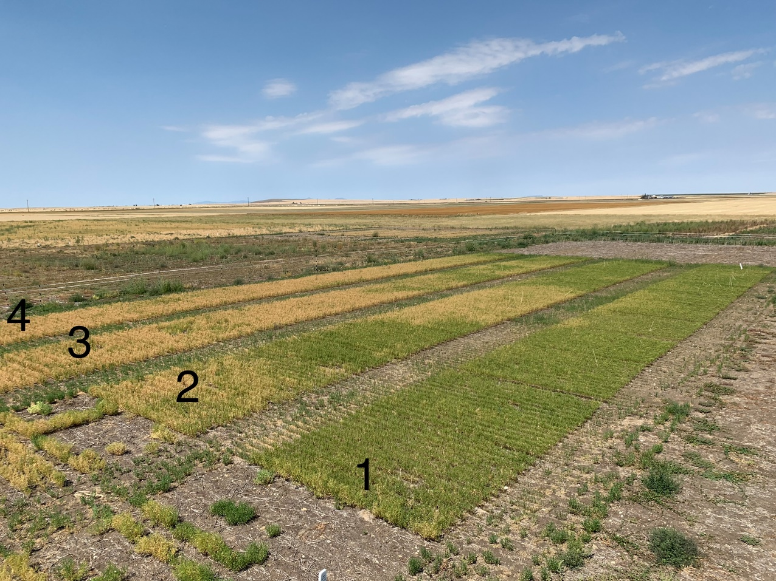

Figure 1. Spatial heterogeneity in soil depth creates characteristic patterns in crop growth stage of lentil independent of experimental design (randomized complete block). Treatment replicate numbers of the small-plot trial are indicated in black.

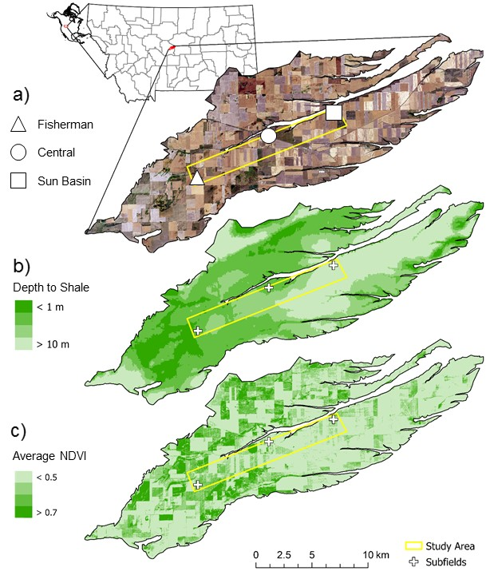

Figure 2. Moccasin Terrace color composite (a) in Judith Basin, Montana with shale depth (b; adapted from Sigler et al., 2018) and spatially-averaged NDVI (c) for the 2019 growing season (Sentinel 2).

Table 1. Coordinates, soil depth, elevation, and slope estimates for individual points, grouped by subfield.



Table 2. Parameter estimates for non-linear regression models where soil depth (*zf*) was designated as a predictor and NDVI as a response variable, grouped by sensor, year, acquisition day of year (DOY), and field. Regressions were performed using NDVI of fields planted to spring wheat in central Montana.



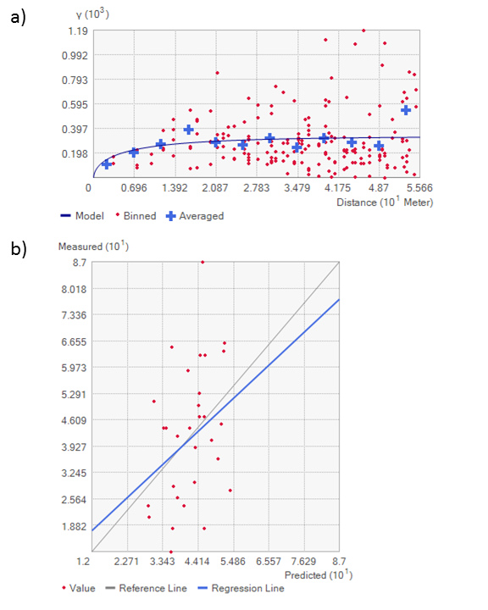

Figure 3. Empirical and fitted variogram (a) and cross validation results (b) in m of ordinary kriging (n = 30) at Central.

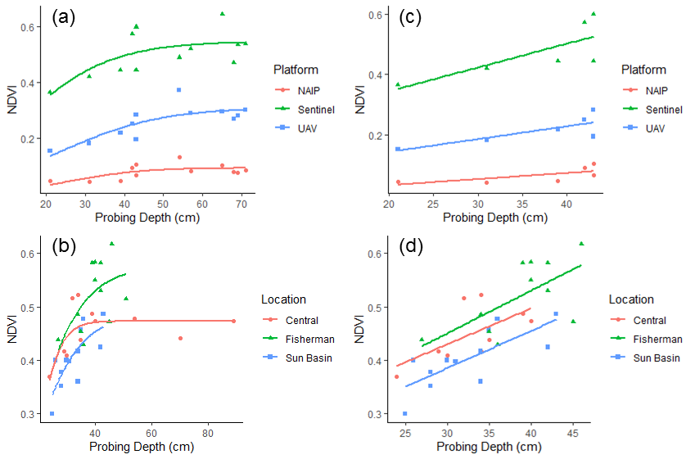

Figure 4. Impacts of image resolution and field on non-linear (a-b) and linear (c-d) regression models for probing depth versus NDVI. Probing depth observations > 50 cm were excluded in linear regressions. Impacts of sensor (a,c) and field (b,d) on probing depth-NDVI relationships were minimal.

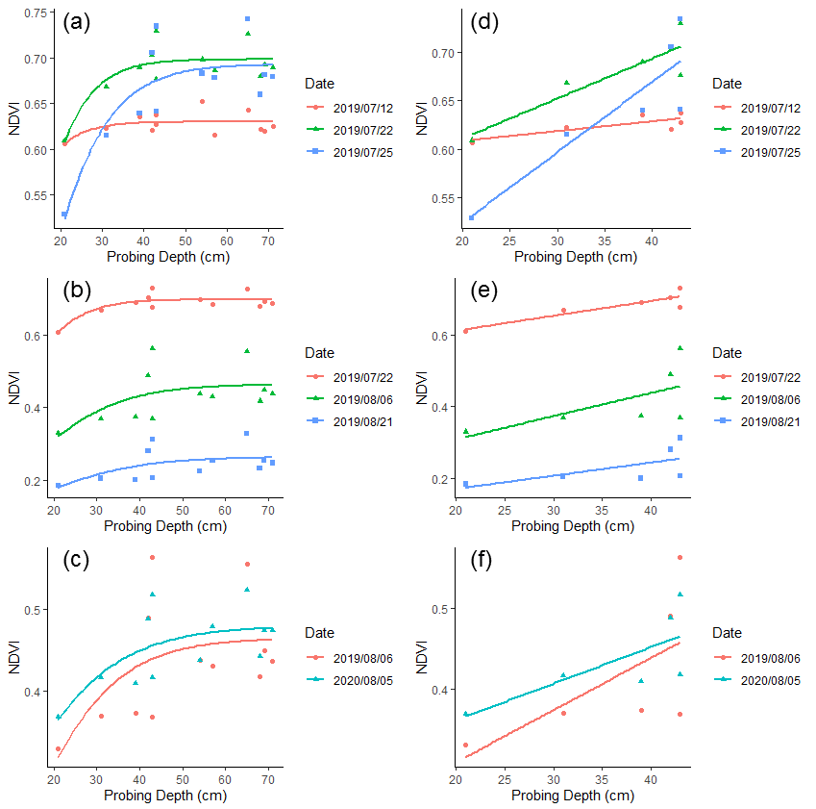

Figure 5. Impacts of image acquisition timing on non-linear (a-c) and linear (d-f) regression models for probing depth versus NDVI. Probing depth observations > 50 cm were excluded in linear regressions. Impacts of acquisition timing on probing depth-NDVI relationships were severe when acquisition occurred immediately before and immediately after the beginning of senescence (a,d) but mild thereafter (b,e). Effects of year were minor for the same Julian day in 2019 and 2020 (c,f).

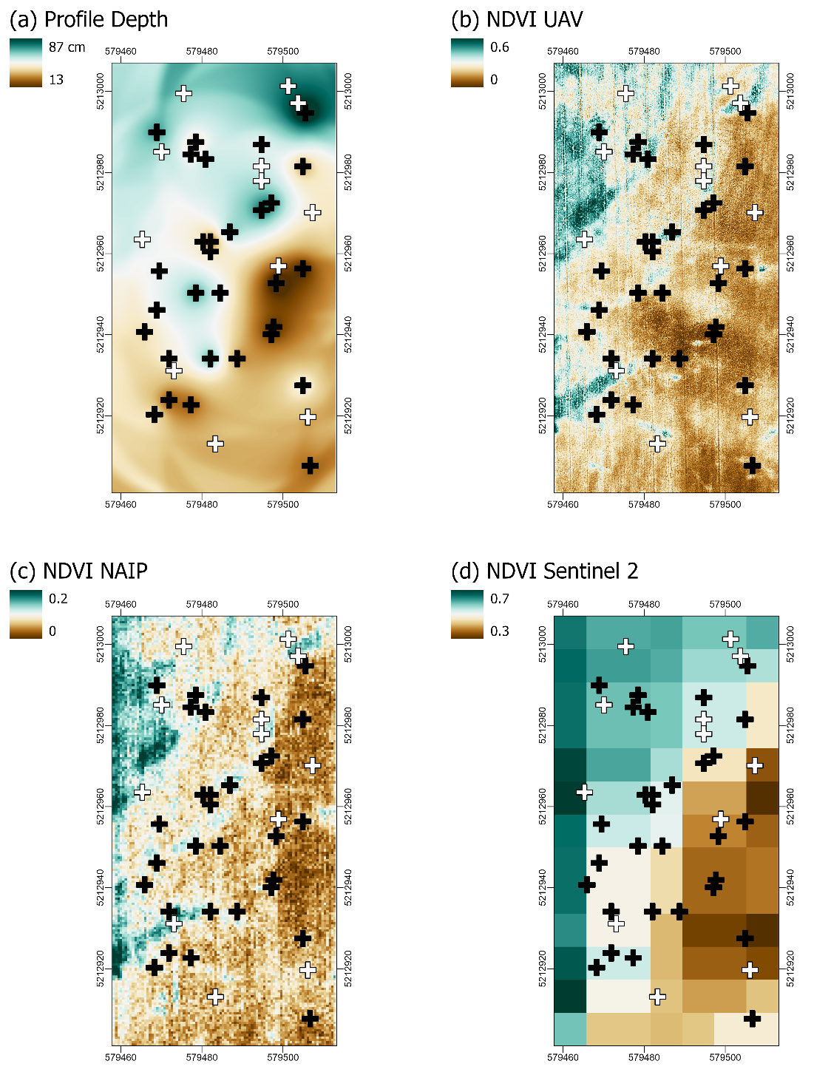

Figure 6. Kriged estimates of soil depth (a) with well-timed (i.e., during senescence) NDVI from an unmanned aerial vehicle (UAV; b), the National Agricultural Imagery Program (NAIP; c), and Sentinel 2 (d). Black symbols are the 30 initial tile probing locations and white symbols are the 12 locations withheld for cross validation.

## References

Basso, B., Ritchie, J. T., Cammarano, D., & Sartori, L. (2011). A strategic and tactical management approach to select optimal N fertilizer rates for wheat in a spatially variable field. European Journal of Agronomy, 35(4), 215-222.

Bestwick, M. L. (2016). Water stress in Montana cropping systems: effects of cultivar, management, and environment on crop production in dryland systems (Master’s thesis, Montana State University-Bozeman, College of Agriculture).

Dietrich, W. E., Reiss, R., Hsu, M. L., & Montgomery, D. R. (1995). A process‐based model for colluvial soil depth and shallow landsliding using digital elevation data. Hydrological Processes, 9(3‐4), 383-400.

Carr, P., Fordyce, S. I., Lachowiec, J., Bishop, S., Fryer, H. K., & Dahlhausen, S. (2021). Replacing fallow with warm‐season annual crops in dryland wheat systems. Agronomy Journal.

Copernicus Sentinel data (2020), processed by ESA.

Gholizadeh, A., Žižala, D., Saberioon, M., & Borůvka, L. (2018). Soil organic carbon and texture retrieving and mapping using proximal, airborne and Sentinel-2 spectral imaging. Remote Sensing of Environment, 218, 89-103.

Grylls, J. P., Webb, J., & Dyer, C. J. (1997). Seasonal variation in response of winter cereals to nitrogen fertilizer and apparent recovery of fertilizer nitrogen on chalk soils in southern England. The Journal of Agricultural Science, 128(3), 251-262.

John, A. A., Jones, C. A., Ewing, S. A., Sigler, W. A., Bekkerman, A., & Miller, P. R. (2017). Fallow replacement and alternative nitrogen management for reducing nitrate leaching in a semiarid region. Nutrient Cycling in Agroecosystems, 108(3), 279-296.

Jones, C., Chen, C., McVay, K., Stougaard, B., Westcott, M., Eckhoff, J., Lenssen, A., Weeding, J., & Greenwood, M. (2011). Measured and predicted temporal changes in soil nitrate-N levels from late summer to early spring in Montana. Western Nutrient Management Conference Proceedings, 9, 77-82.

Krüger, H., Frolla, F., & Zilio, J. (2020). Soil depth, water availability and wheat yield in the austral pampa of Argentina. Ciencia del Suelo, 38(2), 274-283.

Lacoste, M., Mulder, V. L., Richer-de-Forges, A. C., Martin, M. P., & Arrouays, D. (2016). Evaluating large-extent spatial modeling approaches: A case study for soil depth for France. Geoderma Regional, 7(2), 137-152.

Maynard, J. J., & Levi, M. R. (2017). Hyper-temporal remote sensing for digital soil mapping: Characterizing soil-vegetation response to climatic variability. Geoderma, 285, 94-109.

McKenzie, N. J., & Ryan, P. J. (1999). Spatial prediction of soil properties using environmental correlation. Geoderma, 89(1-2), 67-94.

Pinheiro J, Bates D, DebRoy S, Sarkar D, R Core Team (2021). nlme: Linear and Nonlinear Mixed Effects Models. R package version 3.1-153, <https://CRAN.R-project.org/package=nlme>.

R Core Team (2021). R: A language and environment for statistical computing. R Foundation for Statistical Computing, Vienna, Austria. <https://www.R-project.org/>.

Santanello Jr, J. A., Peters-Lidard, C. D., Garcia, M. E., Mocko, D. M., Tischler, M. A., Moran, M. S., & Thoma, D. P. (2007). Using remotely-sensed estimates of soil moisture to infer soil texture and hydraulic properties across a semi-arid watershed. Remote Sensing of Environment, 110(1), 79-97.

Sigler, W. A., Ewing, S. A., Jones, C. A., Payn, R. A., Miller, P., & Maneta, M. (2020). Water and nitrate loss from dryland agricultural soils is controlled by management, soils, and weather. Agriculture, Ecosystems & Environment, 304, 107158.

Sigler, W. A., Ewing, S. A., Jones, C. A., Payn, R. A., Brookshire, E. J., Klassen, J. K., ... & Weissmann, G. S. (2018). Connections among soil, ground, and surface water chemistries characterize nitrogen loss from an agricultural landscape in the upper Missouri River basin. Journal of Hydrology, 556, 247-261.

Taylor, J. A., Jacob, F., Galleguillos, M., Prevot, L., Guix, N., & Lagacherie, P. (2013). The utility of remotely-sensed vegetative and terrain covariates at different spatial resolutions in modelling soil and water table depth (for digital soil mapping). Geoderma, 193, 83-93.

Tesfa, T. K., Tarboton, D. G., Chandler, D. G., & McNamara, J. P. (2009). Modeling soil depth from topographic and land cover attributes. Water Resources Research, 45(10).

USDAa (2020). Soil Survey Staff, Natural Resources Conservation Service, United States Department of Agriculture. Soil Survey Geographic (SSURGO) Database. Available online at <https://sdmdataaccess.sc.egov.usda.gov>. Accessed October 2020.

USDAb (2020). National Agricultural Statistics Service Cropland Data Layer (Online) <http://nassgeodata.gmu.edu/CropScape/>. Accessed October 2020.

USDAc (2020) Farm Service Agency NAIP Imagery <https://www.fsa.usda.gov/programs-and-services/aerial-photography/imageryprograms/naip-imagery/>. Accessed October 2020.

Vazquez-Amabile, G. G., Gonzalo, M., Pella, M., Galbusera, S., & Cueto, G. B. (2013). Evaluation of the Variable Rate Fertilization in winter crops for shallow soils using soil depth maps and crop simulation models in southeastern Pampas, Argentina. In 2013 Kansas City, Missouri, July 21-July 24, 2013 (p. 1). American Society of Agricultural and Biological Engineers.

Williams, C. J., McNamara, J. P., & Chandler, D. G. (2008). Controls on the temporal and spatial variability of soil moisture in a mountainous landscape: the signatures of snow and complex terrain. Hydrology & Earth System Sciences Discussions, 5(4).

Zadoks, J. C., Chang, T. T., & Konzak, C. F. (1974). A decimal code for the growth stages of cereals. Weed Research, 14(6), 415-421.

Ziadat, F. M. (2010). Prediction of soil depth from digital terrain data by integrating statistical and visual approaches. Pedosphere, 20(3), 361-367.

Zillmann, E., Graeff, S., Link, J., Batchelor, W. D., & Claupein, W. (2006). Assessment of cereal nitrogen requirements derived by optical on‐the‐go sensors on heterogeneous soils. Agronomy Journal, 98(3), 682-690.

# CHAPTER THREE

# SPATIOTEMPORAL PATTERNS OF NITROGEN MINERALIZATION

# IN A DRYLAND WHEAT SYSTEM

## Contribution of Authors and Co-Authors

Manuscript in Chapter 3

Author: Simon Fordyce

Contributions: data collection, analysis, interpretation, writing, revising, editing

Co-Author: Pat Carr

Contributions: data interpretation, revising, editing

Co-Author: Clain Jones

Contributions: data interpretation, revising, editing

Co-Author: Jed Eberly

Contributions: data interpretation, revising, editing

Co-Author: Rob Payn

Contributions: data analysis, interpretation, revising, editing

Co-Author: Adam Sigler

Contributions: data interpretation, revising, editing

Co-Author: Stephanie Ewing

Contributions: data interpretation, revising, editing

## Manuscript Information

Simon Fordyce, Pat Carr, Clain Jones, Jed Eberly, Rob Payn, Adam Sigler, Stephanie Ewing

*Agriculture, Ecosystems, and Environment*

Status of Manuscript:

_ x _ Prepared for submission to a peer-reviewed journal

____ Officially submitted to a peer-reviewed journal

____ Accepted by a peer-reviewed journal

____ Published in a peer-reviewed journal

Elsevier

## Abstract

Soil depth (*zf*) affects offseason (October-March) nitrogen (N) dynamics in dryland wheat systems, in part because inorganic N losses to leaching are greater in shallow soils (< 50 cm). Methods used to estimate leaching often assume equal net-N mineralization rates at the surface of deep and shallow profiles, yet differences in surficial mineralization with changes in *zf* have only rarely been measured. Gradients in *zf* within three fields in central Montana continuously cropped to winter or spring wheat (*Triticum aestivum* L.) from 2017 to 2020 were identified using satellite imagery (Sentinel 2). Surface soils (0-20 cm) were sampled in fall and spring for soil organic matter (SOM), as well as activity of β-glucosidase (BG) and β-glucosaminidase (NAG), extracellular enzymes used as indices of carbon and N mineralization. An imagery-based regression tree classifier was used to group samples into deep and shallow soil classes. Mixed effects modelling across fields indicated SOM was higher (*p* < 0.01) and NAG activity was lower (*p* = 0.05) in the shallow class, while BG activity was not different (*p* = 0.68) between depth classes when sampling occurred in fall. NAG in shallow soils was consistently low regardless of sampling time. The combination of high SOM and low NAG activity suggests comparatively low net N mineralization rates in shallow soils. Lower mineralization in shallow soils may offset apparent inorganic N losses from leaching in the offseason. The study contributes to an understanding of the mechanisms controlling offseason N dynamics in dryland wheat systems, with implications for site specific fertility management.

## Introduction

Nitrogen (N) fertilizer application in dryland wheat systems is partially incentivized by the premium prices paid for higher-protein grain, which often determines farm profitability. Therefore, wheat farmers may be tempted to apply high fertilizer rates to their crops to ensure high quality. However, high fertilizer rates can contribute to water quality issues due to elevated nitrate leaching risks (Schmidt & Mulder, 2010; Miller, 2013; John et al., 2017, Sigler et al., 2018). Mitigating N losses to leaching preserves the quality of ground and surface water resources and slows soil degrading processes like acidification (Rengel, 2003). Leaching mitigation strategies include timely soil testing (Pariera-Dinkins & Jones, 2013) and cropping to legumes grown for grain (John et al., 2017) or non-legume cover crops (Thapa et al., 2018) rather than idling arable land during the growing season (i.e., summer fallow replacement).

Many researchers have questioned 14-21 month fallow periods (i.e., summer fallow) in dryland wheat systems (Black et al., 1981; Rasmussen & Parton, 1994; Aase & Pikul, 1995), particularly on shallow soils with low precipitation storage efficiencies (Vomocil & Ramig, 1984; Sigler et al., 2020; Carr et al., 2021). Summer fallow increases the risk of groundwater nitrate contamination by increasing both percolation below the root zone and soil nitrate concentrations (Dinnes et al., 2002), two prerequisite conditions for nitrate leaching. Soils are at the highest risk of nitrate leaching during and shortly after the summer fallow phase. Summer fallow replacement with annual legumes can mitigate nitrate leaching losses in shallow soil environments and preserve or increase net revenue (John et al., 2017).

Over- or under-fertilization is possible when spring fertilizer needs are based on fall soil tests, since fall nitrate is a poor predictor of spring nitrate (Jones et al., 2011). Non-fertilizer N inputs (e.g., mineralization) and losses (e.g., leaching) exhibit substantial spatiotemporal variability during the offseason (October-March), correlating with management, previous crop, *zf*, moisture, and other environmental factors (Jones et al., 2011). Winter weather events (e.g., freeze-thaw cycles) can lead to biophysical changes in soil that affect processes including N mineralization (Roth & Fox, 1990; Heaney et al., 1992; McCracken et al., 1994; Ryan et al., 2000), denitrification (Christensen & Tiedje, 1990; Heaney et al., 1992; Burton & Beauchamp, 1994; Röver et al., 1998), volatilization (Engel et al., 2011) and leaching (Liang et al., 1991; Campbell et al., 1994). These factors affect the magnitude and direction of N change over this period. Thus, soil N test results from fall can mislead farmers about fertilizer needs the following spring without accounting for offseason changes in available N.

Most studies report increasing inorganic N during the offseason (McCracken et al., 1994; Mitchell et al., 1996), although Jokela (1992) found nitrate decreased between fall and spring, possibly because spring sampling occurred after plant uptake was underway. Jones et al. (2011) reported average offseason soil nitrate gains ranging from 13 to 29 kg ha-1 following fallow and annual legumes, respectively, but offseason nitrate changes for individual sampling locations ranged from -67 to +72 kg ha-1. Overall, soil nitrate gains were 9 kg ha-1 lower in shallow than deep soils in the research by Jones et al. (2011). Jones & Olson-Rutz (2019) recommended soil sampling in spring rather than fall because of the temporal variability in offseason N changes. However, springtime soil sampling is often impractical due to a combination of factors, including wet and inaccessible fields and heavy workloads in spring.

Predicting the magnitude and direction of offseason N changes in dryland wheat systems may be possible by characterizing the physiographic controls spatially. For example, Sigler et al. (2018) spatially characterized depth to an impermeable shale layer in central Montana, hypothesizing that this variable exerted a time-invariant control on leaching rates by partitioning more precipitation to overland flow where shale was close to the surface. Previous research indicates that greenness of cereal crops at senescence (growth stage code 90-93; Zadoks et al., 1974) is related to water availability as a function of *zf* (Chapter 2). Sigler et al. (2020) used the normalized difference vegetation index (NDVI) to spatially characterize *zf*. The use of NDVI to characterize soil properties spatially that impact N loss has implications for site-specific N fertilizer management (Sigler et al., 2020). Recent work suggests that the effect of *zf* on offseason changes in total water extractable N is independent of year (Fordyce et al., 2021), suggesting N fertilizer prescription maps based on *zf* have potential for decision support regardless of weather and climate variability. Effects of weather and climate on offseason N change may be more easily interpreted by accounting for time-invariant, physiographic controls such as *zf*. Theobald et al. (2015) advanced a similar concept to assist in climate adaptation planning, wherein static abiotic variables were used to develop a classified map of physiography against which the effects of climate change on biodiversity could be more easily interpreted.

A warmer climate could have consequences for soil N dynamics in the offseason, but nitrate leaching and export simulations under future climate scenarios have produced contradictory results. For example, changes in growing season length and precipitation patterns could increase nitrate leaching three-fold in parts of the northern Great Plains (He et al., 2018). However, declining N exports based on the combined effects of reduced mineralization and reduced streamflow in hotter, drier conditions are also possible in arid environments (Ye & Grimm, 2013). In shallow soil environments, variable rate technology may help reduce residual soil nitrate concentrations at leaching ‘hotspots’ across the landscape (Sigler et al., 2020), thereby tempering weather- and climate-related uncertainty in N leaching models. Unfortunately, support for variable rate N fertilizer management is lacking among dryland wheat farmers in these environments and others (Appendix A; Lowenberg-Deboer & Erickson, 2019). Furthermore, farmers in these regions may be vulnerable to economic loss from over- or under-fertilization, a problem which could be exacerbated by a warmer climate. A recent survey suggests nearly a third of the operators on large farms in central Montana were unfamiliar with current climate projections and one quarter directly challenged them. Furthermore, the few (35%) farmers who reported soil sampling regularly did so every other year or less often, and 20% reported not sampling at all (Appendix A).

Leaching was proposed as the main driver of observed variation in offseason N changes in shallow soil environments in Jones et al. (2011). A simulation study from Sigler et al. (2020) corroborated this finding, showing that annual leaching losses were at least five times higher in very shallow soils (< 25 cm) than in deep soils (>100 cm). While water retention as a function of soil depth is almost certainly an important factor in predicting nitrate leaching, the potential for surficial carbon (C) and N mineralization to vary with soil thickness has not been assessed. We hypothesized that deeper, more productive soils retain a larger pool of surficial SOM leading to higher C and N mineralization rates and greater offseason inorganic N increases relative to thin soils.

## Methods

### Study Area

The Moccasin Terrace in the Judith River Watershed, Montana is a 260-km2 gravel deposit with shallow water tables (1-10 m) and shallow soils (63 ± 30 cm; Sigler et al., 2020) overlying a calcareous gravel layer. A 15-km transect of the Moccasin Terrace delineated the study area (Figure 7). The transect was oriented to capture a range in depth to shale contact, which can reside within 1 m of the soil surface at the shallowest locations. Overland flow is more likely in these areas and therefore infiltration and nitrate leaching are less likely than in deeper shale areas (Sigler et al., 2018). The transect was also oriented in the direction of the prevailing winds (southwest) to minimize differences in precipitation among sites. Within the transect, three fields (A, B, and C) with taxonomically similar soils (complex of Vertic Argiustolls and Typic Calciustolls; 0-2% slopes; USDAa, 2020) were targeted for soil sampling.

Details of field selection were given in Chapter 2. Briefly, a 0.4-ha area within each field was identified based on high variation in the spectral index NDVI within images taken near cereal crop senescence by the National Agricultural Imagery Program (NAIP; USDAb, 2020). Twelve fully randomized sampling locations were assigned within each subfield. Landform context and hydrogeology of the Moccasin Terrace were described in detail in Sigler et al. (2018). Long-term offseason precipitation (1909-2020) and temperature (1911-2020) averaged 162 mm and 1.4 °C at the Central Agricultural Research Center near the center of the study area (Site B). Total offseason (October-March) precipitation for crop years 2018 and 2019 was higher than long-term averages, although average temperatures were lower (Table 3). Drier-than-average offseason conditions and normal offseason temperatures were observed in the 2020 crop year. In 2020, the majority of the study area was planted to winter wheat, spring wheat, barley, or left fallow (USDAc, 2021).

### Estimating Soil Depth

Soil depth was modelled for three fields using Sentinel (Copernicus, 2020) multispectral images and NDVI of spring wheat during senescence (growth stage code 90-93; Zadoks et al., 1974). Two separate modelling approaches were used to predict *zf* as categorical and continuous variables. In the categorical approach, apparent profile depth was spatially characterized across management boundaries using the Classification and Regression Trees (CART) classifier (Breiman et al., 1984) with 4-band (R, G, B, NIR) Sentinel 2 imagery (10 m resolution) in Google Earth Engine (Goerlick et al., 2017). Individual bands of Sentinel 2 images acquired between 16 June and 04 September 2020 were spatially averaged prior to classification. Normalized difference vegetation index from NAIP (0.6 m resolution) was used to define training and validation polygons, within which every pixel was treated as a training or validation point. Training polygons included a total of 124 and 126 pixels for ‘deep’ and ‘shallow’ classes, respectively, satisfying the 100-pixel guideline suggested by Campbell and Wynne (2011).

In the continuous approach, mean (NDVIMEAN) and max NDVI (NDVIMAX) for the period 16 June to 04 September were included as independent variables in a logistic model:

where parameters *a* and *b* are empirically-derived constants representing the maximum slope of the *zf* –NDVI relationship and value of *zf* at the maximum slope, set to 0.013 and -22.3, respectively, based on an iterative parameterization which optimized the regression statistics of predicted and observed *zf*. Observed *zf* was measured at random as described in Chapter 2. Briefly, maximum depth of a tile probe (Φ = 19 mm) at 1 MPa of vertical pressure on a tractor-mounted Giddings hydraulic soil probe was used to estimate *zf* as defined in Sigler et al. (2020). Performance of categorical and continuous models were assessed using analysis of variance and linear regression. Specifically, *zf* was designated as the response variable with categorical or continuous *zf* estimates designated as fixed effects crossed with field (*zf* × field). Because interactions were not observed in either model, the interaction term was dropped and field was designated as a random effect in linear mixed-effects models assessing the ability of *zf* predictions to explain variance in *zf* observations after accounting for random effects of field.

Non-linear modelling (Eq. 1) and CART classification of Sentinel imagery accurately characterized soil depth across field boundaries, despite differences in planting dates (> 2 weeks; Chapter 2). Specifically, both the continuous and categorical predictions explained 29% of the variation in *zf* after accounting for random effects of field. However, the categorical model outperformed the continuous model based on *p*-values (*p* < 0.001 vs *p* < 0.01), residual standard errors (5.7 vs. 6.2 cm), and the Akaike information criterion (224 vs. 226). While the error matrix and accuracy statistics of the CART classification (Table 4) are not directly applicable to *zf* characterization (i.e., *zf* was not measured in all training/test areas) results are an indication that spatial patterns of NDVI in well-timed NAIP images are reproducible with Sentinel imagery on a landform where such patterns are known to correlate with *zf* (Chapter 2). Therefore, categorical estimates of *zf* were used to investigate the effects of *zf* on textural, chemical, biological, and other soil attributes. Visual comparisons with NDVI from well-timed NAIP and unmanned aerial vehicle (UAV) imagery at Site B (Chapter 2) gave confidence in this approach (Figure 8).

### Soil Sampling

A Giddings hydraulic soil probe was used to collect soil cores (0-20 cm) from up to 12 randomly assigned locations within each subfield, with sampling number dependent on field accessibility and mechanical failures of the hydraulic probe, necessitating hand coring and preventing sampling of all locations. At sites A, B, and C, twelve cores per site were collected in fall 2018. Twelve and four locations were resampled (within 0.5 m) at Sites A and B, respectively, in spring 2020. Additional samples were collected at site B in spring (n = 4) and fall (n = 12) of 2019. All soil samples were kept frozen until processing in spring 2020. Textural, chemical, and biological analyses were conducted by Ward Laboratories, Inc. (Kearney, Nebraska). Soil organic matter (loss on ignition; 3 g soil; 2 hr at 360°C), pH (1:1), % clay, and % sand (hydrometer) were determined for samples collected in fall 2018. Soil moisture, permanganate oxidizable carbon (POXC; 8:1 KMnO4, Weil et al., 2003), extractable nitrate (NO3-), ammonium (NH4+), calcium (Ca), and magnesium (Mg; 10:1, weak acid H3A-3: 2 L DI water, 2.6 g lithium citrate, 1.2 g malic acid, 1.0 g citric acid, and 0.6 g oxalic acid; Haney et al., 2010), water extractable (10:1; Haney et al., 2012) organic C (WEOC), total N (WEN), nitrate (WENO3-), ammonium (WENH4+), inorganic N (WEIN; WENO3- + WENH4+), organic N (WEON; WEN - WEIN), and the ratio of WEOC to WEON (C:N), as well as activity of β-glucosidase (BG; Burns et al., 2013) and β-glucosaminidase (NAG; Tabatabai, 1994), were determined on all samples. BG and NAG are extracellular enzymes responsible for the degradation of cellulose and chitin, respectively. Importantly, NAG has been proposed as an index of net N mineralization (Tabatabai et al., 2010).

At site B, a bulk density sampler (AMS, American Falls, Idaho) was used to determine dry bulk density (0-20 cm) at four randomly selected points across the subfield. Dry bulk density averaged 1.5 ± 0.04 g cm-3 across samples. Soil depth did not correlate with bulk density and the coefficient of variation among samples was small (3%). Bulk densities measured in this study were within the range of surface (0-15 cm) bulk densities reported by Sigler et al. (2020). Surficial inventories (mass ha-1) of NO3-, NH4+, Ca, Mg, POXC, WEOC, WEN, WEON, and WEIN were calculated using a dry bulk density of 1.5 g cm-3 for all samples. Volumetric water content (VWC) was calculated in kind and reported as a percentage.

### Soil Respiration Measurements and Data Cleaning

Six auto-closing soil respiration (SR) chambers (CFLUX-1, PP Systems, Inc., Amesbury, MA) were deployed at site B due to ease of field access and because *zf* was characterized with a higher degree of confidence (Chapter 2). Exact placement of SR chambers was based on a restricted randomization scheme within a transect oriented roughly perpendicular to *zf* isolines within the subfield. SR chambers were set to measure and log internal carbon dioxide (CO2) concentration dynamics once per second for 60 seconds per hour from 8 October 2019 to 18 May 2020. Instruments were periodically disconnected from power sources when air temperatures fell below the instrumental operation limit (-4 °C). Both low SR and low signal to noise ratios created difficulties in objectively separating positive CO2 fluxes from those that were not meaningful (zero or errant measurements). Therefore, a quality control protocol was needed to filter the SR dataset.

A data filter was developed that identified positive SR flux estimates based on patterns in raw CO2 readings taken immediately after chamber lid closure. A primary criterion for that data filter was the standard deviation of CO2 concentrations (σCO2) recorded over a given flux measurement. Across the flux measurement periods, values for σCO2 exhibited a bimodal structure that suggested two populations of measurement quality when early (t0-t13), ‘unstable’ measurements were included (Figure 9a). However, only one mode was present when early measurements were excluded (Figure 9b). We suggest that a higher σCO2 is a relatively simple, yet effective, criterion for selecting data that are more likely to represent a meaningful respiration measurement suitable for assessing the potential variation in respiration due to *zf*.

Soil respiration measurements with stable CO2 gradients early in the cycle were presumed non-meaningful either because CO2 flux from the soil was too small at the time of the measurement or because mechanical failures caused by inclement weather seized the driver arm of the SR chamber and fixed the lid in an open or closed position. Therefore, we selected a minimum σCO2 threshold (1.6 mg m-2) that divided the population near the minimum frequency separating the modes. Three data integrity metrics were applied in addition to the σCO2 threshold exclusions. Specifically, measurement cycles were excluded if: (1) error messages associated with mechanical failures were logged by the instrument’s software; (2) a *p*-value statistic of the regression slope for stable readings suggested that uncertainty in the inferred slope would not allow it to be distinguished from zero (*p* > 0.05); and (3) the increase in time during measurement could not statistically explain a meaningful amount of the increase in CO2 readings (t14-t60) as indicated by a Pearson’s correlation coefficient (r) less than 0.85.

### Statistical Analysis

The potential for soil thickness to affect surficial textural, chemical, and biological variables was assessed by linear mixed modelling using the lmer function in the lme4 package version 1.1-15 (Bates et al., 2013) of R statistical software (R Core Team, 2021). Predicted *zf* (categorical) was designated as a fixed effect and field as a random effect in linear mixed models to predict various soil attributes, provided no field × *zf* interactions were detected at *p* < 0.05 and assumptions of normality and equal variance were satisfied (i.e., Shapiro’s and Levene’s test *p* > 0.01). The only exception to this rule was a weak (*p* = 0.03) field × *zf* interaction detected for POXC during the fall sampling event, perhaps reflecting this parameter’s relative sensitivity to management. Samples from all sites (A, B, and C) were included in models predicting time-invariant response variables (pH, SOM, %sand, %clay). Samples from sites A and B were used for all other response variables, with the exception of SR, which was measured at site B only. Site C was excluded from time-variant analyses because sampling occurred after fertilizer was applied in spring 2020.

Only SR measurements that met the minimum σCO2 threshold and passed all three integrity metric criteria with matching sample times (to the nearest hour) across all six instruments were included in subsequent analyses. Linear mixed modelling was conducted in R statistical software (lmer function, lme4 package) to assess the continuous fixed effect of *zf* on SR after accounting for categorized random effects of sample date. Accounting for sample date as a random effect normalized the assessment of variation in respiration with *zf* to other effects likely related to soil properties that vary over time, such as temperature and moisture. SR was log-transformed to satisfy assumptions of normality and homogeneity of variance. Mixed model statistical analyses were repeated at thresholds that included (least restrictive) or excluded (most restrictive) an additional 5% of the respiration measurements to assess the potential for subjectivity in the selection of the σCO2 threshold to influence conclusions.

The potential for sampling season (fall or spring) and year (2018 or 2019) to affect time-variant chemical and biological variables was assessed by linear mixed modelling. Soil depth classes were analyzed separately in models assessing effects of sampling season, and sampling season classes were analyzed separately in models assessing effects of sampling year. Sampling season or sampling year was designated as a fixed effect and field as a random effect in linear mixed models to predict various soil attributes, provided no sampling season × field or sampling year × field interactions were detected (*p* > 0.05) and assumptions of normality and equal variance were satisfied (i.e., Shapiro’s and Levene’s test *p* > 0.01). Samples from sites A and B were included in models assessing effects of sampling season. Only samples from site B were included in models assessing effects of sampling year.

## Results

### Effects of Soil Depth on Surficial Soil Properties

Surficial SOM, pH, % sand, and extractable Ca were higher in shallow soils, while % clay was lower (*p* < 0.05; Table 6). Activity of NAG was lower in shallow soils (*p* = 0.05) in fall, but not spring (*p* = 0.26). Ammonium was lower in shallow soils in spring (*p* = 0.02) and nearly lower in fall (*p* = 0.06). Multiple soil properties, including VWC, POXC, Mg, WEOC, WEN, WEON, WEIN, NO3-, BG, and C:N were not different between depth classes in fall and spring (*p* > 0.1). NAG activity was low in fall and spring in shallow soils but decreased from fall to spring in deeper soils (Table 7). Ammonium declined from fall to spring in both shallow and deep soils (*p* < 0.05), while WEOC increased slightly in deep soils only (*p* = 0.02). As noted, WEIN was not statistically different between shallow and deep soils and was unaffected by sampling time when analyzed across fields. However, in the multiyear, single location model (site B only; Table 8), WEIN was higher in shallow soils (*p* < 0.05) in fall but not spring (*p* = 0.97). Activity of BG was also higher in shallow soils after accounting for effects of year, but the sample timing trend was reversed, with near-differences detected in spring (*p* = 0.06) and no differences in fall (*p* = 0.76). Surficial Ca was 80% higher in shallow soils after accounting for effects of year in spring (*p* < 0.05) but not fall (*p* = 0.20) in the multi-year model (Table 8). Surficial Mg was lower in shallow soils in both spring and fall (*p* < 0.05) after accounting for effects of year. Differences between depth classes were not observed for any other soil properties after accounting for effects of year (Table 8).

### Soil Respiration Measurements

Soil respiration measurement exclusions based on mechanical failure error messages (error messages 71 and 72), *p*-values (*p* < 0.05), and Pearson’s correlation coefficient (r > 0.85) were 6, 14, and 64% of the raw dataset, compared to 26, 8, and 36% of the dataset after the σCO2 threshold was imposed (Table 5). Soil temperature (0-6 cm) averaged 3 ± 5 and 12 ± 6°C (± SD) for the raw and clean datasets, respectively. Linear mixed modelling with sensitivity analysis indicated that *p*-values of the *zf* with SR regression were sensitive to small (± 5%) adjustments of the σCO2 threshold. Specifically, *p*-values of the least and most restrictive threshold scenarios were 0.02 and 0.21, respectively. However, the marginal R2 was low (0.01-0.02) across all mixed model analyses, even when *p* < 0.05. The conditional R2 was substantially higher (0.38-0.51). No SR differences were detected between depth classes based on linear mixed modelling with *zf* as a categorical variable. Soil respiration in fall (October - November) averaged 113 ± 7 and 125 ± 8 (± SE) mg CO2 m-2 hr-1 in shallow and deep soils, respectively. Averaged over the spring measurement period (March - May), SR rates were 100 ± 6 and 96 ± 5 mg CO2 m-1 hr-1 in shallow and deep soils, respectively (Table 8).

## Discussion

Results do not support the hypothesis that deeper, more productive soils retain a larger pool of SOM in the top 20 cm, leading to higher C mineralization in surface soils. Rather, SOM was lower in the top 20 cm of deep soils, while respiration and other C mineralization indicators were not different between depth classes. The prediction of higher N mineralization in deeper soils was supported by higher NAG activity in these soils, but ammonium in both depth classes decreased from fall to spring, while WEIN declined in shallow soils only. Leaching of WEIN was almost certainly a factor in the current study, given above-average offseason precipitation in 2018 and 2019 crop years (Table 3). However, leaching from the top 20 cm should not have varied between depth classes, and if it did, the textural boundary near the surface of shallow profiles should have reduced surficial leaching in the shallow depth class due to ‘tension barriers’ which develop at such boundaries, serving to slow infiltration rates (Stormont & Anderson, 1999). Results suggest that net N mineralization is suppressed in shallow soils despite higher SOM contents.

It is theorized that SOM is greater where profile depth is shallow because the volume of soil that a root explores is smaller, leading to more root biomass per volume of soil, and therefore higher SOM. While the mechanism(s) explaining elevated surficial SOM with decreasing soil depth cannot be disentangled from observed pH, textural, and other differences, elevated extractable Ca in shallow soils suggest Ca-mediated stabilization of SOM. Higher surficial SOM in shallow soils without a corresponding increase in respiration and reduced NH4+ and NAG could imply moisture limits C and N mineralization in these environments, as suggested by Grylls et al. (1997). However, similar VWC between shallow and deep soils at the time of sampling suggests this is not the case. Apparent offseason N losses from shallow soil environments (Jones et al., 2011) could be partially explained by decreased N mineralization (i.e., greater immobilization) in addition to increased losses from leaching.

The decoupling of SOM and N mineralization potentials along a gradient in *zf* has implications for N fertilizer requirements in shallow soil environments. In Montana, it is currently recommended that N fertilizer rates be reduced by 17-22 kg ha-1 where SOM is 3% or higher in the top 15 cm (Pariera-Dinkins & Jones, 2013). However, an adjustment of this magnitude could result in under-fertilization of wheat crops in shallow soils since SOM and mineralization potentials respond differentially to changes in profile depth. Nonetheless, we do not advocate for higher N fertilizer rates in agroecosystems with shallow soils. In fact, the recommendation of reduced fertilizer application above 3% SOM may work well in shallow soil environments, but for different reasons. That is, the guideline may inadvertently prevent extreme leaching losses from shallow soil environments since the microbial release of N from SOM likely does not meet the ca. 20 kg ha-1 expectation in these environments. While lower mineralization may contribute to larger offseason N losses from shallow soils, more work is needed to assess interactions with leaching, as well as the role of suppressed crop uptake related to early depletion of stored soil water and the inability of roots to efficiently scavenge N in the previous growing season.

Although surficial SOM contents were higher in shallow soils, we found no evidence that C mineralization varied between depth classes. Specifically, activity of the extracellular enzyme responsible for the hydrolysis of the abundant and C-rich compound cellulose (i.e., BG), as well as surficial pools of labile carbon (POXC, WEOC), C:N ratios, and offseason SR were not different in the upper 20 cm between depth classes. Activity of BG is known to be sensitive to management (Ali et al., 2019), so it is possible that effects of depth classes were masked by subtle differences in management across fields. Indeed, in the single location, multiyear assessment, BG was nearly higher (*p* = 0.06) in shallow soils when sample collection occurred in spring (Table 8). However, this finding does not change our interpretation of results, as higher, rather than lower, BG activity in deeper soil environments would support the hypothesis of higher surficial C mineralization in these soils.

Soil respiration measurements during the offseason proved difficult and the filtering protocol may not have resolved all data integrity issues. Imposing the σCO2 threshold left a higher percentage of measurements with mechanical failure error messages, possibly because high variation in the data was more likely when an error occurred. However, a lower percent exclusion due to regression statistics (*p*-value, r) after imposing the σCO2 threshold gives confidence that the approach preserved non-suspect SR measurements. Furthermore, soil temperature at the time of measurement increased by 9 °C after filtering the data, confirming that the protocol effectively eliminated SR measurements made during periods of frozen or near-frozen soil. While the sensitivity analysis indicated that *p*-values of the *zf* with SR regression were sensitive to small (± 5%) adjustments of the σCO2 threshold, the marginal R2 was low (0.01-0.02) across all mixed model analyses, even at *p* < 0.05, indicating that *zf* failed to explain a meaningful amount of variation in soil respiration rates. A substantially higher conditional R2 (0.38-0.51) suggests the random effects captured by the time of measurement described much more variation in respiration than *zf*. Lastly, slopes of *zf* with SR regression lines were consistently negative in continuous models (data not shown), challenging the prediction of greater surficial C mineralization in deeper soils.

Water extractable Ca was consistently higher at the surface of shallow profiles, likely due to the surficial proximity of the calcareous horizon coinciding with the gravel layer at the bottom of the soil profile. This finding raises questions about the potential for Ca-mediated SOM stabilization as demonstrated in recent work (Rowley et al., 2018). The proximity of the calcareous layer to the surface also likely affected surficial pH, such that higher pH values were observed in shallow soils. This finding is not likely to impact our enzymatic conclusions since activities were determined at optimal pH values, although pH is a strong driver of soil microbial community composition. Surface-proximal calcareous horizons of shallow soils may confer a pH buffering effect. Specifically, this phenomenon could slow acidification associated with long-term application of ammonium-based fertilizers, a growing problem in the Great Plains (Schroder et al., 2011) and worldwide (Von Uexküll & Mutert, 1995). More work is needed to determine mechanisms of SOM stabilization in shallow soil environments, specifically regarding pH and Ca interactions.

Supervised classification and non-linear modelling based on Sentinel image reduction techniques have potential for characterizing soil profile depth across management boundaries. Previous research has characterized soil depth at high spatial resolutions (< 10 m; Bestwick, 2016; Sigler et al., 2020), but the extent of profile depth prediction was improved three-fold in the current study (145 vs 44 ha) by including multiple fields. Previous studies documented higher offseason N losses from leaching in shallow soils (Jones et al., 2011; John et al., 2017; Sigler et al., 2020), but ours is the first to suggest a corresponding difference in surficial N mineralization. The study adds to a growing body of evidence that differential fertility management of shallow and deep soils could confer significant agronomic benefits, particularly in semi-arid agroecosystems.

## Conclusion

Results of this study suggest shallow soils retain a large pool of surficial SOM, likely a function of more root biomass per volume of soil and/or Ca-mediated SOM stabilization. However, differences in SOM stability may prevent corresponding increases in C and N mineralization which may offset losses of dissolved inorganic N in the offseason in shallow soils. Variable rate applications of N fertilizer may be better suited to shallow soil environments since soil depth affects multiple nitrogen cycling pathways and can be spatially characterized with satellite imagery. Future work should investigate depth-affected yield differences and the potential for soil depth maps to serve as base layers in precision agricultural initiatives, with special attention given to the fertility management implications of feedbacks among soil organic matter, extractable calcium, pH, and N mineralization.

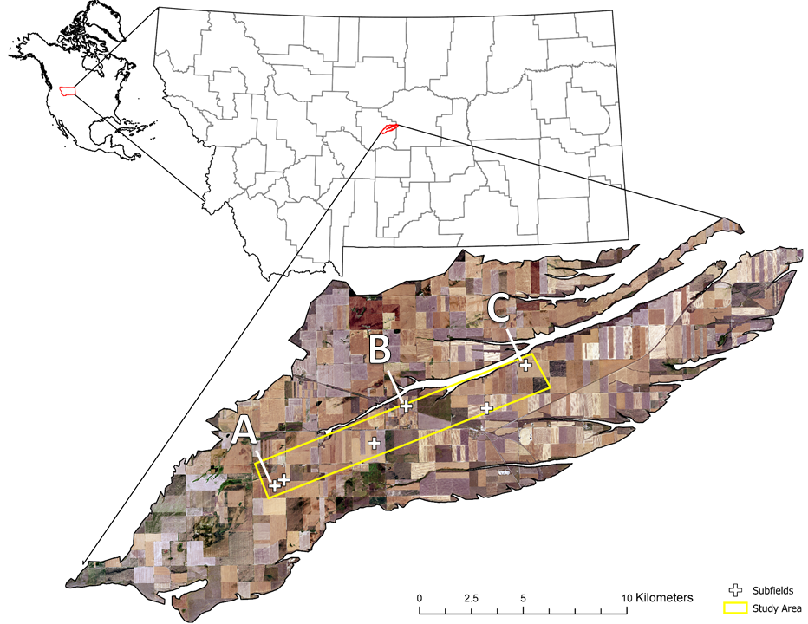Figure 7. Moccasin Terrace with study area and subfields. Time-invariant soil properties were sampled at A, B, and C. Other soil properties were sampled at A and B in fall 2018 and spring 2020. Other subfields were excluded based on unplanned changes in crop rotation (i.e., alternative crops, fallow) or tillage system.

Table 3. Monthly average precipitation (Precip.) and temperature (Temp.) during the study period. Averages are 111-yr and 109-yr for precipitation and temperature, respectively.



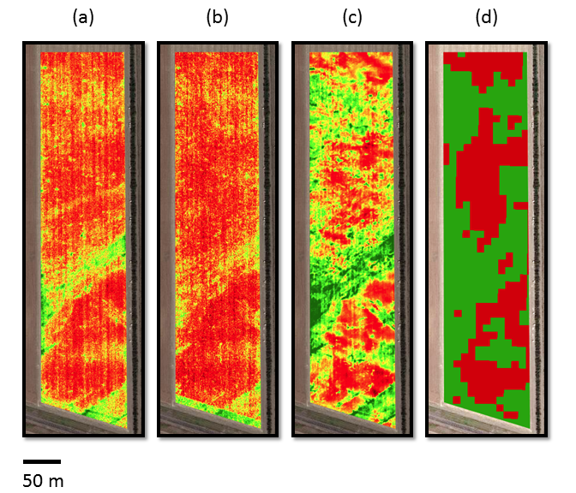

Figure 8. Site B ancillary imagery and predicted depth classes. NDVI of spring wheat captured during crop senescence by the National Agricultural Imagery Program (0.6 m) in 2017 (a) and 2019 (b) and an unmanned aerial vehicle (0.01 m) in 2017 (c), as well as predictions of the classification and regression trees classifier with 4-band Sentinel 2 imagery (10 m) from 16 June 2020 through 04 September 2020 (d).

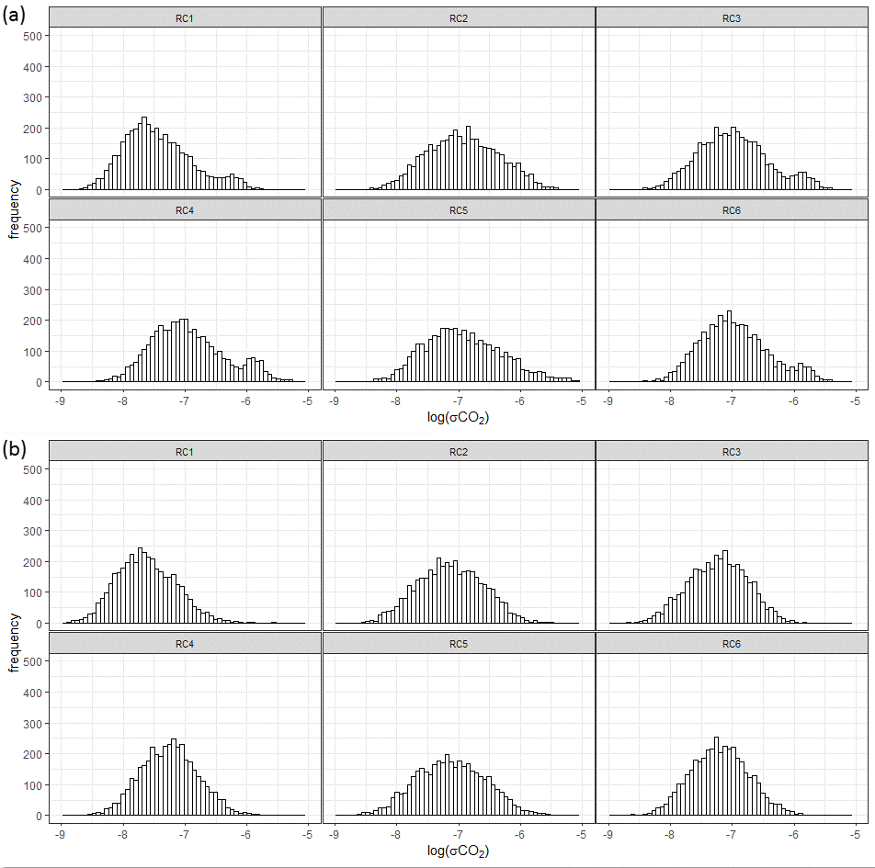 Figure 9. Histograms of log-transformed standard deviations of chamber carbon dioxide (CO2) concentrations for individual measurement cycles with early (t0 - t13), ‘unstable’ CO2 readings included (a) and excluded (b), grouped by instrument.

Table 4. Accuracy assessment of classification and regression tree analysis for apparent soil depth, with reference, reliability, and overall accuracy, and κ value.

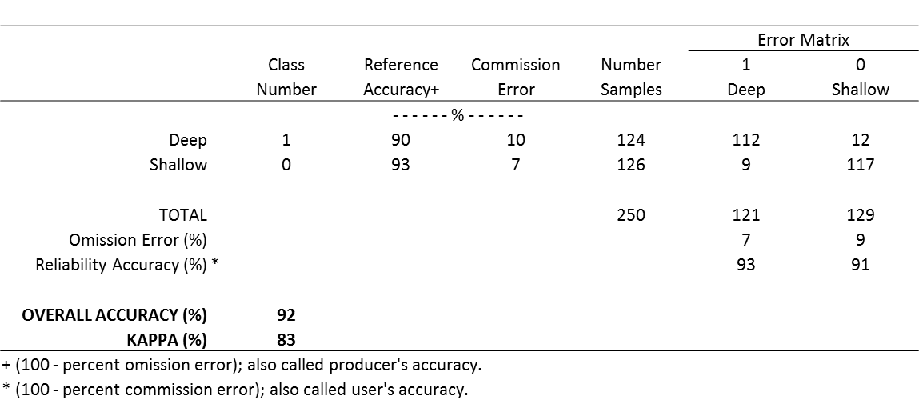

Table 5. Number of soil respiration measurements remaining and percent excluded by individual integrity metrics before (raw) and after imposition and adjustment (± 5% of raw data) of the carbon dioxide standard deviation threshold (σCO2 > 1.6 mg m-2).



Table 6. Estimated marginal means ± standard errors and significance of mixed effects models for various soil properties (response), where the categorical variable soil depth class (class) was designated as a fixed effect and site (subfield) was designated as a random effect. Results are grouped by timing of sample collection (fall or spring). Soil depth class (0 = shallow; 1 = deep) was determined based on satellite image reduction (Sentinel 2; 16 June 2020 - 04 September 2020) and supervised classification.



Table 7. Estimated marginal means ± standard errors and significance of mixed effects models for various soil properties (response) at sites A and B in fall 2018 and spring 2020, where the categorical variable sample timing (fall or spring) was designated as a fixed effect and site (subfield) was designated as a random effect. Results are grouped by depth class (0 = shallow; 1 = deep), determined based on satellite image reduction (Sentinel 2; 16 June 2020 - 04 September 2020) and supervised classification.



Table 8. Estimated marginal means ± standard errors and significance of mixed effects models for various soil properties (response) at site B, where the categorical variable soil depth class (class) was designated as a fixed effect and date or year were designated as random effects. Results are grouped by timing of sample collection (fall or spring). Soil depth class (0 = shallow; 1 = deep) was determined based on satellite image reduction (Sentinel 2; 16 June 2020 - 04 September 2020) and supervised classification.



## References

Aase, J. K., & Pikul Jr, J. L. (1995). Crop and soil response to long‐term tillage practices in the northern Great Plains. Agronomy Journal, 87(4), 652-656.

Ali, J., Sharma, D. C., Bano, A., Gupta, A., Sharma, S., Bajpai, P., & Pathak, N. (2019). Exploiting microbial enzymes for augmenting crop production. In Enzymes in Food Biotechnology (pp. 503-519). Academic Press.

Bates, D., Mächler, M., Bolker, B., & Walker, S. (2014). Fitting linear mixed-effects models using lme4. arXiv preprint arXiv:1406.5823.

Bestwick, M. L. (2016). Water stress in Montana cropping systems: effects of cultivar, management, and environment on crop production in dryland systems (Master’s thesis, Montana State University-Bozeman, College of Agriculture).

Black, A. L., Brown, P. L., Halvorson, A. D., & Siddoway, F. H. (1981). Dryland cropping strategies for efficient water-use to control saline seeps in the northern Great Plains, USA. Agricultural Water Management, 4(1-3), 295-311.

Breiman, L., Friedman, J., Olshen, R., & Stone, C. (1984). Classification and regression trees. Wadsworth Int. Group, 37(15), 237-251.

Burns, R. G., DeForest, J. L., Marxsen, J., Sinsabaugh, R. L., Stromberger, M. E., Wallenstein, M. D., ... & Zoppini, A. (2013). Soil enzymes in a changing environment: current knowledge and future directions. Soil Biology and Biochemistry, 58, 216-234.

Burton, D. L., & Beauchamp, E. G. (1994). Profile nitrous oxide and carbon dioxide concentrations in a soil subject to freezing. Soil Science Society of America Journal, 58(1), 115-122.

Campbell, C. A., Lafond, G. P., Zentner, R. P., & Jame, Y. W. (1994). Nitrate leaching in a Udic Haploboroll as influenced by fertilization and legumes (Vol. 23, No. 1, pp. 195-201). American Society of Agronomy, Crop Science Society of America, and Soil Science Society of America.

Campbell, J. B., & Wynne, R. H. (2011). Introduction to remote sensing. Guilford Press.

Carr, P., Fordyce, S. I., Lachowiec, J., Bishop, S., Fryer, H. K., & Dahlhausen, S. (2021). Replacing fallow with warm‐season annual crops in dryland wheat systems. Agronomy Journal.

Christensen, S., & Tiedje, J. M. (1990). Brief and vigorous N2O production by soil at spring thaw. Journal of Soil Science, 41(1), 1-4.

Copernicus Sentinel data (2020), processed by ESA.

Dinnes, D. L., Karlen, D. L., Jaynes, D. B., Kaspar, T. C., Hatfield, J. L., Colvin, T. S., & Cambardella, C. A. (2002). Review and interpretation: Nitrogen management strategies to reduce nitrate leaching in tile-drained Midwestern soils.

Engel, R., Jones, C., & Wallander, R. (2011). Ammonia volatilization from urea and mitigation by NBPT following surface application to cold soils. Soil Science Society of America Journal, 75(6), 2348-2357.

Fordyce, S., Carr, P., Jones, C., Eberly, J., Ewing, S., & Sigler, A. (2021) Predicting overwinter nitrate-N changes at the subfield scale in leaching-susceptible, agricultural soils. Western Sustainable Agriculture Research and Education. <https://projects.sare.org/project-reports/gw18-179/>

Gorelick, N., Hancher, M., Dixon, M., Ilyushchenko, S., Thau, D., & Moore, R. (2017). Google Earth Engine: Planetary-scale geospatial analysis for everyone. Remote Sensing of Environment, 202, 18-27.

Grylls, J. P., Webb, J., & Dyer, C. J. (1997). Seasonal variation in response of winter cereals to nitrogen fertilizer and apparent recovery of fertilizer nitrogen on chalk soils in southern England. The Journal of Agricultural Science, 128(3), 251-262.

Haney, R. L., Haney, E. B., Hossner, L. R., & Arnold, J. G. (2010). Modifications to the new soil extractant H3A-1: A multinutrient extractant. Communications in Soil Science and Plant Analysis, 41(12), 1513-1523.

Haney, R. L., Franzluebbers, A. J., Jin, V. L., Johnson, M. V., Haney, E. B., White, M. J., & Harmel, R. D. (2012). Soil organic C: N vs. water-extractable organic C: N. Open Journal of Soil Science, 2(03), 269.

He, W., Yang, J. Y., Qian, B., Drury, C. F., Hoogenboom, G., He, P., ... & Zhou, W. (2018). Climate change impacts on crop yield, soil water balance and nitrate leaching in the semiarid and humid regions of Canada. PloS One, 13(11), e0207370.

Heaney, D. J., Nyborg, M., Solberg, E. D., Malhi, S. S., & Ashworth, J. (1992). Overwinter nitrate loss and denitrification potential of cultivated soils in Alberta. Soil Biology and Biochemistry, 24(9), 877-884.

John, A. A., Jones, C. A., Ewing, S. A., Sigler, W. A., Bekkerman, A., & Miller, P. R. (2017). Fallow replacement and alternative nitrogen management for reducing nitrate leaching in a semiarid region. Nutrient Cycling in Agroecosystems, 108(3), 279-296.

Jokela, W. E. (1992). Nitrogen fertilizer and dairy manure effects on corn yield and soil nitrate. Soil Science Society of America Journal, 56(1), 148-154.

Jones, C., Chen, C., McVay, K., Stougaard, B., Westcott, M., Eckhoff, J., Lenssen, A., Weeding, J., & Greenwood, M. (2011). Measured and predicted temporal changes in soil nitrate-N levels from late summer to early spring in Montana. Western Nutrient Management Conference Proceedings, 9, 77-82.

Jones C, Olson-Rutz K (2019) Soil Testing: Getting a good sample. Montana State University. <http://landresources.montana.edu/soilfertility/documents/PDF/sscoop/SoilTestGetGoodSampleSS.pdf>

Liang, B. C., Remillard, M., & MacKenzie, A. F. (1991). Influence of fertilizer, irrigation, and non‐growing season precipitation on soil nitrate‐nitrogen under corn (Vol. 20, No. 1, pp. 123-128). American Society of Agronomy, Crop Science Society of America, and Soil Science Society of America.

Lowenberg-DeBoer, J. M., & Erickson, B. (2019). Setting the record straight on precision agriculture adoption. Agronomy Journal.

McCracken, D. V., Smith, M. S., Grove, J. H., MacKown, C. T., & Blevins, R. L. (1994). Nitrate leaching as influenced by cover cropping and nitrogen source. Soil Science Society of America Journal, 58(5), 1476-1483.

Miller, C. R. (2013). Groundwater nitrate transport and residence time in a vulnerable aquifer under dryland cereal production (Master’s thesis, Montana State University-Bozeman, College of Agriculture).

Mitchell, M. J., Driscoll, C. T., Kahl, J. S., Likens, G. E., Murdoch, P. S., & Pardo, L. H. (1996). Climatic control of nitrate loss from forested watersheds in the northeast United States. Environmental Science & Technology, 30(8), 2609-2612.

Pariera-Dinkins, C., & Jones, C. (2013). Interpretation of soil test reports for agriculture. MT200702AG, Montana State University Extension.

R Core Team (2021). R: A language and environment for statistical computing. R Foundation for Statistical Computing, Vienna, Austria. <https://www.R-project.org/>.

Rasmussen, P. E., & Parton, W. J. (1994). Long‐term effects of residue management in wheat‐fallow: I. Inputs, yield, and soil organic matter. Soil Science Society of America Journal, 58(2), 523-530.

Rengel, Z. (Ed.). (2003). Handbook of soil acidity (Vol. 94). CRC Press.

Roth, G. W., & Fox, R. H. (1990). Soil nitrate accumulations following nitrogen‐fertilized corn in Pennsylvania (Vol. 19, No. 2, pp. 243-248). American Society of Agronomy, Crop Science Society of America, and Soil Science Society of America.

Röver, M., Heinemeyer, O., & Kaiser, E. A. (1998). Microbial induced nitrous oxide emissions from an arable soil during winter. Soil Biology and Biochemistry, 30(14), 1859-1865.

Rowley, M. C., Grand, S., & Verrecchia, É. P. (2018). Calcium-mediated stabilisation of soil organic carbon. Biogeochemistry, 137(1), 27-49.

Ryan, M. C., Kachanoski, R. G., & Gillham, R. W. (2000). Overwinter soil nitrogen dynamics in seasonally frozen soils. Canadian Journal of Soil Science, 80(4), 541-550.

Schmidt, C., & Mulder, R. (2010). Groundwater and surface water monitoring for pesticides and nitrate in the Judith River Basin, central Montana. Helena, MT: Montana Department of Agriculture.

Schroder, J. L., Zhang, H., Girma, K., Raun, W. R., Penn, C. J., & Payton, M. E. (2011). Soil acidification from long‐term use of nitrogen fertilizers on winter wheat. Soil Science Society of America Journal, 75(3), 957-964.

Sigler, W. A., Ewing, S. A., Jones, C. A., Payn, R. A., Brookshire, E. J., Klassen, J. K., ... & Weissmann, G. S. (2018). Connections among soil, ground, and surface water chemistries characterize nitrogen loss from an agricultural landscape in the upper Missouri River basin. Journal of Hydrology, 556, 247-261.

Sigler, W. A., Ewing, S. A., Jones, C. A., Payn, R. A., Miller, P., & Maneta, M. (2020). Water and nitrate loss from dryland agricultural soils is controlled by management, soils, and weather. Agriculture, Ecosystems & Environment, 304, 107158.

Stormont, J. C., & Anderson, C. E. (1999). Capillary barrier effect from underlying coarser soil layer. Journal of Geotechnical and Geoenvironmental Engineering, 125(8), 641-648.

Tabatabai, M. A. (1994). Soil enzymes. Methods of soil analysis: Part 2 Microbiological and Biochemical Properties, 5, 775-833.

Tabatabai, M. A., Ekenler, M., & Senwo, Z. N. (2010). Significance of enzyme activities in soil nitrogen mineralization. Communications in Soil Science and Plant Analysis, 41(5), 595-605.

Thapa, R., Mirsky, S. B., & Tully, K. L. (2018). Cover crops reduce nitrate leaching in agroecosystems: A global meta‐analysis. Journal of Environmental Quality, 47(6), 1400-1411.

Theobald, D. M., Harrison-Atlas, D., Monahan, W. B., & Albano, C. M. (2015). Ecologically-relevant maps of landforms and physiographic diversity for climate adaptation planning. PloS One, 10(12), e0143619.

USDAa (2020). Soil Survey Staff, Natural Resources Conservation Service, United States Department of Agriculture. Soil Survey Geographic (SSURGO) Database. Available online at <https://sdmdataaccess.sc.egov.usda.gov>. Accessed October 2020.

USDAb (2020) Farm Service Agency NAIP Imagery <https://www.fsa.usda.gov/programs-and-services/aerial-photography/imageryprograms/naip-imagery/>. Accessed October 2020.

USDAc (2020). National Agricultural Statistics Service Cropland Data Layer (Online) <http://nassgeodata.gmu.edu/CropScape/>. Accessed October 2020.

Von Uexküll, H. R., & Mutert, E. (1995). Global extent, development and economic impact of acid soils. Plant and Soil, 171(1), 1-15.

Vomocil, J. A., & Ramig, R. E. (1984). Annual Cropping on Shallow Soils.

Weil, R. R., Islam, K. R., Stine, M. A., Gruver, J. B., & Samson-Liebig, S. E. (2003). Estimating active carbon for soil quality assessment: A simplified method for laboratory and field use. American Journal of Alternative Agriculture, 18(1), 3-17.

Ye, L., & Grimm, N. B. (2013). Modelling potential impacts of climate change on water and nitrate export from a mid-sized, semiarid watershed in the US Southwest. Climatic Change, 120(1), 419-431.

Zadoks, J. C., Chang, T. T., & Konzak, C. F. (1974). A decimal code for the growth stages of cereals. Weed Research, 14(6), 415-421.

# CHAPTER FOUR

# SUMMARY

A growing body of evidence suggests accurate spatial characterization of soil depth (*zf*) can have important economic and environmental implications for precision agriculture practices such as variable rate fertilizer application. Research studies presented in this thesis suggest intra-annual variability in remote sensing spectra impact correlations between *zf* and normalized difference vegetation index to a greater degree than inter-annual variability, planting date, and sub-intermediate (≤10 m) image resolution in a semi-arid agroecosystem. These findings gave strong justification for the classification of soils into deep and shallow *zf* classes across geologic, drainage, and management boundaries using spaceborne (Sentinel) multi-temporal imagery. Monitoring of soil physical, chemical, and biological attributes within each depth class indicated crops established in shallow soils are more likely to be N deficient due to suppressed nitrogen mineralization from surface soil organic matter in these environments. In typical years, when water rather than N limits growth in semi-arid environments with shallow soils, residual nitrogen is likely to be elevated at the end of the growing season, increasing leaching risks and associated environmental impacts. Thus, site-specific fertility practices which disregard variability in soil depth could overapply nitrogen fertilizer to crops in shallow soils in both wet and dry years.

This thesis addressed the potential for suppressed mineralization in shallow soil environments of central Montana, but more work is needed to 1) assess this relationship in a broader geographic context, and 2) establish best practices of variable rate fertilizer application in shallow soil environments. It is hoped that the findings of the presented research prevent or minimize misguided management decisions by early adopters of variable rate fertilizer application technology in shallow soils. Additional questions remain regarding the contributing biogeochemical processes and proposed mechanisms of suppressed mineralization in shallow soils. The proposed mechanism of soil organic matter elevation via calcium-mediated stabilization should be explored further, with special attention given to interactions among soil organic matter, extractable calcium, and pH. Moreover, the effects of pH on soil microbial community structure and implications for net nitrogen mineralization deserve further investigation. Reliability of extracellular enzymes as mineralization indices also should be assessed in this context. Finally, while tension barriers at surficial textural boundaries should prohibit more offseason leaching of inorganic N from the surface of shallow soils, more work is needed to assess the potential for saturated flow to flout this expectation.

# REFERENCES CITED

Aase, J. K., & Pikul Jr, J. L. (1995). Crop and soil response to long‐term tillage practices in the northern Great Plains. Agronomy Journal, 87(4), 652-656.

Ali, J., Sharma, D. C., Bano, A., Gupta, A., Sharma, S., Bajpai, P., & Pathak, N. (2019). Exploiting microbial enzymes for augmenting crop production. In Enzymes in Food Biotechnology (pp. 503-519). Academic Press.

Anantharaman, K., Brown, C. T., Hug, L. A., Sharon, I., Castelle, C. J., Probst, A. J., ... & Banfield, J. F. (2016). Thousands of microbial genomes shed light on interconnected biogeochemical processes in an aquifer system. Nature Communications, 7(1), 1-11.

Basso, B., Ritchie, J. T., Cammarano, D., & Sartori, L. (2011). A strategic and tactical management approach to select optimal N fertilizer rates for wheat in a spatially variable field. European Journal of Agronomy, 35(4), 215-222.

Basso, B., Fiorentino, C., Cammarano, D., & Schulthess, U. (2016). Variable rate nitrogen fertilizer response in wheat using remote sensing. Precision Agriculture, 17(2), 168-182.

Bates, D., Mächler, M., Bolker, B., & Walker, S. (2014). Fitting linear mixed-effects models using lme4. arXiv preprint arXiv:1406.5823.

Benbi, D. K., & Richter, J. (2002). A critical review of some approaches to modelling nitrogen mineralization. Biology and Fertility of Soils, 35(3), 168-183.

Bestwick, M. L. (2016). Water stress in Montana cropping systems: effects of cultivar, management, and environment on crop production in dryland systems (Master’s thesis, Montana State University-Bozeman, College of Agriculture).

Bhattacharjee, R. B., Singh, A., & Mukhopadhyay, S. N. (2008). Use of nitrogen-fixing bacteria as biofertiliser for non-legumes: prospects and challenges. Applied Microbiology and Biotechnology, 80(2), 199-209.

Black, A. L., Brown, P. L., Halvorson, A. D., & Siddoway, F. H. (1981). Dryland cropping strategies for efficient water-use to control saline seeps in the northern Great Plains, USA. Agricultural Water Management, 4(1-3), 295-311.

Bockheim, J. G. (2015). Classification and development of shallow soils (< 50 cm) in the USA. Geoderma Regional, 6, 31-39.

Breiman, L., Friedman, J., Olshen, R., & Stone, C. (1984). Classification and regression trees. Wadsworth Int. Group, 37(15), 237-251.

Bullock, D. S., & Bullock, D. G. (2000). From agronomic research to farm management guidelines: A primer on the economics of information and precision technology. Precision Agriculture, 2(1), 71-101.

Burns, R. G., DeForest, J. L., Marxsen, J., Sinsabaugh, R. L., Stromberger, M. E., Wallenstein, M. D., ... & Zoppini, A. (2013). Soil enzymes in a changing environment: current knowledge and future directions. Soil Biology and Biochemistry, 58, 216-234.

Burton, D. L., & Beauchamp, E. G. (1994). Profile nitrous oxide and carbon dioxide concentrations in a soil subject to freezing. Soil Science Society of America Journal, 58(1), 115-122.

Campbell, C. A., Lafond, G. P., Zentner, R. P., & Jame, Y. W. (1994). Nitrate leaching in a Udic Haploboroll as influenced by fertilization and legumes (Vol. 23, No. 1, pp. 195-201). American Society of Agronomy, Crop Science Society of America, and Soil Science Society of America.

Campbell, J. B., & Wynne, R. H. (2011). Introduction to remote sensing. Guilford Press.

Caranto, J. D., & Lancaster, K. M. (2017). Nitric oxide is an obligate bacterial nitrification intermediate produced by hydroxylamine oxidoreductase. Proceedings of the National Academy of Sciences, 114(31), 8217-8222.

Carr, P. M., Carlson, G. R., Jacobsen, J. S., Nielsen, G. A., & Skogley, E. O. (1991). Farming soils, not fields: A strategy for increasing fertilizer profitability. Journal of Production Agriculture, 4(1), 57-61.

Carr, P., Fordyce, S. I., Lachowiec, J., Bishop, S., Fryer, H. K., & Dahlhausen, S. (2021). Replacing fallow with warm‐season annual crops in dryland wheat systems. Agronomy Journal.

Christensen, S., & Tiedje, J. M. (1990). Brief and vigorous N2O production by soil at spring thaw. Journal of Soil Science, 41(1), 1-4.

Copernicus Sentinel data (2020), processed by ESA.

Dai, Z., Zhang, X., Tang, C., Muhammad, N., Wu, J., Brookes, P. C., & Xu, J. (2017). Potential role of biochars in decreasing soil acidification-a critical review. Science of the Total Environment, 581, 601-611.

Daims, H., Lebedeva, E. V., Pjevac, P., Han, P., Herbold, C., Albertsen, M., ... & Wagner, M. (2015). Complete nitrification by Nitrospira bacteria. Nature, 528(7583), 504-509.

Daims, H., Lücker, S., & Wagner, M. (2016). A new perspective on microbes formerly known as nitrite-oxidizing bacteria. Trends in Microbiology, 24(9), 699-712.

Dampney, P. M. R., Goodlass, G., Froment, M. A., & Stafford, J. V. (1999, January). Environmental and production effects from variable rate nitrogen fertilizer to winter wheat in England. In Proceedings of the Fourth International Conference on Precision Agriculture (pp. 697-708). Madison, WI, USA: American Society of Agronomy, Crop Science Society of America, Soil Science Society of America.

Deng, S. P., & Tabatabai, M. A. (2000). Effect of cropping systems on nitrogen mineralization in soils. Biology and Fertility of Soils, 31(3), 211-218.

Dietrich, W. E., Reiss, R., Hsu, M. L., & Montgomery, D. R. (1995). A process‐based model for colluvial soil depth and shallow landsliding using digital elevation data. Hydrological Processes, 9(3‐4), 383-400.

Dinnes, D. L., Karlen, D. L., Jaynes, D. B., Kaspar, T. C., Hatfield, J. L., Colvin, T. S., & Cambardella, C. A. (2002). Review and interpretation: Nitrogen management strategies to reduce nitrate leaching in tile-drained Midwestern soils.

Drury, C. F., Tan, C. S., Welacky, T. W., Reynolds, W. D., Zhang, T. Q., Oloya, T. O., ... & Gaynor, J. D. (2014). Reducing nitrate loss in tile drainage water with cover crops and water‐table management systems. Journal of Environmental Quality, 43(2), 587-598.

Engel, R., Jones, C., & Wallander, R. (2011). Ammonia volatilization from urea and mitigation by NBPT following surface application to cold soils. Soil Science Society of America Journal, 75(6), 2348-2357.

Engel, R., Jones, C., Romero, C., & Wallander, R. (2017). Late‐fall, winter and spring broadcast applications of urea to no‐till winter wheat I. Ammonia loss and mitigation by NBPT. Soil Science Society of America Journal, 81(2), 322-330.

Franzluebbers, A. J., Haney, R. L., Honeycutt, C. W., Schomberg, H. H., & Hons, F. M. (2000). Flush of carbon dioxide following rewetting of dried soil relates to active organic pools. Soil Science Society of America Journal, 64(2), 613-623.

Fordyce, S., Carr, P., Jones, C., Eberly, J., Ewing, S., & Sigler, A. (2021) Predicting overwinter nitrate-N changes at the subfield scale in leaching-susceptible, agricultural soils. Western Sustainable Agriculture Research and Education. <https://projects.sare.org/project-reports/gw18-179/>

Galloway, J. N., Townsend, A. R., Erisman, J. W., Bekunda, M., Cai, Z., Freney, J. R., ... & Sutton, M. A. (2008). Transformation of the nitrogen cycle: recent trends, questions, and potential solutions. Science, 320(5878), 889-892.

Gholizadeh, A., Žižala, D., Saberioon, M., & Borůvka, L. (2018). Soil organic carbon and texture retrieving and mapping using proximal, airborne and Sentinel-2 spectral imaging. Remote Sensing of Environment, 218, 89-103.

Gorelick, N., Hancher, M., Dixon, M., Ilyushchenko, S., Thau, D., & Moore, R. (2017). Google Earth Engine: Planetary-scale geospatial analysis for everyone. Remote Sensing of Environment, 202, 18-27.

Griffin, B. M., Schott, J., & Schink, B. (2007). Nitrite, an electron donor for anoxygenic photosynthesis. Science, 316(5833), 1870-1870.

Grylls, J. P., Webb, J., & Dyer, C. J. (1997). Seasonal variation in response of winter cereals to nitrogen fertilizer and apparent recovery of fertilizer nitrogen on chalk soils in southern England. The Journal of Agricultural Science, 128(3), 251-262.

Haney, R. L., Haney, E. B., Hossner, L. R., & Arnold, J. G. (2010). Modifications to the new soil extractant H3A-1: A multinutrient extractant. Communications in Soil Science and Plant Analysis, 41(12), 1513-1523.

Haney, R. L., Franzluebbers, A. J., Jin, V. L., Johnson, M. V., Haney, E. B., White, M. J., & Harmel, R. D. (2012). Soil organic C: N vs. water-extractable organic C: N. Open Journal of Soil Science, 2(03), 269.

Hansen, S., Thirup, C., Refsgaard, J. C., & Jensen, L. S. (2001). Modelling nitrate leaching at different scales–application of the Daisy model. Modeling Carbon and Nitrogen Dynamics for Soil Management, 511-547.

He, W., Yang, J. Y., Qian, B., Drury, C. F., Hoogenboom, G., He, P., ... & Zhou, W. (2018). Climate change impacts on crop yield, soil water balance and nitrate leaching in the semiarid and humid regions of Canada. PloS One, 13(11), e0207370.

Heaney, D. J., Nyborg, M., Solberg, E. D., Malhi, S. S., & Ashworth, J. (1992). Overwinter nitrate loss and denitrification potential of cultivated soils in Alberta. Soil Biology and Biochemistry, 24(9), 877-884.

Hug, L. A., & Co, R. (2018). It takes a village: microbial communities thrive through interactions and metabolic handoffs. MSystems, 3(2), e00152-17.

John, A. A., Jones, C. A., Ewing, S. A., Sigler, W. A., Bekkerman, A., & Miller, P. R. (2017). Fallow replacement and alternative nitrogen management for reducing nitrate leaching in a semiarid region. Nutrient Cycling in Agroecosystems, 108(3), 279-296.

Jokela, W. E. (1992). Nitrogen fertilizer and dairy manure effects on corn yield and soil nitrate. Soil Science Society of America Journal, 56(1), 148-154.

Jones, C., Chen, C., McVay, K., Stougaard, B., Westcott, M., Eckhoff, J., Lenssen, A., Weeding, J., & Greenwood, M. (2011). Measured and predicted temporal changes in soil nitrate-N levels from late summer to early spring in Montana. Western Nutrient Management Conference Proceedings, 9, 77-82.

Jones C, Olson-Rutz K (2019) Soil Testing: Getting a good sample. Montana State University. <http://landresources.montana.edu/soilfertility/documents/PDF/sscoop/SoilTestGetGoodSampleSS.pdf>

Jordan, C., Mihalyfalvy, E., Garrett, M. K., & Smith, R. V. (1994). Modelling of nitrate leaching on a regional scale using a GIS. Journal of Environmental Management, 42(3), 279-298.

Kozlowski, J. A., Stieglmeier, M., Schleper, C., Klotz, M. G., & Stein, L. Y. (2016). Pathways and key intermediates required for obligate aerobic ammonia-dependent chemolithotrophy in bacteria and Thaumarchaeota. The ISME Journal, 10(8), 1836-1845.

Krüger, H., Frolla, F., & Zilio, J. (2020). Soil depth, water availability and wheat yield in the austral pampa of Argentina. Ciencia del Suelo, 38(2), 274-283.

Kumon, Y., Sasaki, Y., Kato, I., Takaya, N., Shoun, H., & Beppu, T. (2002). Codenitrification and denitrification are dual metabolic pathways through which dinitrogen evolves from nitrate in Streptomyces antibioticus. Journal of Bacteriology, 184(11), 2963-2968.

Kuypers, M. M., Marchant, H. K., & Kartal, B. (2018). The microbial nitrogen-cycling network. Nature Reviews Microbiology, 16(5), 263-276.

Lacoste, M., Mulder, V. L., Richer-de-Forges, A. C., Martin, M. P., & Arrouays, D. (2016). Evaluating large-extent spatial modeling approaches: A case study for soil depth for France. Geoderma Regional, 7(2), 137-152.

Laughlin, R. J., & Stevens, R. J. (2002). Evidence for fungal dominance of denitrification and codenitrification in a grassland soil. Soil Science Society of America Journal, 66(5), 1540-1548.

Leininger, S., Urich, T., Schloter, M., Schwark, L., Qi, J., Nicol, G. W., ... & Schleper, C. (2006). Archaea predominate among ammonia-oxidizing prokaryotes in soils. Nature, 442(7104), 806-809.

Liang, B. C., Remillard, M., & MacKenzie, A. F. (1991). Influence of fertilizer, irrigation, and non‐growing season precipitation on soil nitrate‐nitrogen under corn (Vol. 20, No. 1, pp. 123-128). American Society of Agronomy, Crop Science Society of America, and Soil Science Society of America.

Lilburne, L. R., Webb, T. H., & Francis, G. S. (2003). Relative effect of climate, soil, and management on risk of nitrate leaching under wheat production in Canterbury, New Zealand. Soil Research, 41(4), 699-709.

Link, J., Graeff, S., Batchelor, W. D., & Claupein, W. (2006). Evaluating the economic and environmental impact of environmental compensation payment policy under uniform and variable-rate nitrogen management. Agricultural Systems, 91(1-2), 135-153.

Liu, J., Yu, Z., Yao, Q., Sui, Y., Shi, Y., Chu, H., ... & Wang, G. (2018). Ammonia-oxidizing archaea show more distinct biogeographic distribution patterns than ammonia-oxidizing bacteria across the black soil zone of northeast China. Frontiers in Microbiology, 9, 171.

Lowenberg-DeBoer, J. M., & Erickson, B. (2019). Setting the record straight on precision agriculture adoption. Agronomy Journal.

Mackelprang, R., Grube, A. M., Lamendella, R., Jesus, E. D. C., Copeland, A., Liang, C., ... & Jansson, J. K. (2018). Microbial community structure and functional potential in cultivated and native tallgrass prairie soils of the midwestern United States. Frontiers in Microbiology, 9, 1775.

Mahal, N. K., Osterholz, W. R., Miguez, F. E., Poffenbarger, H. J., Sawyer, J. E., Olk, D. C., ... & Castellano, M. J. (2019). Nitrogen fertilizer suppresses mineralization of soil organic matter in maize agroecosystems. Frontiers in Ecology and Evolution, 7, 59.

Maier, R. M., & Pepper, I. L. (2015). Bacterial growth. In Environmental Microbiology (pp. 37-56). Academic Press.

Maynard, J. J., & Levi, M. R. (2017). Hyper-temporal remote sensing for digital soil mapping: Characterizing soil-vegetation response to climatic variability. Geoderma, 285, 94-109.

McCracken, D. V., Smith, M. S., Grove, J. H., MacKown, C. T., & Blevins, R. L. (1994). Nitrate leaching as influenced by cover cropping and nitrogen source. Soil Science Society of America Journal, 58(5), 1476-1483.

McKenzie, N. J., & Ryan, P. J. (1999). Spatial prediction of soil properties using environmental correlation. Geoderma, 89(1-2), 67-94.

Miller, C. R. (2013). Groundwater nitrate transport and residence time in a vulnerable aquifer under dryland cereal production (Master’s thesis, Montana State University-Bozeman, College of Agriculture).

Mitchell, M. J., Driscoll, C. T., Kahl, J. S., Likens, G. E., Murdoch, P. S., & Pardo, L. H. (1996). Climatic control of nitrate loss from forested watersheds in the northeast United States. Environmental Science & Technology, 30(8), 2609-2612.

Meisinger, J. J., & Randall, G. W. (1991). Estimating nitrogen budgets for soil‐crop systems. Managing Nitrogen for Groundwater Quality and Farm Profitability, 85-124.

Mikkelsen, R. L., Williams, H. M., & Behel, A. D. (1994). Nitrogen leaching and plant uptake from controlled-release fertilizers. Fertilizer Research, 37(1), 43-50.

Morari, F., Zanella, V., Sartori, L., Visioli, G., Berzaghi, P., & Mosca, G. (2018). Optimising durum wheat cultivation in North Italy: understanding the effects of site-specific fertilization on yield and protein content. Precision Agriculture, 19(2), 257-277.

Nakamura, K., Harter, T., Hirono, Y., Horino, H., & Mitsuno, T. (2004). Assessment of root zone nitrogen leaching as affected by irrigation and nutrient management practices. Vadose Zone Journal, 3(4), 1353-1366.

Nie, S., Zhu, G. B., Singh, B., & Zhu, Y. G. (2019). Anaerobic ammonium oxidation in agricultural soils-synthesis and prospective. Environmental Pollution, 244, 127-134.

O’Dea, J. K., Jones, C. A., Zabinski, C. A., Miller, P. R., & Keren, I. N. (2015). Legume, cropping intensity, and N-fertilization effects on soil attributes and processes from an eight-year-old semiarid wheat system. Nutrient Cycling in Agroecosystems, 102(2), 179-194.

Odeh, I. O. A., McBratney, A. B., & Chittleborough, D. J. (1994). Spatial prediction of soil properties from landform attributes derived from a digital elevation model. Geoderma, 63(3-4), 197-214.

Pariera-Dinkins, C., & Jones, C. (2013). Interpretation of soil test reports for agriculture. MT200702AG, Montana State University Extension.

Patton, N. R., Lohse, K. A., Godsey, S. E., Crosby, B. T., & Seyfried, M. S. (2018). Predicting soil thickness on soil mantled hillslopes. Nature Communications, 9(1), 1-10.

Philippot, L., Hallin, S., & Schloter, M. (2007). Ecology of denitrifying prokaryotes in agricultural soil. Advances in Agronomy, 96, 249-305.

Pinheiro, J., Bates, D., DebRoy, S., Sarkar, D., & R Core Team (2021). nlme: Linear and Nonlinear Mixed Effects Models. R package version 3.1-153, <https://CRAN.R-project.org/package=nlme>.

R Core Team (2021). R: A language and environment for statistical computing. R Foundation for Statistical Computing, Vienna, Austria. <https://www.R-project.org/>.

Rasmussen, P. E., & Parton, W. J. (1994). Long‐term effects of residue management in wheat‐fallow: I. Inputs, yield, and soil organic matter. Soil Science Society of America Journal, 58(2), 523-530.

Rengel, Z. (Ed.). (2003). Handbook of Soil Acidity (Vol. 94). CRC Press.

Rosenblueth, M., Ormeño-Orrillo, E., López-López, A., Rogel, M. A., Reyes-Hernández, B. J., Martínez-Romero, J. C., ... & Martínez-Romero, E. (2018). Nitrogen fixation in cereals. Frontiers in Microbiology, 9, 1794.

Rossel, R. V., Chen, C., Grundy, M. J., Searle, R., Clifford, D., & Campbell, P. H. (2015). The Australian three-dimensional soil grid: Australia’s contribution to the GlobalSoilMap project. Soil Research, 53(8), 845-864.

Roth, G. W., & Fox, R. H. (1990). Soil nitrate accumulations following nitrogen‐fertilized corn in Pennsylvania (Vol. 19, No. 2, pp. 243-248). American Society of Agronomy, Crop Science Society of America, and Soil Science Society of America.

Röver, M., Heinemeyer, O., & Kaiser, E. A. (1998). Microbial induced nitrous oxide emissions from an arable soil during winter. Soil Biology and Biochemistry, 30(14), 1859-1865.

Rowley, M. C., Grand, S., & Verrecchia, É. P. (2018). Calcium-mediated stabilisation of soil organic carbon. Biogeochemistry, 137(1), 27-49.

Ryan, M. C., Kachanoski, R. G., & Gillham, R. W. (2000). Overwinter soil nitrogen dynamics in seasonally frozen soils. Canadian Journal of Soil Science, 80(4), 541-550.

Santanello Jr, J. A., Peters-Lidard, C. D., Garcia, M. E., Mocko, D. M., Tischler, M. A., Moran, M. S., & Thoma, D. P. (2007). Using remotely-sensed estimates of soil moisture to infer soil texture and hydraulic properties across a semi-arid watershed. Remote Sensing of Environment, 110(1), 79-97.

Schmidt, C., & Mulder, R. (2010). Groundwater and surface water monitoring for pesticides and nitrate in the Judith River Basin, central Montana. Helena, MT: Montana Department of Agriculture.

Schomberg, H. H., Wietholter, S., Griffin, T. S., Reeves, D. W., Cabrera, M. L., Fisher, D. S., ... & Tyler, D. D. (2009). Assessing indices for predicting potential nitrogen mineralization in soils under different management systems. Soil Science Society of America Journal, 73(5), 1575-1586.

Schott, J., Griffin, B. M., & Schink, B. (2010). Anaerobic phototrophic nitrite oxidation by Thiocapsa sp. strain KS1 and Rhodopseudomonas sp. strain LQ17. Microbiology, 156(8), 2428-2437.

Schroder, J. L., Zhang, H., Girma, K., Raun, W. R., Penn, C. J., & Payton, M. E. (2011). Soil acidification from long‐term use of nitrogen fertilizers on winter wheat. Soil Science Society of America Journal, 75(3), 957-964.

Selbie, D. R., Lanigan, G. J., Laughlin, R. J., Di, H. J., Moir, J. L., Cameron, K. C., ... & Richards, K. G. (2015). Confirmation of co-denitrification in grazed grassland. Scientific Reports, 5(1), 1-9.

Sigler, W. A., Ewing, S. A., Jones, C. A., Payn, R. A., Brookshire, E. J., Klassen, J. K., ... & Weissmann, G. S. (2018). Connections among soil, ground, and surface water chemistries characterize nitrogen loss from an agricultural landscape in the upper Missouri River basin. Journal of Hydrology, 556, 247-261.

Sigler, W. A., Ewing, S. A., Jones, C. A., Payn, R. A., Miller, P., & Maneta, M. (2020). Water and nitrate loss from dryland agricultural soils is controlled by management, soils, and weather. Agriculture, Ecosystems & Environment, 304, 107158.

Simon, J., & Klotz, M. G. (2013). Diversity and evolution of bioenergetic systems involved in microbial nitrogen compound transformations. Biochimica et Biophysica Acta (BBA)-Bioenergetics, 1827(2), 114-135.

Spott, O., & Florian Stange, C. (2011). Formation of hybrid N2O in a suspended soil due to co‐denitrification of NH2OH. Journal of Plant Nutrition and Soil Science, 174(4), 554-567.

Stanford, G., & Smith, S. J. (1972). Nitrogen mineralization potentials of soils. Soil Science Society of America Journal, 36(3), 465-472.

Stormont, J. C., & Anderson, C. E. (1999). Capillary barrier effect from underlying coarser soil layer. Journal of Geotechnical and Geoenvironmental Engineering, 125(8), 641-648.

Strous, M., Pelletier, E., Mangenot, S., Rattei, T., Lehner, A., Taylor, M. W., ... & Le Paslier, D. (2006). Deciphering the evolution and metabolism of an anammox bacterium from a community genome. Nature, 440(7085), 790-794.

Tabatabai, M. A., & Bremner, J. M. (1972). Assay of urease activity in soils. Soil Biology and Biochemistry, 4(4), 479-487.

Tabatabai, M. A. (1994). Soil enzymes. Methods of soil analysis: Part 2 Microbiological and Biochemical Properties, 5, 775-833.

Tabatabai, M. A., Ekenler, M., & Senwo, Z. N. (2010). Significance of enzyme activities in soil nitrogen mineralization. Communications in Soil Science and Plant Analysis, 41(5), 595-605.

Tanimoto, T., Hatano, K. I., Kim, D. H., Uchiyama, H., & Shoun, H. (1992). Co-denitrification by the denitrifying system of the fungus Fusarium oxysporum. FEMS Microbiology Letters, 93(2), 177-180.

Taylor, J. A., Jacob, F., Galleguillos, M., Prevot, L., Guix, N., & Lagacherie, P. (2013). The utility of remotely-sensed vegetative and terrain covariates at different spatial resolutions in modelling soil and water table depth (for digital soil mapping). Geoderma, 193, 83-93.

Tesfa, T. K., Tarboton, D. G., Chandler, D. G., & McNamara, J. P. (2009). Modeling soil depth from topographic and land cover attributes. Water Resources Research, 45(10).

Thapa, R., Mirsky, S. B., & Tully, K. L. (2018). Cover crops reduce nitrate leaching in agroecosystems: A global meta‐analysis. Journal of Environmental Quality, 47(6), 1400-1411.

Theobald, D. M., Harrison-Atlas, D., Monahan, W. B., & Albano, C. M. (2015). Ecologically-relevant maps of landforms and physiographic diversity for climate adaptation planning. PloS One, 10(12), e0143619.

United States Environmental Protection Agency (2014). CASTNET Data. http://epa.gov/castnet/javaweb/index. Accessed 1 February 2015

USDAa (2020). Soil Survey Staff, Natural Resources Conservation Service, United States Department of Agriculture. Soil Survey Geographic (SSURGO) Database. Available online at <https://sdmdataaccess.sc.egov.usda.gov>. Accessed October 2020.

USDAb (2020) Farm Service Agency NAIP Imagery <https://www.fsa.usda.gov/programs-and-services/aerial-photography/imageryprograms/naip-imagery/>. Accessed October 2020.

USDAc (2020). National Agricultural Statistics Service Cropland Data Layer (Online) <http://nassgeodata.gmu.edu/CropScape/>. Accessed October 2020.

Van Kessel, M. A., Speth, D. R., Albertsen, M., Nielsen, P. H., den Camp, H. J. O., Kartal, B., ... & Lücker, S. (2015). Complete nitrification by a single microorganism. Nature, 528(7583), 555-559.

Vazquez-Amabile, G. G., Gonzalo, M., Pella, M., Galbusera, S., & Cueto, G. B. (2013). Evaluation of the Variable Rate Fertilization in winter crops for shallow soils using soil depth maps and crop simulation models in southeastern Pampas, Argentina. In 2013 Kansas City, Missouri, July 21-July 24, 2013 (p. 1). American Society of Agricultural and Biological Engineers.

Vomocil, J. A., & Ramig, R. E. (1984). Annual Cropping on Shallow Soils.

Von Uexküll, H. R., & Mutert, E. (1995). Global extent, development and economic impact of acid soils. Plant and Soil, 171(1), 1-15.

Weil, R. R., Islam, K. R., Stine, M. A., Gruver, J. B., & Samson-Liebig, S. E. (2003). Estimating active carbon for soil quality assessment: A simplified method for laboratory and field use. American Journal of Alternative Agriculture, 18(1), 3-17.

Williams, C. J., McNamara, J. P., & Chandler, D. G. (2008). Controls on the temporal and spatial variability of soil moisture in a mountainous landscape: the signatures of snow and complex terrain. Hydrology & Earth System Sciences Discussions, 5(4).

Ye, L., & Grimm, N. B. (2013). Modelling potential impacts of climate change on water and nitrate export from a mid-sized, semiarid watershed in the US Southwest. Climatic Change, 120(1), 419-431.

Zadoks, J. C., Chang, T. T., & Konzak, C. F. (1974). A decimal code for the growth stages of cereals. Weed Research, 14(6), 415-421.

Zentner, R. P., Campbell, C. A., Biederbeck, V. O., Selles, F., Lemke, R., Jefferson, P. G., & Gan, Y. (2004). Long-term assessment of management of an annual legume green manure crop for fallow replacement in the Brown soil zone. Canadian Journal of Plant Science, 84(1), 11-22.

Zhang, S., Liu, G., Chen, S., Rasmussen, C., & Liu, B. (2021). Assessing soil thickness in a black soil watershed in northeast China using random forest and field observations. International Soil and Water Conservation Research, 9(1), 49-57.

Ziadat, F. M. (2010). Prediction of soil depth from digital terrain data by integrating statistical and visual approaches. Pedosphere, 20(3), 361-367.

Zillmann, E., Graeff, S., Link, J., Batchelor, W. D., & Claupein, W. (2006). Assessment of cereal nitrogen requirements derived by optical on‐the‐go sensors on heterogeneous soils. Agronomy Journal, 98(3), 682-690.

# APPENDICES

APPENDIX A

# SURVEY TOOL

