**TomTom Watch Interface**

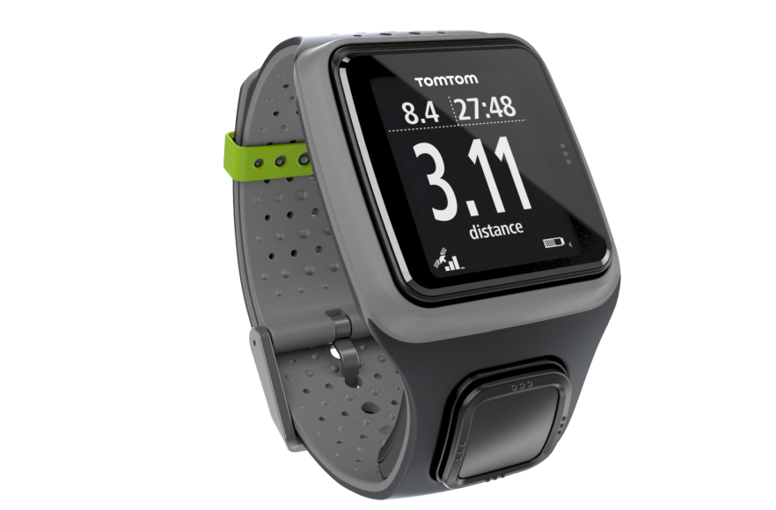

# TomTom Watch interface

## Introduction

The TomTom Watch family (Multisport, Spark, Runner, Adventurer) are GPS watches with a multitude of fitness tracking functions. TomTom still adds new functions, though (07-2017) it appears that TomTom will move out of wearables. The watches are used in combination with the TomTom Mysports cloud account. A local application on PC or Mobile/Tablet is used to communicate to the watch and sync between the watch and the cloud.

In order to create a PC application I continued reverse engineering the watch. The start of this was formed by the excellent application ttwatch of Ryan Binns. It has been applied in the TomTomWatch Application (<http://blog.studioblueplanet.net/?page_id=566>).

## Interface

The watch has two physical interfaces:

* Bluetooth
* USB

This document is limited to the USB interface. Using this interface a client can issue commands to the watch and read, write and delete files. First the file system and formats are described, then the USB interface.

# File system

## Overview

The watch interface functions are based on a file system that is accessible via Bluetooth and the USB interface. Note that another file system is present that is accessible via the PC via USB as regular removable storage and used for transfer of music. This file system is mapped on the PC file system (like an USB stick) when the watch is connected.

This section describes the former filesystem. Files are addressed by an 32 bit integer ID. In this document the file IDs are given in an 8 character hexadecimal, like **0x00910000**.

Following files have been identified:

|  |  |
| --- | --- |
| File ID | Description |
| 0x00000012 | Bluetooth Low Energy (BLE) firmware. Used for firmware upgrades. (NOT CHECKED) |
| 0x000000F0 | System firmware. Used for firmware upgrades |
| 0x00010100 | GPS Quickfix data, used for obtaining a quick GPS lock. Is written each time the watch is connected to TomTom MySports. For the adventurer, the file is downloaded from <https://gpsquickfix.services.tomtom.com/fitness/sifgps.f2p3enc.ee> |
| 0x00010200 | GPS Firmware. (NOT CHECKED) |
| 0x00010301 | Some version numbers?? |
| 0x00013000 | Stacktrace. Text file |
| 0x00013001 | BLE firmware Update log (NOT CHECKED) |
| 0x00013002 | Sysem firmware Update log. Text file |
| 0x00013100 | System log. Text file |
| 0x0071xxnn | Races. xx defines the activity. nn is the race number. Proprietary format. |
| 0x0072nnnn | Race history. (NOT CHECKED) |
| 0x0073xxnn | History data. For each activity type (xx) for the last 10 activities (0xnn) such a file is generated |
| 0x0081nnnn | Language files |
| 0x008300xx | Activity summary. Each file contains the last 10 activities. This file is used by the watch to show the last 10 activities for each activity type xx. |
| 0x0085000n | Manifest files. Contain the settings. 0x00850000 is the current list of settings. 0x00850001 and 0x00850002 are backups |
| 0x0091nnnn | Activity files. Correspond with the ttbin files. Proprietary file format containing records. |
| 0x00B100nn | Tracked activity (steps, calories, heart rate, sleep, fitness points, etc) for upload to TomTom MySports. Up to 20 files are generated. A new file is generated each time the watch is connected to the PC and disconnected. The files are uploaded and deleted when the watch is connected to TomTom MySports. Protobuf format |
| 0x00B20000 | Tracked activity, temporary file which is used during the time the watch is connected to the PC. When disconnected, this file is ‘renamed’ to the next 0x00B100nn file (if there are 20 0x00B100nn files, tracked activity keeps being logged to this file; rename after the the 0x00B100nn files have been deleted; CHECK!). Same protobuf format as 0x00B100nn |
| 0x00B20001 | Unclear. 4 bytes. |
| 0x00B3000n | Tracked activity of the last 7 days. n=8-f. Same protobuf format as 0x00b100nn, however heartrates are not stored. |
| 0x00B8nnnn | Routes (track planning). Each file contains a route. Protobuf format. |
| 0x00B9nnnn |  |
| 0x00BEnnnn | The personalized workouts, added since firmware version 1.7.53 (Adventurer). Protobuf format. |
| 0x00F20000 | Preferences file. XML format. Contains the watch name and other preferences for connecting to TomTom MySports |

## Preferences file, 0x00f20000

The preferences file is an XML file containing the preferences used when connecting to TomTom MySports. After factory reset the watch does not have such a preference file. When connecting the watch to the ‘TomTom Sports Connect’ it is created as part of the registration process. A.o. a token and secret are generated and coupled to a TomTom Mysports cloud account. When connecting the Watch to ‘TomTomWatch’ a default preference file is written without token and secret (file will be overwritten by ‘TomTom Sports Connect’).

Apart from the token and secret it contains the watch name, configuration service URL and some additional configuration. The file is also copied on a Windows PC to:

c:\users\<user>\TomTom Sports\<device serial>\preferences.dat

Changing the watch name can be done by changing the name between the <watchName></watchName> tags.

<?xml version="1.0" encoding="UTF-8"?>

<preferences version="1" modified="Sun Oct 29 17:12:36 2017">

<ephemerisModified>0</ephemerisModified>

<watchName>GPS Watch Jorgen</watchName>

<ConfigURL>https://mysports.tomtom.com/service/config/config.json</ConfigURL>

<exporters>

<online>

<export id="MySports" autoOpen="1"/>

<MySportsAuthToken>...</MySportsAuthToken>

<MySportsTokenSecret>...</MySportsTokenSecret>

</online>

</exporters>

</preferences>

## Firmware files (0x000000F0, 0x00000012, 0x00010200)

Firmware update steps are:

1. Fetch the configuration service as defined in the preferences file, <ConfigURL> tags.  
   E.g.   
   <ConfigURL>https://mysports.tomtom.com/service/config/config.json</ConfigURL>
2. Get the “service:firmware” url from the resulting JSON:  
   E.g.   
   https://sports.tomtom-static.com/downloads/firmware/{PRODUCT_ID}/FirmwareVersionConfigV2.xml
3. Fill in the {PRODUCT_ID} as resulted from the product ID USB function.  
   E.g. for the adventrurer:   
   https://sports.tomtom-static.com/downloads/firmware/E0070000/FirmwareVersionConfigV2.xml
4. Retrieve the xml file. This xml file defines the latest firmware and corresponding firmware files

<FirmwareVersion>

<latestVersion>

<Major>1</Major>

<Minor>7</Minor>

<Build>53</Build>

</latestVersion>

<isCritical>yes</isCritical>

<URL>1_7_53/0x000000F0</URL>

</FirmwareVersion>

1. Download the firmware files from the same location  
   E.g.   
   https://sports.tomtom-static.com/downloads/firmware/E0070000/1_7_53/0x000000F0
2. Upload the firmware files to the watch
3. Execute an USB reboot command to the watch.

Note:

* Firmware upgrades usually lead to an extension of the number of settings as stored in the manifest files (0x0085000n).
* I downgraded the firmware, by applying 1.3.255 0x000000F0 file to my watch running 1.6.26. This succeeded, however it resulted in a full reset and a required a reconfiguration. Not clear if downgrading is generally supported.

## GPS Quickfix file (0x00010100)

Procedure for uploading quickfix data:

1. Fetch the configuration service as defined in the preferences file, <ConfigURL> tags.  
   E.g.   
   <ConfigURL>https://mysports.tomtom.com/service/config/config.json</ConfigURL>
2. Get the “service:ephemeris” url from the resulting JSON:  
   E.g.   
   https://gpsquickfix.services.tomtom.com/fitness/sifgps.f2p{DAYS}enc.ee
3. Replace the {DAYS} by the number of days ahead. 3 seems the only possible value…  
   E.g.   
   https://gpsquickfix.services.tomtom.com/fitness/sifgps.f2p3enc.ee
4. Download the file.
5. Upload the file to the watch using file ID 0x00010100.

## Manifest files (0x0085000n)

These files contain the watch settings as key-value pairs. The number of settings is defined by the Length field. The list is settings is extended usually at software updates.

|  |  |  |  |
| --- | --- | --- | --- |
| Field | Description | Bytes | Format |
| File type | 0x0085 | 2 | Integer |
| Length | Number of tag-value pairs | 2 | Integer |
| Array: |  |  |  |
| Tag | Tag. Seems to be an increasing number from 0 to (Length-1) | 2 | Integer |
| Value | Value | 4 | Integer |

## Activity files (0x0091nnnn)

### Handling

When using the TomTom Sports Connect application, the 0x0091NNNN files are downloaded and stored on disk. Under windows the path is:

c:\users\<user>\TomTom Sports\<watch name>\<YYYY-MM-DD>\<sport>_<hh-mm-ss>.ttbin

For example:

c:\users\<user>\TomTom Sports\GPS Watch Jorgen\2017-01-01\Freestyle_20-35-58.ttbin

When using the Android app the files are stored on the file store:

/TomTom_MySports/<serial>/workouts/uploaded/<fileId>_<YYYYMMDD>_<hhmmss>.ttbin

For example:

/TomTom_MySports/HL1456G01770/workouts/uploaded/00910000_20170101_203558.ttbin

(Writing a ttbin file to /TomTom_MySports/<serial>/workouts/ and starting the TomTom App makes the App upload the ttbin file to the TomTom MySports cloud.

### File format

Activity files contain the logged activities. After deleting all **0x0091nnnn** files, the next activity is logged with nnnn=0, subsequent files are logged by increasing nnnn by 1.

Format:

|  |
| --- |
| Record 0 – Header |
| Record 1 |
| Record 2 |
| … |
| Record N |

The ttbin file consist of a series of record. Each record starts with a tag followed by a number of values. The tag identifies the record type and defines the values to follow. A value can consist of 1 or more bytes encoding an integer or float value.

|  |  |  |  |  |  |  |
| --- | --- | --- | --- | --- | --- | --- |
| Tag | Value 1 | Value 2 | Value 3 | … | … | Value M |

All integers are little endian (LSB first)

The first record in the file is the header record (tag=0x20). This is a special record a.o. defining the records in the file.

### Header record

It is the first record in the ttbin file. The header defines the ttbin file. Amongst others it defined the record types that occur in the file with their lengths.

Length: 117 (version<=0x09) or 120 bytes (version>=0x0a), excluding the array with tags and lengths.

|  |  |  |  |
| --- | --- | --- | --- |
| Field | Description | Bytes | Format |
| Tag | 0x20 | 1 | integer |
| version | Version of the ttbin file format. Versions of 0x09 and 0x0A have been checked. | 1 | integer |
| firmware version | Versions of  watch firmware, consisting of major, medium, minor, like 1.3.255.  In ttbin “version” <=0x09 for each part 1 byte is reserved, “version” >=0x0A two bytes, little endian. | Version <=0x09: 3  >=0x0A: 6 | integer |
| product ID | ID of the product. For Adventurer: 0xE0070000, Runner 3 Music 0xD1070000 | 2 | integer |
| Start time | Start time of the activity, as epoch seconds, e.g. 0x5A0EF328 which corresponds to GMT: Friday, November 17, 2017 14:33:12 | 4 | integer |
| Software version | On the Adventurer: all 0x00 | 16 | byte array |
| GPS firmware version | On the Adventurer: all 0x00 | 80 | byte array |
| Watch time | Watch time as epoch seconds. On the adventurer the same as “Start time” | 4 | integer |
| Local time offset | Time offset between local time and GMT. For Amsterdam this is 3600 seconds in winter, 7200 seconds in summer. | 4 | integer |
| Reserved |  | 1 |  |
| Length records | The next section of the header defines the record tags that appear in the file, with the corresponding record length. This field defines the number of tag-length pairs in the array. | 1 | integer |
| Array: |  |  |  |
| Tag | Record tag, defining the type of record | 1 | integer |
| Length | Length of the record in bytes. For a number of records (e.g. 0x4B) a length of 0xFFFF is defined, meaning variable length. In that case the length is defined in the record itself. | 2 | integer |

### Status record

The record indicates status changes. READY -> ACTIVE <-> PAUSED -> STOPPED. READY is the state when the activity is chosen. ACTIVE is when ‘get going’ is selected. PAUSED when the activity is PAUSED by pressing the left button on the watch. STOPPED is when the left button is pressed another time and the activity is finished.

Length: 7 bytes

|  |  |  |  |
| --- | --- | --- | --- |
| Field | Description | Bytes | Format |
| Tag | 0x21 | 1 | Integer |
| Status | New status: READY – 0, ACTIVE – 1, PAUSED – 2, STOPPED – 3 | 1 | Integer |
| Activity | Activity code | 1 | Integer |
| Timestamp | GMT Timestamp in epoch seconds | 4 | Integer |

### GPS Record

This record is added each second when the watch is in the ACTIVE state.

Length: 28 bytes

|  |  |  |  |
| --- | --- | --- | --- |
| Field | Description | Bytes | Format |
| Tag | 0x22 | 1 | Integer |
| Latitude | Latitude * 1E7 degrees, -180E7 – 180E7 degrees | 4 | Integer |
| Longitude | Longitude * 1E7 degrees, -180E7 – 180E7 | 4 | Integer |
| Heading | Heading * 1E2 degrees, 0-360E2 | 2 | Integer |
| Speed | Speed in 1E2 m/s | 2 | Integer |
| Timestamp | GMT Timestamp in epoch seconds | 4 | Integer |
| Calories | Cumulative calories burned (cal) | 2 | Integer |
| Filtered speed | Some filtered speed value in m/s | 4 | Float |
| Distance | Cumulative distance in m | 4 | Float |
| Cycles | The cycles per second. For running 2-3. | 1 | Integer |

### Extended GPS record

Additional information regarding the GPS tracking.

Length: 20 (version<=0x09) or 24 bytes (version>=0x0a).

|  |  |  |  |
| --- | --- | --- | --- |
| Field | Description | Bytes | Format |
| Tag | 0x23 | 1 | Integer |
| EVPE | Estimated Vertical Precision Error in cm | 2 | Integer |
| EHPE | Estimated Horizonal Precision Error in cm | 2 | Integer |
| HDOP | Horizontal Dilution of Precision | 1 | Integer |
| Unknown |  | 4 | Int Array |
| Unknown |  | 4 | Int Array |
| Unknown |  | 4 | Int Array |
| Unknown |  | 1 | Integer |
| Unknown |  | 1 | Integer |
| TBD |  | 4 |  |

### Heart rate record

This record is added each second when the watch is in the ACTIVE state and the HR sensor is active or an external HR sensor is connected.

Length: 6 bytes

|  |  |  |  |
| --- | --- | --- | --- |
| Field | Description | Bytes | Format |
| Tag | 0x25 | 1 | Integer |
| Unknown | 0xFF for external HR sensor, other value for internal sensor | 1 | Integer |
| Timestamp | Timestamp in epoch seconds. Oddly enough, this is local time, whereas the rest of the timestamps in is GMT. | 4 | Integer |

### Summary record

Summary of the activity. Logged when the activity is STOPPED.

Length: 14 (version<=0x09) or 18 bytes (version>=0x0a).

|  |  |  |  |
| --- | --- | --- | --- |
| Field | Description | Bytes | Format |
| Tag | 0x27 | 1 | Integer |
| Activity | Activity code | 1 | Integer |
| Distance | Distance | 4 | Integer |
| Duration | Duration of the activity in seconds. Excluding pause. | 4 | Integer |
| Calories | Calories burned during the activity | 2 | Integer |
| Unknown | ? 0x004A=74 – Starting heartrate?? | 2 | Integer |
| Duration2 | Seems to be the duration. When paused slightly longer (2-3 sec) than Duration… | 4 | Integer |

### Pool size record

Pool size. Used in Swimming activity.

Length: 5 bytes

|  |  |  |  |
| --- | --- | --- | --- |
| Field | Description | Bytes | Format |
| Tag | 0x2A | 1 | Integer |
| Pool size | Pool size in cm | 4 | Integer |

### Wheel size record

Wheel size. Used in cycling.

Length: 5 bytes

|  |  |  |  |
| --- | --- | --- | --- |
| Field | Description | Bytes | Format |
| Tag | 0x2B | 1 | Integer |
| Wheel size | Wheel circumference in mm, as defined under Cycling. | 4 | Integer |

### Training setup record

Defines the training. Not used if no training set.

Length: 10 bytes

|  |  |  |  |
| --- | --- | --- | --- |
| Field | Description | Bytes | Format |
| Tag | 0x2D | 1 | Integer |
| Goal | Training goal  0 = goal distance, 1 = goal time, 2 = goal calories, 3 = zones pace, 4 = zones heart, 5 = zones cadence, 6 = race, 7 = laps time, 8 = laps distance, 9 = laps | 1 | Integer |
| Minimum | Minimum value: metres, seconds, calories, sec/km, km/h, bpm sec/km, km/h, bpm (only used for zones). | 4 | Float |
| Maximum | Maximum value. Used in combination with the miminum, e.g. to indicate a heartrate zone min and max value. If only one limit is needed, only minimum is used and Maximum is set to 0x00000000. | 4 | Float |

### Lap record

Lap not checked

Length 11 bytes

|  |  |  |  |
| --- | --- | --- | --- |
| Field | Description | Bytes | Format |
| Tag | 0x2F | 1 | Integer |
| Time | Total time in seconds | 4 | Integer |
| Distance | Total distance in meters | 4 | Float |
| Calories | Total calories (cal) | 2 | Integer |

### 0x30 record

Length 3 bytes

|  |  |  |  |
| --- | --- | --- | --- |
| Field | Description | Bytes | Format |
| Tag | 0x30 | 1 | Integer |
|  |  |  |  |
|  |  |  |  |

### Cycling cadence record

Revolutions and time counters. Can be used to calculate the cadence. not checked

Length 11 bytes

|  |  |  |  |
| --- | --- | --- | --- |
| Field | Description | Bytes | Format |
| Tag | 0x31 | 1 | Integer |
| Wheel revolutions | Counts the wheel revolutions | 4 | Integer |
| Wheel revolutions time | Counts the time in ms | 2 | Integer |
| Crank revolutions | Counts the crank revolutions | 2 | Integer |
| Crank revolutions time | Counts the time in ms | 2 | Integer |

### Treadmill record

Treadmill. not checked

Length: 17 bytes

|  |  |  |  |
| --- | --- | --- | --- |
| Field | Description | Bytes | Format |
| Tag | 0x32 | 1 | Integer |
| Timestamp | Timestamp in epoch seconds, UTC | 4 | Integer |
| Distance | Total distance in m | 4 | Float |
| Calories | Calories burned | 2 | Integer |
| Steps | Number of steps since ?? | 4 | Integer |
| Step length | Step length in cm | 2 | Integer |

### Swim record

Treadmill. not checked

Length: 21 bytes

|  |  |  |  |
| --- | --- | --- | --- |
| Field | Description | Bytes | Format |
| Tag | 0x34 | 1 | Integer |
| Timestamp | Timestamp in epoch seconds, UTC | 4 | Integer |
| Distance | Total distance in m | 4 | Float |
| Frequency |  | 1 | Integer |
| Stroke type |  | 1 | Integer |
| Strokes | Strokes since the last record | 4 | Integer |
| Completed laps |  | 4 | Integer |
| Calories |  | 2 | Integer |

### 0x37 record

??. not checked

Length: 2 bytes

|  |  |  |  |
| --- | --- | --- | --- |
| Field | Description | Bytes | Format |
| Tag | 0x37 | 1 | Integer |
| ? |  | 1 |  |

### Interval setup record

Interval training setup as defined on the watch. not checked

Length: 22 bytes

|  |  |  |  |
| --- | --- | --- | --- |
| Field | Description | Bytes | Format |
| Tag | 0x39 | 1 | Integer |
| Warm type | 0 – Distance, 1 - Time | 1 | Integer |
| Warm | Warm up in meters or seconds | 4 | Integer |
| Work type | 0 – Distance, 1 – Time | 1 | Integer |
| Work | Work in meters or seconds | 4 | Integer |
| Rest type | 0 – Distance, 1 – Time | 1 | Integer |
| Rest | Rest in meters or seconds | 4 | Integer |
| Cool type | 0 – Distance, 1 – Time | 1 | Integer |
| Cool | Cool down in meters or seconds | 4 | Integer |
| Sets | Number of sets | 1 | Integer |

### Interval start record

Start of the interval. not checked

Length: 2 bytes (version ≤ 0x09), 3 bytes (version ≥ 0x0a)

|  |  |  |  |
| --- | --- | --- | --- |
| Field | Description | Bytes | Format |
| Tag | 0x3A | 1 | Integer |
| Type | 1 - warm up, 2 - work, 3 - rest, 4 - cool down, 5 - finished | 1 | Integer |

### Interval finish record

Interval finish report. not checked

Length: 12 bytes (version ≤ 0x09), 14 bytes (version ≥ 0x0A)

|  |  |  |  |
| --- | --- | --- | --- |
| Field | Description | Bytes | Format |
| Tag | 0x3B | 1 | Integer |
| Type | 1 - warm up, 2 - work, 3 - rest, 4 - cool down, 5 - finished | 1 | Integer |
| Time | Duration of the interval in seconds | 4 | Float |
| Distance | Distance covered during the interval in m | 4 | Integer |
| Calories | Calories burned | 2 | Integer |
| ? |  |  |  |

### Race setup record

Race definition file. not checked

Length: 41 bytes

|  |  |  |  |
| --- | --- | --- | --- |
| Field | Description | Bytes | Format |
| Tag | 0x3C | 1 | Integer |
| Race ID | Only used for web services race, otherwise 0 | 16 | Byte array |
| Distance | Distance in m | 4 | Float |
| Duration | Duration in seconds | 4 | Integer |
| Name | Null terminated character string | 16 | Char array |

### Race result record

Race results. not checked

Length: 11 bytes

|  |  |  |  |
| --- | --- | --- | --- |
| Field | Description | Bytes | Format |
| Tag | 0x3D | 1 | Integer |
| Distance | Distance in m | 4 | Float |
| Duration | Duration in seconds | 4 | Integer |
| Calories | Calories burned | 2 | Integer |

### Altitude update record

Altitude record. Since version ≥ 0x0A no longer present on the Adventurer. It has been replaced by the elevation record (tag=0x47) not checked

Length: 8 bytes

|  |  |  |  |
| --- | --- | --- | --- |
| Field | Description | Bytes | Format |
| Tag | 0x3E | 1 | Integer |
| Rel. Altitude | Relative altitude since start of the workout | 2 | Integer |
| Climb | Total climb | 4 | Float |
| Qualifier | Not defined yet | 1 |  |

### Heart rate recovery record

This record presents the heart rate recovery. The recovery is measured when the watch is set to pause. During 1 minute the decrease in heart rate is recorded.

Length: 9 bytes

|  |  |  |  |
| --- | --- | --- | --- |
| Field | Description | Bytes | Format |
| Tag | 0x3F | 1 | Integer |
| Score | Score: 0 – no recovery, 1 – poor recovery, 2 – fair recovery, 3 – good recovery, 4 – excellent recovery (≥40 bpm) | 4 | Integer |
| Recovery | Heart rate recovery in BPM per minute. A positive value means decrease, a negative value means an increase after the minute (no recovery). | 4 | Integer |

### Indoor cycling record

Indoor cycling not checked

Length: 12 bytes

|  |  |  |  |
| --- | --- | --- | --- |
| Field | Description | Bytes | Format |
| Tag | 0x40 | 1 | Integer |
| Timestamp | Timestamp in epoch seconds, UTC | 4 | Integer |
| Distance | Distance in m | 4 | Integer |
| Calories | Calories burned | 2 | Integer |
| Cadence | Cadence | 1? | Integer |

### Gym record

Gym record not checked

Length: 11 bytes

|  |  |  |  |
| --- | --- | --- | --- |
| Field | Description | Bytes | Format |
| Tag | 0x41 | 1 | Integer |
| Timestamp | Timestamp in epoch seconds, UTC | 4 | Integer |
| Calories | Calories burned | 2 | Integer |
| Cycles | Total number of cycles | 4 | Integer |

### Movement record

Some status regarding movement TBD

Length: 2 bytes

|  |  |  |  |
| --- | --- | --- | --- |
| Field | Description | Bytes | Format |
| Tag | 0x42 | 1 | Integer |
| Movement status | Not clear: 0 - standing still, 1 – moving slower, 2 – moving, 3 – moving?? |  |  |

### Route description record

Description of the planned route.

Length: 101 bytes

|  |  |  |  |
| --- | --- | --- | --- |
| Field | Description | Bytes | Format |
| Tag | 0x43 | 1 | Integer |
| ?? | 0x00? | 16 |  |
| ?? |  | 4 |  |
| Route name | Null terminated string | 80 | Char array |

### Elevation record (Adventurer)

Contains barometric elevation information

Length: 12 bytes

|  |  |  |  |
| --- | --- | --- | --- |
| Field | Description | Bytes | Format |
| Tag | 0x47 | 1 | Integer |
| Unknown | Some status. Bit values. | 1 | Integer |
| Elevation 1 | Absolute altitude, probably GPS altitude, in m | 2 | Integer |
| Elevation 2 | Relative altitude, starting at 0, in m | 2 | Integer |
| Ascend | Total cumulative ascend in m | 2 | Integer |
| Descend | Total cumulative descend in m | 2 | Integer |
| Unknown | Seems to be a measure for the height increase (dz/dt) | 2 | Integer |

### 0x49 record

??

Length 5 bytes

|  |  |  |  |
| --- | --- | --- | --- |
| Field | Description | Bytes | Format |
| Tag | 0x49 | 1 | Integer |
|  |  |  |  |
|  |  |  |  |
|  |  |  |  |

### Fitnesspoints record

Contains the TomTom fitness points. Fitness points are an evaluation of the workout that depends on the heartrate.

Length 9 bytes

|  |  |  |  |
| --- | --- | --- | --- |
| Field | Description | Bytes | Format |
| Tag | 0x4A | 1 | Integer |
| Timestamp | Timestamp in epoch seconds | 4 | Integer |
| Fitnesspoints 1 | Cumulative fitness points | 2 | Integer |
| Fitnesspoints 2 | Appears to be same value as Fitnesspoints 1 | 2 | Integer |

### Workout record 1

Has something to do with the workout.

Length: variable (0xFF)

|  |  |  |  |
| --- | --- | --- | --- |
| Field | Description | Bytes | Format |
| Tag | 0x4B | 1 | Integer |
| Length | Length of the remainder of the record in bytes | 2 | Integer |
| ?? |  |  |  |
| ?? |  |  |  |

### Workout record 2

Has something to do with the workout. Contains the messages. The record does not seem to be mentioned in the header (tag=0x20)

Length: variable (0xFF)

|  |  |  |  |
| --- | --- | --- | --- |
| Field | Description | Bytes | Format |
| Tag | 0x4C | 1 | Integer |
| Length | Length of the remainder of the record in bytes | 2 | Integer |
| ?? |  |  |  |
| ?? |  |  |  |

## Routefiles (0x00b8nnnn)

Route files were added on the TomTom Adventurer for ahead track planning. The files are Google ‘Protocol Buffers’ encoded. Protocol buffers (<https://developers.google.com/protocol-buffers/>: *Protocol buffers are Google's language-neutral, platform-neutral, extensible mechanism for serializing structured data – think XML, but smaller, faster, and simpler*). The file format is defined in a .proto file that can be compiled into encoding/decoding code for various programming languages.

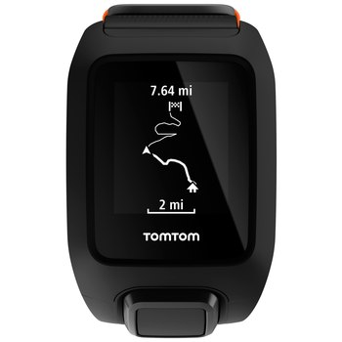

Below you find the .proto definition file for the route files.

|  |
| --- |
| //#################################################################################################  //  // Definition file for the TomTom routes (files with ID 0x00b8nnnn). A route is the result of  // trackplanning by converting and uploading GPX track files.  //  //#################################################################################################  syntax = "proto2";  *<Language specific statements>*  message MetaData  {  required fixed32 unknown1 =1; // always 0x1234DAEB?  required fixed32 unknown2 =2; // always 0x00010100?  }  // 1st level  message RootContainer  {  optional MetaData metaData =7;  optional TrackLevel1 level1 =8;  }  message LatLon  {  required fixed32 value =1;  }  // Container  message Coordinate  {  required LatLon lat =1;  required LatLon lon =2;  }  // Coordinate container  message CoordinateData  {  required Coordinate coordinate =1;  }  // Start coordinate  message StartCoordinate  {  required Coordinate coordinate =1;  required int32 index =2;  }  // Route segment  message Segment  {  required int32 numberOfCoordinates =1;  repeated CoordinateData data =2;  }  // Segment section  message SegmentData  {  required int32 numberOfSegments =1;  repeated Segment data =2;  }  // Bounding box enclosing the route  message BoundingBox  {  required LatLon latDown =1;  required LatLon lonLeft =2;  required LatLon latUp =3;  required LatLon lonRight =4;  }  // Some information on the route  message TrackMetaData  {  required string name =1;  required BoundingBox box =2;  required bytes time =3;  }  // 3rd level  message TrackLevel2  {  required TrackMetaData metadata =1;  repeated StartCoordinate coordinate =2;  required SegmentData data =3;  }  // 2nd level  message TrackLevel1  {  required TrackLevel2 level2 =1;  }  // The Root  message Root  {  repeated RootContainer container =1;  } |

The highest level is a .proto file is Root. It contains three levels of containers: RootContainer, TrackLevel1 and TrackLevel2. At TrackLevel2 we find TrackMetadata (name, bounding box, time), the StartCoordinate and the SegmentData. SegmentData contains one or more Segments, each segment contains the Coordinates.

The total number of Coordinates in all Segments should not exceed 500. If a route to encode contains more than 500 points, skip some intermediate coordinates.

## Activity types

In several places a code is used to identify the activity. Next table shows the meaning:

|  |  |
| --- | --- |
| Code | Sport |
| 0x00 | Running |
| 0x01 | Cycling |
| 0x02 | Swimming |
| 0x07 | Treadmill |
| 0x08 | Freestyle |
| 0x09 | Gym |
| 0x0a | Hiking |
| 0x0b | Indoor cycling |
| 0x0e | Trail running |
| 0x0f | Skiing |
| 0x10 | Snowboarding |

# USB Interface

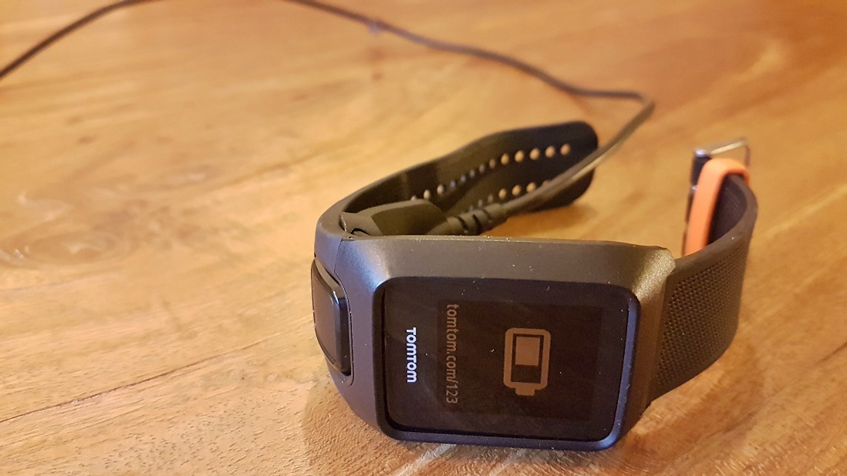

## Generic mechanism

The communication to the watch at low level takes place by writing request packets to the write endpoint of the USB device and reading response packets from the read end point.

Request packet (TX):

|  |  |  |  |  |
| --- | --- | --- | --- | --- |
| 1 | 1 | 1 | 1 | N, 0≤N≤252 |
| 0x09 | N+2 | Counter | tx msg type | Payload |

Response packet (RX):

|  |  |  |  |  |
| --- | --- | --- | --- | --- |
| 1 | 1 | 1 | 1 | M, 0≤M≤252 |
| 0x01 | M+2 | Counter | rx msg type | Payload |

Header (green)

1. Start of message  
   0x09 for TX, 0x01 for RX
2. Length of remaining part of the message  
   Including the remaining header bytes
3. Counter  
   Should be increased on each TX. RX reflects the value sent in the corresponding TX. Can be used to check if the response belongs to the request.
4. Message type   
   Usually the msg type in the response is equal to the msg type in the request. The exception is the read data request (MSG_READ_FILE_DATA_REQUEST)

|  |  |  |  |  |  |
| --- | --- | --- | --- | --- | --- |
| Device | Vendor ID | Product ID | Read endpoint | Write endpoint | TX Packet size |
| Multisports | 0x1390 | 0x7474 | 0x84 | 0x05 | N+4 |
| Spark Music | 0x1390 | 0x7475 | 0x81 | 0x02 | 256 |
| Runner Music | 0x1390 | 0x7475 | 0x81 | 0x02 | 256 |
| Spark Cardio | 0x1390 | 0x7475 | 0x81 | 0x02 | 256 |
| Runner Cardio | 0x1390 | 0x7477 | 0x81 | 0x02 | 256 |
| Adventurer | 0x1390 | 0x7477 | 0x81 | 0x02 | 256 |

In case the packet size is 256 and N<252, the remainder of the packet can be set to 0.

Identified message types:

|  |  |
| --- | --- |
| Message type (cmd) | Description |
| 0x02 | MSG_OPEN_FILE_WRITE |
| 0x03 | MSG_DELETE_FILE |
| 0x04 | MSG_WRITE_FILE_DATA |
| 0x05 | MSG_GET_FILE_SIZE |
| 0x06 | MSG_OPEN_FILE_READ |
| 0x07 | MSG_READ_FILE_DATA_REQUEST |
| 0x09 | MSG_READ_FILE_DATA_RESPONSE |
| 0x0A | ~~MSG_FIND_CLOSE~~ |
| 0x0C | MSG_CLOSE_FILE |
| 0x0D | MSG_UNKNOWN_0D |
| 0x0E | MSG_FORMAT_WATCH |
| 0x10 | MSG_RESET_DEVICE |
| 0x11 | MSG_FIND_FIRST_FILE |
| 0x12 | MSG_FIND_NEXT_FILE |
| 0x14 | MSG_GET_CURRENT_TIME |
| 0x1A | MSG_UNKNOWN_1A |
| 0x1D | MSG_RESET_GPS_PROCESSOR |
| 0x1F | MSG_UNKNOWN_1F |
| 0x20 | MSG_GET_PRODUCT_ID |
| 0x21 | MSG_GET_FIRMWARE_VERSION |
| 0x22 | MSG_UNKNOWN_22 |
| 0x23 | MSG_UNKNOWN_23 |
| 0x28 | MSG_GET_BLE_VERSION |

## Higher level functions

### Open File/Close File/Delete file

TX:

|  |  |  |  |  |
| --- | --- | --- | --- | --- |
| 1 | 1 | 1 | 1 | 4 |
| 0x01 | 6 | cnt | **CMD** | File ID |

RX:

|  |  |  |  |  |  |  |  |  |
| --- | --- | --- | --- | --- | --- | --- | --- | --- |
| 1 | 1 | 1 | 1 | 4 | 4 | 4 | 4 | 4 |
| 0x01 | 22 | cnt | **CMD** |  | File ID |  |  | Error |

|  |  |
| --- | --- |
| Variable | Description |
| CMD | Command byte (message type) |
| File ID | ID of the file. Appears to be 0x00000000 on the adventurer |
| Error | Error indication. 0 – no error, other value - error |

|  |  |
| --- | --- |
| Command (cmd) | Description |
| 0x02 | MSG_OPEN_FILE_WRITE |
| 0x03 | MSG_DELETE_FILE |
| 0x06 | MSG_OPEN_FILE_READ |
| 0x0C | MSG_CLOSE_FILE |

### Reading files

1. Open file for reading (MSG_OPEN_FILE_READ)
2. Request file size (=bytes to be read; MSG_GET_FILE_SIZE)
3. Repeat: read file data chunk (MSG_READ_FILE_DATA_REQUEST)
4. Close file (MSG_CLOSE_FILE)

Reading file data: File is read in chunks. The amount of bytes to read is defined in the TX message

TX:

|  |  |  |  |  |  |
| --- | --- | --- | --- | --- | --- |
| 1 | 1 | 1 | 1 | 4 | 4 |
| 0x01 | 10 | cnt | **0x07** | File ID | Length |

RX:

|  |  |  |  |  |  |  |
| --- | --- | --- | --- | --- | --- | --- |
| 1 | 1 | 1 | 1 | 4 | 4 | Read |
| 0x01 | Read+10 | cnt | **0x09** | File ID | Read | File data |

|  |  |
| --- | --- |
| Variable | Description |
| File ID | File to read |
| Length | Bytes to read from the opened file. For the Multisports it is max. 50, for Spark, Runner, Adventurer it is max. 242 bytes. |
| Read | Bytes read. Should be equal to Length |
| File Data | Chuck of file data read. |

### Writing files

1. Open file for writing (MSG_OPEN_FILE_WRITE)
2. Repeat: Write file data chunk (MSG_WRITE_FILE_DATA)
3. Close file (MSG_CLOSE_FILE)

Writing file data in chunks:  
File is written in chunks. Therefore the file data has to be split up in chunks. The number of chunks is roundup(fileSize/maxChunkSize). The maxChunkSize depends on the watch type (see below).

TX:

|  |  |  |  |  |  |
| --- | --- | --- | --- | --- | --- |
| 1 | 1 | 1 | 1 | 4 | Length |
| 0x01 | Length+6 | cnt | **0x04** | File ID | Chunk data |

RX:

|  |  |  |  |  |  |  |  |  |
| --- | --- | --- | --- | --- | --- | --- | --- | --- |
| 1 | 1 | 1 | 1 | 4 | 4 | 4 | 4 | 4 |
| 0x01 | 22 | cnt | **0x04** |  | File ID |  |  |  |

|  |  |
| --- | --- |
| Variable | Description |
| File ID | File to write |
| Length | Bytes to write from the opened file. For the Multisports it is max. 54, for other Spark, Runner, Adventurer it is max. 246 bytes. |
| Read | Bytes read. Should be equal to Length |
| File Data | Chuck of file data read. |

### Request file size

TX:

|  |  |  |  |  |
| --- | --- | --- | --- | --- |
| 1 | 1 | 1 | 1 | 4 |
| 0x01 | 6 | cnt | **0x05** | File ID |

RX:

|  |  |  |  |  |  |  |  |  |
| --- | --- | --- | --- | --- | --- | --- | --- | --- |
| 1 | 1 | 1 | 1 | 4 | 4 | 4 | 4 | 4 |
| 0x01 | 22 | cnt | **0x05** |  | File ID |  | Size |  |

|  |  |
| --- | --- |
| Variable | Description |
| File ID | ID of the file. Appears to be 0x00000000 on the Adventurer |
| Size | File size in bytes |

### Listing/enumerating files

This method can be used to enumerate files IDs and corresponding lengths.

1. List first file, resets the enumeration (MSG_FIND_FIRST_FILE)
2. Repeat: list subsequent files (MSG_FIND_NEXT_FILE)
3. ~~Close find (MSG_FIND_CLOSE)~~

List first file:

TX:

|  |  |  |  |  |  |
| --- | --- | --- | --- | --- | --- |
| 1 | 1 | 1 | 1 | 4 | 4 |
| 0x01 | 10 | cnt | **0x11** | 0 | 0 |

RX:

|  |  |  |  |  |  |  |  |  |
| --- | --- | --- | --- | --- | --- | --- | --- | --- |
| 1 | 1 | 1 | 1 | 4 | 4 | 4 | 4 | 4 |
| 0x01 | 22 | cnt | **0x11** |  | File ID |  | Size | End of list |

List next file:

TX:

|  |  |  |  |
| --- | --- | --- | --- |
| 1 | 1 | 1 | 1 |
| 0x01 | 2 | cnt | **0x12** |

RX:

|  |  |  |  |  |  |  |  |  |
| --- | --- | --- | --- | --- | --- | --- | --- | --- |
| 1 | 1 | 1 | 1 | 4 | 4 | 4 | 4 | 4 |
| 0x01 | 22 | cnt | **0x12** |  | File ID |  | Size | End of list |

|  |  |
| --- | --- |
| Variable | Description |
| File ID | ID of the file. |
| Size | File size in bytes |
| End of list | 0 if more files available, otherwise if not. If this value is unequal to 0, File ID and size have no meaning. |

### Get Watch time

TX:

|  |  |  |  |
| --- | --- | --- | --- |
| 1 | 1 | 1 | 1 |
| 0x01 | 2 | cnt | **0x14** |

RX:

|  |  |  |  |  |  |  |  |  |
| --- | --- | --- | --- | --- | --- | --- | --- | --- |
| 1 | 1 | 1 | 1 | 4 | 4 | 4 | 4 | 4 |
| 0x01 | 22 | cnt | **0x14** | Time |  |  |  |  |

|  |  |
| --- | --- |
| Variable | Description |
| Time | The current time in epoch seconds (UTC) |

### Firmware version (MSG_GET_FIRMWARE_VERSION)

TX:

|  |  |  |  |
| --- | --- | --- | --- |
| 1 | 1 | 1 | 1 |
| 0x01 | 2 | cnt | **0x21** |

RX:

|  |  |  |  |  |
| --- | --- | --- | --- | --- |
| 1 | 1 | 1 | 1 | length |
| 0x01 | 2+length | cnt | **0x21** | Version |

|  |  |
| --- | --- |
| Variable | Description |
| Version | The version as string of *length* bytes, like ‘1.7.53’ |

### Bluetooth Low Energy version (MSG_GET_BLE_VERSION)

TX:

|  |  |  |  |
| --- | --- | --- | --- |
| 1 | 1 | 1 | 1 |
| 0x01 | 2 | cnt | **0x28** |

RX:

|  |  |  |  |  |
| --- | --- | --- | --- | --- |
| 1 | 1 | 1 | 1 | 4 |
| 0x01 | 6 | cnt | **0x28** | Version |

|  |  |
| --- | --- |
| Variable | Description |
| Version | The version |

### Product ID (MSG_GET_PRODUCT_ID)

TX:

|  |  |  |  |
| --- | --- | --- | --- |
| 1 | 1 | 1 | 1 |
| 0x01 | 2 | cnt | **0x20** |

RX:

|  |  |  |  |  |
| --- | --- | --- | --- | --- |
| 1 | 1 | 1 | 1 | 4 |
| 0x01 | 6 | cnt | **0x20** | Product ID |

|  |  |
| --- | --- |
| Variable | Description |
| Product ID | Product ID, for Adventurer 0xe0070000. |

### Reset device (MSG_RESET_DEVICE)

TX:

|  |  |  |  |
| --- | --- | --- | --- |
| 1 | 1 | 1 | 1 |
| 0x01 | 2 | cnt | **0x10** |

The reset is used after uploading firmware files. The reboot installs the firmware. Since the watch resets, no response (RX) is sent.

### Reset GPS processor (MSG_RESET_GPS_PROCESSOR)

TX:

|  |  |  |  |
| --- | --- | --- | --- |
| 1 | 1 | 1 | 1 |
| 0x01 | 2 | cnt | **0x1D** |

RX:

|  |  |  |  |  |
| --- | --- | --- | --- | --- |
| 1 | 1 | 1 | 1 | length |
| 0x01 | 2+length | cnt | **0x1D** | Reboot message |

|  |  |
| --- | --- |
| Variable | Description |
| Reboot message | A message as string of *length* bytes, like  ‘wait 1 minute before disconnecting USB’ |

### Format Watch (MSG_FORMAT_WATCH)

This method formats the watch. It is required to download and write the firmware as described in ‘Firmware files (0x000000f0, 0x00000012, 0x00010200)’. Beware that the required preference file is also deleted during the format, so download this file first before formatting the watch.

Disconnecting the watch after format and before writing the firmware results in the watch asking to be reconnected again:

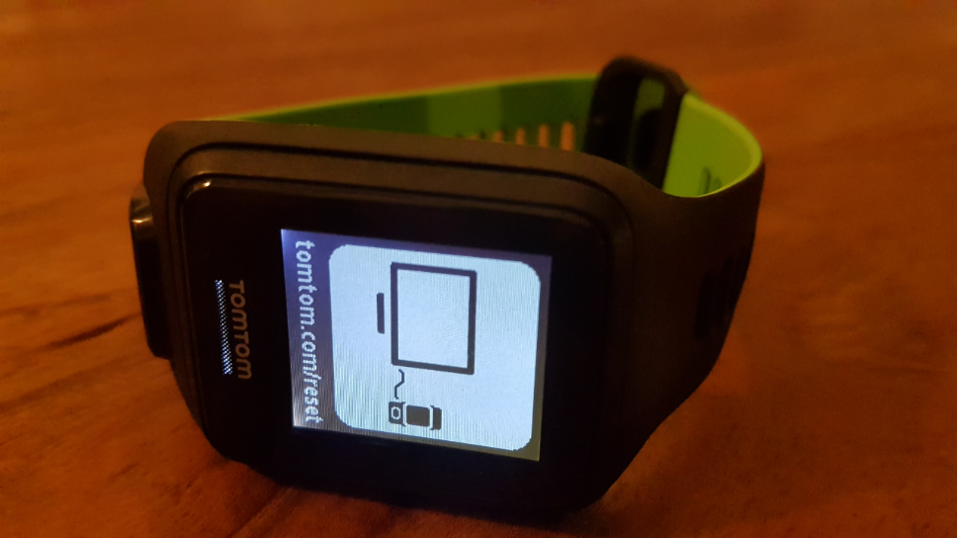

After the format and writing the firmware the watch can be registered again using TomTom Sports Connect.

TX:

|  |  |  |  |
| --- | --- | --- | --- |
| 1 | 1 | 1 | 1 |
| 0x01 | 2 | cnt | **0x0E** |

RX:

|  |  |  |  |  |  |  |  |  |
| --- | --- | --- | --- | --- | --- | --- | --- | --- |
| 1 | 1 | 1 | 1 | 4 | 4 | 4 | 4 | 4 |
| 0x01 | 22 | cnt | **0x0E** |  |  |  |  | Error |

|  |  |
| --- | --- |
| Variable | Description |
| Error | 0 if no error, >0 if an error occurred |