1번  SCAN TO BORROW  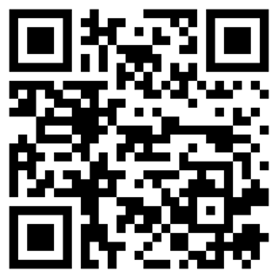 | 2번  SCAN TO BORROW   |  |  | 3번  SCAN TO BORROW   |  | 4번  SCAN TO BORROW  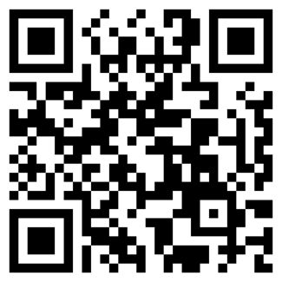 |  | 5번  SCAN TO BORROW  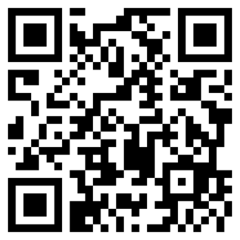 |  | 6번  SCAN TO BORROW  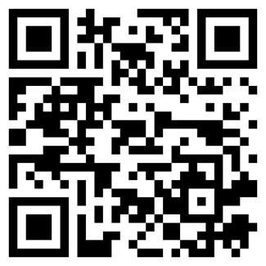 |  | 7번  SCAN TO BORROW  
8번  SCAN TO BORROW  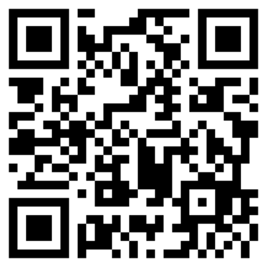 | 9번  SCAN TO BORROW   |  |  | 10번  SCAN TO BORROW  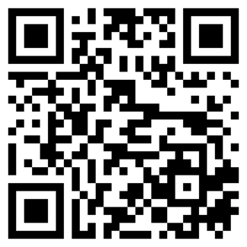 |  | 11번  SCAN TO BORROW  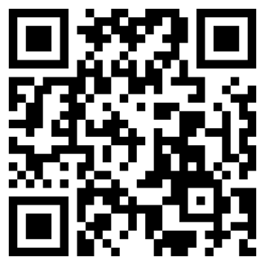 |  | 12번  SCAN TO BORROW  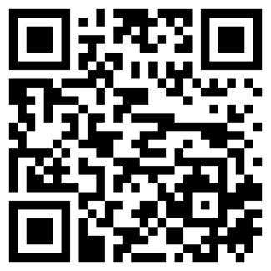 |  | 13번  SCAN TO BORROW  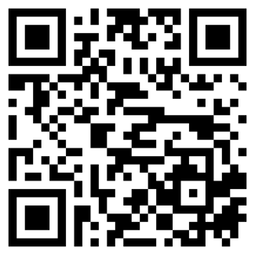 |  | 14번  SCAN TO BORROW  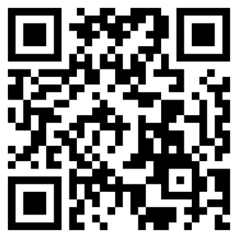
15번  SCAN TO BORROW  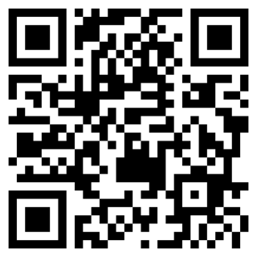 | 16번  SCAN TO BORROW  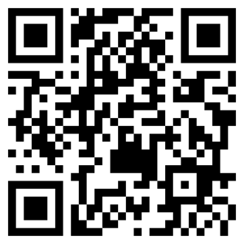 |  |  | 17번  SCAN TO BORROW  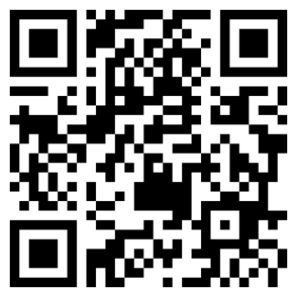 |  | 18번  SCAN TO BORROW  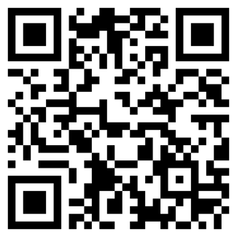 |  | 19번  SCAN TO BORROW  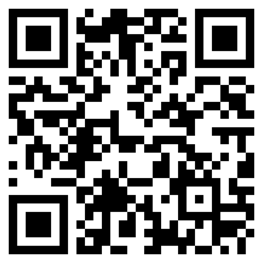 |  | 20번  SCAN TO BORROW  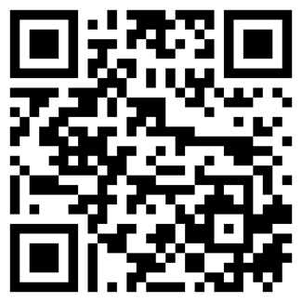 |  | 21번  SCAN TO BORROW  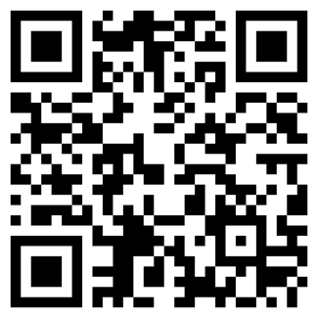
22번  SCAN TO BORROW  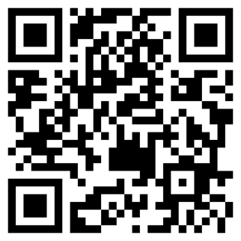 |  | 23번  SCAN TO BORROW  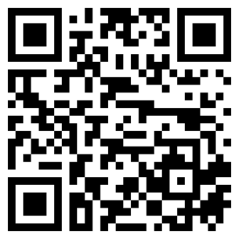 | 24번  SCAN TO BORROW  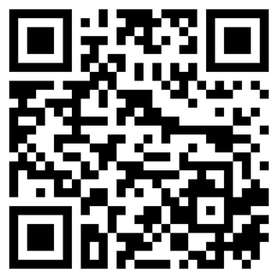 |  | 25번  SCAN TO BORROW   |  | 26번  SCAN TO BORROW  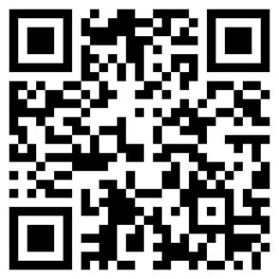 |  | 27번  SCAN TO BORROW  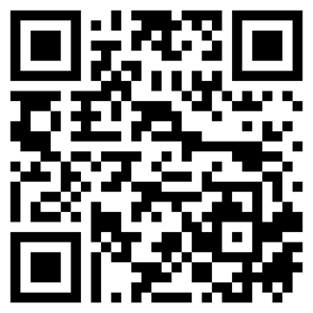 |  | 28번  SCAN TO BORROW  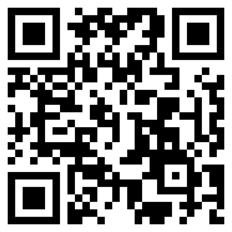
29번  SCAN TO BORROW  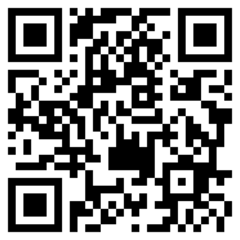 |  | 30번  SCAN TO BORROW  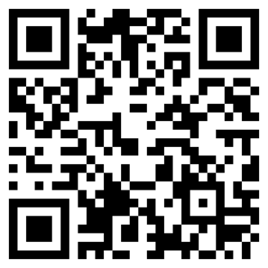 | 31번  SCAN TO BORROW  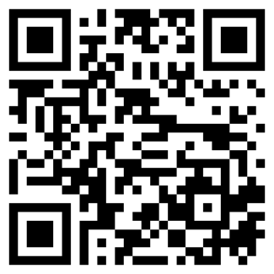 |  | 32번  SCAN TO BORROW  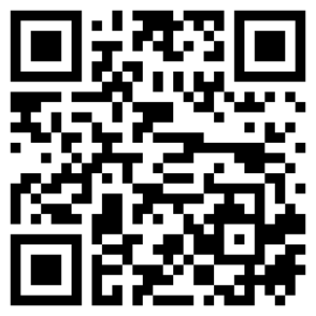 |  | 33번  SCAN TO BORROW  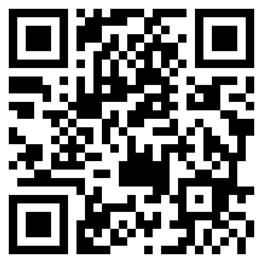 |  | 34번  SCAN TO BORROW  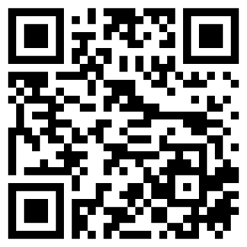 |  | 35번  SCAN TO BORROW  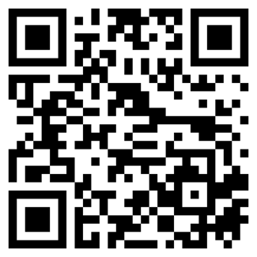
36번  SCAN TO BORROW  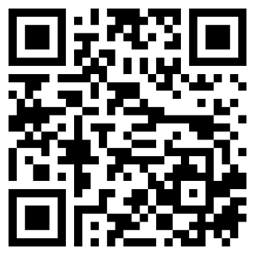 | 37번  SCAN TO BORROW  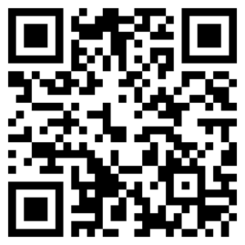 |  |  | 38번  SCAN TO BORROW  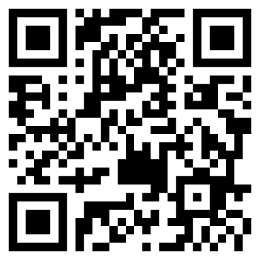 |  | 39번  SCAN TO BORROW  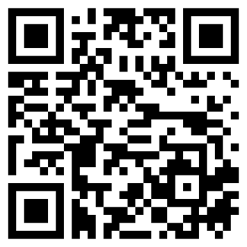 |  | 40번  SCAN TO BORROW  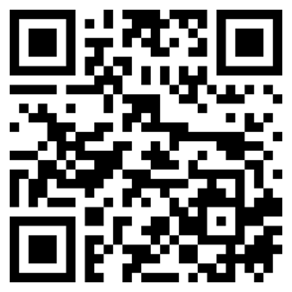 |  | 41번  SCAN TO BORROW  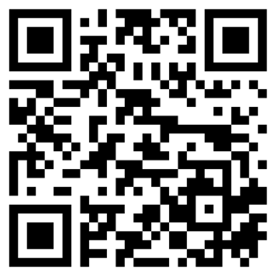 |  | 42번  SCAN TO BORROW  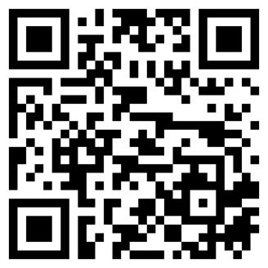
43번  SCAN TO BORROW   | 44번  SCAN TO BORROW  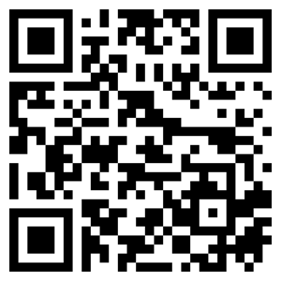 |  |  | 45번  SCAN TO BORROW   |  | 46번  SCAN TO BORROW  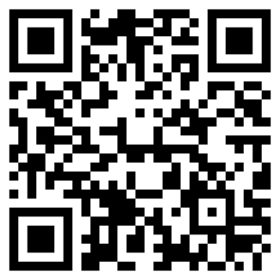 |  | 47번  SCAN TO BORROW  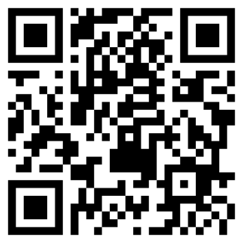 |  | 48번  SCAN TO BORROW  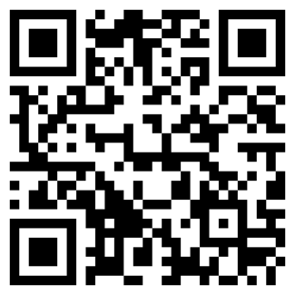 |  | 49번  SCAN TO BORROW  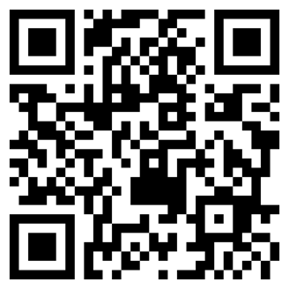
50번

SCAN TO BORROW
