***Grayscale:***

***Forward DCT coefficient (logscale):***

***Denormalized Quantized Image:***

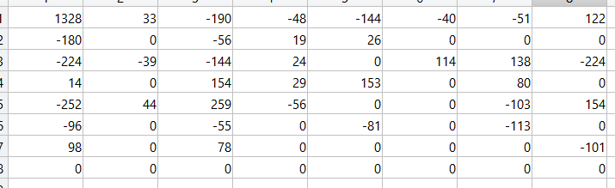

***Reconstructed:***

***OUTPUT:***

