Contents
3.2. Question 1: 4
1.1. Installing Windows Server on Hyper-V: 4
1. RAM: 4
2. HDD: 5
3. Network: 5
4. Desktop Experience: 6
5. Screenshot OF GIF-SERVER01 Hostname in System Properties: 6
1.2. Installing necessary Roles and features: 7
2. Select Server Roles: 7
3. Feature Success: 8
1.3 . Configuration of System updates 8
4. System updates and enable remote desktop access: 8
2. System Properties 9
5. Screenshot of a client machine connecting via RDP to GIF-SERVER01: 10
3. Demonstrate Disk partitioning and user account creation: 10
1.4. Demonstrate Disk partitioning and user-account creation: 10
4. Disk Management: 11
5. Computer Management: 11
3.2. Question 2 11
2.1. Promote the server to a domain controller called technova.local 11
• Successful Promotion completion message before restarts: 12
• Deliverables: 13
• Active Directory Users and Computers showing IT, finance and HR: 13
2.3. Creating at least 2 users per OU and assigning them to groups: 13
• Deliverables: 13
• Showing at least 2 users within each OU: 13
• Members Tab for the newly created groups, showing its assigned users: 14
2.4. Configure DNS with forward 16
• Forward lookup Zone: 16
• Reverse Lookup Zone: 17
2.5. Setup DHCP with One Scope: 17
• Deliverables: 17
6. New Scope Wizard 18
7. Add exclusions and Delay 18
8. Reservations 20
3.4. Question 3: 21
9. Deliverables: 21
3.2. Link the GPO to the domain 22
10. Deliverables: 22
3.3. Configuring an additional GPO to map a network drive to users in the HR OU: 24
11. Deliverable: 24
3.4. Install AD CS and issue basic certificate template: 25
Deliverables: 25
3.5. Export and import a user certificate for encrypted email: 26
12. Deliverable: 27
3.5. Question 4: 28
4.1. Install and configure Windows Defender Antivirus and Windows Firewall: 28
13. Deliverables: 28
4.2. Create firewall rules to allow RDP and block ICMP ping requests: 30
4.3. Configure and Test VPN or Direct Access functionality: 31
14. Deliverables: 31
4.4. Demonstrate the use of Remote Access Management Console: 33
15. Deliverables: 33
4.5. Describe and apply two best practices for hardening Windows Server 2019: 34
16. Deliverables: 34

3.2. Question 1:

Installing Windows Server on Hyper-V:
Changing the hostname of the Virtual Machine to GIF-SERVER01.
Changing the hostname is done inside the Virtual Machine(VM) in system properties.
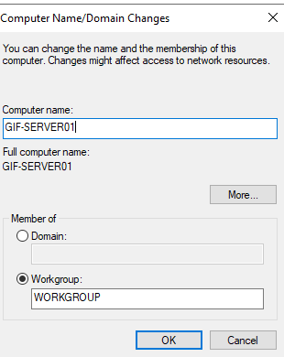
Screenshot of Virtual Machine Creation Settings:

RAM:
The settings show the amount of Minimum memory and maximum memory that can be assigned to the virtual machine.
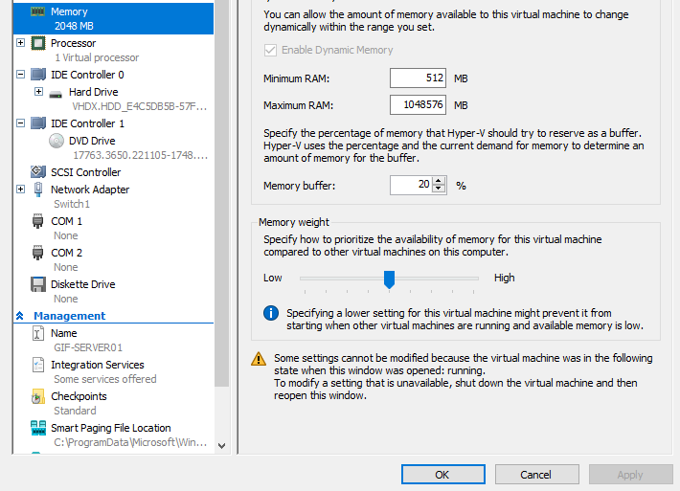

HDD:
The hard drive shows the location where the virtual machine was created.
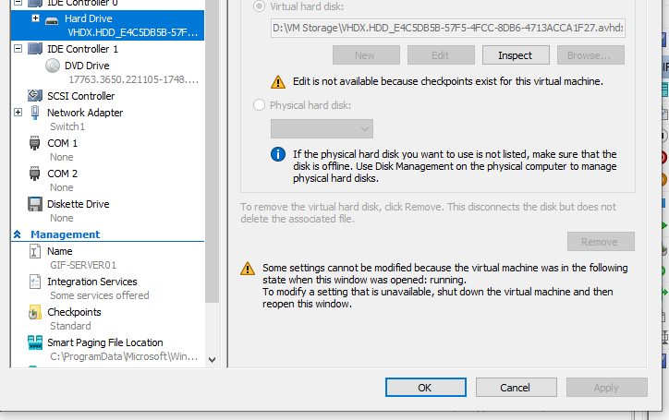

Network:
The network settings, this is where you can create switches. Hence, those switches can be further be placed in the same network as the client machine.
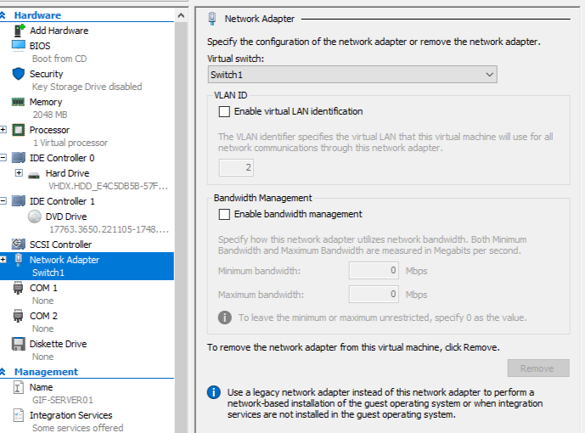

Desktop Experience:
Here you select the type of operating system you want to install. Hence, the image below shows that we have selected a desktop experience as our operating system.
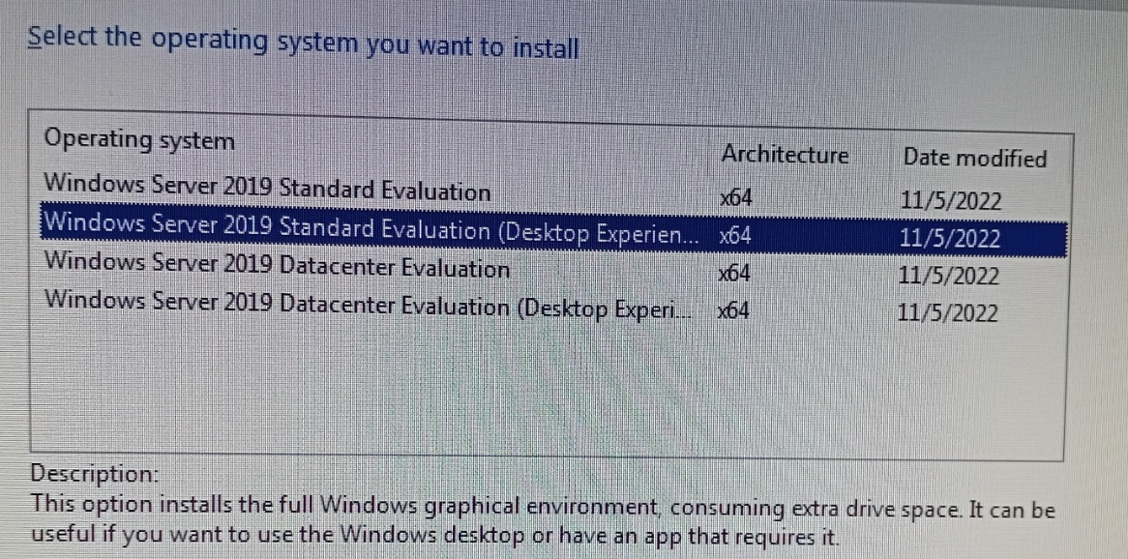

Screenshot OF GIF-SERVER01 Hostname in System Properties:
This where you can change your device name.
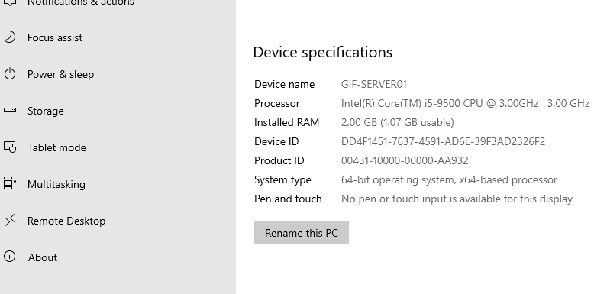

Installing necessary Roles and features:
- The screenshot shows the services that add to the server through roles and features in the server manager.
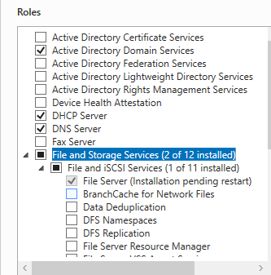

Select Server Roles:
You choose the type of server where you are adding the roles and features.

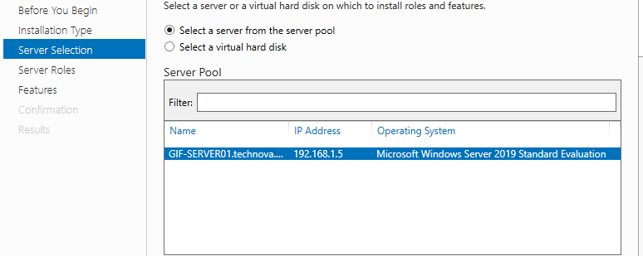

Feature Success:
The below picture shows that the services where successfully installed to the virtual machine.
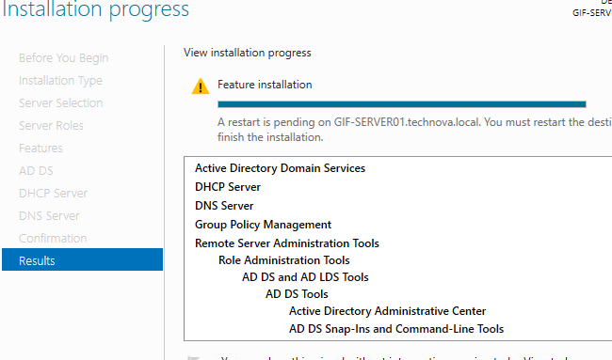

. Configuration of System updates

System updates and enable remote desktop access:
The picture below shows where you can do window update or patches.
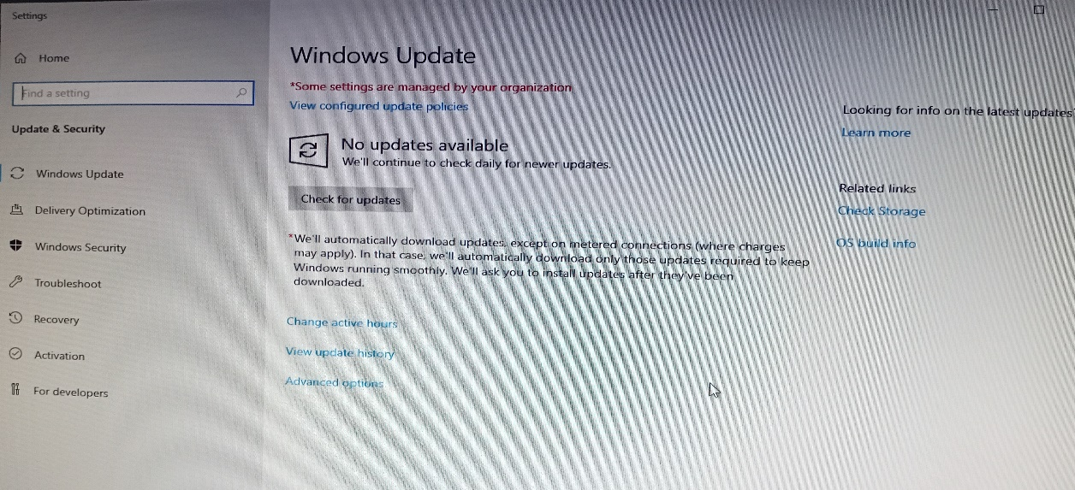

System Properties
- In system properties we can enable remote connections on the computer, allow the client to be able to remotely access the server from the client machine.
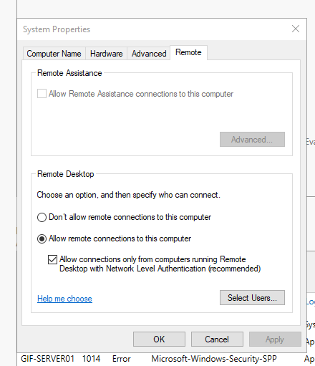

Screenshot of a client machine connecting via RDP to GIF-SERVER01:

The image shows there was a successful Remote Desktop Connection, enabling windows 10 to the server.

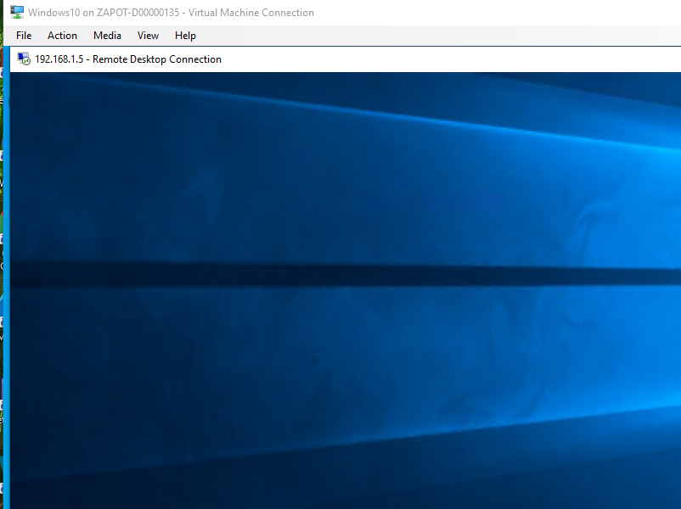

Demonstrate Disk partitioning and user-account creation:

Disk Management:
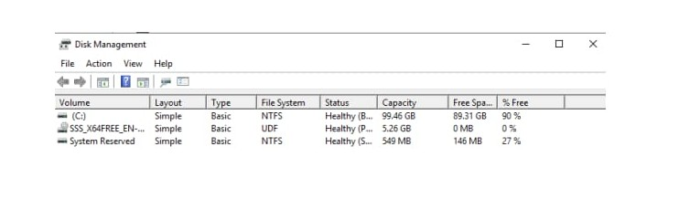

Computer Management:
This is where users can also be created but it is more preferred to create users in AD User and computers.
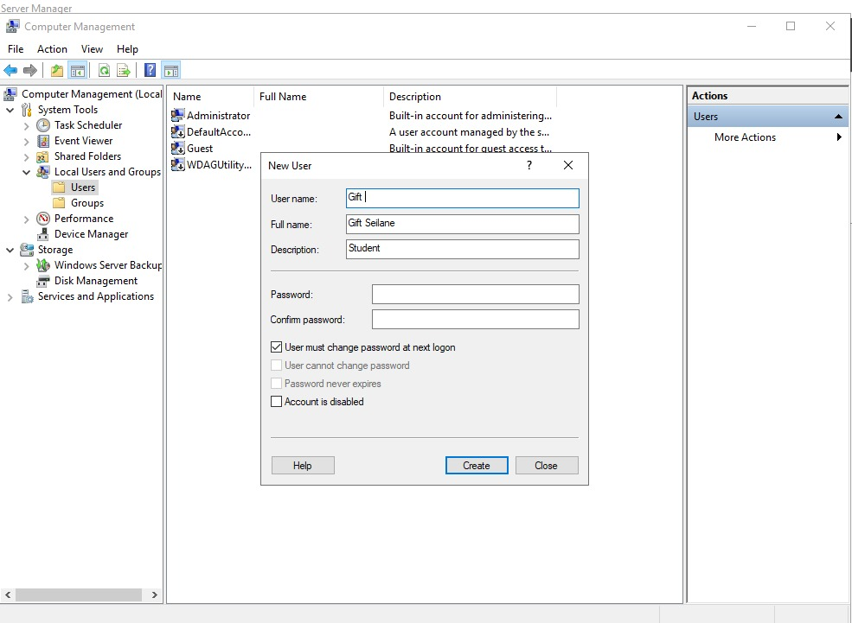

Question 2
  - Promote the server to a domain controller called technova.local:
- Deployment configuration with add new forest:
This is where the domain is created known as technova.local

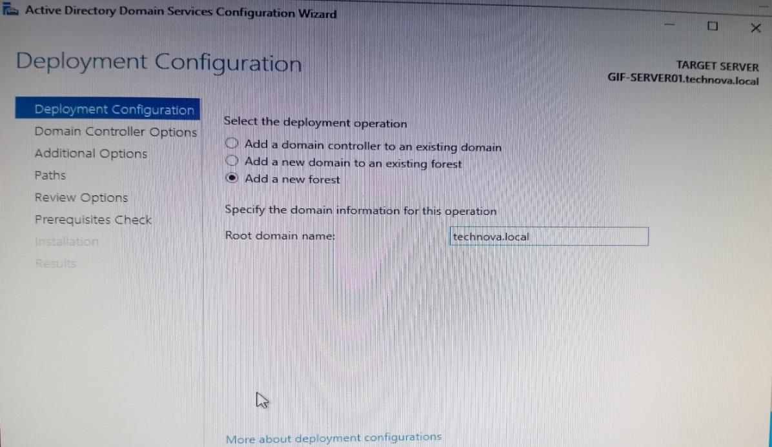

Successful Promotion completion message before restarts:
The server was able to have a successful Promotion.
The image shows the server was successfully promoted to a domain controller.
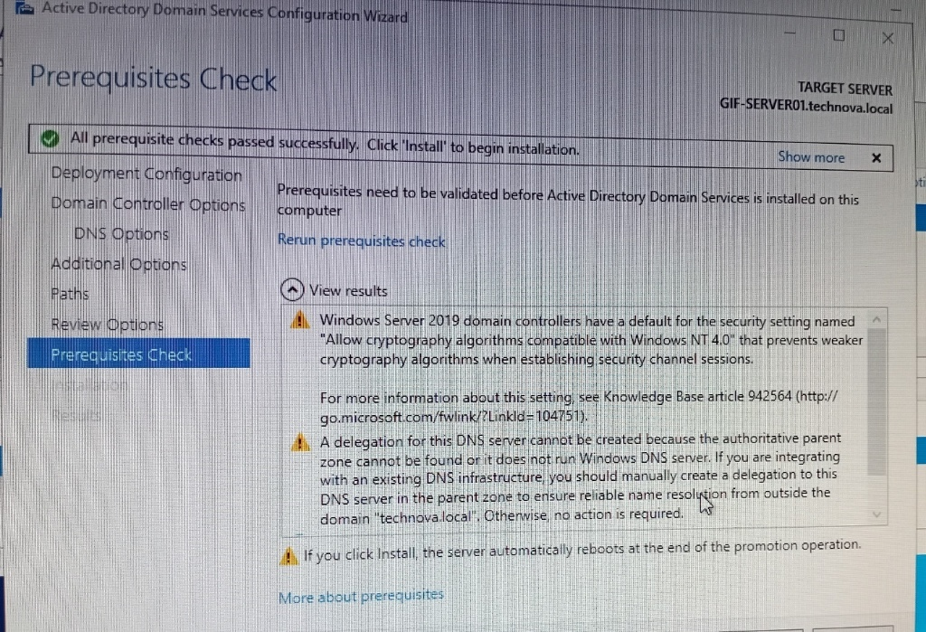

  - Creating and Organizing 3 Organizational units:
- Creating Organizational units for HR, IT and Finance in AD Users and Computers.

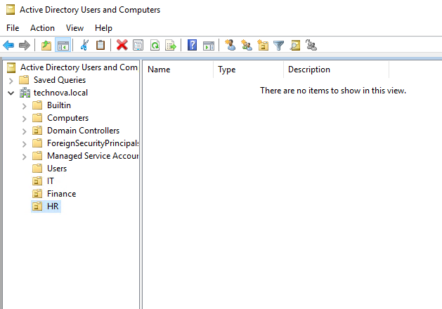

Creating at least 2 users per OU and assigning them to groups:
- Active Directory Users and Computers (ADUC):
Creating at least 2 users in ADUC for each OU.
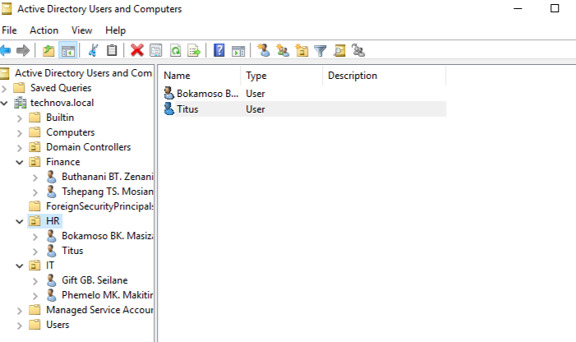

Members Tab for the newly created groups, showing its assigned users:
The image below shows the IT Staff as a group in the OU of IT and in the members tab we can see which that the users were added to the group.
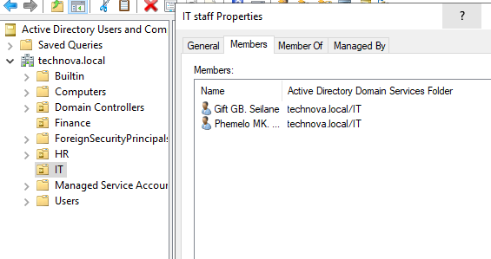

Configure DNS with forward

Forward lookup Zone:
We created a forward lookup zones, which translates names into IP-addresses.
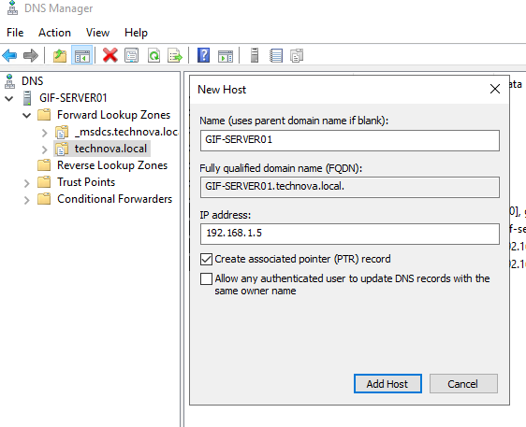

Reverse Lookup Zone:
We also created a Reverse lookup zone which translated IP-addresses into names.
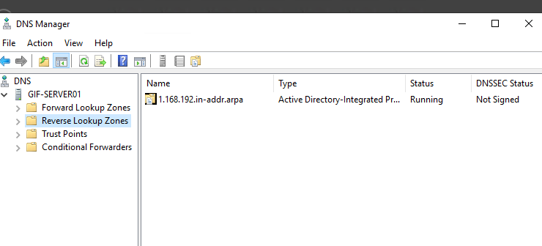

Setup DHCP with One Scope:

- DHCP showing authorized server:

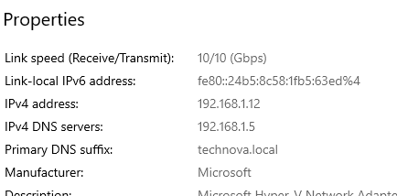

New Scope Wizard
This shows a range of IP-addresses distributed by the scope.
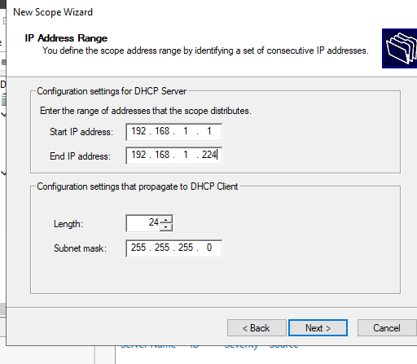

Add exclusions and Delay
When we configure the DHCP server, we make a range of IP-addresses which will be assigned as automatic IP-addresses to the client machine.

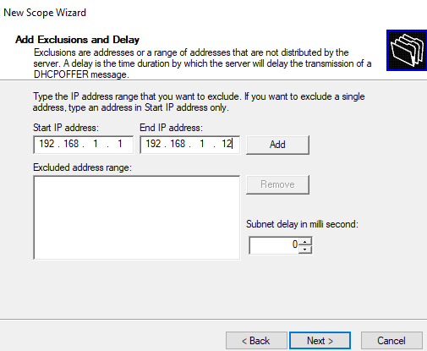

- Scope Options

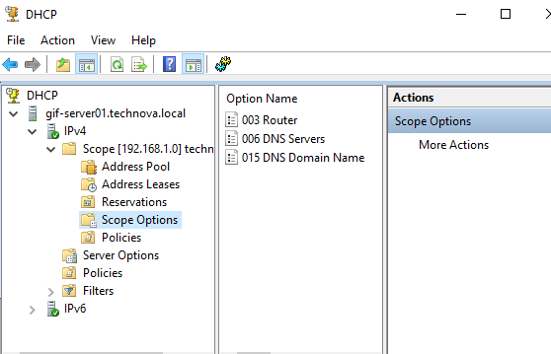

Reservations

Question 3:

3.1. Creating new Group Policy Object
- Group Policy Management Console (GPMC) showing TechNova security created. This is a policy which is applied to the domain, this means that computer or use configurations can be made.

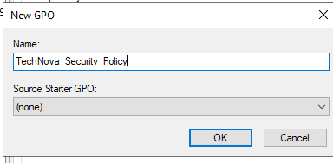

- Screenshots of configured Password Complexity:
I enabled password which makes the computers joined to the domain more secure, making them less vulnerable to threats.
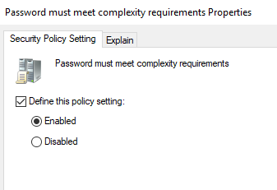

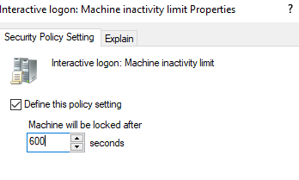

3.2. Link the GPO to the domain
- Verify its effect using gpresult or rsop.msc
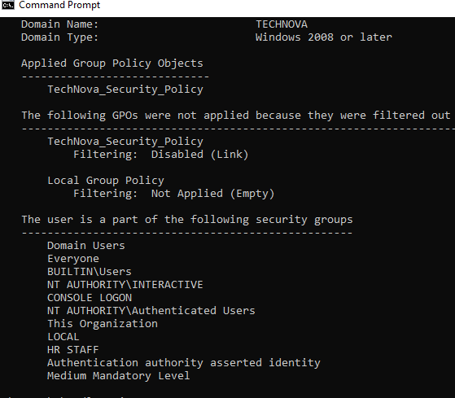
- rsop.msc on windows 10:
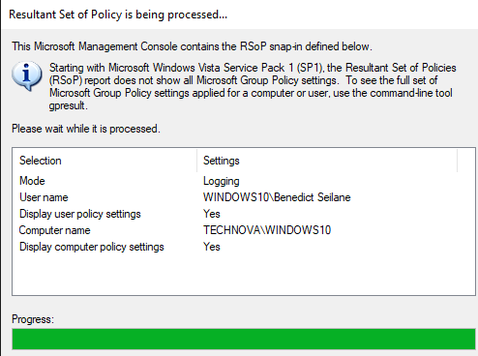

3.3. Configuring an additional GPO to map a network drive to users in the HR OU:
- Shared folder:
Creating a shared folder, is an important step in creating drive maps.
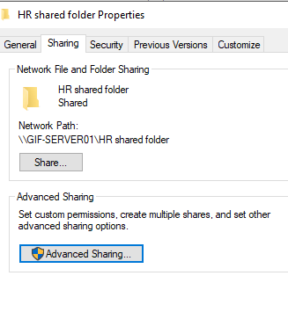
Drive Maps:
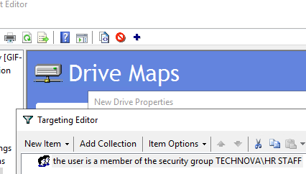
Client User Machine

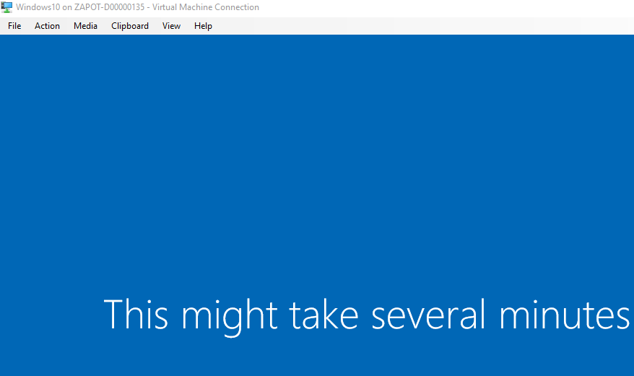

Install AD CS and issue basic certificate template:
We install AD CS from roles and features by pressing manager in the server manager.
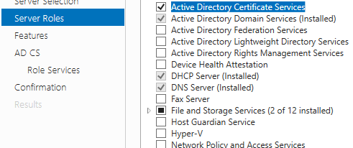
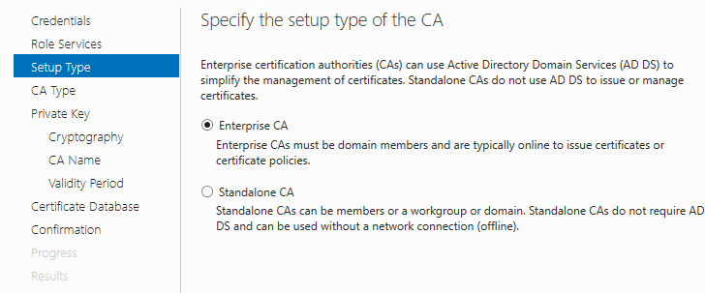
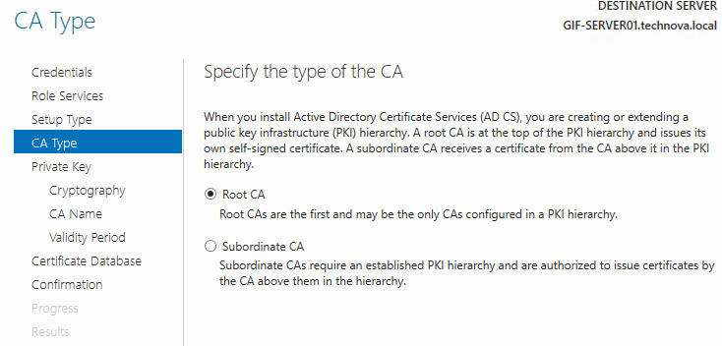

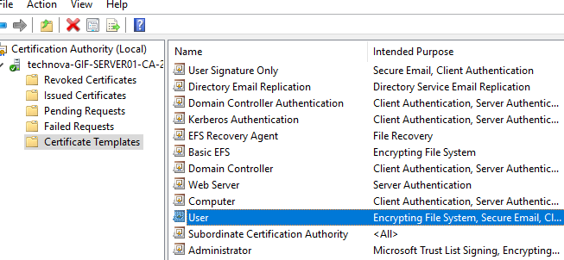

3.5. Export and import a user certificate for encrypted email:
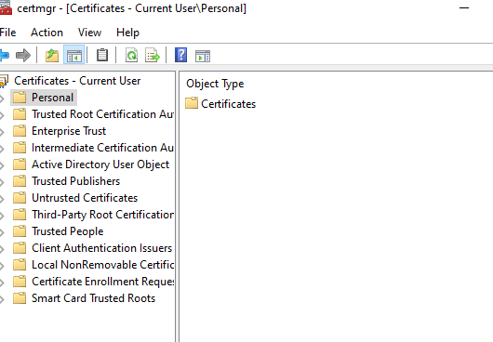

3.5. Question 4:

4.1. Install and configure Windows Defender Antivirus and Windows Firewall:
1. Windows Security can show you virus and threat protection status.

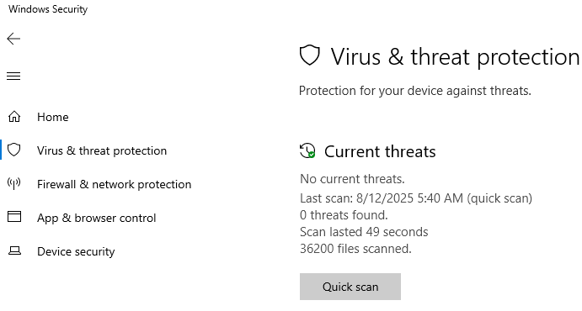

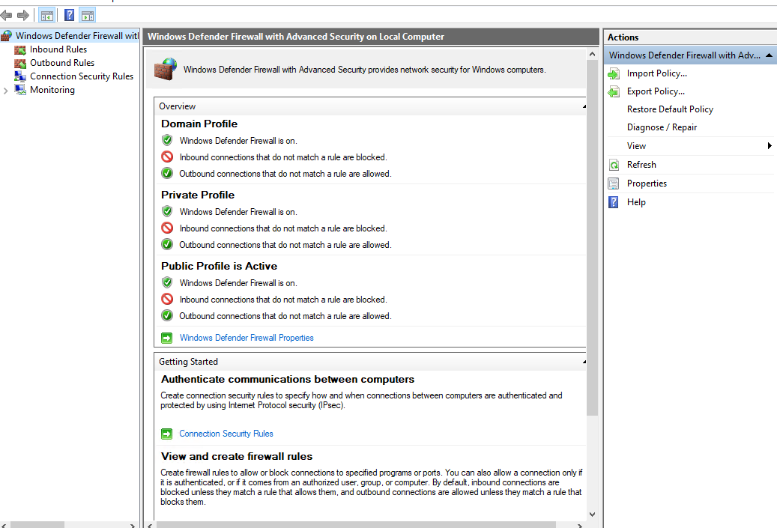

4.2. Create firewall rules to allow RDP and block ICMP ping requests:
You press wf.msc to access the firewall. This where you can enable remote desktop (TCP-In) rule.
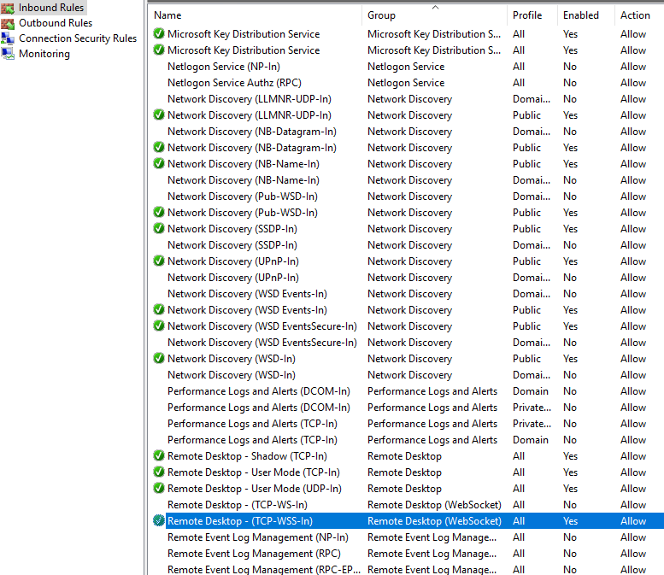
- We also create a Block_ICMP_Ping inbound rule and enable it.
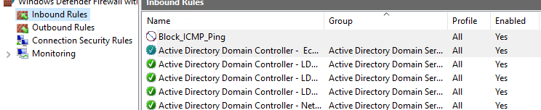

- Showing a successful RDP connection to GIF-SERVER01.
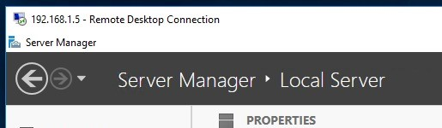

- Showing failed ping.
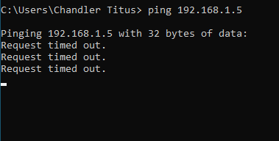

4.3. Configure and Test VPN or Direct Access functionality:
1. The screenshot below shows that we were adding remote Access to the server which will allow VPN connection to the server.

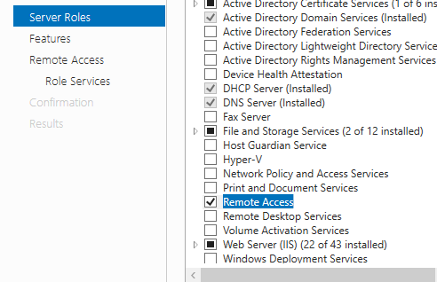

- The green arrow next to the server name, shows that the server has been enabled.
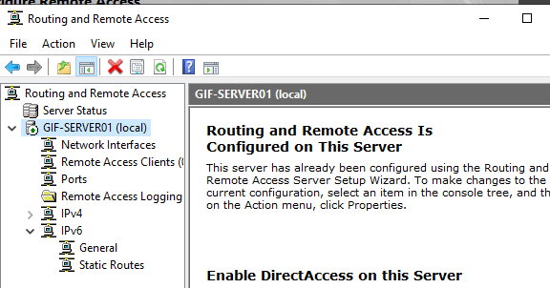

- VPN connection settings.
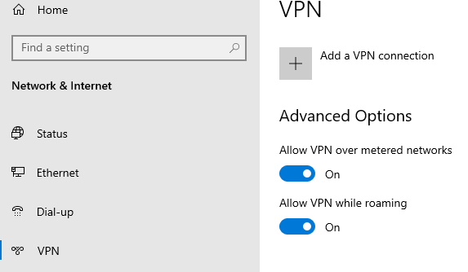

- The image below shows the VPN has successfully connected to the server.
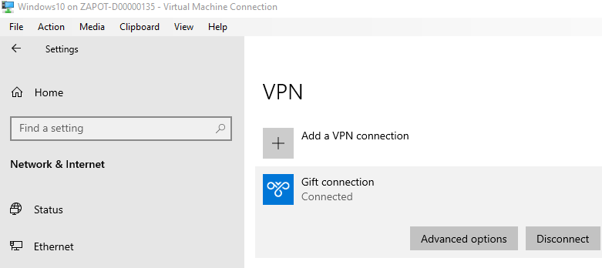

4.4. Demonstrate the use of Remote Access Management Console:

- Since we added Remote Access, in the server we can see a client that has been successfully connected to the server.
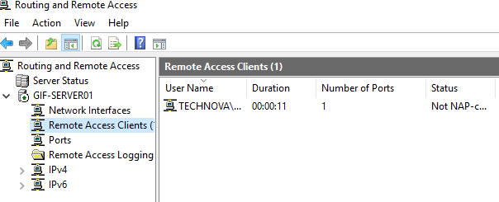

- Get-RemoteAccessConnection

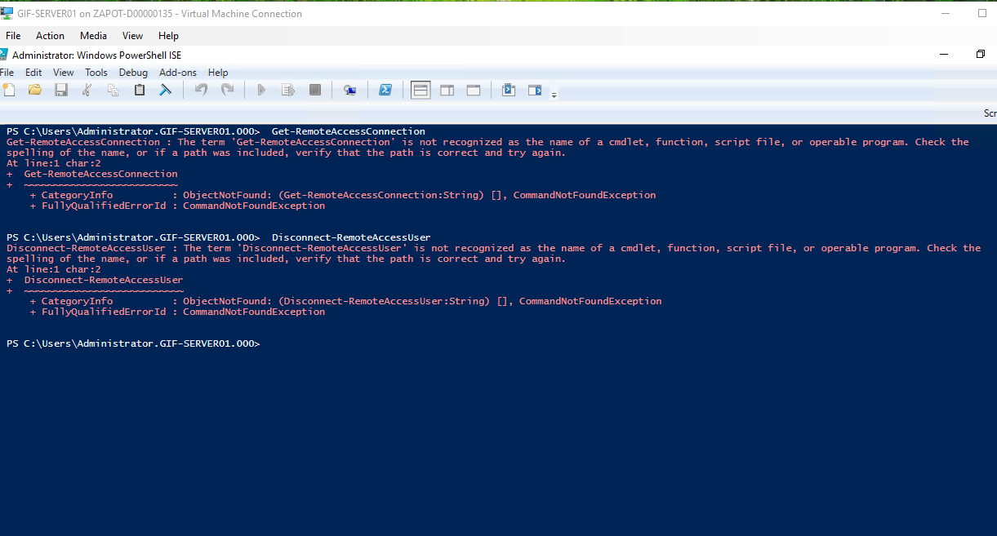

4.5. Describe and apply two best practices for hardening Windows Server 2019:

- Least Privilege:
This means that users only have the minimum rights that are necessary to perform their tasks. E.g., A student should have basic privileges for students and not for lectures.

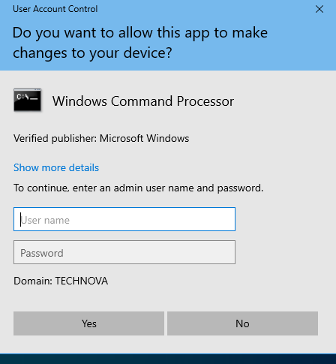

- Disable unnecessary services:
I disabled the services for Application identity by pressing stop.
