**No Name Brand Softwares (Group)**

**Crop Disease Surveying Drone Software**

**Request for Proposal**

**Version 1.0**

**09.24.2023**

**Crop Disease Surveying Drone Software**

**Request for Proposal**

*Project Version 1.0*

**Document History**

| **Version** | **When** | **Who** | **What** |
| --- | --- | --- | --- |
| 1.0 | 09.24.2023 | Hyewon Jeon, Michael Sandrin, Dylan Smith, Shaylin Ziaei, Krishna Raju, Nikhil Sabharwal, Aryana Rahimi | Initial Drafting |

**Table of Contents**

1.0 Problem description

2.0 Project Objectives

3.0 Current System(s)

4.0 Intended users and their interaction with the system

5.0 Known interaction with other systems within or outside the client organization

6.0 Known constraints to development

7.0 Project Schedule

8.0 Project team

9.0 Glossary of terms

**1.0 Problem description / expression of need**

In 2022, the Total estimated yield loss from wheat disease in the U.S. and Ontario was 55.7 million bushels and was valued at nearly 500 million USD. Every year, crop diseases and fungus cause significant yield losses. The traditional method to detect a crop disease is naked-eye observation which is time-consuming and expensive, demanding a high level of expertise. To combat this issue head-on, this document aims to explain and envision groundbreaking software that can detect and treat fungal and disease infections in crop fields. This envisioned software would not only help our organization but also farming organizations globally, by providing a data-driven, fully remote crop harm-reduction solution.

Within our organization, “Big Fun Agriculture”, we have felt these saddening and devastating crop yield losses. In late September 2022 right before our annual harvest, we found a fungal infection which had infected 4.9% of our largest field. Upon our swift investigation, we were able to effectively remove the infected crops. Our estimates suggest that the fungus would have spread to at least 10% of the field. These losses corresponding to the loss of our yield reduced our profits and created losses throughout the entire organization. In order to mitigate this issue in the future, we believe that using a software solution to target and eliminate diseases, fungus and pests throughout the growth of the crops. This would allow us to minimize losses and improve the overall quality of yield.

**2.0 Project Objectives**

The objective of this project is to develop software that works with hardware like drones and cameras to detect and treat potential disastrous plant disease/fungal infection for crop farms. Its main goal is to prevent the development of disease by finding the symptoms at the early stages. Once it detects the infected area, the software will analyze the type of the disease, degree of the damage, and available pesticides in the inventory to find the best treatment for the disease. The software is expected to assist farmers to increase crop yield annually and improve the quality of the crops that are harvested. This software will also be responsible for assisting farmers with manual labour, reducing time spent thereby reducing production costs and of course, protecting the crops that are sowed into the field.

**3.0 Current System(s)**

“Big Fun Agriculture” is an agricultural organization with multiple farms under management, supported by an effective and useful suite of management systems(software applications?). These systems include a wide range of functionalities such as task scheduling and allocation, asset management, health and safety management, accounting and payroll. Furthermore, our organization has integrated effective communication tools that have nurtured a strong sense of teamwork and project management. These systems(or tools?) all work together to push (help?) “Big Fun Agriculture” to optimize resource allocation to maximize results and productivity, along with supplying an effective platform for communication and collaboration.

**4.0 Intended users and their interaction with the system**

The intended users are our organization, “Big Fun Agriculture” and the farmers outside of our organization. They will be utilizing various types of hardware to gather large amounts of data and receive real-time feedback to the software. The feedback will be delivered through an app that integrates the hardware deployed in the field with AI/ML algorithms to process accurate results and predictions of the field and crop status. Data that will be collected includes the weather forecast, crop imaging with drone utilization, soil and water quality to identify trends and issues with pests and diseases throughout the farm.

.**5.0 Known interaction with other systems within or outside the client organization**

1. Integration with weather forecasting

In the agricultural industry, having a deep understanding of the weather forecast is integral to a successful farm and business. Farmers rely heavily on weather forecasts to understand the ideal environment for planting, harvesting, and properly irrigating their crops to create the largest and healthiest yield from their land. Many issues can occur from improper understanding of weather from overwatering crops resulting in lower quality produce to pests overtaking crops in heavily humid conditions, requiring heavier pesticide use. Using modern technologies such as AI/ML will help provide more accurate predictions on crop quality and yield using previous and future weather data (precipitation, humidity, UV indexes).

1. Integration with plant diseases library (database)

The deployed hardware will be continuously using CV to monitor the crops and their respective groups to analyze these images and footage taken by the hardware and software. This will require an in-depth knowledge of what various plant diseases may look like, and how they present themselves in various other crops. It will be essential for a database to use AI/ML algorithms which will then process their visual information, and cross-reference known information from outside sources (i.e. a reliable plant disease library).

1. Integration with pesticide inventory systems

Pesticides are widely used in agriculture to reduce damage to crops by pests and diseases and ensure the most sustainable agriculture. The use of AI/ML in the application of pesticides will understand the most effective pesticide for the identified disease, resulting in maximum crop protection while using the pesticides in a conservative manner. The pesticides will be stocked up and ordered based on the season and weather patterns, benefitting from each specific pesticide accordingly.

**6.0 Known constraints to development**

1. Budget Constraints

* The previous year did not have a good yield in quality and quantity for crops, resulting in less money to spend for the next farming season/year

2. Considering the environment constraints

* Need to prevent overapplication of pesticides to ensure compliance with local and federal regulations

3. Compatibility with the existing applications

* Existing systems may use different protocols and technologies, so it is important to ensure that the new application does not interfere with the functionality of existing applications

**7.0 Project Schedule**

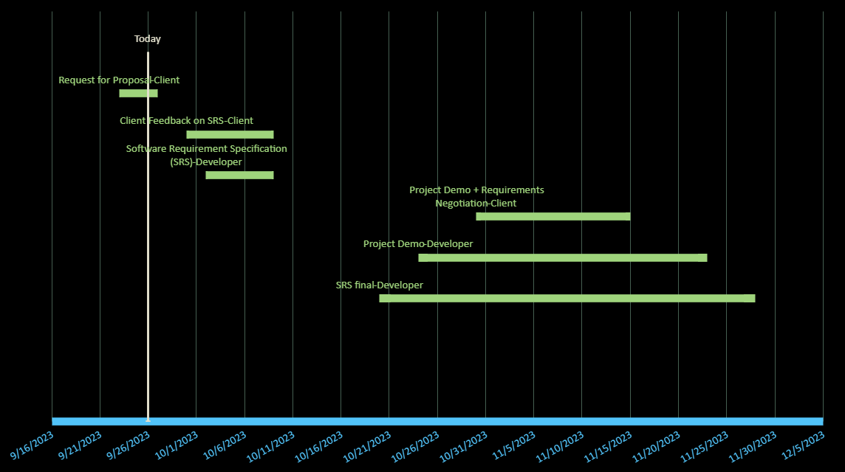

| **Date** | **Meeting Purpose** |
| --- | --- |
| **2023-09-24** | **Deciding the project we want to work on, Dividing tasks, Filling Request for Proposal (RFP)** |
| **2023-10-1** | **Weekly meeting to catch up and divide tasks** |
| **2023-10-8** | **Review teammates' work, give each other feedback and update our work, Divide tasks** |
| **2023-10-19** | **discussion on the received feedback from the developer team on SRS, Review the tasks that each member has done** |
| **2023-10-22** | **Go over SRS as a designer team** |
| **2023-11-2** | **Weekly meeting to catch up and divide tasks** |
| **2023-11-5** | **Weekly meeting to catch up and divide tasks** |
| **2023-11-12** | **Go over Project Demo + Requirements Negotiations(As clients) tasks that we can improve or work on** |
| **2023-11-21** | **Project Demo final version( As designer team) +**  **Discussing Software Requirement Specification (SRS) (As a designer Team)** |
| **2023-11-26** | **Final review and discussion on SRS** |

**8.0 Project team**

Project team member's info, roles and contact information

| Team member’s name | Contact info | Role |
| --- | --- | --- |
| Hyewon Jeon | Email: [hyeny99@my.yorku.ca](mailto:hyeny99@my.yorku.ca)  Phone: +1 647-825-6553 | Subject Matter Expert |
| Shaylin Ziaei | Email: [shaylinz@my.yorku.ca](mailto:shaylinz@my.yorku.ca)  Phone: +1 437-981-2814 | Agricultural and Food Science Technician |
| Michael Sandrin | Email: [msandrin@my.yorku.ca](mailto:msandrin@my.yorku.ca)  Phone: +1 647-537-7327 | Farm Equipment Technician |
| Krishna Raju | Email: [krishnar@my.yorku.ca](mailto:krishnar@my.yorku.ca)  Phone: +1 647-563-8655 | Agricultural Inspector |
| Nikhil Sabharwal | Email: [nikhis345@gmail.com](mailto:nikhis345@gmail.com)  Phone: +1 437-223-7417 | Crop Consultant |
| Dylan Smith | Email: [dsmitty@my.yorku.com](mailto:dsmitty@my.yorku.com)  Phone: +1 647-525-9111 | Business Analyst |
| Aryana Rahimi | Email: [arianahr@my.yorku.ca](mailto:arianahr@my.yorku.ca)  Phone: +1 437-988-8943 | Crop Manager |

**9.0 Glossary of terms**

AI: Artificial Intelligence  
CV: Computer Vision  
ML: Machine Learning