**CS4347 Database Systems**

**Final Project Deliverable 1**

Car Listing

Group members

Aashutosh Krishnan

Kevin Puga

Hoang Tran

John Thomas

Saurabh Mittal

Edith Solorzano

Blanca Berrios

## Description:

Title: Car Listing

GitHub repo URL: [Github-Repo](https://github.com/4347-007-teamName/CS4347-Project-AK-KP-HT-JT-SM-ES-BB)

Member: Aashutosh Krishnan, Kevin Puga, Hoang Tran, John Thomas, Saurabh Mittal, Edith Solorzano, Blanca Berrios

Tasks:

* EER Diagram – Kevin Puga, Aashutosh Krishnan
* Database - Hoang Tran
* Deliverable 1 Report - Aashutosh Krishnan, Kevin Puga, Hoang Tran, John Thomas, Saurabh Mittal, Edith Solorzano, Blanca Berrios

Motivation: The motivation for this project is the rising demand for used cars, largely due to their affordability compared to new cars. This platform is designed to help users find reliable listings in an organized, efficient manner. By allowing private sellers and buyers to connect directly, our system removes the need for a middleman, reducing costs and increasing transparency. It can be useful for dealerships, individuals buying and selling cars, and car aggregators.

Timeline:

Week 1: Decide how we want to set up our project and our vision and start working on deliverable 1.

Week 2: Description and introduction should be mostly finished, start working on database and EER diagram.

Week 3: Database and EER - still in development

Week 4: Database, EER, and Background and Related Works are completed.

## Introduction:

Our goal is to develop a database of used cars and design a front-end interface that allows

users to view a listing and browse through the available entries in the database. The system will

provide a user-friendly way to search and filter car options based on the various attributes such

as make, model, year, color, features, location and price.

Our motivation to develop this project was due to the increasing demand for user-friendly platforms that allow consumers to browse and compare used cars. We were inspired by similar systems that are already in the market and wanted to create one that is both scalable and easy to maintain as our system will not limit used cars that are only at one dealer. It could be used by car dealerships, independent sellers and buyers who are looking for an easier way to buy and sell vehicles. It also can be apple in local markets, online advertise, event, dealership management software. We will scale in and compete with Carmax or

AutoTrader.

## Background and Related Work:

In the early 2000s, vehicle dealerships primarily operated in a traditional setting in which face-to-face negotiation was an important factor in buying a vehicle. Some dealerships would use basic websites on where they would provide the customer with the dealership contact information and hours of operation. Although the customer was not given the option to search for a vehicle or have an updated inventory list. By 2010 the vehicle marketplace evolved, Autotrader and Carmax, two of the most well-known companies, emerged. The customer was now able to browse, compare and purchase vehicles without visiting a dealership. These benefits also brough new challenges such as keeping data accuracy and financing options. In this section we examine the key features and limitations of different systems and studies that have made an impact in the vehicle marketplace. We also discuss how our project builds upon these ideas and improves existing designs.

1. **Ebay Motors (2000)**

Ebay motors was one of the first platforms in the online vehicle marketplace. It is considered a pioneered platform that gave the users the opportunity of a digital platform for buying and selling new and used vehicles. Ebay motors set the standard for online vehicles, providing the user a safe place to purchase a vehicle. Same as Ebay motors our project also uses a detailed vehicle listing which includes specifications such as make, model, color and mileage. Our project inspires in the recommendation feature from Ebay to give flexibility to the user, allowing vehicle searches by make, model, year, etc., through well-defined attributes to enhance the user’s experience in the system. In contrary to Ebay motors that do not make a differentiation between sellers and buyers our project does make a differentiation between buyers and sellers. This allows for more precise tracking of user behavior. For example, the number of purchases or sales, and separate buyer and seller ratings, are managed independently. This gives a more granular view of user activities and roles, providing specific metrics for both.

1. **Relational Models for Vehicle Listing (2010)**

"Relational Models for Vehicle Listings" published in 2010 is a work by Jiang, J., & Ni, Q. In this study Jiang explores relational database structures, focusing in storing and manipulating data efficiently. Its goal is to normalize vehicle data by creating various relationships among various entities such as vehicle sellers and listing. It highlights the importance of a clean relational structure, keeping the entities separated on their own table. This separation was able to maintain data consistency, without creating problems when data was removed or changed. Furthermore, Jiang puts a big importance on the schema creation, proposing the “composite primary key” idea on where a primary key would be made up of two or more columns that together uniquely identify a row in a table creating query optimization in the overall system. This study had an important impact in the vehicle marketplace database, dealerships were introduced to this idea, and they started implementing it, managing large datasets. These same ideas helped us build our project particularly in areas like the use of composite keys, efficient query structures, and maintaining data integrity through strong relational models. Additionally, we integrated more features to enhance user experience providing the user to a more personalized insight on where the user is able to see information regarding the seller, vehicle listing, tracking the number of purchases and sales. We use behavior analytics to recommend the best options based on their search in the system. We also put a big importance on financing functionality and instead of relying on external systems for transactional functions we decided to tie financing directly to sellers, allowing them to offer interest rates to buyers.

1. **Automotive E-Commerce Trends (2021)**

The article “Automotive E-Commerce Trends” was published in 2021 by Smith, J. This article discusses how automotive sales have evolved throughout the years and the importance of providing a seamless online vehicle shopping experience. It explains in detail important features in an online vehicle marketplace such as easy vehicle comparison and providing a safe and transparent system. Our project builds upon these features by offering a comprehensive schema allows and providing a detailed and updated vehicle listing. Our project focuses on the unique roles of users, enabling more targeted functionalities such as user-specific ratings. Additionally, while Smith, J emphasizes general shopping trends, our project dives deeper into the structural design of the database. This allows for a more optimized query and enhances data integrity through the use of composite primary keys, improving the overall efficiency and the user’s experience in our platform by facilitating quick and accurate search.

The evolution of the online vehicle marketplace has dramatically changed how buyers and sellers interact, transitioning from a traditional face-to-face negotiation to a seamless digital experience. Our project builds on these foundational ideas by integrating a detailed vehicle listing system that enhances user experience through robust search and recommendation features. We ensure that our project has efficient query structures to ensure data integrity and scalability. What distinguishes our project is the integration of financing options directly linked to sellers, enabling personalized interest rates for buyers. This innovation streamlines the transaction process, addressing a critical gap identified in earlier works. By combining user-friendly features with a strong, efficient database architecture, our project significantly enhances the online vehicle marketplace, setting a new standard for user experience and operational excellence.

## Design & Implementation (phase I):

**EER Model:**

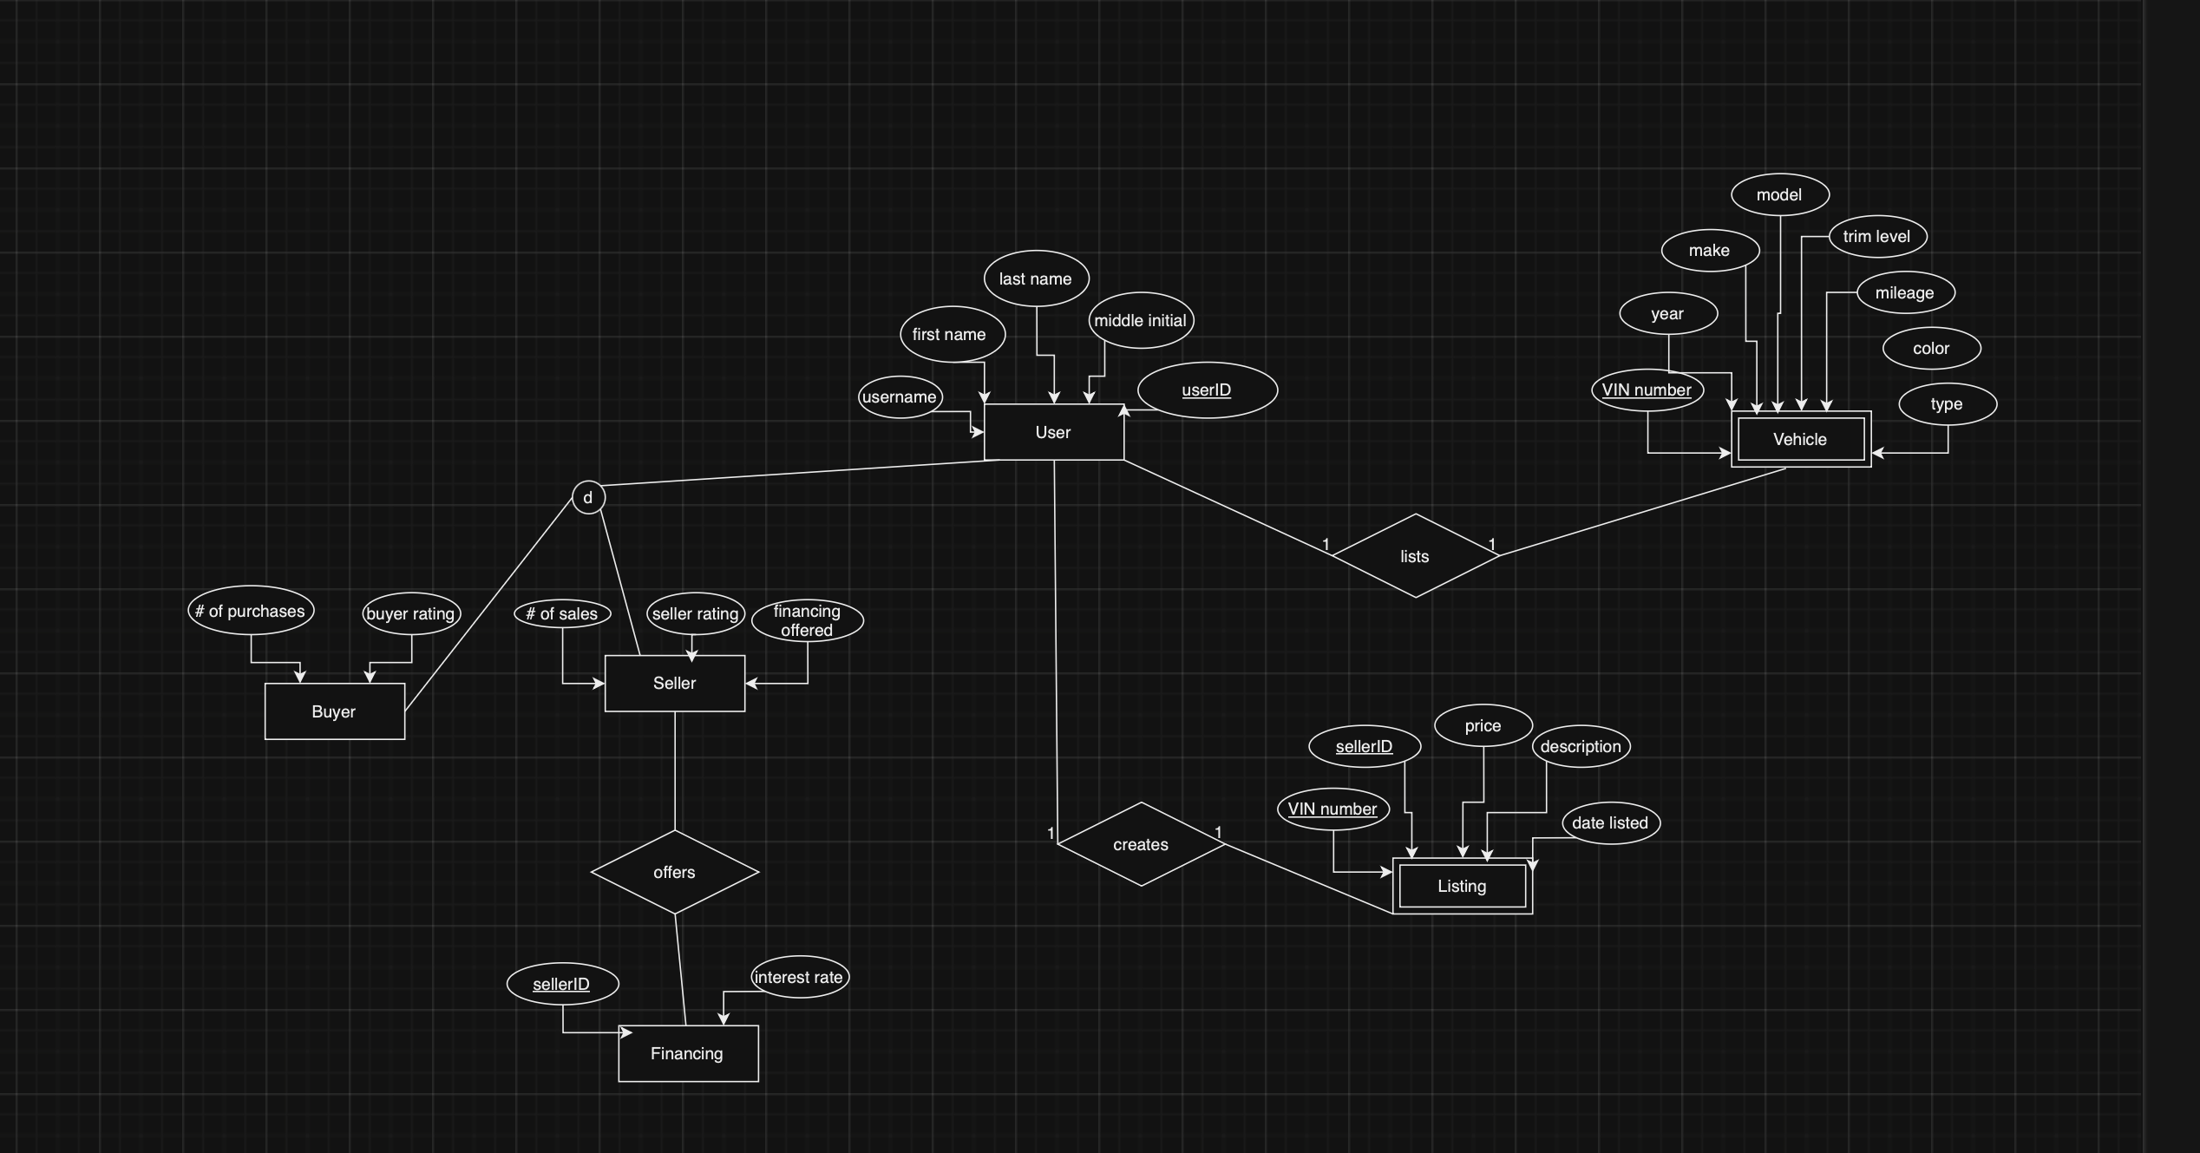

**Schema:**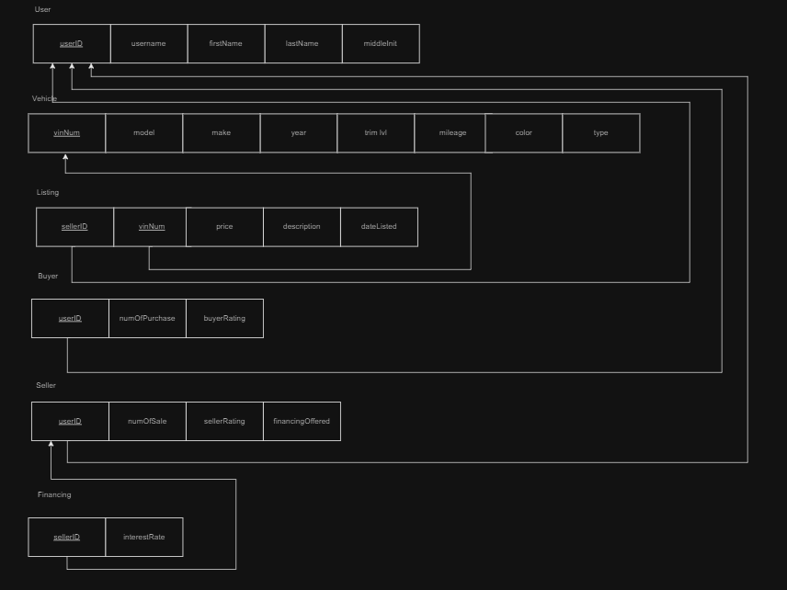

**Database:**

**Creation code:**

CREATE DATABASE Project;

CREATE TABLE Users (

userID INT PRIMARY KEY,

userName VARCHAR(50) NOT NULL,

firstName VARCHAR(50) NOT NULL,

middleInit CHAR(1),

lastName VARCHAR(50) NOT NULL );

CREATE TABLE Vehicle (

vinNum VARCHAR(17) PRIMARY KEY,

year INT NOT NULL, make VARCHAR(50) NOT NULL,

model VARCHAR(50) NOT NULL,

trim_lvl VARCHAR(50),

mileage INT NOT NULL,

color VARCHAR(30),

type VARCHAR(20) );

CREATE TABLE Listing (

sellerID INT,

vinNum VARCHAR(17),

price DECIMAL(10, 2) NOT NULL,

description TEXT,

dateListed DATE NOT NULL,

PRIMARY KEY (sellerID, vinNum),

FOREIGN KEY (sellerID) REFERENCES Users(userID) ON UPDATE CASCADE ON DELETE CASCADE,

FOREIGN KEY (vinNum) REFERENCES Vehicle(vinNum) ON UPDATE CASCADE ON DELETE CASCADE );

CREATE TABLE Buyer (

userID INT PRIMARY KEY,

numOfPurchase INT DEFAULT 0,

buyerRating FLOAT CHECK (buyerRating BETWEEN 1 AND 5),

FOREIGN KEY (userID) REFERENCES Users(userID) ON UPDATE CASCADE ON DELETE CASCADE );

CREATE TABLE Seller (

userID INT PRIMARY KEY,

numOfSale INT DEFAULT 0,

sellerRating FLOAT CHECK (sellerRating BETWEEN 1 AND 5),

financingOffered BOOLEAN,

FOREIGN KEY (userID) REFERENCES Users(userID) ON UPDATE CASCADE ON DELETE CASCADE );

CREATE TABLE FinancingInfo (

sellerID INT PRIMARY KEY,

interestRate DECIMAL(3, 2) CHECK(interestRate BETWEEN 0 AND 100),

FOREIGN KEY (sellerID) REFERENCES Seller(userID) ON UPDATE CASCADE ON DELETE CASCADE );

**Populating Code:**

INSERT INTO Users (userID, userName, firstName, middleInit, lastName) VALUES

(1, 'john_doe', 'John', 'A', 'Doe'),

(2, 'jane_smith', 'Jane', 'B', 'Smith'),

(3, 'mark_johnson', 'Mark', 'C', 'Johnson'),

(4, 'lisa_brown', 'Lisa', 'D', 'Brown'),

(5, 'peter_parker', 'Peter', 'E', 'Parker'),

(6, 'clark_kent', 'Clark', 'F', 'Kent'),

(7, 'bruce_wayne', 'Bruce', 'G', 'Wayne'),

(8, 'tony_stark', 'Tony', 'H', 'Stark'),

(9, 'natasha_romanoff', 'Natasha', 'I', 'Romanoff'),

(10, 'diana_prince', 'Diana', 'J', 'Prince');

INSERT INTO Vehicle (vinNum, year, make, model, trim_lvl, mileage, color, type) VALUES

('1HGCM82633A123456', 2005, 'Honda', 'Accord', 'EX', 120000, 'Blue', '4-door'),

('1FTFW1ET0EKE12345', 2014, 'Ford', 'F-150', 'Lariat', 80000, 'Red', '4-door'),

('2FMDK3KC7DBA98765', 2013, 'Ford', 'Edge', 'SEL', 60000, 'Black', '4-door'),

('1C4RJFBGXEC123456', 2014, 'Jeep', 'Grand Cherokee', 'Limited', 70000, 'White', '4-door'),

('1N4AL3AP7EC123456', 2014, 'Nissan', 'Altima', '2.5 SV', 50000, 'Silver', '4-door'),

('1HGCR2F3XFA123456', 2015, 'Honda', 'Civic', 'LX', 30000, 'Gray', '4-door'),

('1GNEK13Z03J123456', 2003, 'Chevrolet', 'Tahoe', 'LT', 150000, 'Green', '4-door'),

('1ZVBP8AM1A1234567', 2010, 'Ford', 'Mustang', 'GT', 45000, 'Yellow', '2-door'),

('1FAHP2E84BG123456', 2011, 'Ford', 'Taurus', 'SEL', 70000, 'Blue', '4-door'),

('2C4RDGEG7ER123456', 2014, 'Chrysler', 'Town & Country', 'Limited', 80000, 'Brown', '4-door');

INSERT INTO Listing (sellerID, vinNum, price, description, dateListed) VALUES

(1, '1HGCM82633A123456', 8000.00, 'Well maintained Honda Accord.', '2023-10-01'),

(2, '1FTFW1ET0EKE12345', 25000.00, 'Great condition Ford F-150.', '2023-09-15'),

(3, '2FMDK3KC7DBA98765', 22000.00, 'Family-friendly Ford Edge.', '2023-08-20'),

(4, '1C4RJFBGXEC123456', 30000.00, 'Luxury Jeep Grand Cherokee.', '2023-07-30'),

(5, '1N4AL3AP7EC123456', 15000.00, 'Economical Nissan Altima.', '2023-06-25'),

(6, '1HGCR2F3XFA123456', 18000.00, 'Reliable Honda Civic.', '2023-10-10'),

(7, '1GNEK13Z03J123456', 15000.00, 'Spacious Chevrolet Tahoe.', '2023-10-05'),

(8, '1ZVBP8AM1A1234567', 30000.00, 'Classic Ford Mustang GT.', '2023-09-01'),

(9, '1FAHP2E84BG123456', 16000.00, 'Comfortable Ford Taurus.', '2023-09-12'),

(10, '2C4RDGEG7ER123456', 21000.00, 'Versatile Chrysler Town & Country.', '2023-09-20');

INSERT INTO Buyer (userID, numOfPurchase, buyerRating) VALUES

(1, 5, 4.5),

(2, 10, 4.8),

(3, 2, 4.0),

(4, 3, 4.2),

(5, 1, 5.0),

(6, 4, 3.8),

(7, 6, 4.1),

(8, 5, 4.7),

(9, 2, 4.6),

(10, 7, 4.9);

INSERT INTO Seller (userID, numOfSale, sellerRating, financingOffered) VALUES

(1, 10, 4.6, TRUE),

(2, 8, 4.9, FALSE),

(3, 5, 4.5, TRUE),

(4, 3, 4.3, FALSE),

(5, 7, 4.8, TRUE),

(6, 9, 4.1, FALSE),

(7, 4, 4.4, TRUE),

(8, 12, 4.7, FALSE),

(9, 5, 4.2, TRUE),

(10, 6, 4.5, FALSE);

INSERT INTO FinancingInfo (sellerID, interestRate) VALUES

(1, 3.5),

(3, 4.0),

(5, 3.0),

(7, 3.8),

(9, 4.5);

Users:

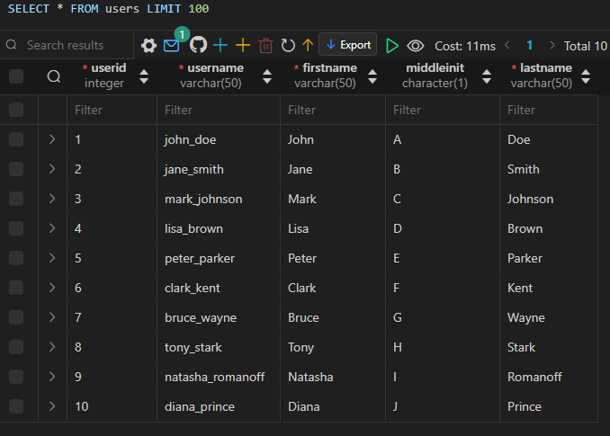

Vehicle:

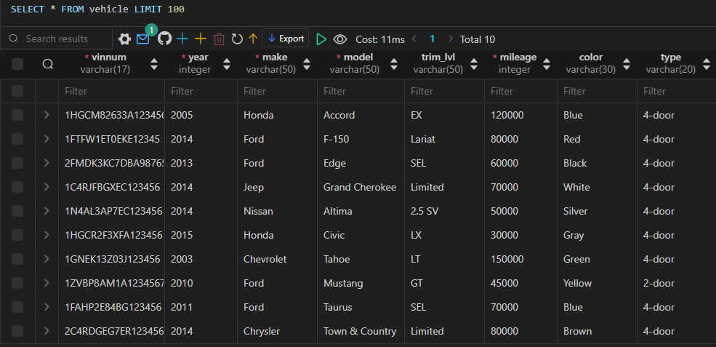

Listing:

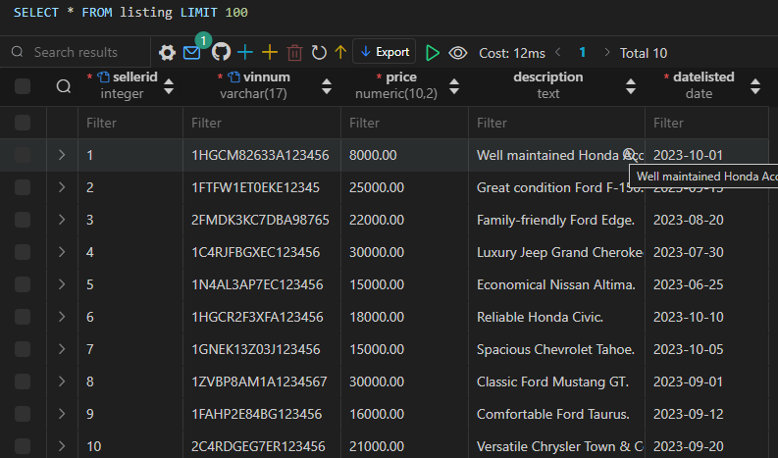

Buyer:

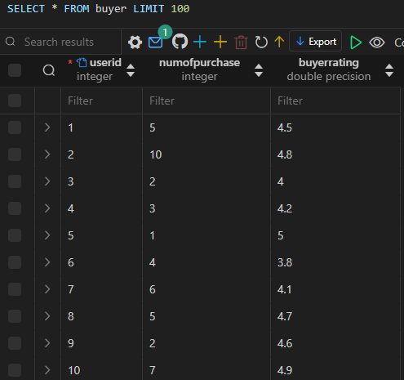

Seller:

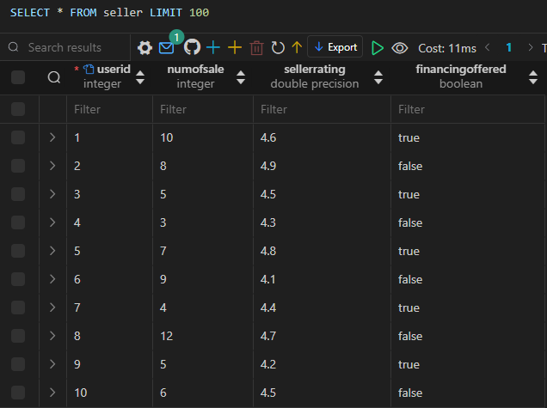

Financing:

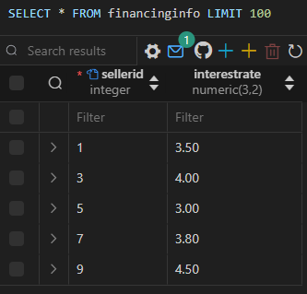

**Query Execution:**

SELECT:

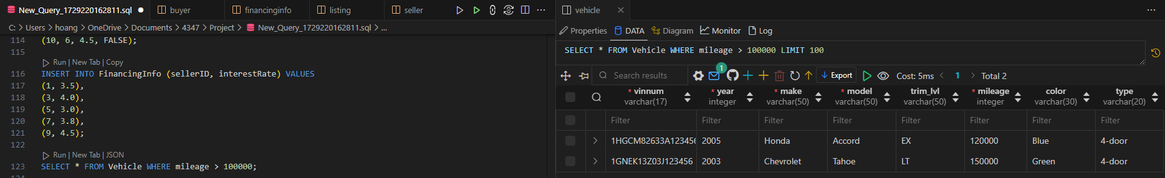

INSERT:

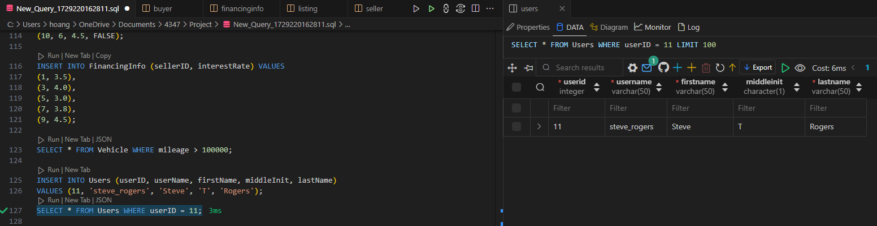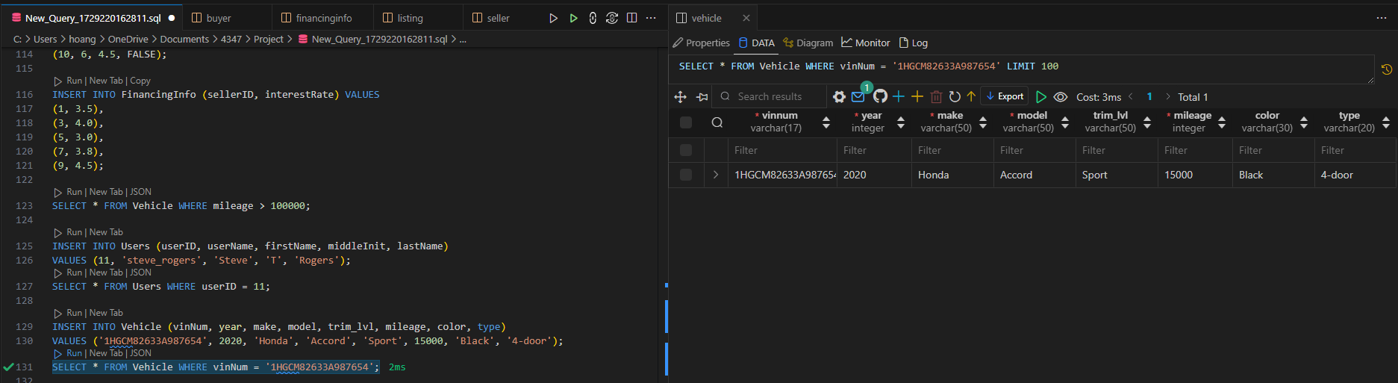

DELETE:

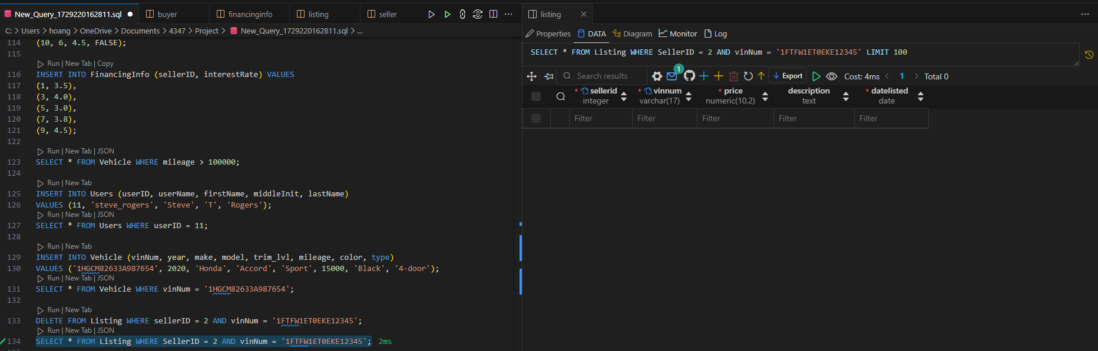

UPDATE:

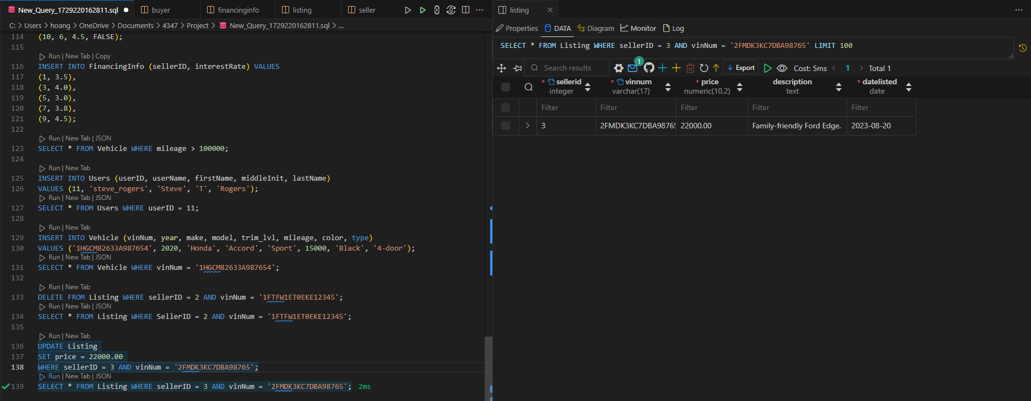

## References:

[1] J. Jiang and Q. Ni, "Relational Models for Vehicle Listings," *Journal of Database Management*, vol. 24, no. 2, pp. 45-59, Feb. 2010.

[2] eBay Motors, "eBay Motors: Buy and Sell Vehicles", eBay, Inc., 2000. [Online]. Available: https://www.ebay.com/motors. [Accessed: Oct. 18, 2024].

[3] J. Smith, "A Review of Online Vehicle Marketplaces: eBay Motors and Beyond," *Journal of E-Commerce*, vol. 20, no. 3, pp. 55-67, Mar. 2008.

[4] Smith, J. "Automotive E-Commerce Trends," 2021.