

Course Code: CSE479

Course Title: Web Database Programming

Section: 02

Project Report:

**PONJIKA**

**Submitted To**:

Md. Tanvir Alam

Lecturer

Department of Computer Science & Engineering

**Submitted By**:

|  |  |
| --- | --- |
| Name | ID |
| Md. Huzaifa Saad | 2019-1-60-079 |
| Rafa Tasnim | 2019-31-60-081 |
| Malyha Bintha Mabud | 2019-1-60-128 |

**Date of Submission:**

16.01.2023

**Introduction:**

Nowadays storage websites are really popular.A storage website, is a platform that allows users to upload, store, and access files, documents, and other digital data remotely. These services typically offer a web-based interface or mobile app that makes it easy to upload, download, and manage files, as well as share them with others. Ponjika is such a storage website.

**Features:**

1. Create user account
2. Login to user account
3. Create a category   
   A. Category name

B. Category detail

1. Add item to category   
   A. Item name   
   B. Item icon

C. Item detail

1. Delete /edit category
2. Delete/edit item
3. Search an item
4. Logout

**Languages:**

The languages that have been used in the project are:

      
   

**Description:**Ponjika is a storage website. This website will help to store various information like description, icons and links of other sites. It will help keep the information neat and clean. And help users to organize information accordingly. At first the user has to create an account. Then they are ready to store any information. This website will use API to collect information for anime, movies, and books. Other than these the users can also create customized categories as per their desire. Then they can save the links of the similar items on the categories**.**

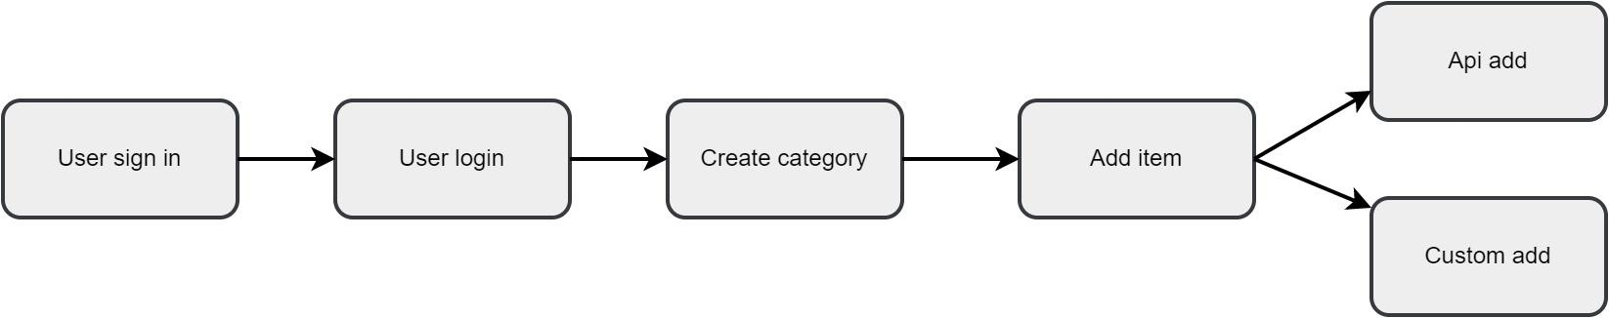

**Functionalities:**

API calling: API (Application Programming Interface) calling is the process of requesting data or services from a remote server using a specific protocol, typically HTTP or HTTPS. This allows different software systems to communicate with each other and exchange information. When making an API call, the client (i.e. the software making the request) sends an HTTP request to the server, containing details such as the endpoint (URL) being requested, any parameters or data to be sent along with the request, and any authentication or authorization information required. The server then processes the request and sends back an HTTP response, which typically includes a status code indicating whether the request was successful or not, and any data or information requested. This response can be in various formats like XML, JSON or HTML.

In this project three different API are used for collecting the information of movies,animes,mangas and animes.

**Project UI:**

At first a user has to sign up

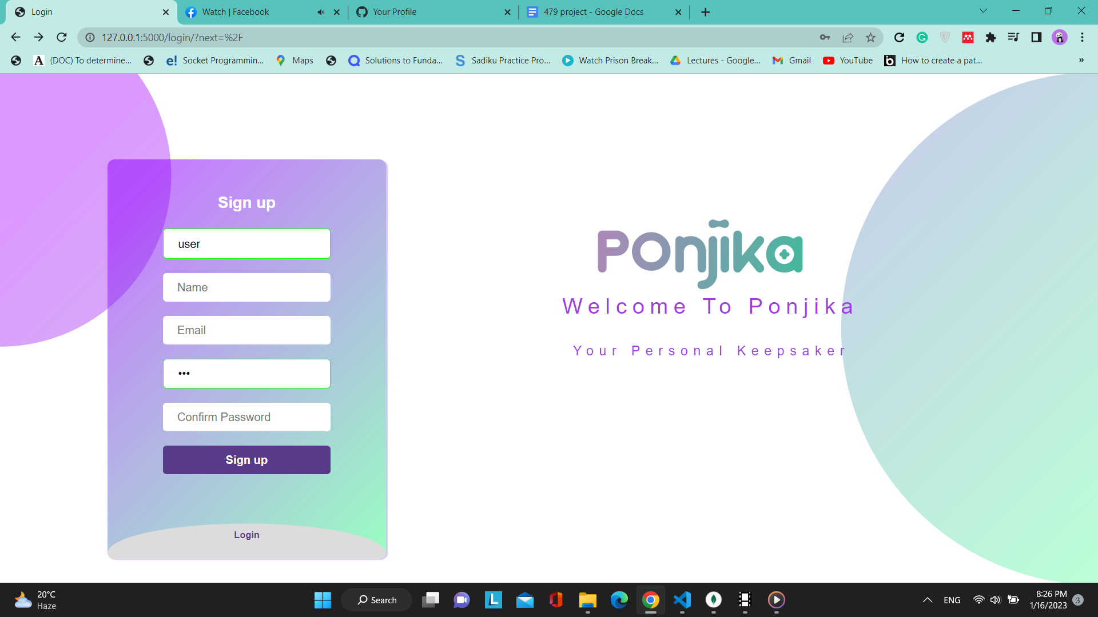

Then he can login using the email and password

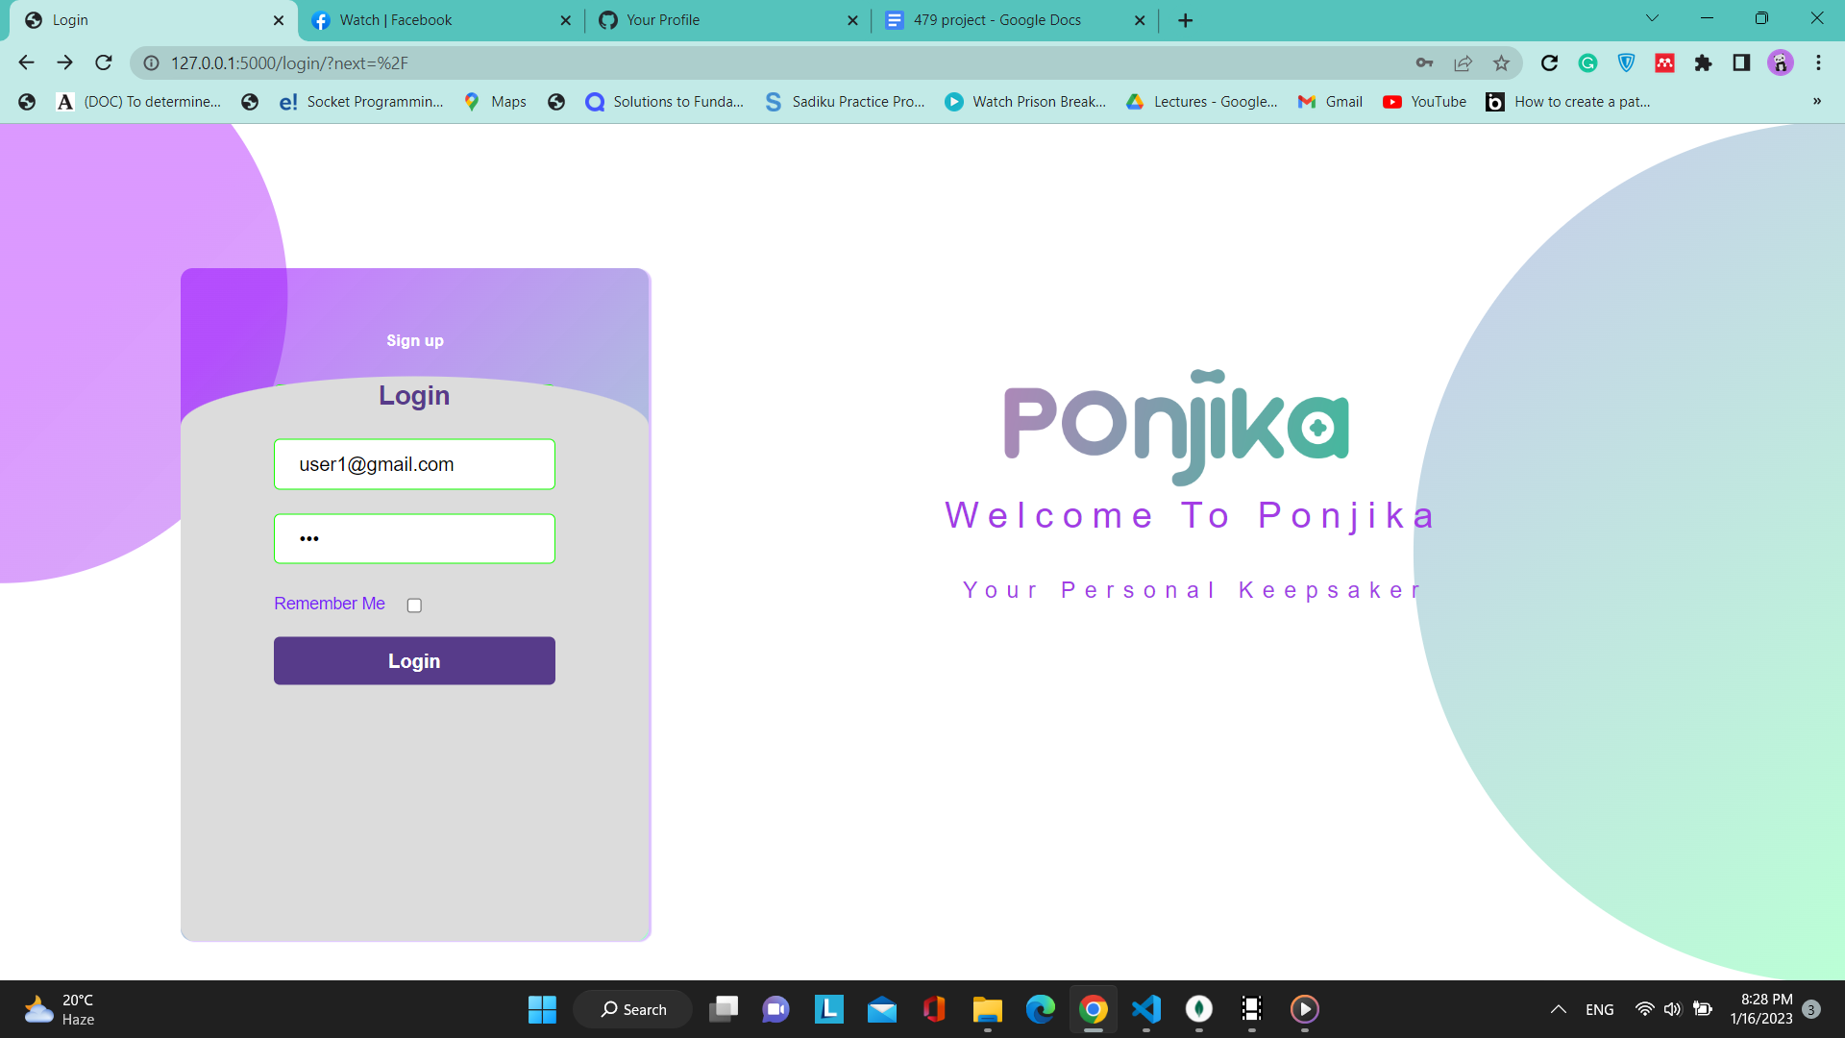

Home page   
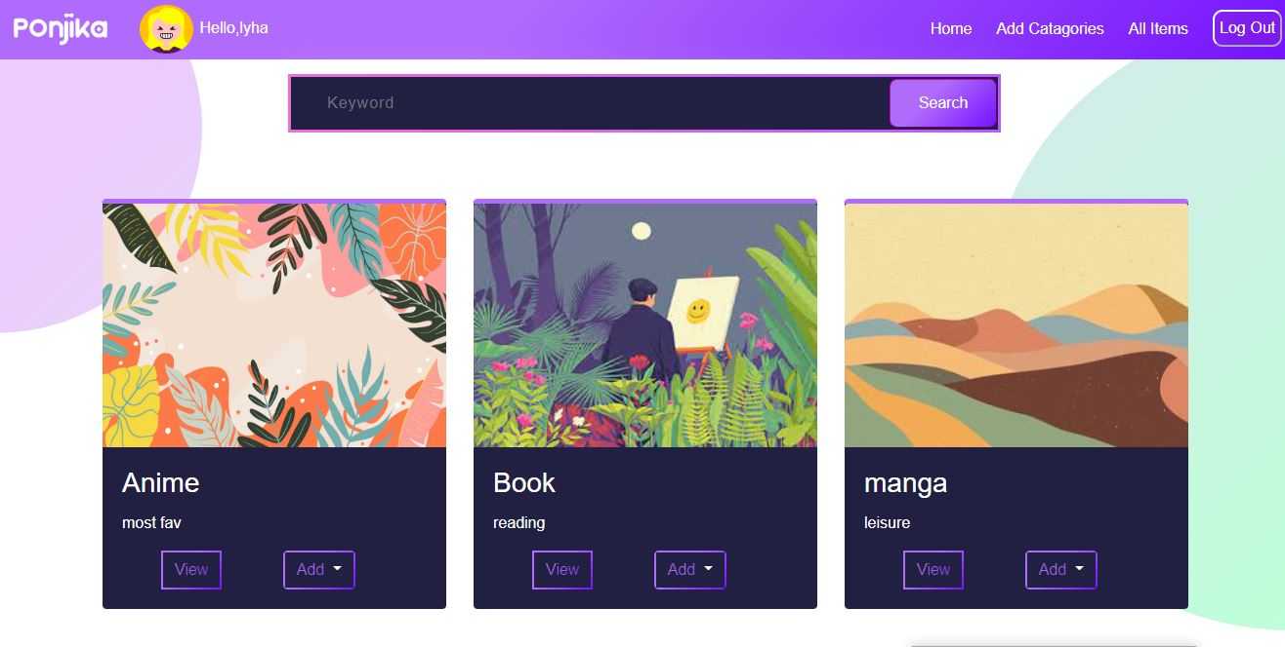

This is the user account

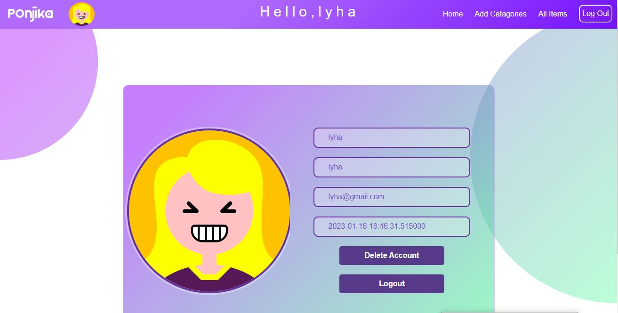

Create a new category   
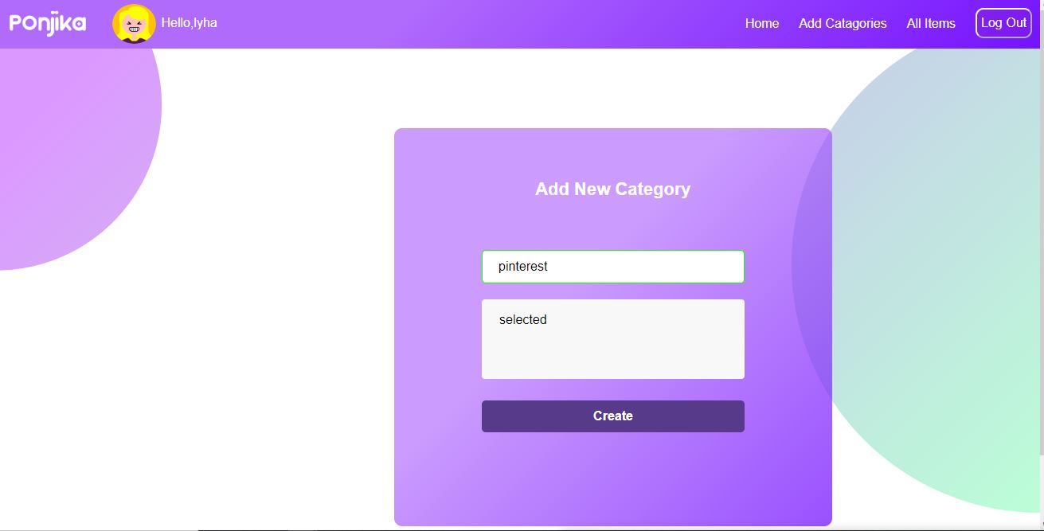

New category added   
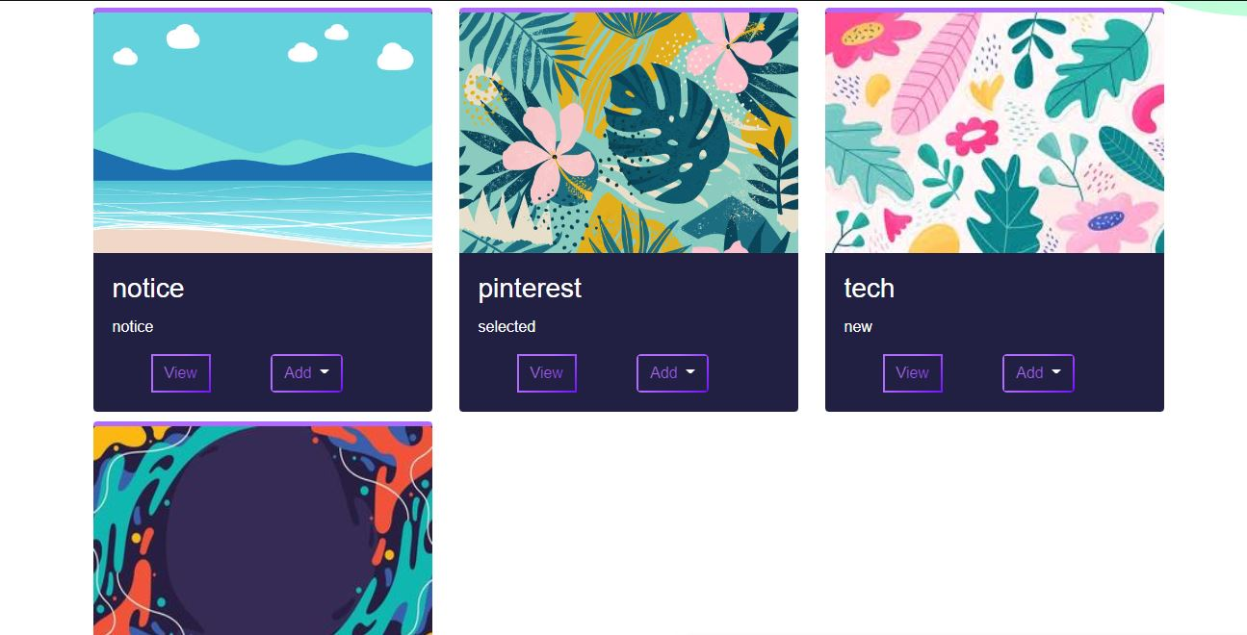

Search category

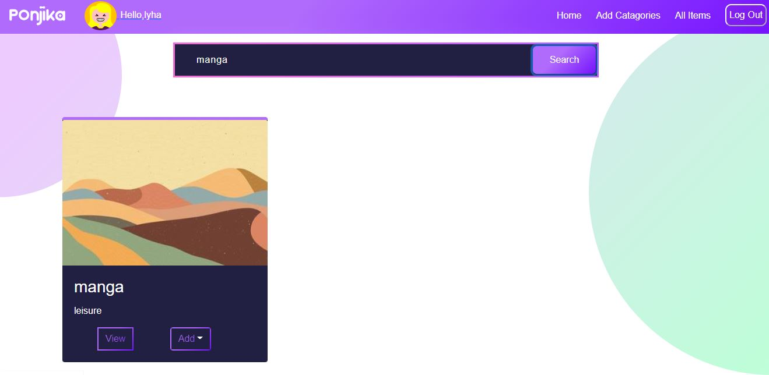

Adding item by using API

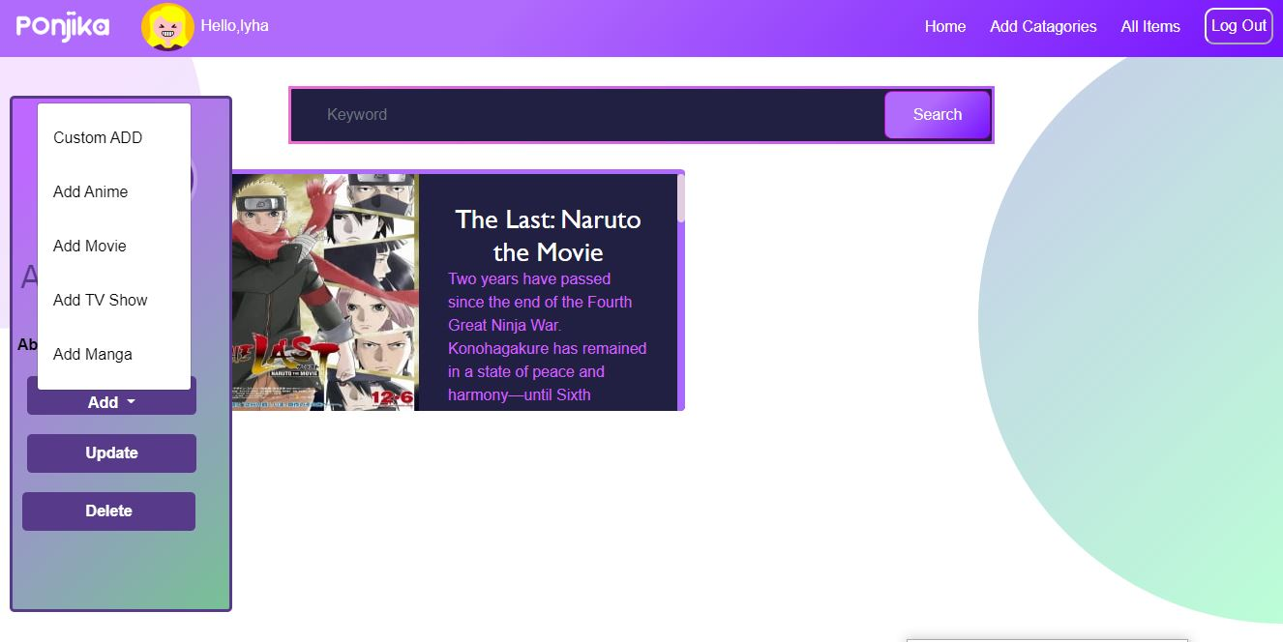

Search through API

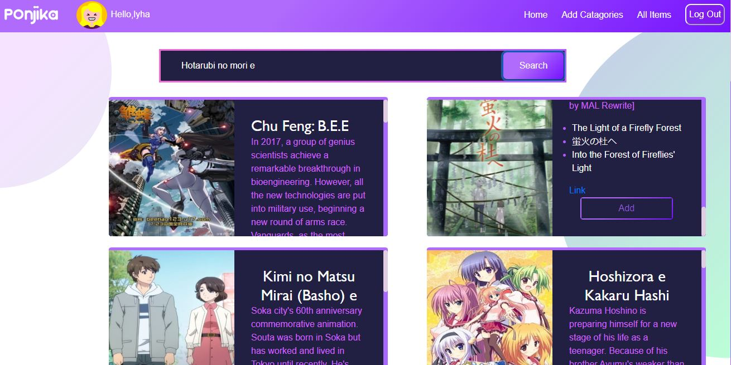

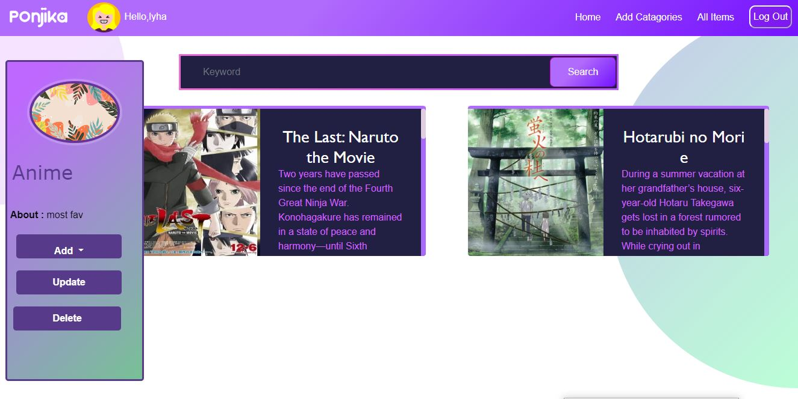

Adding an item by custom adding

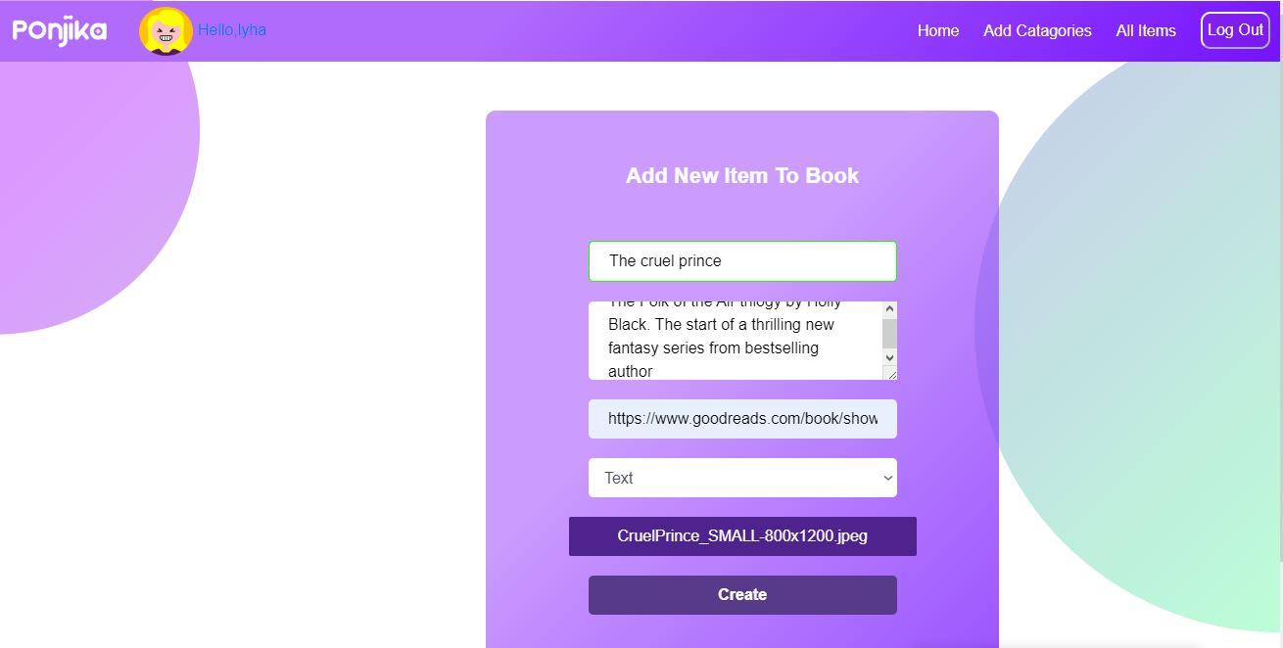

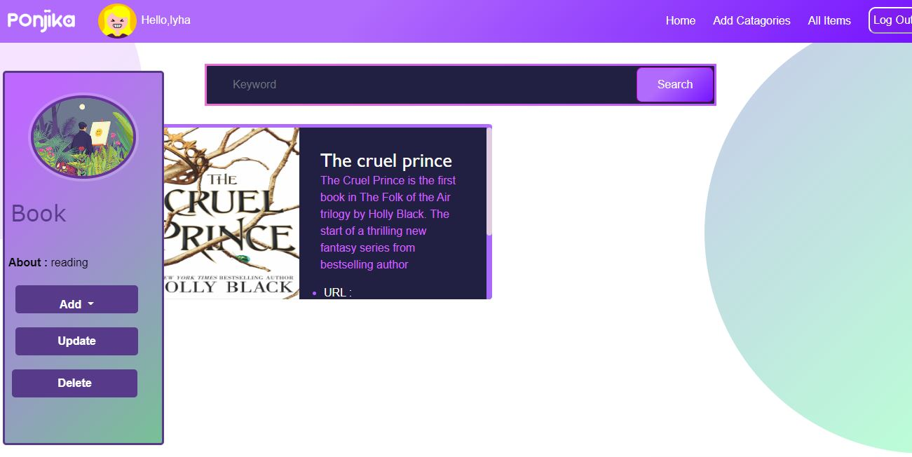

**Conclusion**: In conclusion, a storage website is a platform that allows users to upload, store, and access files and other digital data remotely over the internet. It provides a convenient and accessible way to manage digital files and can be used for personal or business purposes. With increasing demand for storage, they are also becoming more integrated into other services, such as productivity tools and business applications. So, this website PONJIKA will provide a secure, accessible and scalable solution for the storage needs of the individuals.