REPUBLIC OF KENYA
SOCIAL HEALTH INSURANCE ACT, 2023
SOCIAL HEALTH INSURANCE REGULATIONS, 2024

CLAIMS

IMPORTANT CLAIM FILING REMINDERS

1. PLEASE USE CAPITAL LETTERS AND TICK THE APPROPRIATE BOXES.
2. Submit this form with supporting documents within seven (7) days from the discharge date.
3. All fields in this form are mandatory. Incomplete forms will not be processed.
4. Providing false or incorrect information may result in criminal or administrative liabilities.
PLEASE BE AS COMPREHENSIVE AND ACCURATE AS POSSIBLE WHEN COMPLETING THIS CLAIM FORM. ERRORS OR OMISSIONS MAY DELAY CLAIM PAYMENTS
CLAIM NO:_ 056_____
PART I - HEALTH CARE PROVIDERS DETAILS

1. Health Provider Identification Number: FID-42-112905-7
2. Name of Health Care Provider/Facility: ST FRANCIS HILLSIDE MEDICARE KISUMU
PART II - PATIENT DETAILS

Patient's Full Name:
● Last Name: ASENO
● First Name: REAGAN
● Middle Name: OMONDI
3. Social Health Authority Number: CR7128874826673-1
4. Residence: DARAJA MBILI
5. Do you have another Health Insurance:(If Yes, State which one): NO
6. Relationship to the Principal: CHILD
PART III - PATIENT VISIT DETAILS
7.. Referral Information:
Was the patient referred by another Health Care Provider?
● NO ✔️
● If, YES
● Name of referring Health Care Provider/Facility:
Visit type: ☑️Inpatient ☐Outpatient ☐ Day-care:
Visit/Admission Date:  APR 27, 2026 |  | OP/IP No.:  SFS/IP/256/26 | New/Return Visit:
Discharge Date:  APR 30, 2026 | Rendering Physician Name and Registration No:  DR. FRANCIS ODIRA OUKO  A4344
Type of  Accommodation: | (Female Medical, Male Medical, Female Surgical, Male Surgical, Gynaecology, Maternity,NBU, Psychiatric Unit, Burns, ICU, HDU, NICU, Isolation)  MALE MEDICAL

9. Patient Disposition upon discharge (select only 1):
● Improved ☐
● Recovered ☑️
● Leave Against/Discharged Against Medical Advice ☐
● Absconded ☐
● Died ☐
10. Referred (If not referred type N/A)
● Name of Referral Institution: N/A
● Reason/s for referral: N/A
11. Admission Diagnosis/es: INFECTIOUS GASTROENTERITIS
12. Discharge Diagnosis/es:
● Diagnosis: INFECTIOUS GASTROENTERITIS
● ICD-11 Code/s: 1A40.Z
● Related Procedure/s (if any):
● Date of Procedure:
14. SHA Health Benefits:
* For outpatient services, Date of service is the Date of admission.
Date of  Admission | Date of  Discharge | Case  Code | ICD 11/  Procedure  Code | Description | Preauth  No. | Bill  Amount | Claim  Amount
27/04/2026 | 30/04/2026 | SHA-07-001 | 1A40.Z
Total |  |  |  |  |  | 9,160 | 6585.60
Any unforeseen circumstances or additional information that led to an increased length of stay for this admission? _ _ _ _ _ _ _ _ _ _ _ _ _ _ _ _ _ _ _ _ _ _ _ _ _ _ _ _ _ _ _ _ _ _ _ _ _ _ _ _ _ _ _ _ _ _ _ _ _ _ _ _ _ _ __ _ _ _ _ _ _ _ _ _ _ _ _ _ _ _ _ _ _ _ _ _

(If the patient is unable to write, please provide necessary information.)
PATIENT’S/ AUTHORISED PERSON’S DECLARATION: I certify that I have received the above treatment, and that the above information is correct. I understand that it is an offence to falsify information to obtain any benefit under the SHI Act 2023.
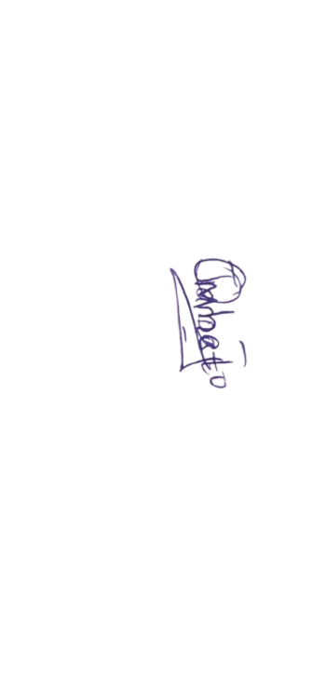
Names(Majina): REAGAN OMONDI ASENO____________Signature(Sahihi): ____________ Date(Tarehe): 30-APR-2026
E. HOSPITAL DECLARATION: This is to certify that to the best of my knowledge, the information contained above, and any attachments provided is true, accurate, and complete and the service(s) rendered is necessary to the patient's health. I understand that it is an offence to knowingly make any
false statement to obtain any benefit under the SHI Act 2023. Please arrange to pay the hospital the sum of Ksh. 6,585.60 being the approved amount for services rendered.
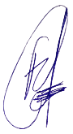
Facility stamp
Signature: ________________________________ Date: 30-APR-2026

F. FOR OFFICIAL USE ONLY
SHA Receiving
Receiving Officer Name: _________________________ Date: ________________________
Stamp
Notice: Any person/institution who/ knowingly files a statement of request or claim containing any misrepresentation or false, incomplete, or misleading information may be guilty of medical fraud punishable under law.

