1. Screen shot1 of repo on VS Code for submission

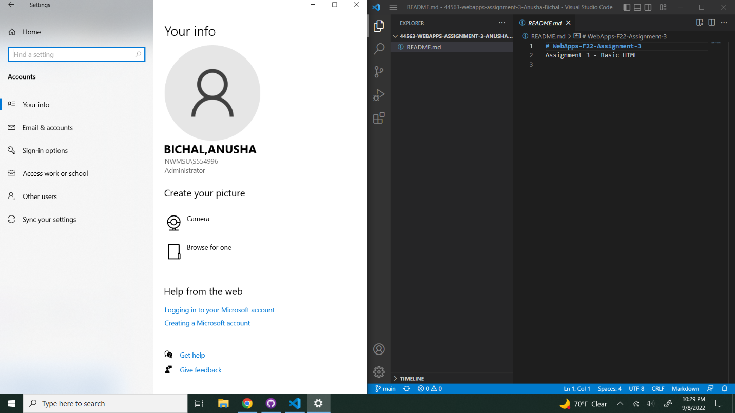

1. Screen shot2 on your browser of rendered page and the inspector.

