**Web Apps Assignment 3**

**Screen shot3 on VS Code of edited index.html**

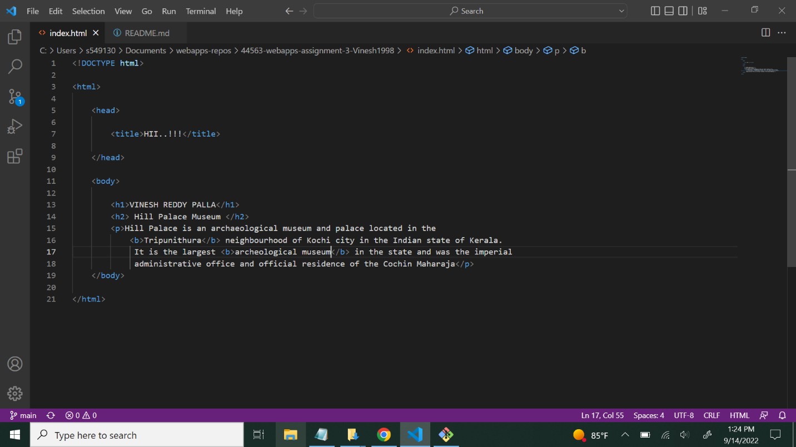

**Screen shot4 on browser showing section with inspector**

**Screen shot 5 in GitHub desktop showing the state of the repo (or a screenshot of git bash running git diff index.html)**

**Screen shot 6 in GitHub desktop showing the changes for about me (or a screenshot of git bash running git diff AboutMe.md)**

**Screen shot 7 on browser showing table section with inspector.**

**Screen shot 8 on browser showing code section**

**Bonus:**

